Rural Women Supporting their Families

Mid Year Report (2011-2012)
Submitted to
Global Giving
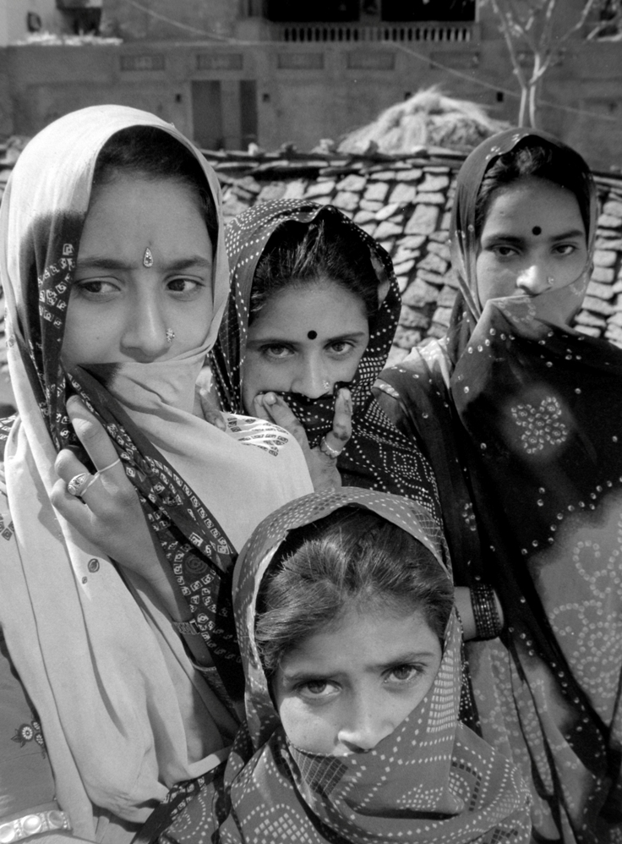

SEVA MANDIR
Udaipur Rajasthan, India

info@sevamandir.org
www.sevamandir.org
Introduction

Self Help Groups (SHGs) bring women together in saving and credit activities, eventually providing them with an opportunity to access external finances. Through these, they can support a variety of productive activities and fulfill the immidieate needs of cash for their families.

The Self Help Group (SHGs) is a part of Seva Mandir’s Women Economic Empowerment Projec. For more than twenty-five, the women’s empowerment program has helped us develop a deep understanding of gender issues in a local context. This is reflected in our evolving strategies which are both effective in transforming gender relations and enable women to gain greater control over their own lives and to become agents of positive social change.

Progress made so far
During the reporting period, there were 534 SHGs with a membership of 8,161. 15 new SHGs were formed and nine SHGs were closed for various reasons. Considerable effort was directed towards vision development and capacity building of staff and the SHGs. One of the most significant achievements during this period was that the vision of the SHG program was reviewed and revised. Furthermore, regular monthly meetings of SHGs were organized in this period.

The records of all the SHGs were maintained by 141 accountants. For all these SHGs, the account books have completely been computerized. This is very encouraging and it helps us maintain records easily. The table below gives an account of the Self Help Groups in all the blocks of Seva Mandir –
Name of Block | No of SHGs | Membership
Urban | 87 | 1,722
Badgaon | 67 | 1,053
Girwa | 71 | 1,111
Jhadol | 100 | 1,313
Kherwara | 116 | 1,697
Kumbhalgarh | 93 | 1,265
Total | 534 | 8,161

Financial Status of SHGs
The net-owned fund of the 493 SHGs until September, 2011 was Rs. 23,885,387 (USD 508,200). The total savings stands at Rs. 22,182,137 (USD 307,872). The amount deposited in the bank was Rs. 6,311,945 (USD 134,297); the cash in hand was Rs. 1,391,273 (USD 29,602) and the amount of outstanding loans was Rs. 17,403,148 (USD 370,280).

The savings to loan ratio is almost 1:1 which indicates that members are rotating all their savings for credit; it was 3:1 in Girwa, 1.5:1 in Jhadol and 2:1 in Kumbhalgarh which reflects the need of greater loan rotation in these two blocks.

The cash at bank was 26.43% of the total funds. It was highest in Jhadol (81.78%) and Kherwara (39.67%) block and lowest in Urban (0.73%) and Badgaon (3.71%) block. The table below explains the current status of funds in all the SHGs-

Name of Block | Savings |  | Cash in hand | Cash at bank | Loan outstanding
Name of Block | Compulsory | Voluntary | Cash in hand | Cash at bank | Loan outstanding
Urban | 85,64,900 | 19,03,546 | 80,671 | 13,79,488 | 95,69,100
Badgaon | 29,00,310 | 5,82,298 | 1,35,117 | 8,03,708 | 28,75,053
Girwa | 14,22,220 | 76,602 | 2,77,650 | 5,94,461 | 5,31,674
Jhadol | 14,47,640 | 1,70,133 | 2,18,961 | 13,40,853 | 10,82,827
Kherwara | 33,84,957 | 5,86,025 | 4,25,651 | 19,20,054 | 26,83,770
Kumbhalgarh | 10,64,600 | 78,906 | 2,53,223 | 2,73,381 | 6,60,724
Total | 1,87,84,627 | 33,97,510 | 13,91,273 | 63,11,945 | 1,74,03,148
The total cash in hand was 5.82% of the net owned fund. It was highest in Kumbhalgarh (21.34 %) and Girwa (17.93 %) and lowest in Urban (0.73%) and Badgaon block (3.71%).

Performance of SHGs
The performances of SHGs were based on the main indicators like interest repayment and regularity in meetings, savings and attendance. The table below shows the performance of the six blocks.
Name of Block | Meeting Regularity (%) | Attendance Regularity (%) | Saving Regularity (%) | Interest Re-payment (%)
Urban | 99 | 91 | 87 | 100
Badgaon | 88 | 81 | 69 | 100
Girwa | 90 | 79 | 77 | 100
Jhadol | 84 | 74 | 64 | 67
Kherwara | 93 | 79 | 75 | 100
Kumbhalgarh | 96 | 82 | 82 | 100

The table displays that the Urban Block outperforms of all the other six blocks and the interest repayment rate is 100% in all blocks except Jhadol.

Profit Distribution
During the reporting period, profits distributed in SHGs were based on both attendance and savings made during the year 2010-2011. Most of the members did not withdraw the distributed profit, which was added to their individual compulsory savings, and some people used the profit for repaying their old loans.

130 SHGs have raised their accountant’s honorarium and 73 SHGs have raised their savings.

Capacity Building
Following are the details of the capacity building trainings imparted during the reporting period –

a. Campaigns
During this period, 34 campaigns were organized for a day in all the blocks, in which 1038 women from 182 SHGs participated. These campaigns focused mainly on the concepts of SHGs, performance indicators and addressing the specific problems of the SHGs. These campaigns have proved very effective in improving the group performance in terms of attendance, savings and repayment of their loans.

b. Training of Accountants
During the reporting period, SHG records were maintained by 141 accountants. Monthly meetings and seven training programs were organized regularly for enhancing the accounting skills of accountants. In addition, these trainings ensured the flow of data from village to block for maintaining MIS.
Six trainings were organized for the weak accountants and the one remaining training was carried out for the accountants responsible for the auditing of SHGs. These trainings focused on enhancing the accountancy skills of the accountant and were facilitated by block and unit level staff members of Seva Mandir. In addition, regular monthly meetings at the zonal level were organized to further build accountancy skills and ensure flow of data from village to block.

c. Course in Rural Entrepreneurship, Administration and Management (CREAM)
Seva Mandir conducted a short course (37 days) called Course in Rural Entrepreneurship, Administration and Management (CREAM) in collaboration with a team of consultants. The course included six modules and the participants included 18 people - 10 staff and 8 entrepreneurs. The first module under the course was completed in March’11 and the remaining five modules were completed in the month of April, May, June, July and September, 2011. These modules focused on finance and accounting, sales and marketing, operations management, strategy management and final exam and viva. The participants were presented certificates on successful completion of the course in the last module.

Income Generation Initiatives
All the existing income generation activities including goatery, dairy, fisheries, pottery, individual enterprises etc were continued during this reporting period.

One day training on dairy was organized on 13th May 2011 with one SHG called ‘Ambamata Swayam Sahayata Samuh’ in Jhadol Block. 11 women participated in this training. This group had received a loan for dairy development from a bank under a Government Scheme called Swarnjayanti Gram Swarojgar Yojana which assists rural poor in self employment. The training was facilitated by Doctor Shakti Singh, a veterinarian from Udaipur.
During the reporting period, 538 litres of soy milk and 610.05 kg of tofu were sold to Residential Learning Camp (run by Seva Mandir), Vidya Bhawan, local vendors and the central public schools. Total sales were made of Rs. Rs. 77,872. However, the total sales were only enough to meet the cost of raw materials and did not able to meet the operational expenses like salaries, transport etc. In the coming months, efforts will be made to increase sales and simultaneously reduce operational cost to generate net profit.

Story of Transformation
Rodi Bai, lives in Falasia. She became a member of self help group (SHG) in her village in March last year. In the beginning she was saving Rs. 25/- every month (USD ½), which gradually increased up to Rs.50/- (USD 1).
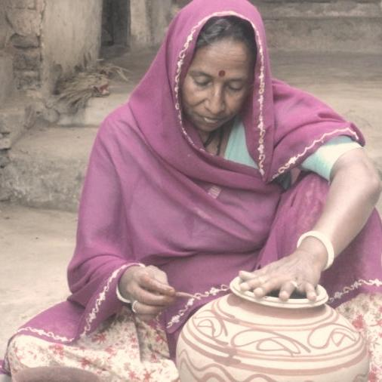
She and her husband have three sons, one daughter and a daughter-in-law. The economic condition of her family is not too sound as her husband is the only breadwinner of the family. His income isn’t enough to meet the ends meet. After being a member of the SHG, Rodi Bai thought of reviving her traditional family business of pottery. Unfortunately, she didn’t have enough money to start and the saving which was pooled up by the SHG wasn’t sufficient either to meet her requirement of cash. Subsequently, the SHG applied for a bank loan under a Government Scheme ’SwarnaJayanti Gram Swarojgar’. The group was successful in obtaining a loan of Rs. 312,500 (USD 6,250) from a bank. Rodi was provided with a loan of Rs. 50,000 (USD 1,000) to start her pottery business.
Rodi bai and her husband have started making clay pots and other items. They sell their products in the local and main markets of Udaipur city. Rodi has begun to earn an annual income of Rs. 60,000 (USD 1,200). She has been able to repay more than half of the loan she owes to the bank. Rodi bai and her family is doing well and is very proud of their traditional business.

