

**Doña Arminda, Nueva Primavera, Guatemala**

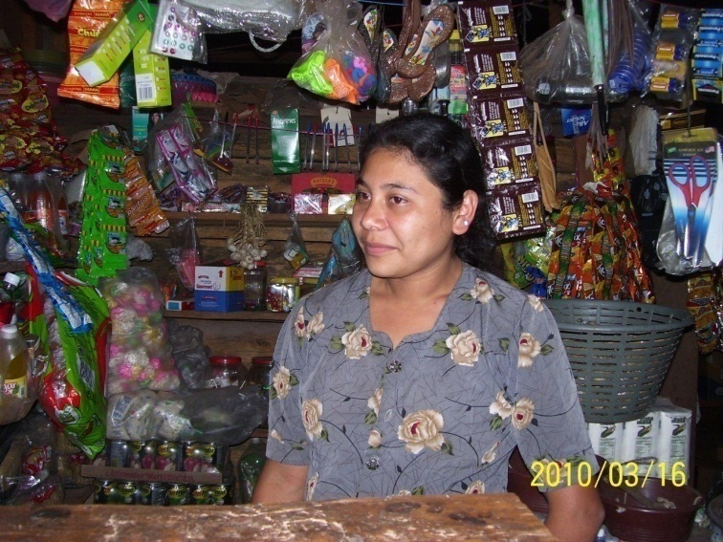

*Doña Arminda at her general store*

Doña Arminda is a determined and diligent resident of Nueva Primavera, an Agros Guatemala community. Through her involvement in the women’s Community Bank, she has been able to open a small general store so that her neighbors in Nueva Primavera and Villa Linda do not have to walk long distances to purchase basic items. Her lucrative business has been fruitful: she has been able to support her husband with household income as well as build her own savings. Currently, Arminda has saved $93 and serves as an entrepreneurial role model for all of Nueva Primavera.

Including Arminda, eleven women are currently participating in the Community Bank in Nueva Primavera. The women are now in their eleventh loan cycle with the bank, investing their funds in various small businesses like raising pigs and chickens and selling tamales, in addition to Arminda’s store. The women met three times this past quarter to update their bank records and make loan and savings payments. Each takes out a loan of approximately $175 each cycle. Additionally, the women are learning important skills and principles in business management and administration, including the use of commercial documents such as receipts and invoices.

There are several economic development workshops available to the women in the Community Bank. This quarter, ten women entrepreneurs from Nueva Primavera and neighboring Agros community Villa Linda participated in a workshop to learn how to make lamb sausage. The participants were thrilled to learn such a unique skill and put their new abilities to practice in order to help expand their businesses. Furthermore, women raising animals vaccinated fourty pigs and thirty sheep. A shelter was constructed for the animals to keep them safe and also allow the families to collect animal manure. This manure will be used to improve production in their coffee and cardamom fields.

Other business trainings offered this quarter included a candle-making workshop to learn how to make yellow and white candles. Five women from the community learned how to make these candles that are used in the families’ homes and to sell for income, further strengthening the small businesses supported by the community bank.

The story of Doña Arminda and the other women of Nueva Primavera provides just a small glimpse into how transformative the community bank model has been for women in Agros communities. These women receive business development training and take on loans to launch income-generating projects that can dramatically change their lives, introducing the concept of savings and loans to many for the first time. Since they are also supported by workshops on business skills, marketing, gender, and self-esteem, these women are boldly empowered by the process, working toward a more secure future. The loan repayment results have also been immensely positive, with the initial repayment rate for all Community Banks sponsored by Agros holding steady at 99 percent. Thanks to your support, this project continues to **transform rural, undereducated farmers into businesswomen.**

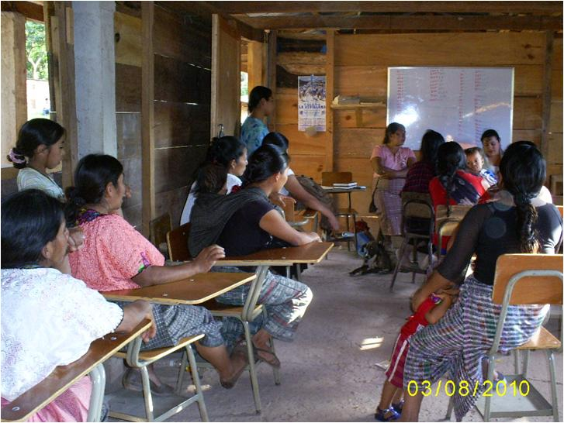

*Members of the Nueva Primavera Community Bank at their repayment meeting*