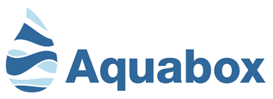

___________________________________________________

[**Report #16 - Status of Shipments February 2024**](https://www.globalgiving.org/projects/aquabox-water-and-aid-for-yemen/reports/?subid=208870)

**-- Table of Contents.**

**1-- General Comments.**

**2-- TENTH Aquabox shipment sent to YEMEN in December 2023.**

**3—Next shipment to YEMEN, the ELEVENTH shipment.**

**4-- Total shipments to YEMEN to date.**

**5-- Other Aquabox shipments since October.**

**6—Alternative video link.**

**7---PHOTOS**

___________________________________________________

1. **General Comments.**

The repeated deliveries tend to give rise to repeated comments.

Many thanks to donors for the funds already accumulated, which are received from GlobalGiving monthly and transferred to Aquabox in full within two working days.

This includes non-targeted donations which are thankfully allocated to this project by GlobalGiving. The crisis in Yemen continues and your donations have been and continue to be much needed. Apart from one part time administrator Aquabox is staffed entirely by volunteers.

This project raises funds specifically for the benefit of the needy in Yemen. There are other and newer disasters around the globe, sometimes appearing to suppress news of an ongoing crisis such as the Yemen conflict. Unfortunately, there is still a great need for the support of those caught up in this dreadful conflict.

Aquabox will be increasing the number of filters produced each week by adopting new bespoke tools in the assembly shop.

Consignment contents –

There are 2 categories of shipped units.

-- Water filters to provide clean drinking water. This is the chief requirement for many disaster targets. There are 2 types of filter, the Family Filter and the Community Filter. An Aqua12 is a box containing 12 Family Filters.

-- Gold Boxes which contain a Family Filter plus items classed as essential aids, with the latter having some variation according to the requested needs of the targeted people.

1. **TENTH Aquabox shipment sent to Yemen.**

250 Gold Boxes were again loaded into the container and sent to partner JOY for them to add medical equipment prior to shipment to Yemen. They were humanitarian aid packs designed to meet all of the basic needs for shelter building, cooking, education needs for the families to rebuild their lives. Each Gold Box also includes a family filter that will provide water for 6-10 people.

This is a repeat of the previous shipment in June, sent some 2 months later than originally scheduled because of other emergencies. This shipment left the Aquabox depot on 1st December, with pictures available in the related document.

Cost to Aquabox of tenth shipment to Yemen (excluding delivery).

250 gold boxes @ £150 per box = £ 37,500, with each box including a Family Filter.

**3.** **Next shipment to Yemen, the ELEVENTH shipment.**

The war in Ukraine and disasters in Turkey, Syria and Morocco have been at the forefront of recent donations to Aquabox, and this has affected their schedules. Donations directed to Yemen or non-specific donations are vital.

There is currently a problem with scheduling delivery and so a date cannot be specified with any certainty. The next shipment is expected to contain 200+ gold boxes. The need is great and continues as before.

**4. Total shipments to Yemen to date.**

2024 - Gold Boxshipment still to be scheduled.

2023 - 250 Gold Boxesshipped in December

2023 - 250 Gold Boxesshipped in June

2022 - 250 Gold Boxes shipped in October

2022 - 300 Gold Boxes shipped in April

2021 - 400 Gold Boxes

2020 - 500 Gold Boxes

2020 - 5 Community Filters

2020 - 120 Family Filters

2019 - 270 Gold Boxes

2018 - 60 Gold Boxes (trial shipment)

Each of the 2280 Gold Boxes contains a Family Filter.

The total of 2400 Family Filters and 5 Community Filters delivered or being prepared for Yemen can produce over 1100 million litres of clean drinking water over the working lives of the filters.

The total cost to Aquabox of Yemen aid above exceeds £380,000, as calculated using the original 2019 costs which have since increased.

**5. Other Aquabox shipments since October 2023.**

***5.1 Nepal –*** *pending.*

Another consignment of 250 Gold boxes is ready for dispatch to Nepal, to be delivered and distributed by the Gurkha Rifle

**5.2 Morocco –** delivered.

The villages most affected by the earthquake have been identified, together with secure delivery routes. This will enable the provision of Aquafilters for the supply of much-needed safe drinking water to families and communities. It will also help prevent the spread of deadly waterborne diseases in the aftermath of the devastating earthquake.

249 Gold Boxes were dispatched to Morocco on 5 October 2023.

**5.3 Libya –** delivered.

24 Family Filters and 20 Community Filters were dispatched to Libya on 5 October 2023.

**5.4 TURKEY –** en route.

It is over a year since the powerful earthquake hit Turkey, and there are still many families and orphans who are without adequate shelter or safe water supplies. Many are unable to return to their homes so are still homeless or in temporary camps. Further earthquakes also caused more damage.

250 Gold Boxes were dispatched to Turkey & Syria on 10 October 2023

In addition, 150 Family Filters left the Aquabox depot on 15th January bound for the Hattay province. The funding was raised by the Rotary Club of Tenterden, and the shipment is scheduled to leave the Operation Orphan’s base in Nottingham on 26th January.

**6. Alternative video link.**

<https://www.youtube.com/watch?v=qZ-MOkxFGlU>

This 8-minute YouTube video is the original video. Some people prefer this to the newer video which is accessible from the main project page. Filters have been improved since the original video was created.

**7. PHOTOS**

--- Distribution in Yemen

--- Delivery to Yemen starting 1 December 2023

--- Content of Gold Box 2023/24

Aquabox Distribution in Yemen

Aquabox Distribution in Yemen

**DELIVERY SEQUENCE via J.O.Y.**

1. Yemen shipment leaving Aquabox depot 1-Dec-2023.

2. Yemen shipment leaving Aquabox depot 1-Dec-2023

3. Yemen shipment at JOY in Shipley 1-Dec-2023

6. Yemen shipment at JOY in Shipley 1-Dec-2023

**GOLD BOX -Sample Content**

Each Gold box contains an Aquabox family filter, plus a range of items carefully selected to make life easier for people living in extreme deprivation: tools, lighting, survival aids, cooking equipment, eating and drinking, educational aids and hygiene provisions. This is not a random selection: we liaise regularly with our partners ‘on the ground’ in refugee camps and disaster areas, and the items that go in the Gold box are the things they tell us are most needed.

Because of the need to be confident that aid items are sourced from factories which don’t involve child labour, slave labour or money laundering, the goods in the Gold boxes are purchased only from suppliers who can demonstrate ethical employment and management policies. Wherever possible Aquabox purchase goods in bulk, direct from the producer, to ensure that they buy on the best possible terms; and because the Gold boxes are packed entirely by unpaid volunteer teams, there is no additional labour cost involved. Nevertheless, each Gold box represents a cost to Aquabox of £150 at 2023 prices, and like everyone else we face rising prices across the board.

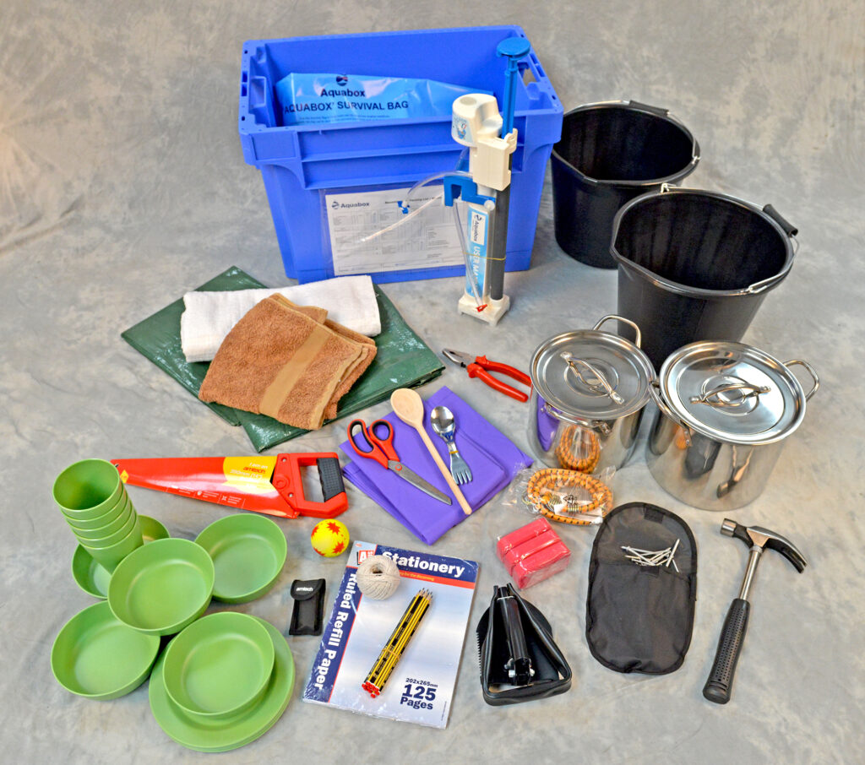

Contents of a Gold Box

To keep the contents of the Gold box safe during transit, Aquabox use old towels as packing materials, and donations of clean used towels are always welcome.

### Gold Box - Recommended Packing List

**Essential Items**

Bucket x 2

Cooking Pot x 1

Liner Bag x 1

Survival Bag x 1

Tarpaulin x 2

**Hygiene Items**

Carbolic Soap (pack of 2) x 2

**General Items**

Ball of String x 1

Solar Lamp x 1

Wind up Torch x 1

Towel/Blanket x 2

**Filter Items**

Aquabox Family Filter x 1

**Children’s Items**

Ponchos x 2

Paper A4 Pad x 1

Pencils x 10

Small Ball x 1

**Shelter Items**

Bungees x 1

Clothes Line x 1

Folding Knife x 1

Folding Pick Axe/Shovel x 1

Hammer x 1

Pack of Nails x 1

Pliers x 1

Saw x 1

Scissors x 1

**Kitchen Items**

Bamboo Bowls x 5

Bamboo Cooking Spoon x 1

Bamboo Cups x 5

Bamboo Plates x 5

Spoon/Fork Combined x 5

**Miscellaneous Items**

Box and Lid x 1

+++++++++++++++++++++++++++++++++++++++++++++++++++++++++++++++++++++++++++++++

+++++++++++++++++++++++++++++++++++++++++++++++++++++++++++++++++++++++++++++++