 a gift of Life 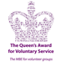
BENEFITS of CLEAN DRINKING WATER
By preventing cholera and other waterborne diseases, clean drinking water
can greatly assist in maintaining health.
This in turn has the following associated benefits:
-- help keep an adult able to look after his or her family
-- help keep an adult at work
-- help keep a child at school
-- help prevent a shortened life
-- help reduce the impact of poverty
-- help boost overall benefit to the local community

Gold box contents (currently under review following feedback from Yemen)
  - Essential items:
– 1 Family filter
– 1 Bucket
– 1 Cooking pot
– 2 Survival bags
– 1 Tarpaulin
– 5 Bowls
  - Items related to hygiene (e.g soap, sanitary wear)
  - Cooking and Eating items (e.g. mugs, spoons, cooking pot)
  - Shelter/General living items (e.g. clothes line, folding shovel, hammer, nails, folding knife, wind-up torch, solar lamp, tape)
Additional J.O.Y. Items: For the shipment to Yemen, these include a range of medical supplies, wheelchairs, education equipment and supplies.

Filter Operation: The filter is mechanical. It operates by a pump action which draws contaminated water through a coarse filter to remove debris and then through a series of microtubules. The microtubules walls are perforated by pores of diameter 0.02 microns which filter out pathogens e.g. those causing cholera, typhoid, polio and parasitic worm cysts. The water that emerges from the filter is potable. Filter maintenance is simple. Instructions in several languages are included with the filter. The clean water meets all WHO standards.

Family Filters: Over its lifetime, a Family Filter is capable of producing up 500 000 litres of potable water. It can produce safe drinking water at a rate of 1 litre per minute.

Community Filters: These work on the same micro-filtration technology. Community Filters are capable of producing up to 1,000,000 litres of safe drinking water at a rate of 6 litres per minute, and is used by medical centres, schools, villages etc.

Award: Aquabox was awarded the Queen’s Award for Voluntary Service in 2016.
Workforce: On each depot shift there is a minimum of 12 volunteers from a pool of 70. They pack the boxes and/or assemble the pump-filters, and also store supplies in the depot. Additional packing schedules are introduced as need dictates.
Location of filter assembly: Aquabox Depot, The Hill, Cromford, Wirksworth, Derbyshire DE4 3QL. The new depot is on the same site.
Video: The new video is viewable from the main project page. The original video is out of date in some respects. It was produced before 1700 gold boxes were sent to Syria. Some of the quoted statistics include the those for the older pumps. The new video illustrates the new pump methodology, which employs micro-filtration and operates without chemicals. The new units last much longer.

No plastic bottles: This calculation may be of interest. Assume a family filter is used for a total of 1 hour per day = 60 litres of water. The life time of the filter is potentially 6 + years. So for 60 litres per day for 6 years (60 x 365 x 6) there is a potential to prevent in excess of 130,000 plastic litres bottles entering the environment, and also a reduction in carbon footprint of transportation of bottles.

JOY and Aquabox: Aquabox have an established a successful working relationship since the first successful trial delivery of aid to Yemen in 2018. This continues today, to the benefit of both charities.

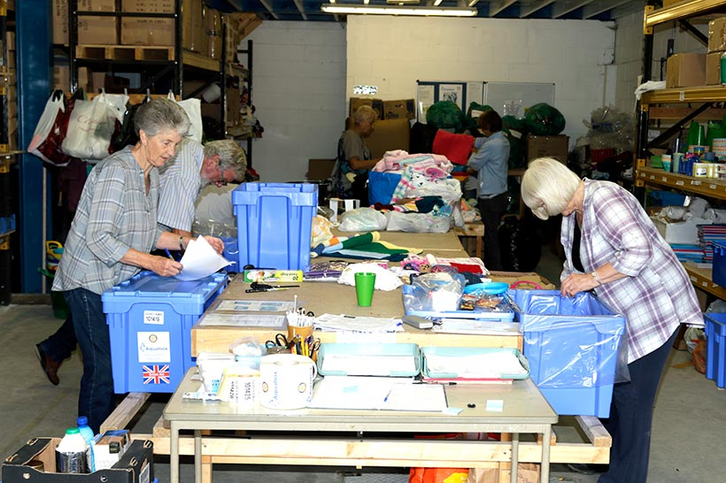
Packing the Gold Boxes
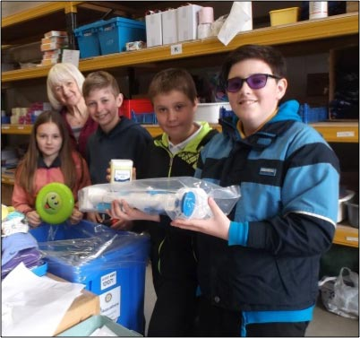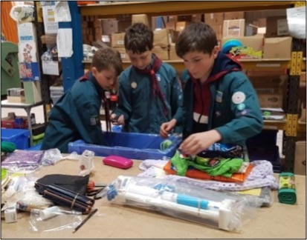
Visits to Aquabox by School Children and Scouts
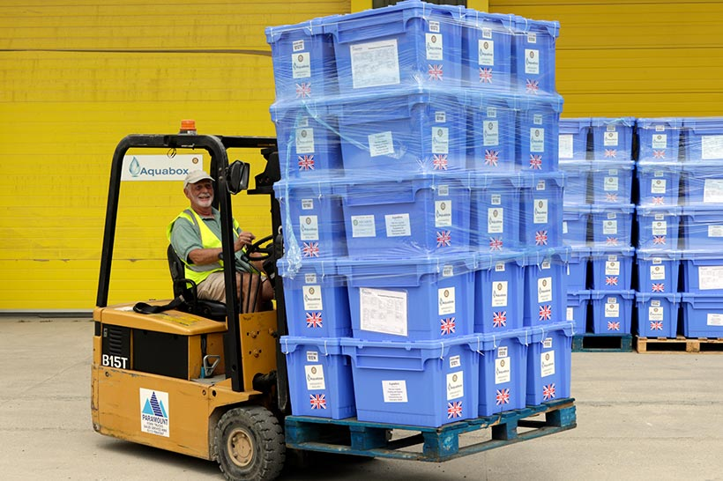
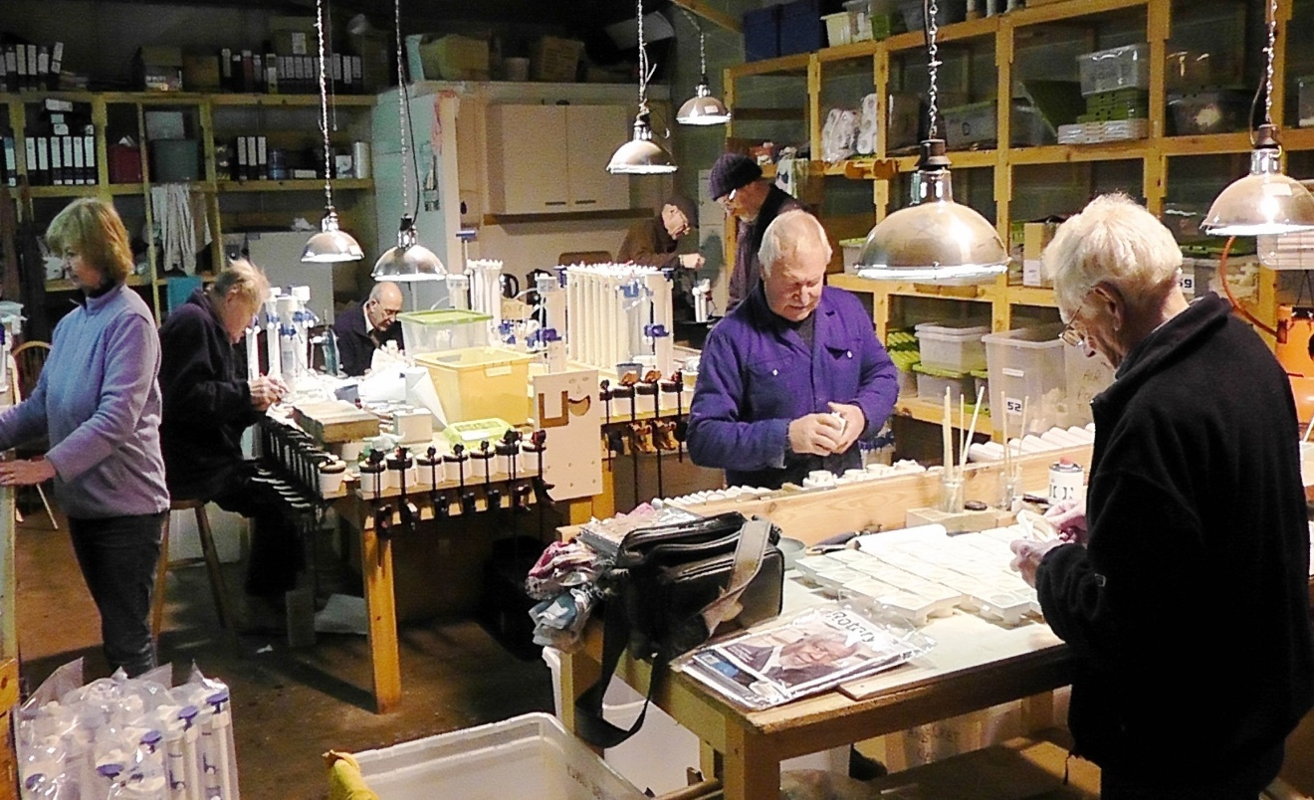
Moving Gold Boxes in the Depot at Wirksworth, Derbyshire, U.K.
Filter assembly in the original Aquabox workshop

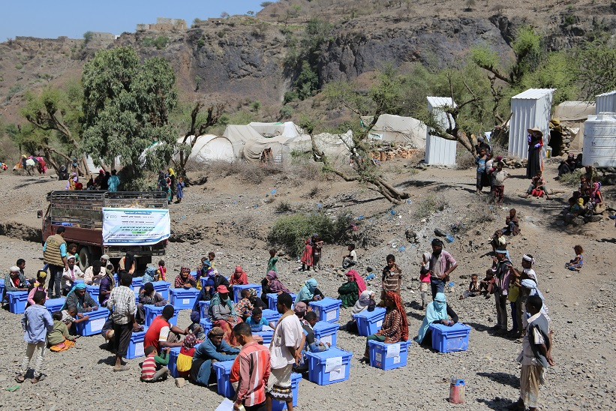

About 30 Gold Boxes just unloaded at one target site in Yemen

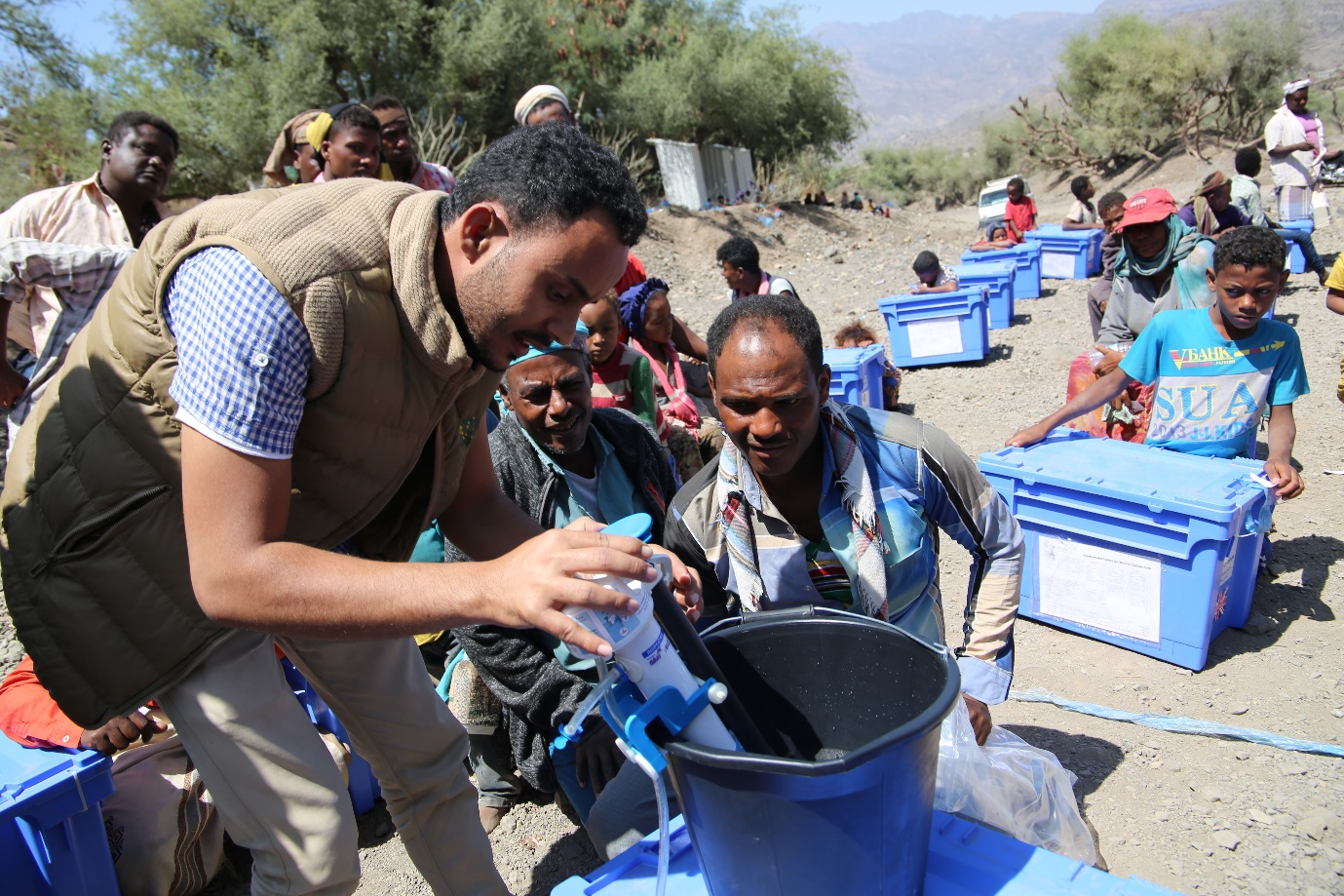
In Yemen, much interest in setting up the Family Filter
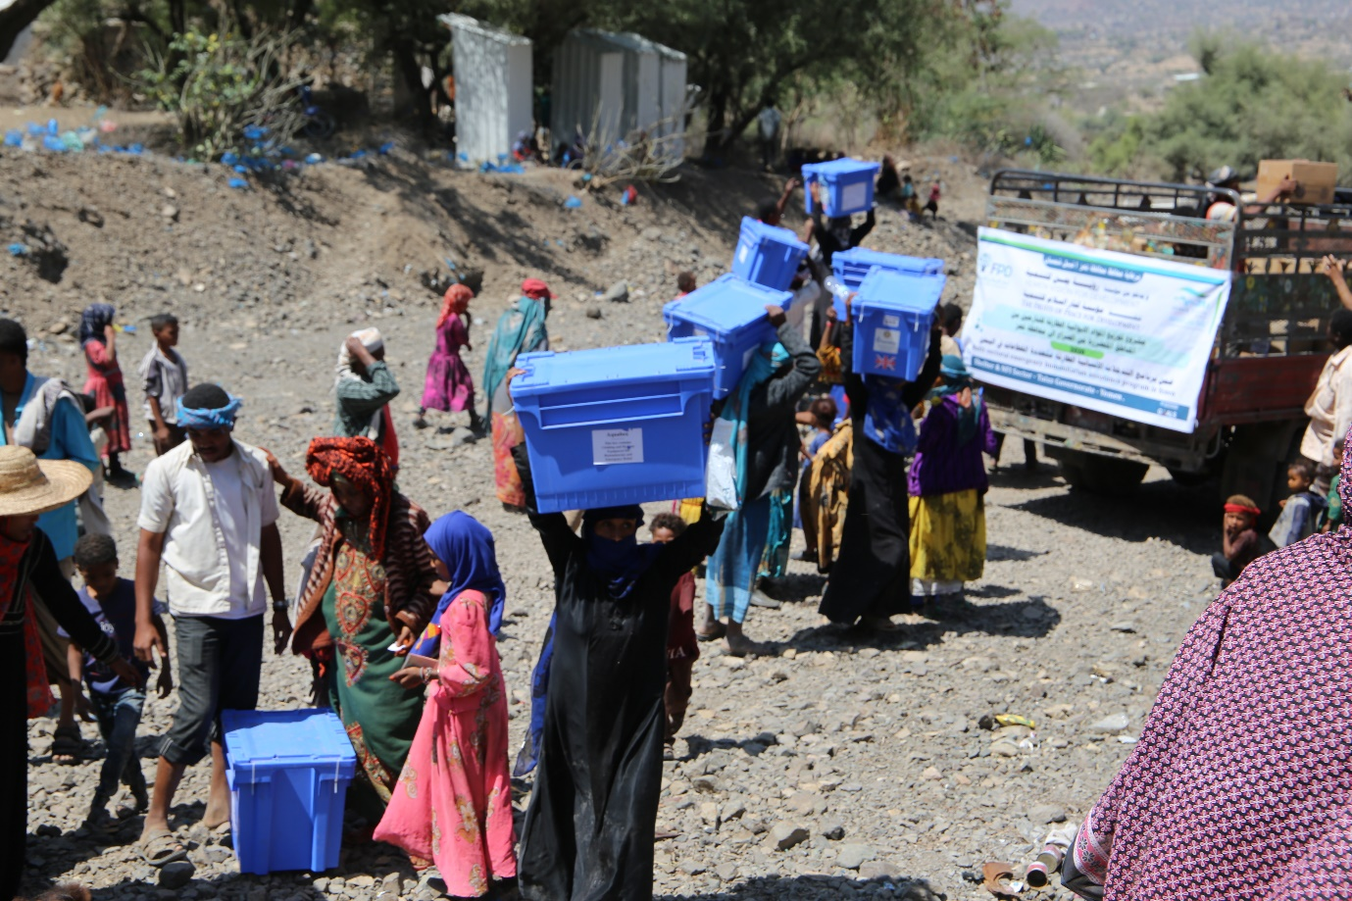
Finally, the Filters and Humanitarian Aid is on the last leg to home
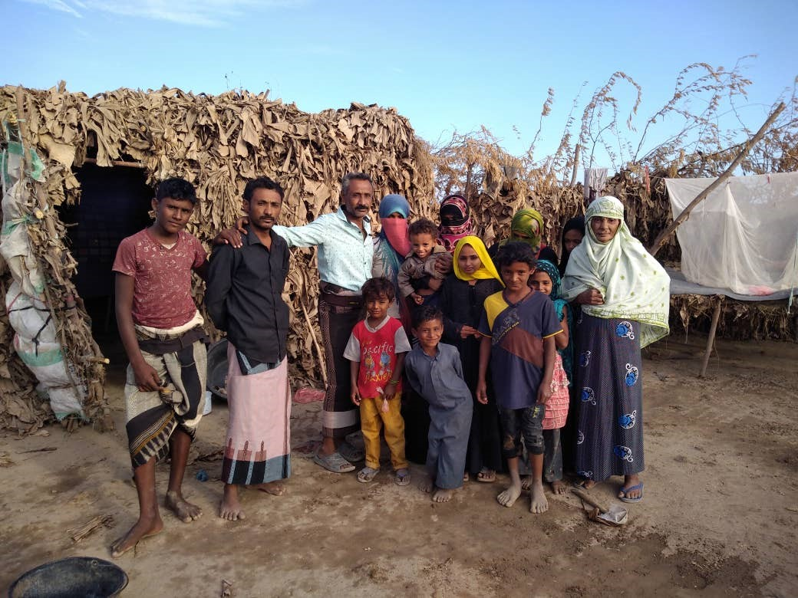
A Yemenese Family
Other Aquabox shipments follow.
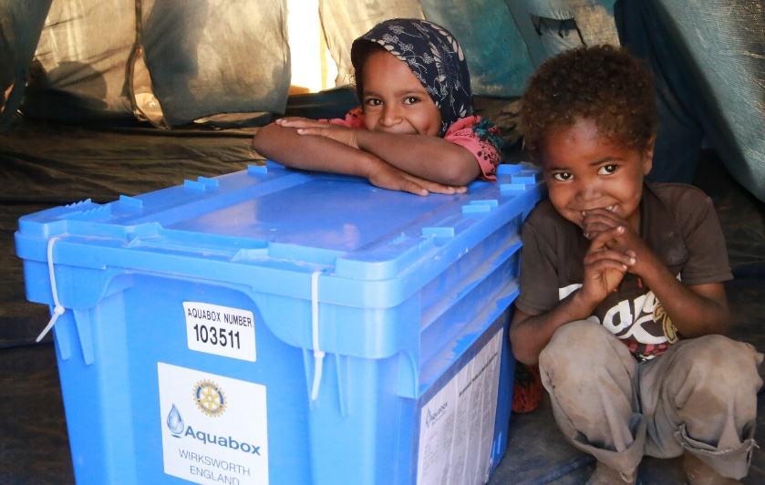
Gold Boxes being distributed in Belize
Gold Boxes being distributed near Bhadgaun, Nepal
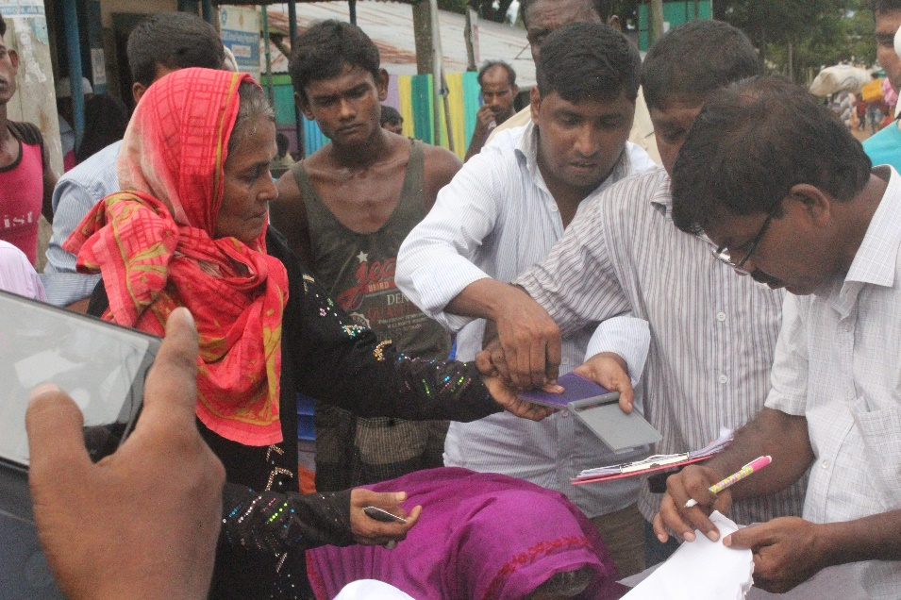
Fingerprinting Rohingya refugees to ensure correct distribution of Aquaboxes

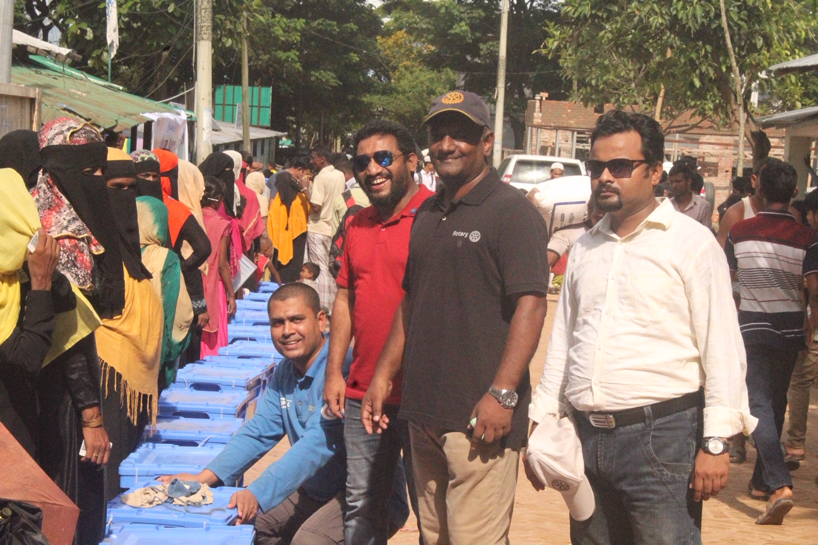
Aquaboxes being distributed in Bangladesh to Rohingya refugees

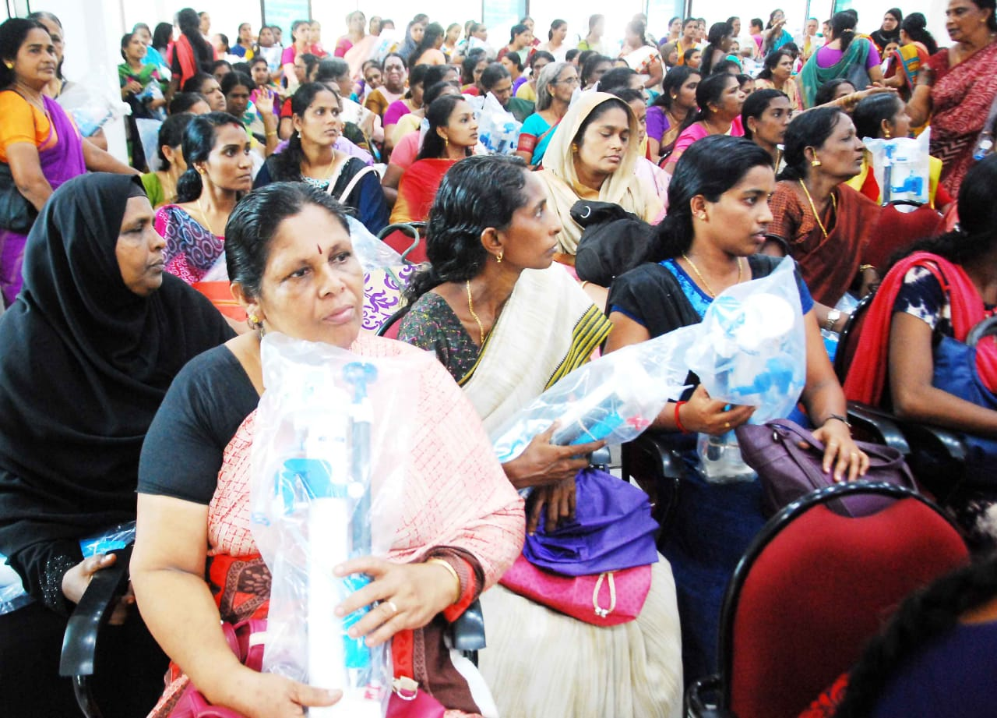Teachers in Anganwadis (schools for underprivileged children) in Kerala receiving tuition in use of Family Filters
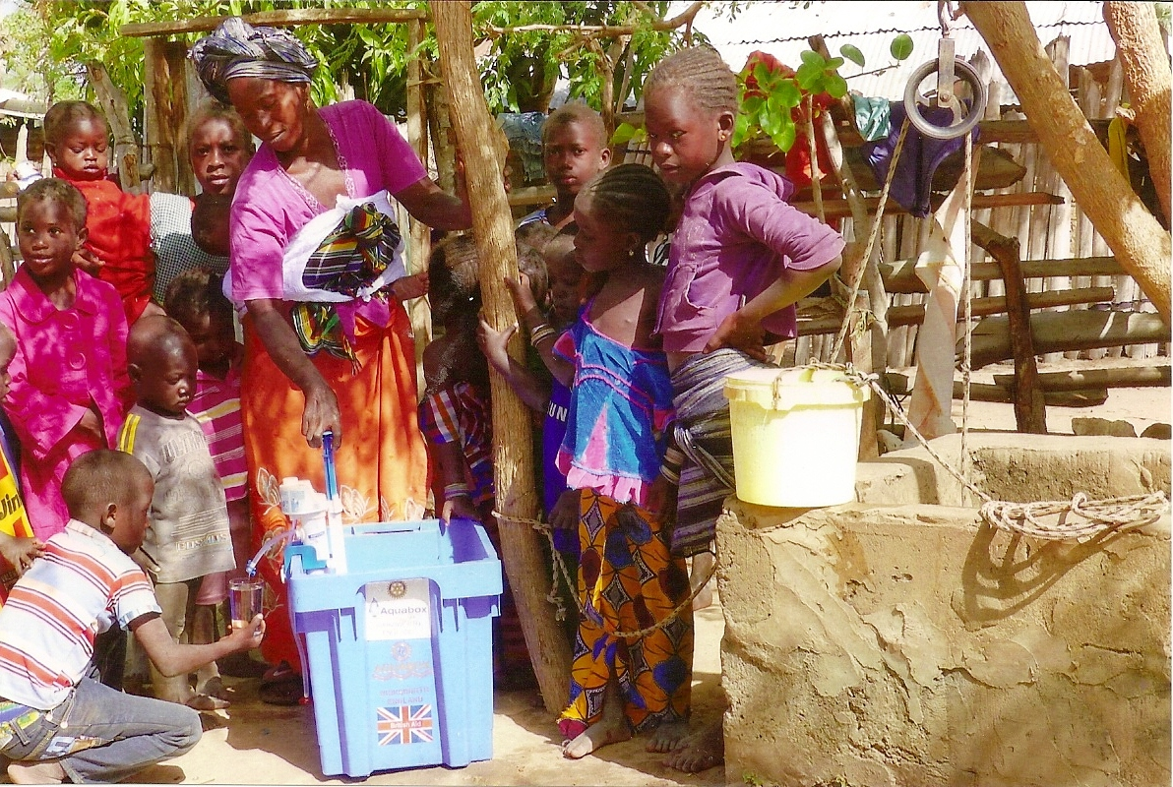
Family Filter being used alongside well in The Gambia

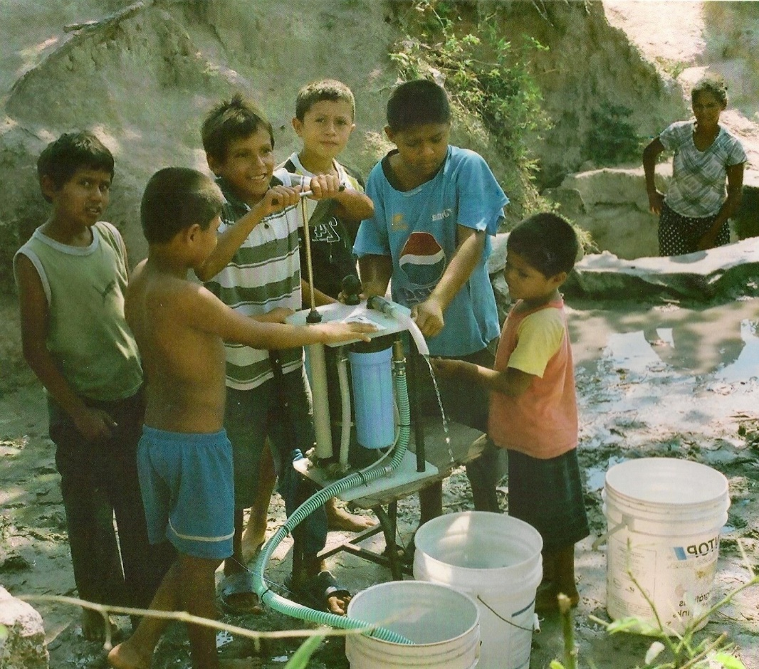
Community Filter in use in Haiti

Aquabox Filters and Costs.
Whenever a disaster strikes, whether it is natural or man-made, there is always an urgent need to provide safe drinking water to those affected. Water supplies are typically severely affected in the aftermath of a disaster. Water pipes may be destroyed, or the water supply will be contaminated with water from sewage and drains.
In these circumstances people have no choice but to collect water from available local sources such as streams, rivers and wells. Such water is often contaminated and unsafe to drink. Water-borne diseases such as cholera will spread rapidly and will affect particularly the more vulnerable young and older members of a community.
The challenge of providing safe drinking water in times of crisis?
Research in the field has identified two requirements: a water supply for schools, medical clinics, and other community centres; and a water supply for family groups of about five individuals.
Innovative AquaFilter technology produces safe and clean drinking water instantly and reliably without the need for chemicals. The AquaFilter Family and Community units are based on sub-micron filters which are impenetrable to bacteria and most viruses.
Costs below are those that applied when the GlobalGiving project started in 2019. They originally included an element of distribution cost, but by 2023 this has now been more than absorbed by inflation.
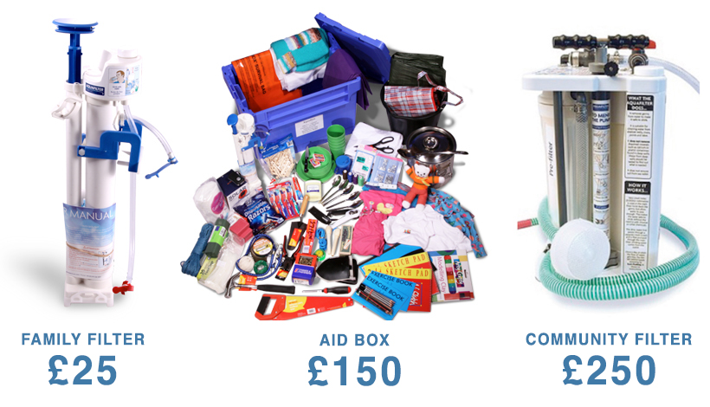
AquaFilter Family Unit.
Designed for use by individuals or a family, the AquaFilter Family unit can deliver 1 litre per minute and half a million litres of clean drinking water over its working life. The AquaFilter Family unit is fastened to a container of water, such as the Aquabox or a bucket, and using a simple hand pump safe drinking water is dispensed to a cup.

AquaFilter Community Unit.
Designed for use in community amenities the AquaFilter Community unit can deliver 6 litres per minute and over 1 million litres of clean drinking water over its working life.
Note: The AquaFilter Family and AquaFilter Community units remove biological contaminants, commonly found in water from ponds, streams, or shallow wells. They do not remove dissolved substances such as salt, or arsenic, typically occurring in deep wells.

Aqua 12s – 12 AquaFilter Family Units in a box.
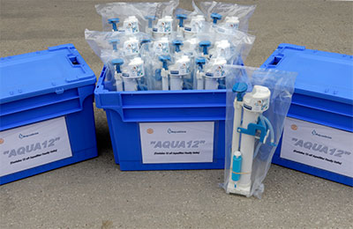
Aquabox continuously strive to meet the requirements of people in differing circumstances and look at how to respond accordingly. Sometimes there is a pressing need to provide families with safe drinking water, but less of a necessity for the other humanitarian aid items which we include in our aid boxes. To fulfil this aim Aquabox are now shipping AquaFilter Family Unit in boxes of 12, known as Aqua12s.
===============================================================

