Clean Water for a WELL Community
Segovia, Honduras

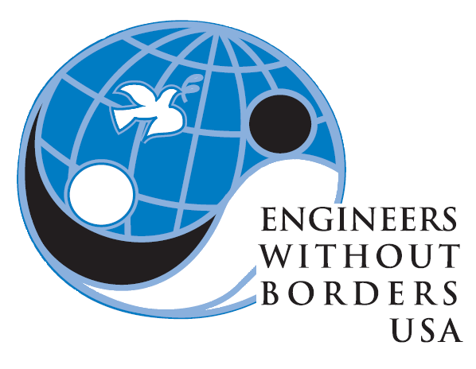

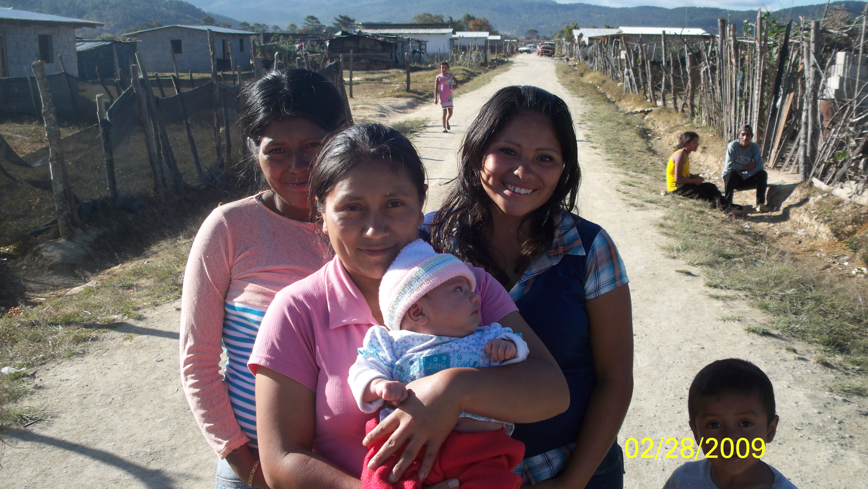
Project Cost
$15,500
Assessment
$2,700

Implementation
$12,800
Funds Needed
$8,100

Chapter
South Central Florida Professionals
Background

Colonia Segovia is a community located on the outskirts of La Esperanza, Honduras. Approximately 74 families, over 370 people, live in Segovia.

We contacted a Peace Corps volunteer in the area, Christopher Hickey, and he informed our chapter about the unsanitary conditions of the well and the existing health issues of the community.

EWB-SCFL officially adopted the project in November of 2008.

Engineers Without BordersTM-USA (EWB-USA) is a non-profit organization established in 2000 to partner with developing communities worldwide in order to improve their quality of life.
Website: www.ewb-usa.org
Phone: 303-772-2723

The Need
The existing well is used for drinking, laundry and meal preparation by the majority of the community and is currently unprotected from contaminants and run-off. Design improvements are required to clean the water and protect it from future pollutants and/or the design for a new well may be required.

The EWB-USA Response
What was done:
The local Alcadia (municipality of La Esperanza) donated 100,000 lempiras (approximately $5,500) to Segovia for construction of a new well and water storage tank. These efforts have been coordinated through a local missionary group called Hope 2 Honduras. The new well has already been dug and the water storage tank construction is expected to be completed by June of 2009.

Assessment
The EWB-SCFL project team completed an assessment trip in February/March of 2009. They inspected the conditions first-hand and complete various water quality tests on the well water. The team met with local government officials to identify possible sources of funding and community labor agreements for the implementation. A topographic survey of the community was completed as well as health surveys for 1/3 of the families.
Implementation
The team will return in June of 2009 to construct the well distribution and filtration systems. Each family will receive a connection to the system and a pila (a water storage unit) that will also be constructed during this trip. The community and team members will partner together to construct the improvements. The EWB-SCFL team will also be educating the community about maintenance of the new system during this trip.

Moving Forward
After the water improvements are completed there are several other ways the EWB-SCFL Segovia team will continue helping the community. There are flooding issues during the wet season, trash burning is a concern, what latrines are available are unsanitary, overflowing and poorly constructed, and harnessing wind power is an opportunity to provide electricity to Segovia. The chapter is excited about the long-term sustainability possibilities with Segovia!

To learn more about this project:

www.ewb-scfl.org
Contact monrealjorge@hotmail.com for more information

