Coffee is Uganda’s main export crop. The country exported 2.7 million bags in the 09-10 growing year.

**UGANDA REPORT: MBALE EPICENTER (Phase II)**

**September 30, 2010**



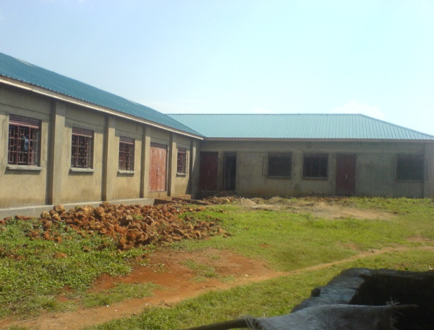

**Six Month Achievements: Mbale**

From April 1, 2010 to September 30, 2010

In Quarter 2 of 2010, members of Mbale Epicenter stocked 100 kilograms (220 pounds) of food in the Mbale Food Bank. InQuarter 3, **the number of food stored nearly tripled to 286 kilograms**, or 630 pounds, leaving Mbale epicenter members with total storage of 386 kilos, or 850 pounds! Also, **2,914 trees were planted** through the Water, Environment and Sanitation program in Mbale.

Through the VCA workshops, the Mbale Epicenter during this reporting period trained 20 animators, over 30 Epicenter Committee Members, **and almost 500 on Women’s Empowerment in the Gender Equality Program**. 62% of the participants were women.

**Executive Summary**

*Moving Towards Building Completion*

Quarters 2 and 3 of 2010 saw tremendous development at Mbale Epicenter. **Local materials were mobilized for the epicenter building**, as well as for the food bank, medical staff quarters and the new six-pit latrine. Epicenter members also began repairing window panes and painting the building’s shutters.

Members completed **construction of a shed to house the heifer** pledged by the Mbale District local government. Although the local government has made budget estimates for their planned contributions toward the construction and furnishing of the epicenter, the epicenter has yet to receive these provisions.

Meanwhile, the nine **Microfinance Program Groups received credit worth a total of 16,950,000 shillings** (US $6,780). Finally, 983 partners (560 women and 423 men) attended Mbale’s 12 Vision, Commitment and Action (VCA) workshops.

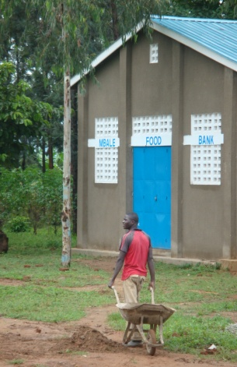

**DID YOU KNOW?**

**Six Month Achievements: Mbale**

From April 1, 2010 to September 30, 2010

**Looking Back in Time…**

**2010**

1,280

267

386

**VS.**

Women trained in VCA Workshops

Women trained in Women’s Empowerment

Kilograms of Food Stocked in Food Bank

386

**2009**

266

114

0

*Image taken July 2010 by THP’s Senior Microfinance Officer, Marie Mintalucci, on her trip to Uganda.*

**Partner Story: Aeron Siu**

*Aeron Siu, an Animator Leader at the Mbale Epicenter, doubles as a local government leader, representing his parish to the regional Sub-County government. Aeron was eager to share his success story with THP’s Mbale Project Officer, Fred Walyaula. This is what he had to say:*

“We in Busoba Sub-County are blessed that THP-Uganda and Mbale District local government selected Busoba to host and implement the Epicenter Strategy.” Aeron went on to recall the time when he and other residents were informed that Namwaro village in Bunanimi Parish of Busoba Sub-County would become an epicenter and part of THP’s strategy. “At the start, we did not properly visualize the future benefits of the epicenter strategy until we attended several of the trainings called the VCA workshops. During one of the workshops, we were told that ‘to end hunger and poverty,’ we needed to change our way of thinking and have a vision for a better future.”

Aeron also remembers that in the past, he had tried to grow a few crops and keep one or two animals; a number of challenges rendered his efforts unsuccessful and almost made him give up on life. He says, “Many development agencies came to our village and supported us, but the problem of hunger and poverty in our village was not solved.” He adds that when family members fell sick, he could not afford to purchase the costly drugs and the family was unable to raise enough food to feed itself. He noted that his children did not attend good schools, and even when they did, they went on an empty stomach, greatly affecting their performance. Aeron added, “This situation was not about to change until I put into practice what THP-Uganda preached about: the issue of changing the mindset and creating a vision of a better future.”

Aeron said that in 2009 and early in 2009, he received several trainings through THP Microfinance Program which enhanced his skills in loan management. He explained, “In January 2010, I accessed a loan worth 300,000 Ugandan Shillings (US $134), which I used to boost my rice-growing enterprise by about two acres. My personal contribution was 400,000 shillings (US $178).” Aeron harvested 20 bags of rice from this undertaking, improving both his income and food security.

Aeron is looking forward to realizing a number of benefits from his family’s epicenter. “I have been actively participating in mobilizing local materials for our epicenter, which is near completion,” he noted, pointing to the almost-finished structures. “Soon, I may not need to ride a bicycle into Mbale town to access drugs when family members and I fall sick.” Aeron stated that he will continue to borrow from the epicenter’s microfinance program, adding “After all, the bank will be managed by us.”

Meanwhile, Aeron’s vision of his future has certainly developed. He shared that he intends to allocate money for his children to receive a better education. He plans to purchase rainwater harvesting tanks; he aims to acquire a pick-up truck to transport his produce to market. He also wants to invest in an alternative source of energy, like bio gas, to ensure his family’s access to energy.

Aeron thanks THP-Uganda for empowering him, and notes that he calls upon his community to embrace THP’s programs in order to sustainably develop. He is grateful to all international partners, pledging to always remember them for the great opportunity they have given both him and his community.

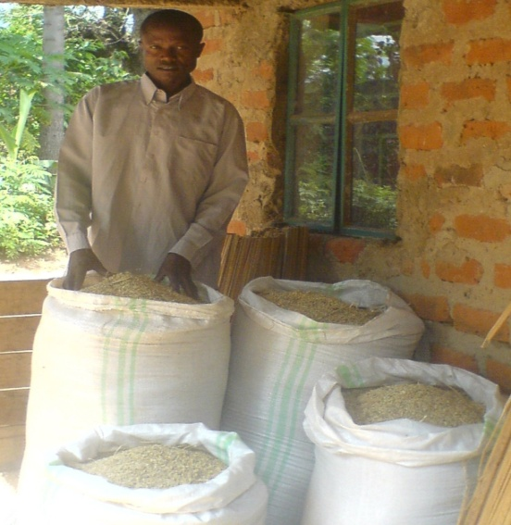

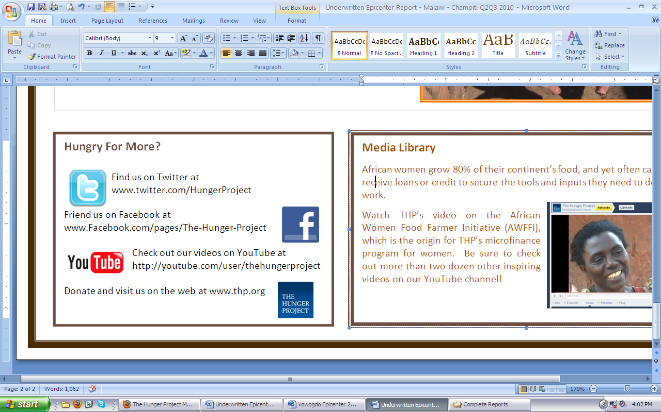

*Aeron is pictured here outside of his home, displaying his bags of rice. Aeron increased his yield after taking out a loan from Mbale Epicenter in January 2010.*