**GLOBAL GIVING Q4, 2024 REPORT**

**CECE YARA CHILD ADVOCACY CENTRE ENHANCED THE CAPACITY OF 600 TEACHERS AND EDUCATORS IN LAGOS AND ABUJA FCT WITH ESSENTIAL CHILD PROTECTION SKILLS**

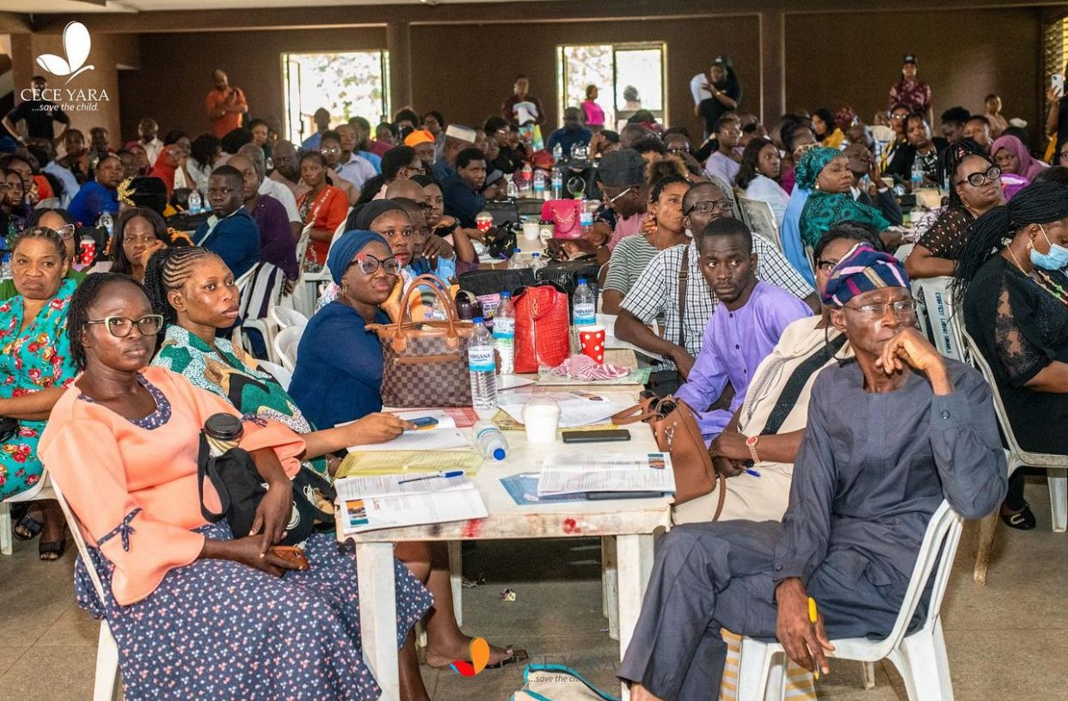

In a concerted effort to address child abuse in Nigerian schools, the Cece Yara Child Advocacy Centre, in partnership with Cummins West Africa Ltd, implemented a targeted training program for teachers across Lagos State and the Federal Capital Territory (FCT), Abuja. This initiative aimed to equip educators with best practices for preventing and responding to child sexual abuse, molestation, and other related offences, emphasizing their impact on child and maternal health.

The training sessions, conducted on August 27, September 10, and September 24, 2024, provided practical and comprehensive guidance to educators from Lagos State Teaching Service Commission Districts 5 and 1, as well as 11 schools in the FCT. The program empowered 561 educators with critical skills for recognizing, preventing, and addressing abuse, reaffirming Cece Yara’s commitment to safeguarding children and supporting educators as frontline guardians of their safety and well-being.

Outcomes and Impact

* **Enhanced Knowledge**: Post-training evaluations revealed that 97% of participants demonstrated significant improvement in their understanding of child protection and abuse prevention.
* **Empowered First Responders**: 79% of teachers expressed confidence in their ability to serve as first responders, providing immediate counselling and support to survivors within their schools.
* **Sustainability Recognition**: Participants highlighted the critical role of Civil Society Organizations (CSOs) and emphasized the need for ongoing collaboration with school management boards to ensure the sustainability of child protection initiatives.

This collaborative effort between Cece Yara Child Advocacy Centre and Cummins West Africa Ltd underscores the importance of equipping educators with the tools and knowledge necessary to protect children. The success of this program reflects the collective commitment to creating safer learning environments and empowering communities to combat the menace of child abuse effectively.

**SAFEGUARDING TRAINING FOR 500 STAFF MEMBERS OF CORONA TRUST COUNCIL**

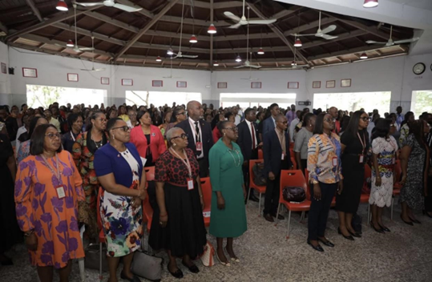

In celebration of its 70th anniversary, the Cece Yara Child Advocacy Center partnered with the Corona Schools Trust Council to successfully retrain over 500 teaching and non-teaching staff across all Corona Schools. This initiative was designed to enhance the capacity of educational professionals to prevent, identify, and respond effectively to cases of child sexual abuse.

The training sessions provided participants with comprehensive insights into recognizing the signs of abuse and implementing strategic methodologies for making appropriate reports when abuse is identified. Attendees also gained practical knowledge in offering first-responder counselling, handling disclosures with sensitivity, and ensuring robust protection mechanisms for children.

Key success indicators of the program include:

* Enhance Confidence: Over 80% of participants reported feeling confident in providing first-responder counselling to survivors of abuse.
* Policy Advocacy: The participants highlighted the critical need for periodic reviews of safeguarding policies within educational institutions, aligning with emerging issues such as sextortion, online sexual abuse, and bullying
* Active Engagement: Interactive sessions allowed participants to engage directly with experts from the Cece Yara Child Advocacy Center, fostering a deeper understanding of child sexual abuse prevention and response strategies

The program’s success underscores the importance of continuous professional development in safeguarding practices. With this training, the Corona Schools Trust Council has taken a significant step towards creating a safer and more responsive educational environment for every child.

**EMPOWERING 180 TEENAGE GIRLS THROUGH SAFE KIDS AWARENESS PROGRAM (SKAP) & LEGAL EDUCATION: A COLLABORATION WITH DLA PIPER AFRICA**

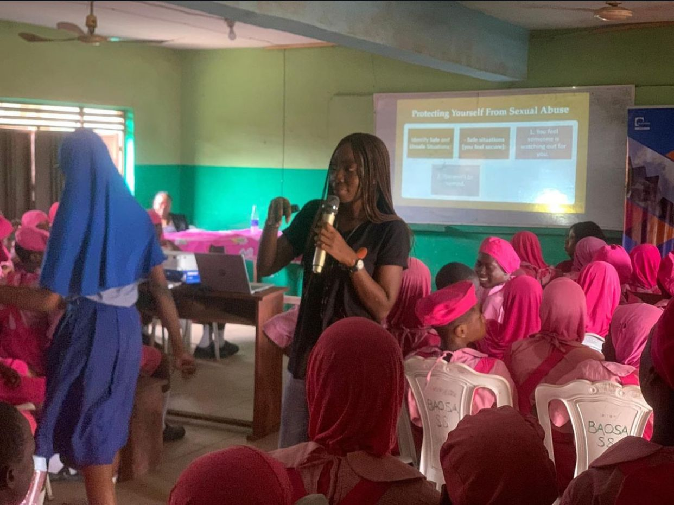

Cece Yara Child Advocacy Center, in collaboration with DLA Piper Africa, commemorated Pro Bono Week by providing legal education to teenage girls on sexual and domestic violence. This impactful initiative was held at Girls Academy School, Lagos Island, and aimed to equip 180 students with the essential knowledge to protect themselves and access justice when needed.

The sessions enlightened the students on critical legal aspects, including their rights and remedies under Nigerian law, and how to access care in cases of abuse. Students gained practical insights on establishing body boundaries, recognizing private parts, and the importance of identifying and confiding in a trusted adult. The concept of case reporting was a focal point, ensuring that students understood the pathways to report abuse confidently.

A significant portion of the engagement emphasized the legal framework surrounding child abuse management. Students developed a broader understanding of laws designed to protect them and hold perpetrators accountable, fostering a sense of empowerment.

The program achieved a remarkable milestone: **100% of the participants expressed strong confidence in their ability to report cases of abuse to appropriate authorities.** This unanimous commitment underscores the effectiveness of the training and represents a critical growth point. Building on this success, Cece Yara can expand the initiative to reach more schools, integrating advanced modules on advocacy skills and peer-led awareness programs to amplify the impact.

This collaboration between Cece Yara and DLA Piper Africa underscores the power of partnerships in creating informed and resilient communities, ensuring a safer future for every child.

**ENHANCING THE CAPACITY OF LAW ENFORCEMENT OFFICERS IN THE FAMILY SUPPORT UNIT OF THE NIGERIA POLICE FORCE (LAGOS STATE COMMAND) IN HANDLING CHILD ABUSE CASES**

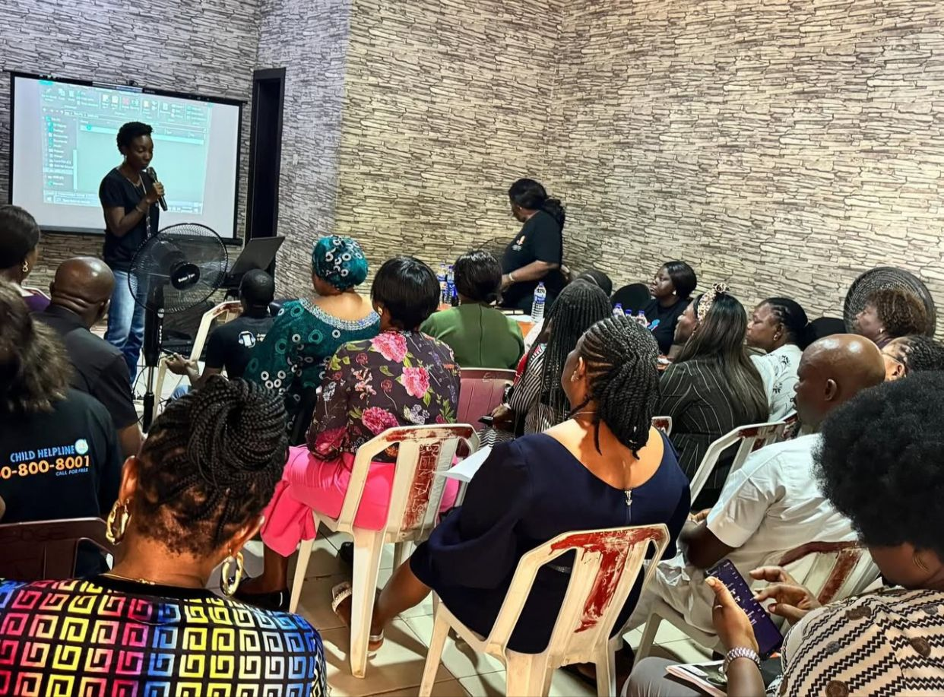

Cece Yara Child Advocacy Center conducted an impactful training session for the Police Officers of the Family Support Units (FSUs) within the Nigerian Police Force, Lagos State Command, through its Gender Desk Department. The training was designed to improve law enforcement officers’ expertise and sensitivity in handling child abuse cases, emphasizing best practices for case reporting, prosecution, and management.

Recognizing the critical role of the police in addressing child sexual abuse, the session underscored their constitutional mandate to diligently prosecute offenders and safeguard the rights of children. Law enforcement processes significantly influence judicial outcomes, ensuring timely court hearings and appropriate sentencing of perpetrators under laws such as the Violence Against Persons Prohibition (VAPP) Act and the Child Rights Law.

The session sharpened officers’ understanding of their pivotal roles and encouraged them to execute their duties with diligence and integrity. It also fostered dialogue on the need for effective prosecution processes to ensure justice for survivors and accountability for perpetrators.

A standout success was the unanimous agreement among all participating officers on the importance of public enlightenment campaigns by Civil Society Organizations (CSOs). Officers emphasized that increased public awareness would bolster confidence in the FSUs and Gender-Desk units, leading to more robust case reporting and trust in law enforcement.

Building on this momentum, Cece Yara can partner with law enforcement agencies to launch public awareness programs, focusing on the role of FSUs and Gender Desks. This collaborative effort would bridge gaps in community trust, increase case reporting, and enhance child protection mechanisms across Lagos State.

This training underscores Cece Yara’s commitment to equipping key stakeholders with the tools needed to combat child abuse effectively and uphold justice for vulnerable children.

**EMPOWERING THE NEXT GENERATION: CELEBRATING THE INTERNATIONAL DAY OF THE GIRL CHILD**

In commemoration of the International Day of the Girl Child, Cece Yara’s centers in Lagos and Abuja hosted impactful events aimed at inspiring and empowering young girls.

In Lagos, 20 girls had the privilege of listening to dynamic speakers who addressed essential topics such as **self-confidence, career building, and mental well-being.** The engaging sessions encouraged the girls to embrace their potential and strive for excellence in all areas of their lives.

In Abuja FCT, the team partnered with the **Woven Impact Network** to reach 188 secondary school girls with critical knowledge on **sexual abuse prevention** and strategies for building a brighter future. The highlight of the event was an inspiring **speech competition**, which saw the top three participants awarded **NGN 100,000 each** as financial support for their WAEC fees.

The project outcomes can be summarized below:

* **Increased Confidence and Knowledge**: Girls in Lagos left the event feeling more confident and equipped with practical tools for their personal and professional growth.
* **Empowerment Through Action**: The Abuja program directly impacted the lives of the winners, easing the financial burden of their education while inspiring others to aim higher.
* **Collaborative Efforts**: The partnership with Woven Impact Network showcased the power of collaboration in delivering meaningful change.

Through these celebrations, Cece Yara reinforced its commitment to empowering girls with the skills and support they need to overcome challenges, realize their potential, and become leaders of tomorrow.

**CECE YARA EMPOWERS 150 STUDENTS AT FOWMAN COLLEGE WITH SAFE KIDS AWARENESS TRAINING PROGRAM (SKAP)**

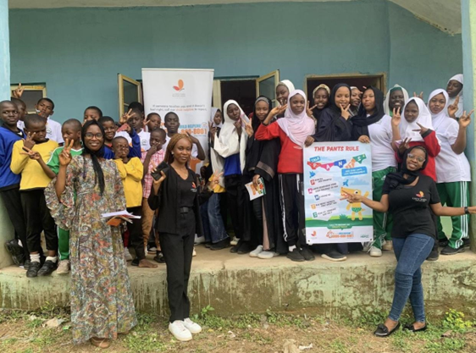

Cece Yara conducted a Safe Kids Awareness Program (SKAP) at Fowman College, Abuja FCT, equipping 150 students (67% girls and 33% boys) with vital knowledge to protect themselves from abuse. This interactive session aimed to build awareness and confidence among students to recognize and respond to potential risks.

During the training, students were taught:

* The correct names for their private parts, foster a sense of body ownership and understanding.
* How to distinguish between safe and unsafe touch, enabling them to identify inappropriate behaviour.
* The importance of setting body boundaries to maintain personal safety.

The session also highlighted the critical need for students to speak up and report any form of abuse to trusted adults. This approach empowers children to take proactive steps toward their protection, fostering a culture of openness and trust.

The program not only enhanced students’ knowledge but also sparked meaningful conversations among participants and their educators about child safety, paving the way for a safer school environment.

Cece Yara remains committed to delivering impactful programs that equip children with the tools they need to stay safe and thrive.

**EDUCATIONAL FIELD VISIT: 10 STUDENTS OF CORONA SECONDARY SCHOOL GAIN INSIGHTS INTO THE JUSTICE SYSTEM AT THE LAGOS STATE JUDICIARY**

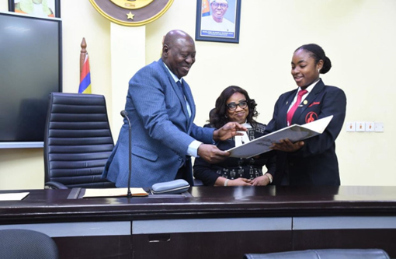

Cece Yara facilitated an educational field visit for students from Corona Schools to the office of the Chief Judge of Lagos State, Hon. Justice Kareem Olanrewaju Alogba. This unique opportunity offered the students a firsthand look into the workings of the judiciary, reinforcing the importance of justice as a fundamental human right.

During the visit, the students were enlightened on:

* The accessibility of the court system and its role in safeguarding their rights.
* The principles of justice and how the legal system functions to uphold fairness and equality.
* The importance of understanding their rights and responsibilities as active members of society.

The visit sparked curiosity and fostered a deeper appreciation for the judiciary's role in promoting justice and protecting rights. This hands-on experience not only broadened their understanding of legal processes but also inspired them to see the legal system as an accessible tool for societal development.

This initiative exemplifies Cece Yara’s commitment to empowering young minds with knowledge, nurturing their sense of justice, and encouraging active citizenship.