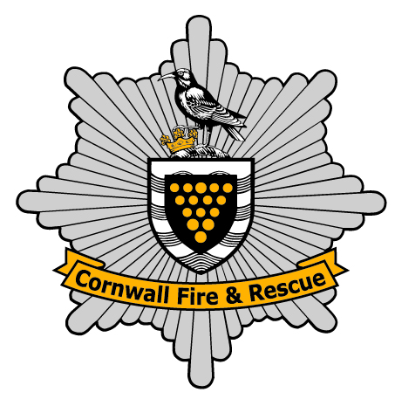
^{District 1290}

Rotary International Overseas Project Team District 1290

Kosova/Albania Humanitarian Aid Convoy

19th September 2010

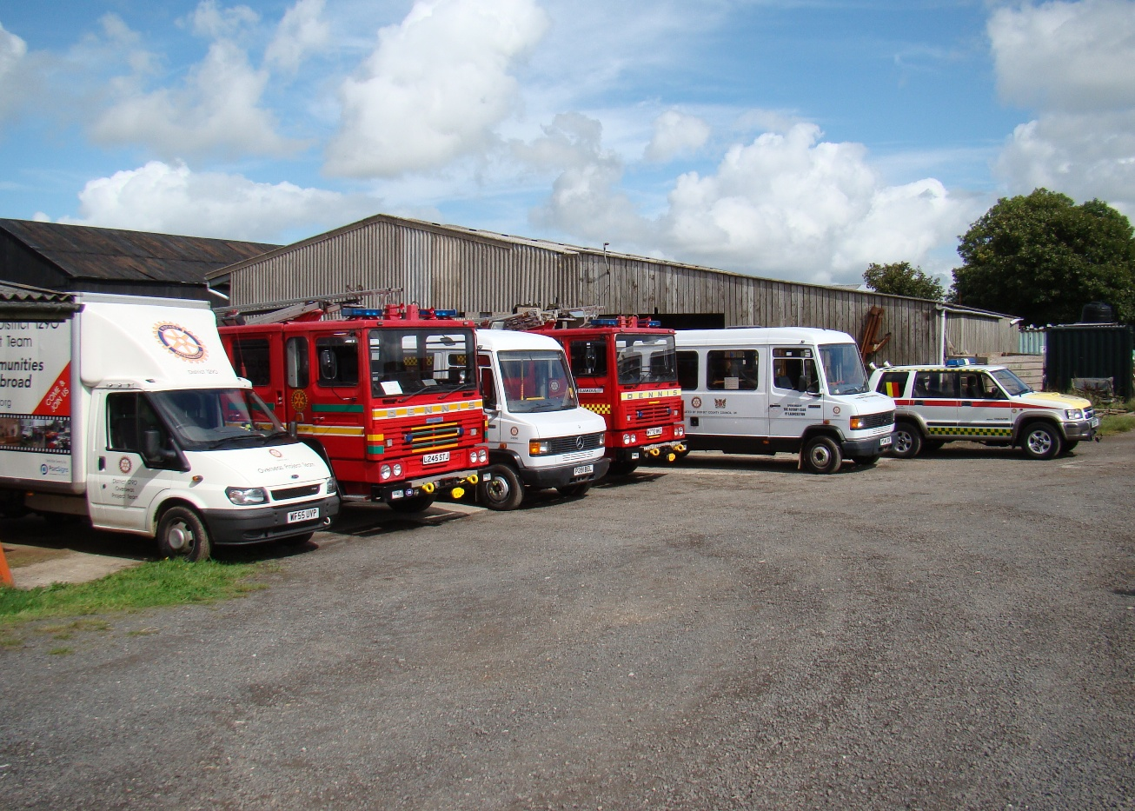

Following months of intense planning, preparation and fund raising throughout the summer by all six crews consisting of many Rotarians and also 5 serving firefighters and 1 civilian mechanic it all finally came to fruition at 0900hrs on Sunday 19th September 2010.

The convoy consisted of all the vehicles as shown in the picture above, the only one to return to the UK as usual was the Rotary International (RI) Overseas Project Team (OPT) District 1290 van (medical supplies); the remainder were all destined for Gjakovё and the Fire service and a hospital.

The two Dennis fire appliances were donated to Gjakovё where on arrival a previously donated Mercedes 1222 fire appliance was to be relocated to Bajram Curri in Northern Albania. This had been programmed for following the scoping study carried out the year before and to make best use of all the donated resources.

The two buses with disabled lifts for wheelchairs, where donated to Handikos in Gjakovё, and finally the jeep – donated by Guernsey Ambulance and Rescue Service – for the Fire Service as a dual purpose fast response all terrain vehicle. This vehicle departed a few days after us, and went a different route to revisit previous projects and get up dates and the evitable wish lists to further assist these areas, and has proved to be very successful.

We departed from Liskeard Fire Station at 0900hrs on 19-09-2010 and headed towards Dover. The first day was very different to previous convoys. Firstly we were running on Bio Diesel and one fire appliance had to go to Stroud in Gloucestershire to collect, whilst the other vehicles all met at Exeter and then proceeded onto Clacket Services M25. We met there at 1600hrs and refuelled the vehicles, except the van with the Bio diesel.

This continued for the next four days and saved the team over a thousand pounds in fuel costs; and not one of us smelt like a chip shop at all. The cooking oil once refined did have a slight odour of chips but that was all, much cleaner than ordinary diesel.

Picture 2

We arrived at Dover around 1730hrs and cleared customs in around 15 minutes, even the customs officer was amazed, detailed paperwork helped yet again. We caught the 2000hrs ferry, gained two hours there, and the 348 miles covered that day were the topic of discussion that night. After a good meal and some refreshments on the ferry to Dunkirk we disembarked and found the Hotel and had a welcome sleep ready for the next five days on the road. Our route would be France, Belgium, Luxembourg, Switzerland, Italy and into Albania and Kosova, our eta was Friday 24th at 2000hrs in five days time.

Picture 3

Dawn of the second day 20-09-10 at 0830hrs we were on the road heading south, the convoy was taking shape and the banter stared in earnest! We had a policy of each driver doing two hours about to maintain the concentration and therefore keeping it as safe as we could. We covered 440 miles and ten hours driving, the key to a successful delivery of the vehicles to Kosova/Albania was to proceed at a steady speed. This was achieved and it preserved the vehicles and reduced fuel costs and allowed us to enjoy the drive, the convoy went as fast as the slowest.

The second night we stopped off at our pre-booked hotel in Mulhouse, refuelled ready for the next day and had a delicious Chinese meal just next door with a few well earned beers, everything was good and morale was high.

The morning of the third day dawned with a good breakfast and beautiful sunny weather-again and we were off and running heading towards Switzerland and into the Alps. After a short clearance of customs paperwork-few minutes we were through and enjoying the fantastic scenery of this country, amazing sights.

Picture 4

The 3rd day we had all settled into a routine and with regular reports being sent home to base at Launceston. The drive was going to plan, and all the vehicles were performing very well indeed and keeping our speed to a maximum of 55mph. Some of the mountains reduced that to 20mph and the rise from 800 feet to 4200 feet at the height of the St Gotthard tunnel and once through this tunnel we had some very good views.

Clearing the main tunnel around midday we stopped for lunch and the picture says it all-we were making good progress and heading for our hotel in Bologna and another well earned rest after 370 miles through the Swiss Alps and the fast Italian roads.

Once again we had a few minutes at customs, but routine only and on towards Bologna where we arrived to a very warm welcome from the Italians who quite frankly could not do enough for us, they were tremendous. Special meal and extra wine, it was good the temperature was 25 degrees and we enjoyed a beer at the front of the hotel late in the evening.

Picture 5

We set off as normal on the fourth day and after about two hours of steady driving all of a sudden the last vehicle in the convoy, a fire appliance with Rob Collins and his crew shouted on the radio they had a big problem. A loud bang had been heard from the engine area and they were pulling over.

The fast Italian roads - the Auto Strada - with only a few stopping places and the thought of it not being able to be fixed and their safety immediately sprang to mind. The crew set to work, two mechanics Chris and Simon, and Rob with the fourth person Martin, the Cool Guy as he was later named by the Vice Commissar of Police in Albania. All four worked extremely well to get the fire engine back running, albeit jury rigged and to the service station 14 miles further south where we were all waiting for them.

Picture 6, broken fire engine.

Prior to their arrival we had a team talk and the general opinion was to split the convoy and send three on towards to Trani for a Rendezvous (RV) there at 1830hrs as planned.

A lot happened in the mean time and phone calls and through our procedures and contacts and in particular our Rotary International contacts, we had local knowledge in Italian to assist and they assisted-fantastic! The bearing on the main cooling fan for the Dennis fire engine disintegrated and the fan came off and cut the fan belt but no other damage. Thank heavens for small mercies.

We were just south of Pesaro near Rimini and still had three hundred plus miles to complete that day. Their team managed to use large cable ties to make a fan belt-which lasted one hundred and fifty miles until we reached the main Cummins engine dealer in FRANCAVILLA, near Pescara in middle Italy on the Adriatic coast.

Picture 7 Tecnocom

Preplanning etc is good but local knowledge and the helpful Italian mechanics were brilliant, they would not let our guys near it and they were just so helpful no other words for them. The bearing was done in ten minutes; the parts were on the shelf! The fan belt took three hours. The larger than standard alternator needed a special size belt, they made new brackets welded and manufactured them from scratch. They drilled them precisely and after nearly three hours we were done and a few beers and pizzas, beautiful food, we were on the road to meet up with the others.

Having jointly all decided to send the other three on to Trani to meet our Rotary contact Achille, we would catch up, proved to be the best and right decision. We arrived after a faultless drive at midnight and 393 miles and immediately checked into the hotel and had some refreshments!

The following day we had to ourselves, our ferry from Bari to Durres did not go until 2300hrs on the Thursday. We were in the harbour area of Trani, a very pleasant area, and enjoyed the local cuisine and just relaxed. That evening at 1600hrs we made our way to the compound where a local Rotarian had secured the vehicles overnight for us and said our Averiderchis and left for the ferry - Achille and his colleagues were so very helpful.

Picture 8

Above you can see “the Mayor” Vic May-he is actually the Mayor of Lostwithiel-and “Cool Guy” Martin from Lostwithiel and our superb host Achille, from the local town of Trani-saying goodbye. They are exchanging Rotary Clubs flags/banners, a tradition when visiting other Rotary clubs from your own-particularly when overseas etc.

The ferry boarding and customs went well and by 2100hrs we were on board and thinking about food and a well earned beer. The Italians on the ferry particularly the loading master was very keen to help, he was interested in the Fire engines and the fire kit we had with us!

Picture 9, ferry loading.

Our 5th day we started early 0700hrs with the disembarkation from the ferry and then the dreaded customs wait, and this was long almost five hours in total. Once we were off and parked up, we had been given a little leeway to be allowed to park away from the hundreds of Lorries so we just had to sit and wait. We were also met by many persons from Albania and Kosova, the final destinations and recipients for the vehicles and equipment that we had just driven from Cornwall 1600 miles away.

Finally after some hard talking and somewhat belated awareness of a bogus customs officer, he was a private agent who did not announce who he was and cost the team a lot of money; we set off for Kosova with at least two more escorts vehicles with the local Rotarians and Fire officers and Police. I must mention Olis he was our “Official Guide” and carried some serious protection with him, so he had total respect and turned out to be one of the nicest and most sensible persons around, particularly after what was to follow.

We arrived at a restaurant around 1400hrs and were met by the local fire service in a fire appliance the Rotary had donated the year before to the town of LAC in Albania. In all we had twenty six persons around the tables, and we ate very well as we had had nothing substantial since the night before.

We set off for the drive through the mountains on the new road and tunnel to the town of Kukes and eventually to the border with Kosova, our final destination.

It was getting dark and was a little behind in our schedule and the border was to close at 2000hrs, we just made it through after some excellent work by Neshjet, the President of the Rotary Club of Gjakovё.

However before that the thought of all this equipment for the Albanians in the towns of Shkoder, Koplik, Pukë, Bajram Curri and finally Krume it was apparent that a little tension was there between them and the Kosovas. The conversations were getting more and more determined and the customs had allowed us to place the stated, as per papers, equipment in their bond for the above to collect later. This proved to be the best answer and we made our way to the border.

Eventually we got across, more customs paperwork as the vehicles-non emergency were right hand drive-these were assigned to the fire service as emergency vehicles but this took some explaining as the man in the know had left before we arrived.

Eventually after 2 further hours and some grumbling stomachs, a police sergeant from Gjakovё presented himself to us asking for me, he was the type where you say Sir! He said I have the pleasure of escorting you to Gjakovё and we said thank you.

We were under blue lights front and rear and were back on the road, arriving only two or three hours later then our planned eta: 1732 miles and two ferry crossings and a major breakdown, from Liskeard six days earlier.

Always a slightly emotional moment you want to get there but you wish it not to end because it just great fun and a terrific sense of purpose and adventure to what we were doing and continue to do.

We were given our rooms and the hospitality given to us was immense from all quarters, the Rotary Club of Gjakovё, the Hotel staff and the Fire station next door until we left. We met many people and the next few days were busy in lots of different ways.

Picture 10 presentations

The Saturday after our arrival was all mapped out for us i.e. presentations and TV and radio coverage etc. It turned out to be a very good ceremony and everyone took part, our Rotary teams, the Firefighters, the Rotary club of Gjakovё the Mayor’s office and the Director of the Fire service in Gjakovё as well.

Hector did the translations and many photographs were taken. There was a small reception in the hotel for all to attend and chat amongst everyone from all countries etc. Later that day at 1700hrs we saw the news and we all made the headlines, with a part of the OPT’s speech in response to the Mayor etc. We were all very proud of what we had achieved.

Once the ceremonies were all over then the work started. The unloading of the medical equipment from the midi bus and van was the first item on the agenda. We split our resources and some did the unloading and the remainder stayed and started on the fire engines, to ensure the correct equipment went to the right vehicle. The exchanging of the equipment for the vehicle destined for Bajram Curri, this was not completed until the Sunday. We were cleaning and flushing the dregs of the bio diesel from the tank, and in the afternoon we were training the Firefighters and Mechanics to operate the pumps as well.

Early Sunday morning the van and the three R’s left for the UK arriving late Wednesday. We had 16 persons, all with different names which made it easier but the three R’s had the van, Roger, Rowly and Richard-a good team.

Shortly after this the Lostwithiel crew took their midi bus to previously visited house to donate a special wheelchair to the occupants. It was very emotional from all accounts but the picture shows the delight of the recipient and their family-well done!

Picture 11

Later in the day also brought a bonus to everyone; the turntable ladder (TL) at the fire station that had been there for a while had not been operating correctly. The challenge to our two mechanics and Rob was to try and fix it, and by the end of the day they achieved a successful outcome, a fully working turntable ladder. This was a real bonus for the OPT that we had managed to assist them in getting the TL to work correctly-now they will need expert training on this.

Picture 12 TL

Other aspects that were found were the lack of routine maintenance and now we have managed to explain to the fire station the need for periodic checks on all equipment at certain intervals, this was brought home in a big way when we managed to get the TL to finally work, constant checking of fluid levels etc to name but one aspect.

On the Sunday two other teams took a midi bus and visited Rahovec a few miles south of Gjakovё where the OPT had previously completed a project. This proved to be very successful and we now have possible further projects there for the future.

Monday saw further training and the majority of the remaining team, nine persons, were on their way home. Before leaving a visit was organised for these and others who had not seen the mass graves-the results of the conflict in the 90’s, and they laid wreaths in the name of the Rotary International OPT at these graveyard sites outside of Gjakovё.

Monday afternoon saw a visit to the neighbouring town of Junik. Here they have forest fires and these play a significant role on the local economy and groves of fruit trees etc, and a large tourist area, hence a few fires. Rob Collins and I visited the Mayor and with the Director Bedri Cahani where the request was made for a fire appliance; they have the trained Firefighters but no vehicle. First rule-no promises, but this is their request.

We were also joined by a lady called Jackie (ex-police officer from Virginia) from the US Embassy in Pristina-capital city of Kosova. Jackie’s work and connection was to try and bring some education regarding fire safety to the people of this area. Possibly between Jackie, the OPT and Cornwall Fire Rescue Service the three of us, and after some discussion at home, and with the fire service we may be able to assist with some basic information in all aspects of home safety and smoke detectors etc.

The Australian forest fires and simple advice there is the first thing that springs to mind as advice-this is being done as we speak.

Picture 13, handover of keys.

Tuesday saw the delivery of the Mercedes 1222 fire appliance (donated during a previous OPT mission) to Bajram Curri in Northern Albania. The pictures show the handover and enthusiasm and gratitude to the OPT for the fire appliance. However it was not without incident, because of some small formality we would have had to go back to the customs at the border crossing near Prizren, and not use this one north of Gjakovё-a massive detour and time wasting exercise with possibly the same outcome!

There were some very firm discussions between both parties, we were not involved until towards the end when a decision was muted to return to Gjakovё and relocate the fire appliance elsewhere. Very soon the Mayor of Bajram Curri arrived and within a few minutes of the ultimatum being muted we were through and on our way for the forty minute drive through the valleys up into mountains to Bajram Curri. Stunning scenery and again a new road just having been built made the journey even more pleasant.

Picture 14

First thing on Wednesday morning we managed to successfully hand over the midi buses to Handikos; on a previous attempt we were unable as the person in charge was not available.

After the handover we returned to complete more Breathing Apparatus Training which took us up to 1200hrs and that was now the end of this massive project. We finished our project and made ready to leave for 1300hrs, there were four of us remaining.

Picture 15, BA Training.

The OPT are now awaiting the arrival of Bedri and Pashtrik to Cornwall for a two day visit-3rd/4th November, to Cornwall Fire and Rescue Service and many Rotary clubs in Cornwall.

We said our goodbyes and were driven to Pristina airport. We said our goodbyes to Pashtrik, the Chief Fire Officer of Gjakovё, and in his broken English thanked all of us from RI OPT District 1290 and CFRS. We waved goodbye at check in and shortly after we took off bound for London Gatwick.

Picture 16 last one!

We arrived at London Gatwick fifteen minutes early! We caught the bus to the hotel, checked in and had a meal and a few very well earnt beers. Lots of talk and an excellent joint agency project and hopefully many more to come after this one, a lot of people in the UK are very interested in our work! We caught our flight to Newquay the next day.

When we left last time we said will be back, we did come back and we will be back again and soon, there are many projects in numerous different fields to focus on so the work for the Rotary International OPT District 1290 continues.

The Rotary will have a full debrief and many lessons are be learnt ready for the next one, if you want details please contact the OPT Co-ordinator Barry Kressinger.

Our sincere thanks to many many people in the Rotary International near and far, the Chief Fire Officer CFRS, and his Brigade Engineer Mike Clayton, and to everyone who did what they did to help us, you know who you are, the gratitude of these people in Kosova and Albania is endless, thank you.

Peter Robinson…….. for the 16 as below in convoy order.

The crew members are as follows so if you want to talk some more contact us:
VTL is the Vehicle Team Leader for each vehicle and he was responsible for the running of and the safety etc of the vehicle from adoption to delivery.

Rotary Van

Roger Watson Driver–Redruth RC-deputy convoy leader-VTL
Rowly Joseph Driver–Redruth RC-convoy doctor (retired)
Richard Chiverton Driver-Isles of Scilly RC

Mercedes Midi Bus P341 DOF-disabled access vehicle-donated by Dorset County Council

Mike Wilson Driver-Launceston RC-VTL
Barrie Boundy Driver-Launceston RC
Neville Helme Driver-Launceston RC

Dennis Fire Appliance L245 STJ-Gjakovё Fire Service-donated to the OPT by Merseyside Fire and Rescue Service.

Dave Hill Driver/Instructor/Firefighter-Launceston-VTL
Roy Hooper Driver/Instructor/Firefighter-Launceston
Stephen Horrell Driver/Instructor /Firefighter/Mechanic-Launceston

Mercedes Midi Bus P391 DOF-disabled access vehicle-donated by Dorset County Council

Vic May Driver-Lostwithiel RC-VTL
Martin Austen Driver-Lostwithiel RC
Ian Hurst Driver-Lostwithiel RC

Dennis Fire Appliance M772 WKC-Gjakovё Fire Service-donated to the OPT by Merseyside Fire and Rescue Service.

Rob Collins Driver/Instructor/Firefighter-Liskeard-VTL
Christopher Ellis Driver/Instructor/Firefighter/Mechanic-Camborne
Simon Jose Driver/Instructor/Mechanic-Redruth

Peter Robinson Convoy Leader-Bodmin RC and Fire Service Liaison.

