~ NEWSFLASH! ~
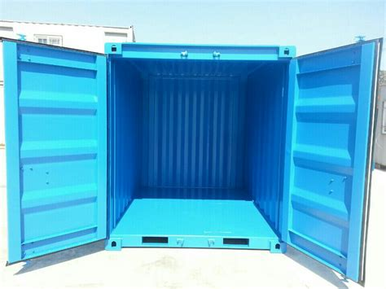
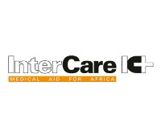
Inter Care’s first ever shipping container is on course to be sent to Africa in spring 2019.

Its destination - Sierra Leone.
Its mission – To safely deliver health care goods to those with the greatest need.

This maiden voyage is a test run of Inter Care’s new shipping strategy, taking us one step closer towards absolute best economic practice.
“This is mission control. IC 1 you are clear to launch!”

What’s happening behind the scenes?
Our Warehouse Assistant William explained “In the warehouse we have a dedicated prototype area near the rollerdoor entrance. It’s marked out by length, width and height to replicate the volume of the actual container so, by using the exact dimensions we will be able to fill it to capacity when it arrives for loading”. The prototype area is rapidly being filled by donations of health care goods from pharmaceutical company partners and, as is our usual, from surplus NHS stock. “Mostly there’s the boxes neatly packed n’ stacked… then any loose items will fill it to the top!”

Why a container, and why now?
2019 is our 45th year as a registered charity and to mark this we recently we celebrated reaching the milestone of having sent 15 million pounds worth of vital medical aid to sub-Saharan Africa! Since we began sending parcels of aid to Africa using the postal service always served our aims and still does however, in a world of rising energy costs these increases are being passed to us as significant price rises. Inter Care now need more economic alternatives to maintain service as usual.

Our first container will only contain health care goods due to their relatively large volume and high weight values. These factors are all considered in relation to medicines, which at this stage will not be sent in shipping containers due to their volatile nature. Medicines will continue to be sent air freight as they arrive faster and can be temperature control compliant. Inter Care’s container will be jig lined (a rudimentary form of insulation) and will be fitted with temperature sensors to map the hour by hour fluctuations inside the container throughout its journey to Africa. This data capture element of the project is crucial for future deliveries as we will be able to ascertain if medicines could ever safely survive the journey.

Inter Care currently send consignments of vital medical aid by international parcel post and by secure delivery within government guidelines however, General Manager Diane says “The bottom line is that rising shipping costs (charged per kilogram) are beginning to prove a step too far for income levels to sustain. By transporting Heath Care Goods (not medicines) by container we anticipate slashing overall shipping costs thus maintaining high levels of aid sent to Africa.”
To learn more about what Inter Care do, and to donate please visit our website www.intercare.org.uk
All enquiries please email: info@intercare.org.uk

