MOB Credentials

- Name of the NGO | MOB Rural Health Centre, Mandya
- Year of Establishment | 16th October 1992
- Located At | Matrujyothi convent,Siddartha Lay Out, Yethagadahalli, Cheernahalli Road, Mandya. Karnataka. 571403
- Registered As | Society
- Contact No | 7559817952  8553461143
- Contact Email | mobmandyasocial@gmail.com
- Website | www.mobmandya.org
- Registered Certificates by State & Central Governments | PAN - AAATM5851H  TAN – BLRM00350A
 | 80 G certificate1-M-72/80G/CIT/Mys/10-11
 | 12 A certificate -M-72/12A/CIT/Mys/01-02
 | FCRA - 094580030
 | Darpan – KA/2018/0169275
-District Disability Welfare Department,
-Department of women and child development.
-District Leprosy Department.

- Governing Board
Total Members | 07
No of Female Members | 07
No of Experts (Legal, Finance, Technology) | 1
No of Experts (development Sector & Domain) | 1

- Approved & Published Policies | Child Protection Policy
 | Protection of Sexual harassment at work Place
 | Financial Management
 | HR
 | Conflict of interest policy
 | Digital media policy
 | Leave policy
 | MIS Policy
 | Procurement Policy
 | Travel Policy

- Committees | Child Protection Policy
 | POSH

- MIS System | Goonjan Software, Tally Software.

- Our Donors/Supporters
Name of the Donor | Year of partnership | Projects Supported | Amt of Grants Provided
UfficioMissionario | 2015-2019 | Organisation | 18 Lakhs (2018-19)
AIFO | 1992-2019 | Leprosy and CBR | 5 lakhs (2018-19)
CHAI | 2018-2019 | Children with disability (Jnanodaya project) | 9 lakhs
Dhwani Foundation | 2018-2019 | Institutional capacity building program | 2.5 lakhs
Dream India | 2018-2020 | Destitute home | 2 lakhs

- We are currently undergoing an Organisation Development Certification process run by Dhwani Foundation, Bangalore

- Awards / recognitions
Sl No | Issuer | Award | Year
1 | Kannada Sahithya Paris hath | Karnataka Rajyotsava | 1995
2 | Rotary club | Kittur Chennamma | 2002
3 | Dalitha Sanga Organisation | Dr. Ambedkar Award | 2003
4 | Mandya Municipality | Mother Theresa | 2003
5 | Red Cross | Red cross Society | 2004
6 | Governor | Best State Mahila Sangha (Women’s Group) | 2005
7 | Department of district disabled welfare | State award for Best Worker for the disabled | 2006
8 | Chief Minister | Best service Honour for the Social work | 2006
9 | Transport Minister | District Best Mahila Sangha | 2007
10 | Governor | Governor Award for best work in leprosy eradication program & activities | 2008
11 | Devaraj Arasu Nigama | Devaraj Arasu Award for the Social work | 2008

MOB Rural Health Centre (ORGANISATION ONE PAGER)
MOB Rural Health Centre is a non-governmental organization, started in 1992 and initiated with the purpose of eradicating leprosy in Mandya District. In 2012, we extended our CBR (Community based Rehabilitation) services to Mysore District.
To address the major challenges, MOB has adopted the following objectives:
Community Based Rehabilitation:
The community-based rehabilitation of differently abled was setup in 2000 with the goal of attaining the highest attainable health standard through health promotion, preventive care, medical care, and rehabilitation / assistance devices.
We built core group, Panchayath level and Taluk federation, District level federation and also plan to build federation at the State Level.
Totally we provide service to 14252 PWDs. We have a federation for Women with Disability working to help protect their rights.
EMPOWERMENT OF WOMENS THROUGH SELF HELP GROUP (SHG)
MOB built 56 women’s SHG’s in Mandya Taluk. 1060 members are benefiting through these SHGs. The ASHRAYA WOMENS FEDERATION at the district level has 56 SHG under its fold.
Through this Federation we have supported
- 80 women start Pod Seri cultural
- 350 Women start Cattle raring
- 250 members were linked through tailoring trainings and working in the garment industry
- 300 members were linked through with Vijaya bank skills training program on vegetable and flower cultivation.
DESTITUTE HOME – An institutional care objective (Colouring of fallen stars)
The destitute elderly need care and to have their economic, social and psychological need met. Satisfactory accommodation, food and basic facilities are some of their minimal needs.
Seeing this need MOB RHC has begun this home for the destitute in August 2017 and has 27 inmates in this centre.
MOB’s current operating annual budget is 25 Lakhs and we have 19 staff. Over the last 26 years, we have diligently worked with partners such as AIFO, CHAI, Dream India, UFFICIO-MISSIONARIO, and Dhwani Foundation.
The organization is governed by 7 board members and compliant with 80G, 12A, FCRA, Darpan, PAN certifications.

CBR (COMMUNITY BASED REHABILITATION) FOR THE DISABLED
Having come across many neglected and rejected persons with u in the rural areas, in the year 2000 the project extended its service to the Community Based Rehabilitation of the disabled in 1219 villages of Mandya, SR Patna, Pandavapura, Nagamangala, Mysore and Savanur Taluks.
Door to door survey is done for identifying persons with disabilities. 12218 persons have been identified and 11,133 have been referred to different centres for assessment and medical certificate. Three physiotherapists of the project go from house to teach the caretakers to give regular physiotherapy to those in need. 1195 disabled persons are given physiotherapy. The disabled are organised into SHGs in order to get financial help from government and non-government organisations. So for we have formed 270 SHGs of the disabled including leprosy patients.
Eye screening camps are conducted in all the school of target area for detecting signs and symptoms of early blindness. During last decade MOB did the eye screening for 64800 village children, out of which 575 referred to eye specialist. 12 blind children are enrolled in Ramanamaharshi academy for the blind. 4320 adults were directed for cataract surgery during the eye camps conducted by government hospitals. 45 children with speech and hearing problem are sent to Montfort School at Belagola, Srirangapatna. Other children with minor disabilities are enrolled in normal schools. Their teachers are motivated to accept them and handle them with care. A good numbers of disabled children are provided with uniforms and study materials. 1850 disabled school children were assists by MOB get scholarships. Our CBR Team in collaboration with local Saksharatha Centres has provided reading and writing skill to 4246 disabled who never attend formal school.
The MOB project financial help for 26 disabled to correctives surgeries in hospitals like Gopalgowda Hospital, Mysore and St. Johan’s Medical College, Bangalore.
The project has supplied the following aids and appliances for the disabled. 568 tricycles, 694 wheelchairs, 312 artificial limbs, 210 pairs of auxiliary crutches, 198 elbow crutches, 136 callipers, 14 walkers, 28 waterbed, 675 hearing aids, 112 white canes and 654 MCR footwear. In Mandya, MOB runs an orthotic centre where the ortho technician makes calliper and splint, and also repairs the aids and appliances.
The project succeeded in obtaining pension for 5618, bus pass for 1400 and train pass for 2848 disabled. 2 career guidance workshops were conducted by APD (Association for physical disabilities) and Infosys in Mandya and Nagamangala for the disabled of the project.
Some of the disabled are trained in our centre for candle making. 23 disable are placed in leather bag making sector of Sumanahalli leprosy project, Bangalore.
WOMEN EMPOWERMENT
Seeing the troubles and problems faced by women in the villages MOB began to organize Mahila Sanghas in 1999 empowerment of village women in Mandya, Srirangapatna, and Pandavapura Taluks. So far 62 SHGs (self help group) of women, comprising 1200 members, are formed by us. These Sanghas have monthly meetings and savings. They have been able to save by themselves Rs. 53, 34,880/=. Besides this, they have received Rs.1, 37, 11,000/=. As loans from the banks. These amount are distributed according to the need of the women after consultation within the group. These women were able to help other people in the village in their emergencies. With the economic process they can now live a better life and send their children including the female ones for basic education and even higher education, which were not possible before.
These Mahila Sanghas form different committees (Environment, education, economic, social and cultural) in order to functions in an organized and systematic way. The responsibilities of the committees are given in the annual report. Every three months the leader of these Sanghas is called for a training programme on saving, account keeping, leadership and other relevant topic. All the SHGs have their own accounts in bank. These Mahila Sanghas are registered as Ashraya Mahilodaya Okkuta, Mandya.
Every year on 8th March, on the occasion of the international women’s day we gather our village women for a public function which starts with a rally from Deputy Commissioner’s office to IMA (INDIAN MEDICAL ASSOCIATION) hall, Mandya. About 1020 women from 62 Sanghas participated in the function this year. Each Sanghas comes from cultural programmes to perform on the stage. The prizes for the Sports programmes conducted for the ST. Joseph’s school ground, Mandya. Every year the best Mahila Sangha receives an award from the president of the function.

DESTITUDE HOME – AN INSTITUTIONAL CARE.
Problems of aged and the infirm are becoming more complex today. In India, the aged constitute about 7.5% of the total population. A large portion of the aged are living in villages where poverty is wide spread. The young people seeking employment outside the villages tend to leave the elderly behind unattended. The elderly are left in isolation and loneliness. Men suffer more when the wife dies.
An important need of the aged is to get “CARE” to meet their economic, social and psychological needs. A satisfactory accommodation, enough food, care and certain facilities that maintain human dignity are needed.
Seeing this, MOB RHC has begun an initiative recently - home for destitute at Mandya. It is a 20 bed centre with a medical room. We have 5 staff members managing this centre including a full time nurse. We also provide counselling services here. We also have a facility to treat leprosy patients suffering from ulcer.
We constantly work to reunite our wards with their families, refer patients suffering from serious illnesses to better equipped hospitals, ensure care and dignity to the homeless and the destitute.
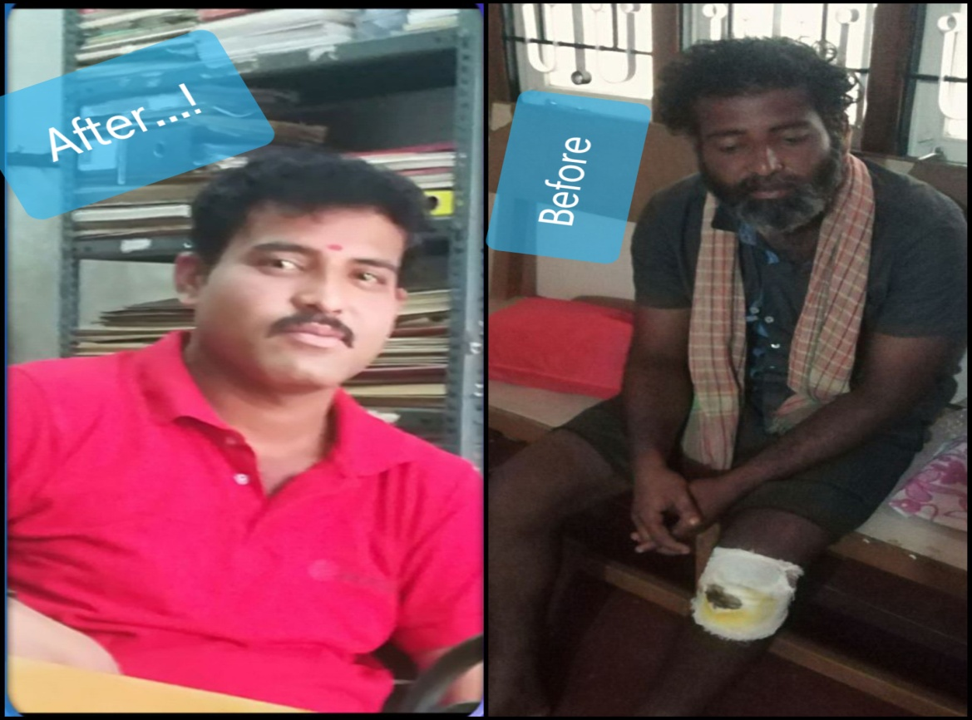
MOB Aerospace System
- Project Framework
Name of the Implementing Organization |  | MOB Rural Health Centre
Project name |  | LIVELIHOOD FOR YOUNG PEOPLE WITH DISABILITY (LOCOMOTOR DISABILITY, SPEECH & HEARING IMPAIRMENT & CEREBRAL PALSY)
Area of Implementation |  | Mandya, Mysore, Maddur, Malavalli, Srirangapatna, Nagamangala and Pandavapura Taluk, of Mandya and Mysore District, Karnataka State, India.
Program Duration |  | April2019-March2020
Budget | Total Program Cost | US $ 36550  @ Rs 71.255= 1US $
Expected number of --------- beneficiaries to be reached during project period. |  | 300 ( Of a 1000 identified, we estimate locomotory-700, SHI-200 and CP-100 )

- Glossary:

CBR | Community Based Rehabilitation
PWDs | Person with Disability
SHI | Speech and Hearing Impairment
MOB RHC | Maria Oliva Bonaldo Rural Health Centre
CP | Cerebral Palsy
SR Patna | SriRanga Patna

- Brief History of NGO:

MOB Rural Health Centre is a Non Governmental Organization founded by a group of committed women. It had a simple beginning at Srirangapatna in 1992 following the request of Dr. Hema Reddy, then Joint Director of Health and Leprosy in Karnataka State. MOB RHC is a Society registered under Karnataka Society Registration Act 1960, whose founding director is Sr. Leela Cheenothuvattukulam who dedicated her life for the cause of poor and marginalized of the society.

The main office of MOB RHC is situated in the premises of the Government Medical College, Mandya. It was started for giving care to the Leprosy affected patients, to create awareness on this dreadful disease and take preventive measures – Leprosy being rampant in the poorer sections of the society certain parts of urban and rural Mandya, it was the felt need at that time. Thanks to the global efforts, Central and State Government interventions and the NGOs collaboration, Leprosy affected persons were treated effectively and the “incidence “ of leprosy came down significantly.
From 1998 MOB RHC expanded its services to other areas like HIV/AIDS, empowerment of Having come across many neglected and rejected persons with disability in the rural areas, in the year 2000 the project extended its service in the field of education, livelihood, entitlements and medical rehabilitation of the disabled in 1219 villages of Mandya, SR Patna, Pandavapura, Nagamangala, Mysore and Savanur Taluks.
Over the last 18 years, 12252 persons have been identified of whom 11,133 were supported through schemes from government, medical, education, local employment opportunities by networking with specialists NGOs, local government and communities. 1200 disabled persons were helped to achieve functional ability and independent mobility through rehabilitation services. Self Help Groups (SHGs) federated – persons with disability to access their rights, entitlements and economic benefits both through government and MOB funding. A total of 9866 persons were helped to access government schemes such as pension’s bus and train passes.
In collaboration with local education department, ensured 4246 children access education, 1850 children with disability were assisted to get scholarships, needy children were supported with uniforms and study materials, 45 children with speech and hearing problem were sent to special schools in Belagola, Srirangapatna and 26 children were provided financial help for corrective surgeries.
The project has supplied 3610 assistive devices and mobility aids through assessments, right fitments and training to ensure independent mobility which led people access education, livelihood opportunities and gain dignity in their communities. 568 tricycles, 694 wheelchairs, 312 artificial limbs, 210 pairs of auxiliary crutches, 198 elbow crutches, 136 calipers, 14 walkers, 28 waterbed, 675 hearing aids, 112 white canes and 654 MCR footwear. In Mandya, MOB runs an orthotic centre where the orthotechnician makes caliper and splint, and also repairs the aids and appliances. Women, Children, Community Based Rehabilitation of the differently able, Ulcer care centre and destitute home.
MOB is the only large service provider in this district and the area experiences a Vulnerability of services with a large unmet population of over 30000 disabled persons.
Now MOB is starting a new chapter continuing the women empowerment program, integration of disabled and a home for the destitute and abandoned.

- Project Goal:

“To ensure livelihood opportunity for 300 young people with disabilities annually”

- Project needs assessment/rationale:
Details on Mandya district disability
 | Total | Male | Female
Disability Population | 36228 | 20027 | 16201
Visual impairment | 7234 | 3517 | 3717
Speech and Hearing | 8240 | 4342 | 3898
Locomotor disabilities | 8848 | 5675 | 3173
Mental retardation | 2625 | 1393 | 1232
Mental illness | 481 | 253 | 228
Multiple disabilities | 5602 | 3026 | 2576
Other disabilities | 3198 | 1821 | 1377
Our target group for livelihood= Government 2011 census data
Age group | Locomotor | Speech & Hearing | Multiple Disability | Total
20-40 | 2980 | 2552 | 903 | 6435

- Project Objectives:

- Providing rehabilitation for independent living skills
- Providing in scope PWDs relevant vocational training.
- Job Placement for 80% youth with disabilities.

- Project Proposed targets:

Type | Director | Indirect
Persons with Disability | 300 | 950
Parents | - | 650
Stakeholders/Networks | 30 | -

- Project Outcomes:

- Training the 450 youths with disabilities in their interested area of skills.
- Ensuring 80% of youth with disabilities job opportunities for self sustainability.
- Jobs with earnings of Rs 8000 to Rs 10000.

- Activities and Outcomes -

Activity | Outcome
Identification of PWDs with Locomotor, SHI and CP | 1000 persons identified for vocational assessments
To administer Vocational Assessments to 1000 PWDs | Candidates shortlisted for Foundation course  No of candidates requiring rehabilitation support
Foundation Course | Out of 600 PWDs 450 PWDs prepared for vocational training program
Networking collaborations to impart vocational skills for 450 PWDs | MoU with organizations to manage scale/scope
Vocational training program | 80% students graduate
Local Placement | 20% - local placement,  80% - thro’networks/collaborators
Field/follow up support | Ensuring and supporting PWD’s to sustain their job.

X Budget:
Title of the Project : Livelihood for young people with disabilities

Time Period : April 2019 to March 2020

 | Budget Heading | Calculations | No. of Units | Unit Cost | Total (Rs.)
A | Program Cost
1 | Foundation course (Residential accommodation and food) | Rs1500/person with 30 people per batch | 20 | 45000 | 900000
2 | Net working collaboration | Rs1000 per visit ; 7 organizations; 3 visits per organization | 7 | 3000 | 21000
3 | Local placement & Follow ups | Rs500 per visit; 20 locations; 3 times per cycle | 20 | 1500 | 30000
4 | Mobility aids | Rs.8000x5 wheel chair | 5 | 8000 | 40000
5 | Rehabilitations support | Rs 2500 per visit; 6 visits per year | 6 | 2500 | 15000
6 | MIS & Evaluation | Rs. 15 per beneficiary | 1000 | 15 | 15000
 | Sub Total - Program Cost |  |  |  | 1021000
B | Salaries
B.1 | Program Staff
1 | ED Salary - Rs, 8000 per month | Part salary | 12 | 8000 | 96000
 | Social security at 13%(PF)+4.75%(ESIC)+ 4.81%(Gratuity) |  | 12 | 1800 | 21600
2 | Program Co-Coordinator - Rs. 15000 per month | 1 persons x 15000 per month | 12 | 15000 | 180000
 | Social security at 13%(PF)+4.75%(ESIC)+ 4.81%(Gratuity) | 1 persons x 3384 | 12 | 3384 | 40608
3 | Field Staff - Rs. 12000 per month | 4 persons x 12000 per month | 48 | 12000 | 576000
 | Social security at 13%(PF)+4.75%(ESIC)+ 4.81%(Gratuity) | 4 persons x 2710 | 48 | 2710 | 130080
 | Sub Total - Program Cost |  |  |  | 1044288
B.2 | Support Staff
1 | Accountant - Rs. 15000 per month | 20% salaries of Rs 15000 per month | 2.4 | 15000 | 36000
 | Social security at 13%(PF)+4.75%(ESIC)+ 4.81%(Gratuity) |  | 2.4 | 1580 | 3792
2 | HR and Met Staff | 20 % salaries of Rs.20000 | 2.4 | 20000 | 48000
 | Social security at 13%(PF)+4.75%(ESIC)+ 4.81%(Gratuity) |  | 2.4 | 2270 | 5448
 | Subtotal of Support Staff |  |  |  | 93240
C | Overheads
1 | Travel Expenses | Rs.10000 per month | 12 | 10000 | 120000
2 | Audit Fee | Rs.10000 per annum | 1 | 10000 | 10000
3 | Electricity/Water | 1000 per month | 12 | 1000 | 12000
4 | Communications | 1000 per month | 12 | 1000 | 12000
5 | Building Maintenance |  | 1 | 20000 | 20000
6 | Printing and Stationary | Printing- Cartage, maintenance  Stationary for day to day operations | 2 | 10000 | 20000
7 | Hospitality | 2000 per month | 12 | 2000 | 24000
 | Sub Total of Overheads |  |  |  | 218000
 | Total |  |  |  | 2376528
 | Cost per beneficiary per annum |  |  |  | 7922

