CHARITABLE YOUTH FOR NATION BUILDING INITIATIVE(CYNBI)

UPGRADING OF GEORGE IWILADE LIBRARY
A PROPOSAL
submitted to

GLOBAL GIVING

FEBRUARY 2019
PROPOSED TITLE: UPGRADING OF GEORGE AKINYEMI IWILADE LIBRARY IN IWO LOCAL GOVERNMENT AREA OF OSUN STATE IN NIGERIA

PROPOSED DATE: FEBRUARY, 2019

TELEPHONE NUMBERS: +234(0)8034978700, +234(0)8057783260

E-MAIL ADDRESS: charitableyouthfor@gmail.com

ADDRESS:
Head Office: 8, Momo Ke, Beside Al-Haq Nursery and Primary School, Academic, Iwo Road, Ibadan, Oyo State, Nigeria.
Branch: 175, Station Road, Oke Odo, Iwo Osun State, Nigeria.
Correspondence Address; 113 Station Road, Opposite Bowen University Road, P.O. Box 32, Iwo, Osun State, Nigeria.

Submitted to: GLOBAL GIVING.
THIS PROPOSAL, UPGRADING OF GEORGE IWILADE LIBRARY WAS WRITTEN BY:
- ADISA, Kabiru Adeniyi
President General, Charitable Youth for Nation Building Initiative

Signature: ____ 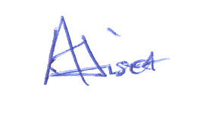
Date: _27th February, 2019

- BADRU, Babatunde Muhaley
Secretary, Charitable Youth for Nation Building Initiative
Signature: __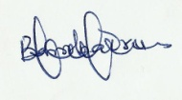____________
Date: 27th February 2019__

BACKGROUND
The Akinyemi Iwilade Library is the first community library in Iwoland and established in the year 2000. It was established by the Iwo Local Government Authority in honour of George Akinyemi Iwilade, a son of Iwoland and a former Secretary General of Obafemi Awolowo University, Ile-Ife whose life was cut short by cultists in the cause of getting his institution rid of cultism. The library, at inception was kept in the custody and being managed by the Federation of Iwoland Students Union (FILSU). This Library had served Iwo students from diverse schools/institutions and different educational levels as well as other professionals for over 2 decades. Despite Iwo being the most populous local government in Osun State, it cannot boast of having any other library except this. Iwo Local Government boasts a school-aged resident population of over a hundred thousand.
In the last few years, the state of the library has been moving from decline to decline. As at the moment, the library cannot boast of a single functional book. What remain of the library include the building, over a dozen chairs, half a dozen tables and empty shelves. The library was last used over 2 years ago. Because of the poor use of the library, the building was almost taken away and now shared with the National Identity Management Commission.
The consequences of the poor state of the library is well felt among Iwo students. A school tour exercise conducted earlier this year shows that the ability of students to read is declining and a few students managed to pass the reading benchmark set by the coalition. From focus group discussions, it was discovered that students’ interest in reading is declining and one of the reasons attributed to this is the lack of functional library. The state government’s policy of replacing textbooks with tablets that did not go round 5% of total school population is also a big underlying factor. Last year, Osun State had the second worst overall result in the entire 17 states that make up Southern Nigeria (only better than Oyo State) and was ranked 22nd in the country from the results of the West African Senior Secondary Certificate Examination. Iwo Local Government has one of the worst ratings in the state. The level of girls transition from secondary school to higher institution in the past five years is alarmingly low.
CYNBI as a civil society organisation and a community based organisation respectively know the value of our community services and understand the roles and impact that functional libraries can play in the educational advancement of citizens and social advancement of a people. In an increasingly digital world, we see the role of libraries as community and cultural centers at times undervalued, and occasionally under fire. When shrinking government budgets combine with the nonstop technological revolution, public library services that focus on building community face-to-face, inspiring and educating the younger ones about art, sciences, literature, and music, and helping them engage in civil discourse can seem quaint. But it is precisely those shrinking budgets and the onslaught of technologically mediated life that make public libraries’ cultural and community offerings more important than ever. More than just books and banks of computers, libraries are still places where individuals gather to explore, interact, and imagine. There is need to take a look at some of the specific ways in which libraries add value to our communities and serve as cultural and educational Centre for the younger generation . The importance of library cannot be over emphasized.
Having a standard library in Iwo will be of great pleasure to the teaming students of the town, the general populace and of course become a resource centre for every intellectual individual.

OUR PROGRAMME
It is obvious Iwoland is having a great challenge when it comes to library. We wish to write your organization to find a lasting solution to the problem by soliciting for assistance towards having a standard and modern library for the community. Through a community intervention, a building has been secured already for the library. All it remains now is the furniture, computers, internet facility and books. We plan to divide the library into two; an e-library and a conventional library. Materials that are being solicited for include;
- Furniture
- Books (for Junior and Senior Secondary School Students) including literary books
- Computers (laptop)
- Internet facilities
- Book shelve
- Generator
- Cabinets
FINANCIAL MANAGEMENT
CYNBI has a standard financial system in place. The organisation’s account manual has been developed and account has been computerized. Accounts are audited by internal auditor on quarterly basis and by a Chartered Accountant firm on a yearly basis. CHARITABLE YOUTH FOR NATION BUILDING INITIATIVE has been keeping required books of accounts and maintains a double entry book keeping system. Our project have programme wise ledgers and maintained cashbook, assets register and log books. Our projects have been audited quarterly by internal audit.
We set up a comprehensive planning and budgeting system, which confirm to policies methods and benchmark of international organisations which we believe GLOBAL GIVING adopts. The monthly management accounts of the project are always compared with budget and management report quarterly to the board of trustee and donors.
An independent audit always takes place for our project during mid-term evaluation and at the end of the project. An external auditor certified by the Institute of Chartered Accountants of Nigeria (ICAN) has been auditing the account. The result of these audits has been including recommendations on how CYNBI’s financial management system should be strengthened, if necessary.

DELIVERABLES
All documentations in respect of this proposed library project will be made available to your GLOBAL GIVING. This will include audiovisual materials both electronic and print; photograph recorded tapes/disc and as well the quarterly publication of Charitable Youth for Nation Building Initiative. Also our organization is ready to endorse appropriate documents/materials transfer agreements ensuring ownership for the deliverables of these materials. This organization will do appropriate consultation with Global Giving, Federation of Iwoland Student Union, Iwo Local Government Authority and other relevant bodies on every work plan, activities and publication arising from this project before any step is taken. Appreciation and acknowledgements shall be in unambiguous language.

MONITORING AND EVALUATION
Charitable Youth for Nation Building Initiative shall ensure strict monitoring and evaluation of this project in conformity with international best practice. There will be a periodic monitoring and evaluation of all activities happening in the library. Reports will be written at interval and sent to appropriate quarter.

MONITORING:
This organization operates with transparent openness and accountability and will monitor the dynamics of inputs and process of this project professionally and be sensitive to hidden factors that may affect or influence our expected outcome. We will utilize the services of external and internal monitors to achieve this. When the project is completed and implemented by this organization will be open to scrutiny by GLOBAL GIVING, law of the land and ethics of human participant shall be considered in doing so. Monitoring and evaluation of the entire process of implementation of this programme shall be done at close interval to help in decision making with a view to making the best use of resources available. We shall develop and generate appropriate documents to ensure effective monitoring and evaluation.

INNOVATION
The organization shall engage a good number of volunteers that will help in carrying out most of the activities on the site in other to reduce cost and fasten the work on the project. Volunteers from the town will be engaged. Already up to 15 individuals have signified interest in working as a volunteer with the zeal of making a project a reality.

SUSTAINABILITY PLAN
One of the feasible strategies built into the program to sustain activities beyond donor funding is the adoption of the participation methodology. The key stakeholders, target groups and beneficiaries i.e. Charitable Youth for Nation Building Initiative, the partners, and Iwo Community representatives of target groups and beneficiaries who are members of the Community Implementation Committees are participants in the implementation of the program. In other words, the involvement of the stakeholders, target groups and beneficiaries in the Planning, implementation, monitoring and evaluation will be a major factor which will ensure that the outcomes continue after the funding by donor has terminated. The second feasible strategy built into the program to sustain activities beyond donor funding relates to the creation and empowerment of community-based organisations, institutions and movements embracing specific groups such as women, youths and elders.
Thirdly, a feasible strategy built into the program to sustain activities beyond GLOBAL GIVING funding relates the promotion of public-private sector partnerships. The foundation for this partnership is provided by the participatory methodology as noted earlier in which stakeholders from the public and private sectors will participate in the implementation of some activities.
The program will strengthen the public-private sector partnership so that such collaboration will continue beyond the donor funding of the program.
Brand Plan
Goal: The main goal of the brand plan proposed for this program is to ensure that both beneficiaries and Nigerians know that the support which GLOBAL GIVING is providing for the program is “from the Donor.” In this programme the branding strategy is designed to address three broad areas as follows: positioning, program communication and publicity and acknowledgements.
Positioning: The program name or title will include a subtitle such as “Sponsored by GLOBAL GIVING: from the British People.” This will normally have the GIVING logo.
Program Communication and Publicity: Communication and publicity are key elements of the program implementation. In the first place, the program materials, posters, pamphlets, public service announcements, billboards, etc. will contain GLOBAL GIVING identity such as “GLOBAL GIVING from the Donor people.” Secondly, the key messages of the program will incorporate GLOBAL GIVING primary message.
Acknowledgements: Since the program will be financed mainly by GLOBAL GIVING, all key activities and reports will acknowledge the fact that the program is funded by GLOBAL GIVING.

BUDGET
Description | Quantity | Rate | No/Month | Amount
Chairs and Tables | 100 | 4,900.00 |  | 490,000.00
Computers | 10 | 98,500.00 |  | 985,000.00
VSAT-for Internet |  |  |  | 2,000,000.00
Books |  |  |  | 2,500,000.00
Book Shelves | 11 | 15,000.00 |  | 165,000.00
Cabinets | 2 | 60,000.00 |  | 120,000.00
Salary | 2 | 40,000.00 | 24 | 1,920,000.00
Generator |  |  |  | 500,000.00
Fuel, Oil etc | 1 | 30,000.00 | 24 | 500,000.00
TOTAL |  |  |  | 9,180,000.00

PICTURES FROM AKINYEMI IWILADE LIBRARY
1. The front view of the Library
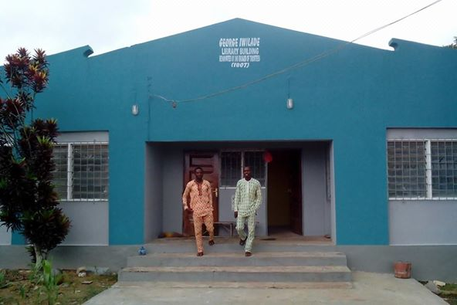

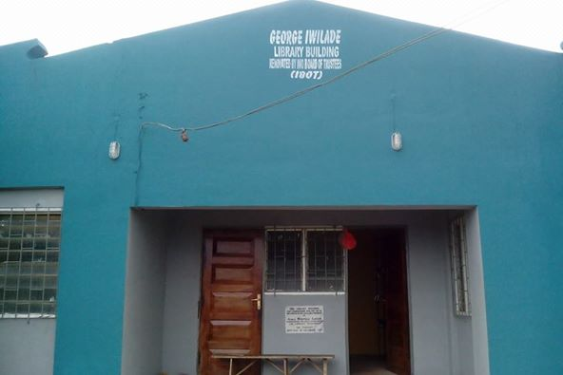
2. A room in the Akinyemi Iwilade Library showing empty shelves and no readers
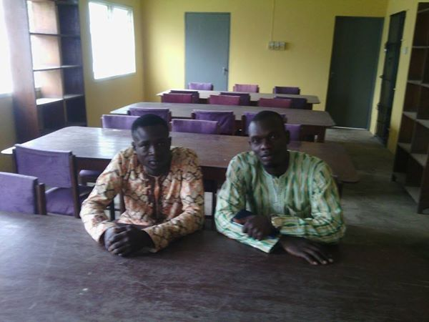

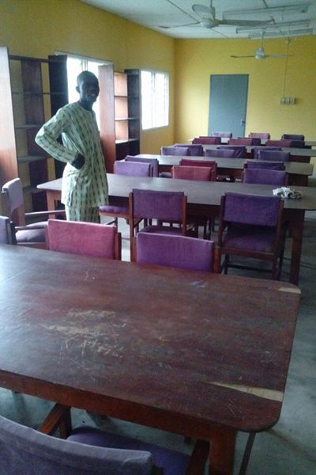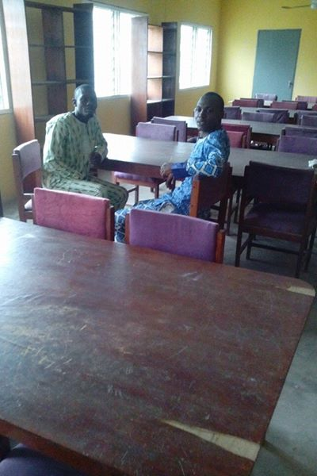
ORGANISATIONAL PROFILE: GUILDANCE COMMUNITY DEVELOPMENT FOUNDATION
CHARITABLE YOUTH FOR NATION BUILDING INITIATIVEis a Non-Governmental Organization (NGO). Our foundation is a non-profit and non-political and it’s registered under part “C” with the Corporate Affairs Commission. Presently we have offices in Osun state and Oyo state with the plan to network throughout Nigeria in the nearest future.
CHARITABLE YOUTH FOR NATION BUILDING INITIATIVEwas born out of the deep burning desire to add values to lives. It’s a foundation that works in giving selfless and humanitarian services to the less privileged and the needy.
CHARITABLE YOUTH FOR NATION BUILDING INITIATIVEbegan operation in the year 2000 but was fully registered in 2008. Its organisation that works in many areas of sustainable development, such as health, education, poverty alleviation, conflict management, capacity building, and good governance to mention just a few. GCDF has a committee of full time and part-time fellows that are appointed for various specialized intervention programs.
WHAT THE NGO STRIVE TO ACCOMPLISH IN LINE WITH OUR EDUCATION SUSTAINABILITY DEVELOPMENT
- The NGO strives to accomplish the empowerment of the community through providing access to useful information, education, training, sensitization and awareness.
- We strive to improve the quality of our youths by creating positive role models for which they may follow. We want to drastically decrease the amount of violence in our community, creating a peaceful and healthy environment. We hope to reform the social amenities established.
- We strive to improve the quality of our females through providing quality and proper education. Giving them the knowledge that they need to succeed in the world. Our target is to increase the literacy rate in our community.
- Our purpose is to also work towards the achievement of Millennium Development Goals (MDGs)

ABOUT IWOLAND DEVELOPMENT COALITION
Iwoland Development Coalition is an organisation of a group of people from Iwo, Aiyedire and Ola-Oluwa local government area for the development of Iwoland as a whole. The main object of the coalition is to operate and function as a non profit organisation for the promotion of good leadership culture, democratic principle and community development in Iwoland in particular and Nigeria in general. To this end, the coalition aims;
1. To empower members to assume roles of leadership and responsibilities in the community.
2. To provide a friendly and helpful environment for members to meet and share knowledge, ideas, goals, best practice, experience and expertise on subjects of interest to the coalition.
3. To provide networking opportunities for members to interact with Iwoland indigenes from within and outside Coalition.
4. To operate financial system, such as cooperative societies, for the promotion of economic interest and welfare of the members.
5. To establish educational institutions whereby leadership education, as a matter of priority, will be included in the instructional materials.
6. To serve as a foundation for leadership development programme.
7. To institute special merit awards for the identification and celebration Iwoland indigenes for outstanding leadership.
8. To contribute to social economic development of the environment within which the coalition operat , through enlightenment campaigns and community development projects.
9. To undertake any other activities which support the objects of the coalition.
Past Achievements
Through collective efforts of some indigenes of Iwoland (at home and in diaspora) we have been able to achieve the following;
1. Repairs of potholes from Adeeke to Kajola area.
2. Donations of hospital equipment by AIRTEL TOUCHING LIVES which we intend to use for health clinic project at Akinbami village.
3. Donation of a building at Akinbami village by Alhaji Suara Adedeji Adeleke to be used for health clinic.
4. Through the help of VITAMINS ANGEL (a United Stated of America donor), Albendazole and vitamin A have been administered to children of ages 0 to 5years at Akinbami village.
5. Through the help of the group members (home and in diaspora) we helped to pay in whole and also in parts of the school fees of some undergraduates who are in need of our help.
6. Donation of safety birth kits to the needing maternities in Iwoland- Ogburo Maternity, Ajangbala Eleha and so on.
7. Reconstruction of Ojude Oba Bridge through self help
8. Nutritional Support to Free the Child Orphanage Margaret in Iwo, Osun State.
9. Schools Tour Program in collaboration with CHARITABLE YOUTH FOR NATION BUILDING INITIATIVEto: 1. Papa Community Grammar School, Iwo on 20th May 2015 (2). Ilupeju Community Grammar School Ilemowu on 21st May 2015 (3). Oluponna High School Oluponna on 22nd May 2015.Core values of our visitation are: Academic excellence, Career talks, Leadership and Community Development. The theme of the program: Protection and Sustainable Development of Educational System in Iwoland.
10. Cleaning and Beautification of Iwo Local Government Roundabout in Osun State of Nigeria on 6th June, 2015 in collaboration with Iwoland Development Coalition.
12. Clearing of premises of defunct Africa International Bank (AIB) building at Oluponna. A place that have been reportedly taken over by reptiles which have become a dangerous zone.
13. Support less privileged with Food and payment of three children school fees.

