UBECI Foundation
Annual Report 2018
Accomplishments and impact

Report:
Our foundation was able to help a total of 4204 children and their parents and reached the goal of reducing child labor hours and incenting the reinscription to school as well as helping them to develop basic skills. Mainly the creation of our new center UBECI AC contributed to this result.
By providing workshops and ludic activities, we offered assistance at four of the main markets in Quito: Chillogallo, the tourist market, Sangolqui and the Guamani market. In these places strategies were developed to raise awareness to the population about the well-being and the optimal development of the children We continue to provide the following projects: STREET CHILDREN PROGRAM, SUMMER PROGRAM, SCHOLL SUPPORT AND CAMPAIGNS.

- STREET CHILDREN PROGRAM
In the Street Children Program, the main goal is to to reduce the labor hours of the children, raise awareness about the importance of education in general and health. Furthermore, we to strengthen the childrens skills through workshops with the following focus and bisemestrial goals: \

  - FOCUS AND GOALS OF 2018

MONTH | FOCUS | GOALS
JANUARY | LEADERSHIP  This focus wanted to help children develop aptitudes and strengths to accomplish challenges in their lives in a correct and peaceful manner. Furthermore, values are taught to lead other people in a positive way. | - Socialise and teach the children about personal hygiene  - Promote the solidarity of children to other people
FEBRUARY | SOCIO-EMOTIONAL  Allowed us to teach the children about the importance of creating strong relationships between family members, as in the markets that trust does not exist. | - Use every meal as a time to enjoy with the family and strengthen the bond between family members.  - Surround the kids with a loving environment.
MARCH | EDUCATION  This focus aims to help the kids develop their intellectual abilities through ludic workshops and also teach them new things so that they can work on personal development. | - Teach the kids that learning is fun  - Teach the kids that education is essential to create responsible citizens.
APRIL | SOCIO-EMOTIONAL  This month we taught the children about the importance of grooming and having a good presentation, with the correct hygiene habits | - Promote a good personal hygiene.  - Promote self and body care.
MAY | LUDIC EDUCATION  This focus helps the kids to learn new things through ludic activities, which help to change the hostile environment at the market. We believe we can create a harmonious and communicative environment for the children. | - Promote artistic activities, like painting and drawing freely.  - Promote traditional games, in order to distract the children from their daily lives at the markets.
JUNE | SOCIO-EMOTIONAL  This month was focused on teaching about the importance of teamwork and honesty on our daily activities. | - Teach the kids about teamwork and help them evolve a better relationship with their friends.  - Help the children be more honest during the activities so that they can have a better impact in society
JULY | EDUCATION  This month we focused on learning skills during their vacations in order to avoid them losing the school rhythm. | - Encourage ludic learning during the holidays through activities such as painting and drawing.  - Improve fine motor skills through manual and ludic activities
AUGUST  SUMMER PROGRAM | LUDIC LEARNING  Helped the children to integrate through doing ludic activities such as different sports, theatre and dance. | - Integrate the children and their Friends through ludic games and sports  - Introduce the kids to theatre pieces and dance .
SEPTEMBER | PREVENTION  Helps to teach the children about the risks and dangers to which they are exposed inside and out of the market. Also, allows us to show them the negative effects of having bad habits in their daily lives. | - Teach the children how to use body language appropriately to avoid sexual abuse, through ludic activities.  - Prevent children pornoraphy, cyberbullying, as well as teaching then the dangers of social media, kidnappings and robberies.
OCTOBER | SOCIO - EMOTIONAL  During this month we worked on acceptance, as inside of the markets there is a hostile and insecure environment. Thanks to this we could help children develop and have a better self-esteem. | - Promote the acceptance and self-respect through ludic activities.  - Develop their focus and their mental agility through games and ludic exercises.
NOVEMBER | GENDER  Allows to teach the children the coexistence rules between the female and male genders. Also, promotes constructive thoughts about the capacities of the human being. | - Teach the kids about gender equality and how to interact correctly with their friends through ludic activities.  - Teach the kids about the rights to learn and have proper education through ludic activities.
DECEMBER | SOCIO - EMOTIONAL  Helped the kids to feel like they are a part of the community and city they live in. Also promoted their self-esteem and the way they react to other people’s comments and opinions about them. | - Teach the kids through traditional games what the “Fiestas de Quito” are.  - Promote self-esteem and self-respect through ludic activities and games.

NEW DEVELOPED AND IMPLEMENTED PROJECT

UBECI made an evaluation in which it identified the development of a daily attention center with the purpose of strengthening the activities that UBECI already carries out.

PERMANENT CENTER UBECI (ACCESS TO KNOWLEDGE)

It’s a strategy that UBECI developed which helps the children who spend the whole day at the market. The goal is to reduce the number of hours of work and stress the importance of education. The ludic activities done in the center are prepared based on the goal of giving them a better life. Those activities include:

- Logical reasoning
- Mathematical reasoning
- Writing techniques
- English
- Music
- Body expression
- Arts and crafts
- Gender and prevention

Children that attended UBECI center in 2018
BOYS | GIRLS | TOTAL NUMBER OF KIDS
26 | 59 | 85

CHILDREN THAT ATTENDED THE STREET CHILDREN PROGRAM
 | ENCUENTRO | DESARROLLO | CONSOLIDADO | TOTAL
CHILLOGALLO | 52 | 74 | 186 | 312
TURISMO | 19 | 23 | 32 | 74
SANGOLQUÍ | 46 | 64 | 67 | 177
GUAMANÍ | 27 | 40 | 56 | 123
TOTAL | 144 | 201 | 341 | 686

CHILDREN THAT ATTENDED THE SUMMER PROGRAM
 | ENCUENTRO  (1 to 3 years old) | DESARROLLO  (4 to 6 years old) | CONSOLIDADO  (7 to 17 years old) | TOTAL
CHILLOGALLO | 49 | 80 | 145 | 274
TURISMO | 16 | 28 | 40 | 84
SANGOLQUÍ | 52 | 103 | 119 | 274
GUAMANÍ | 30 | 41 | 88 | 159
TOTAL | 147 | 252 | 392 | 791

NUMBER OF WORKSHOPS DONE IN 2018

In the daily workshops we focus on the coexisting difficulties the kids have. All the workshops are evaluated, with the goal of understanding the level of focus of the children.

NUMBER OF WORKSHOPS DONE IN THE STREET CHILDREN PROGRAM
BIMESTER | JANUARY-  FEBRUARY | MARCH-APRIL | MAY-JUN | SEPTEMBER-  OCTOBER | NOVEMBER-  DECEMBER
APPROCHES | leadership– Socio -Emotional | Education–  Socio - Emotional | Ludic Education – Socio-Emotional | Gender–  Socio - Emotional | Prevention– Socio -Emotional
ETAPA ENCUENTRO | 32 | 32 | 32 | 32 | 32
ETAPA DESARROLLO | 32 | 32 | 32 | 32 | 32
ETAPA CONSOLIDADO | 32 | 32 | 32 | 32 | 32
TOTAL | 96 | 96 | 96 | 96 | 96

DEVELOPMENT OF THE CHILDREN’S CAPABILITIES AND SKILLS IN 2018

UBECI executed workshops and activities with a bimonthly focus, at the beginning and end of each bimester a test was made to each child to evaluate their progress and the level of comprehension of each activity. The skills and capabilities that were strengthened were:

- Children work better in a team
- They know how to better express emotions
- They get excited when learning new things
- Kids respect and follow the rules
- Promote solidarity between children
- Increase their creativity

The percentages are divided in charts. At the beginning of the year the percentage was 38.06% and at the end of the year was 48%.

PERCENTAGES AND RESULTS AT THE BEGINNING OF 2018
 | ENCUENTRO | DESARROLLO | CONSOLIDADO | TOTAL
MOTOR AREA | 36% | 38% | 40.2% | 38.06%
SOCIAL-EMOTIONAL AREA | 36% | 38% | 40.2% | 38.06%
COGNITIVE AREA | 36% | 38% | 40.2% | 38.06%
TOTAL | 36% | 38% | 40.2% | 38.06%

PERCENTAGE AND RESULTS AT THE END OF 2018

 | ENCUENTRO | DESARROLLO | CONSOLIDADA | TOTAL
MOTOR AREA | 43% | 53% | 51% | 49%
SOCIO-EMOTIONAL AREA | 43% | 46% | 49% | 46%
COGNITIVE AREA | 45% | 53% | 52% | 50%
TOTAL | 44% | 46% | 51% | 48%

CHILDREN IN THE SCOLARISATION STAGE

After the awareness raised in the workshops, the parents learned the importance of education.

NUMBER OF CHILDREN THAT ATTEND SCHOOL IN THE STREET CHILDREN PROGRAM
STAGE | ATTEND | DO NOT ATTEND | TOTAL
DESARROLLO | 195 | 6 | 201
CONSOLIDADA | 341 | - | 341
TOTAL | 542 | 144 | 542

- SUMMER PROGRAM

It’s a program that includes recreational workshops in order to reduce childrens working hours while on school holiday and avoids premature labor.

Type of activities included in the Summer Program

- Paint pictures using watercolors
- Stamp geometrical figures in crafts-paper using cardboard rolls
- Draw outlines to color using crayons
- Form shapes using modeling clay
- Participate in competitive games and stretching
- Memory games: put images and phrases in order
- Reading comprehension: reviewing readings and complete stories.
- Solve puzzles and scrambled letter to improve abstract comprehension.

- CAMPAIGNS

In 2018 UBECI created different campaigns which allowed to give priority to the attended population, physical health, dental, socio-emotional and prevention.

  - DENTAL CAMPAIGN

The dental campaign was created to promote a better dental health and oral hygiene in the kids, with the goal of reducing diseases and other oral related problems. In 2018, UBECI cared for 29 children, that benefited from free dental health care, thanks to the help from the donations.

Month | TREATMENT | BOYS | GIRLS | TOTAL
March | 93 surgeries, 4 removals, 11 zinc oxide | 3 | 8 | 11
Jun | 37 advanced surgeries | 4 | 4 | 8
October | 69 operatorias profundas | 3 | 7 | 10
TOTAL | 214 Treatments | 9 | 18 | 29

  - WEIGHT AND HEIGHT CAMPAIGN

In june, an evaluation of the height and weight of the children was done. In addition, vitamins were given to all the kids.

CHART OF KIDS THAT ATTENDED THE CAMPAIGN
NIÑOS | NIÑAS | TOTAL
53 | 60 | 113

  - PREVENTION LECTURE CAMPAIGN

During 2018, prevention lectures were done, with the goal of raising kids and parents awareness for: hygiene and personal care, health and emotional well-being, kidnapping and organ trafficking.

CHART OF KIDS THAT ATTENDED IN ALL THE CAMPAIGNS
MONTH | THEME | BOYS | GIRLS | TOTAL OF KIDS
JANUARY | NON VIOLENCE BETWEEN KIDS | 74 | 110 | 184
JUNE | HEATH AND NUTRITION | 80 | 108 | 188
SEPTEMBER | GROOMING HABITS | 84 | 76 | 160
OCTOBER | KIDNAPPING AND ORGAN TRAFFICKING | 120 | 160 | 280
DECEMBER | ORAL HEALTH | 59 | 88 | 147
TOTAL |  | 417 | 542 | 959

  - SOCIO-EMOTIONAL ACTIVITY
The socio-emotional campaigns in the markets have the goal of teaching the children about: their rights and obligations, civic and historic holidays and rules for social coexistence. The lectures are done under the staff’s responsibility. The talks were conducted under the responsibility of the staff.

MONTH | THEME | BOYS | GIRLS | TOTAL KIDS
MARCH | WATER DAY | 73 | 99 | 172
MAY | MOTHER’S DAY | 81 | 95 | 176
JUNE | CHILDREN’S DAY | 87 | 110 | 197
JULY | FATHER’S DAY | 77 | 102 | 179
AUGUST | BE NICE TO EVERYONE | 105 | 118 | 223
TOTAL |  | 423 | 524 | 947

  - SCHOOL KIT CAMPAIGN

During the month of October UBECI conducted the School Kit Campaign, the goal was to bring awareness to the children’s parents for the importance and the benefits of education in their kids lives. UBECI gave kits with school supplies to the kids who attended the program regularly in order to fument their studies.

MONTH | BOYS | GIRLS | TOTAL KIDS
OCTOBER | 90 | 96 | 186

  - PARENTS’ AWARENESS

Part of UBECI’s goal to give the children a better life in general is to raise parents’ awareness about issues they regard, like: child labor, childrens’ rights, sexual abuse, social media dangers, kidnapping, people and organ trafficking and health habits. This helps the parents and the kids form a better and more direct relationship at home.
The issues discussed with the parents are directly related to the ones taught to the kids in the workshops. This has a big impact on the hole family dynamics, which created a healthier relationship and environment in the household.

All this assistance created trustworthiness between the family members and UBECI, which allowed to continue the workshops at the markets.

POINT OF ATTENTION | N° OF PARENTS
CHILLOGALLO | 18
TURISMO | 10
SANGOLQUÍ | 12
GUAMANÍ | 10
TOTAL | 50

  - CHRISTMAS CAMPAIGN

In December, Christmas was celebrated in the markets, where 360 ​​children were benefited and their parents were also present.

NUMBER OF CHILDREN BENEFITED FROM THE CHRISTMAS CAMPAIGN
POINT OF ATTENTION | TOTAL
CHILLOGALLO | 127
SANGOLQUÍ | 154
GUAMANÍ | 79
TOTAL | 360

GLOBAL RESULTS
PROGRAMS | TOTAL OF KIDS
STREET CHILDREN | 686
SUMMER PROGRAM | 791
CENTRO PERMANENTE UBECI AC  (ACCESO AL CONOCIMIENTO) | 85
CAMPAIGNS | 2642
TOTAL | 4204

FOTOS

Merry Christmas
VIA NIÑOS

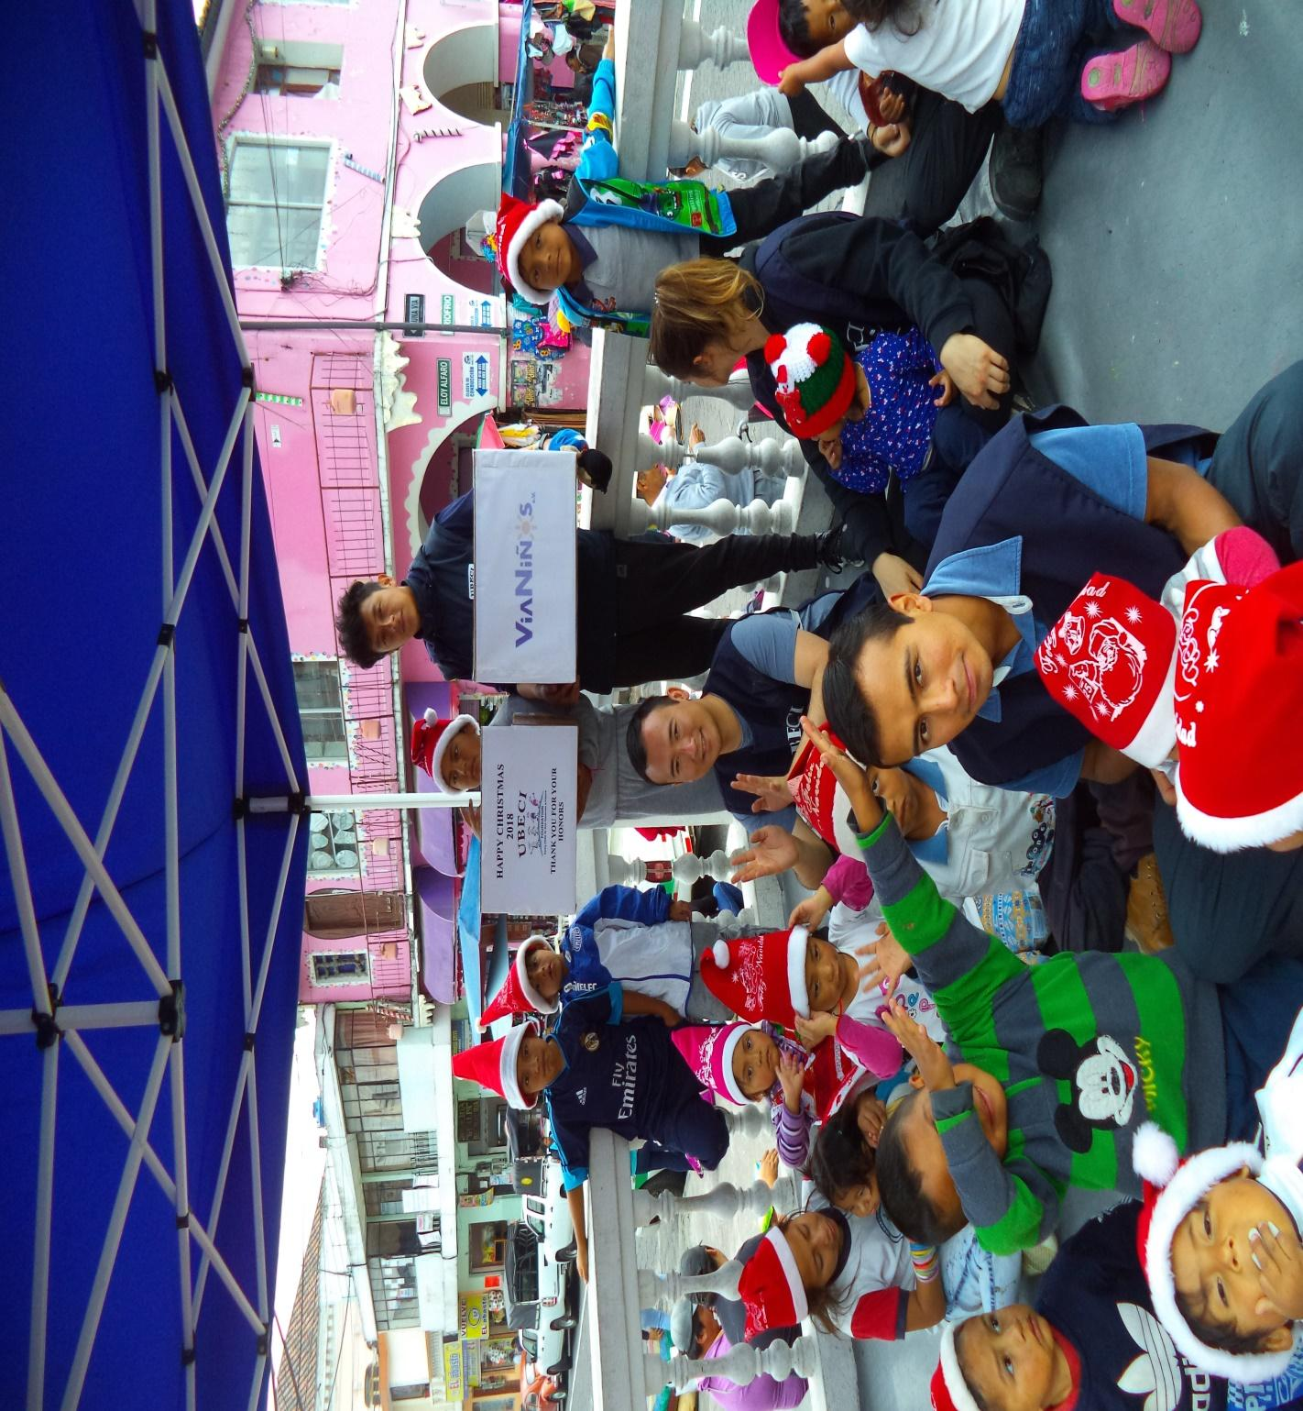

Thank you for your help!

