Title of project: Implementation of analog forestry for degraded areas and ecosystem restauration, economic development and strengthening of gender equality in the territory of Major Community Council of Alto San Juan (ASOCASAN), Chocó, Colombia

Context: The Chocó is globally recognized as one of the world's most biologically diverse regions, only second to Ecuador, and home to more than 11,000 species of vascular plants and 900 species of birds. The tropical forests there absorb significant amounts of greenhouse gases (GHG) and thus help regulate the global climate, making the region one of the “lungs of our planet”. It is also home to the Afro Colombian population, who share incredibly rich ancestral traditions and culture.

Unfortunately, both the environment of the Chocó and its people are under heavy threat. In the 2000s, the region suffered 60% of the total deforestation in Colombia, mainly due to mining activities and agriculture, which led to an alarming proportion of species of plants, birds and animals now being endemic. Experts state that desertification of soils and accelerated global warming are among the effects felt globally. Moreover, the vast majority of the population live in poverty, with 85% of Chocoans living below the poverty line, a 32% illiteracy rate, and only 38% of teenagers affording to go to high school, making it the poorest region in Colombia.

The municipality of Tadó (territory of ASOCASAN), particularly bears the burden of these challenges, having registered one of the highest indicators of deforestation in the region in 2015. The territory is immediately adjacent to some of the most biodiverse areas in the Chocó, which are now threatened. Moreover, most of the population lives in extreme poverty, 40% suffer from health issues because of the exposure to mercury in water and during artisanal mining activities, and women and girls are among the most affected. 20% of households are headed by single mothers, usually the poorest households in the territories. Moreover, average gender income gaps are 20%, and while the global men’s participation rate in the labour market is 74%, it is only 51.8% for women.

The solution: SUSTINERE recognizes reforestation through the use of analog forestry as a cross-sectoral solution for the next 5 years. This project is designed to restore degraded areas, reverse biodiversity loss, sequestrate carbon and decontaminate the water, while also addressing conditions of poverty by including trees and plants that yield fruits and vegetables which will be sold to local markets. Groups of women entrepreneurs will be created, while benefits from the project will prioritize on vulnerable women and girls, particularly single mother headed households. Community strengthening and capacity building will help build future resilience and resourcefulness.

The project builds upon lessons learned from analog forestry projects, one implemented in the Chocó in the Atrato River Basin by Give to Colombia (NGO) in 2013, and others in Honduras and Ecuador between 2011-2015. The project will be executed by SUSTINERE, in collaboration with ASOCASAN (responsible for the economic development component), the Associacion of Agroforestal Engineers of Colombia (ASINAF), who will lead the reforestation activity, and in association with Instituto de Investigaciones Ambientales del Pacífico (IIAP), who will conduct research, monitoring and evaluation, to ensure project objectives are met, and that soil, water and air quality are considerably improved, and carbon sequestrated according to project specifications.

Project objectives:

- Community capacity building and training in environmental sustainability, analog forestry, economic development and gender equality
- Gender equality program, creating a group of women entrepreneurs, prioritizing program benefits for single mother headed households.
- Strategy of economic development, selling food and medicinal products in local markets.
- Analog forestry activity for ecological restoration and productive development
- Carbon sequestration and reversal of biodiversity loss.
- Monitoring and evaluation to ensure objective compliance.

Main activities:

1) Training activities in environmental education, analog forestry, economic development and gender equality, focused on:
a. Training the trainers and promoters in the community
b. Training directed at beneficiary families of the project
c. Training of children and youth
2) Develop gender equality program, notably by:
a. Training of women in the project in gender equality and entrepreneurship
b. Identification and involvement of single mothers heads of households
c. Creation and legal constitution of a group of women entrepreneurs
d. Creation of ties and partnerships with other local women entrepreneurs groups
3) Develop a strategy of economic development commercialization, by:
a. Identifying and characterizing the community’s agricultural productive systems
b. Selecting the agricultural products for commercialization
c. Complete a market study, taking into account barriers to local market access
d. Confirmation of ties of commercialization with local markets
4) Implement analog forestry program for ecosystem restauration, by:
a. Selecting the families and intervention areas, and conducting soil analysis
b. Ecological characterization and design of analog forestry areas
c. Acquiring specific vegetal material for objectives of the project
d. Implementation of analog forestry activity
5) Conduct research, evaluation and monitoring to ensure project objectives are met, by:
a. Conducting ongoing research on soil quality, water contamination levels, etc.
b. Monitoring and evaluating project progress for main activities and against the objectives, ensuring compliance and taking remedial measures when needed

Expected accomplishments:

- 100 hectares of restored tropical forest
- 15,000 tons of sequestrated carbon (160 tons per hectare, with 15% risk buffer)
- 10 edible fruit plant species and 10 medicinal plant species
- Creation of group of 50 women entrepreneurs
- Increase of 20% of household income for project participants (100 families)
- Increase of 20% of women who are economically independent

Detailed description of each budget line (in Colombian pesos):

Description | Quantity | Price (COP$)/Unit | Price (COP$)/Total
Training for analog forestry, environmental sustainability, economic development and gender equality | 100 | 240,000,00 | 2,400,000,00
Analog reforestation activity | 100 | 6,220,000 | 62,200,000,00
Characterization of production systems for carbon sequestration, and medicine and food output | 30 | 310,000,00 | 9,300,000,00
Establishment of agroforestry connected systems | 100 | 2,055,000,00 | 20,550,000,00
Recovered species of flora and fauna | 100 | 240,000,00 | 2,400,000,00
Gender equality program | 50 | 2,400,000,00 | 120,000,000,00
Market study for fruits and medicine, and  commercialization of products | 50 | 1,440,000,00 | 72,000,000,00
Monitoring and evaluation | - | - | 72,000,000,00
Miscellaneous costs | - | - | 48,000,000,00
Total value: 408,850,000,00

Project map/location: Tadó (Chocó), population 19,000 (2017)
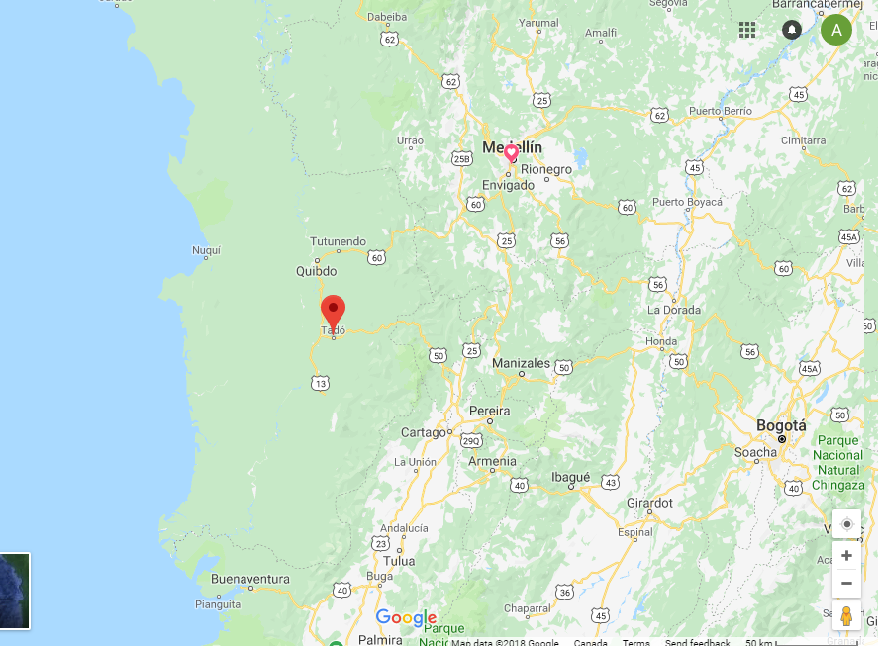
Advantages for sponsorship and partnering with the project:
- Business profit: the organic produce of forestry from the project, including organic fruits, nuts, fodder, fuel, medicine, fibers, bio-chemicals, fur, and feathers, can be sold to your business or organization in regular shipments at a discounted price

- Tax benefits and advantages: Colombian government’s tax benefits for charitable donations, investments in sustainable development, and exemption in income tax for new forest plantations, and the Forest Incentive Certificate (CIF)

- Public acknowledgment, publicity and visibility: this project will attract high publicity and visibility, because it is aligned with:
- 12 of the 17 UN sustainable development goals
- The United Nations’ Secretary General Antonio Guterres and the Intergovernmental Panel on Climate Change’s special report on global warming of October 2018, where reforestation and climate-friendly agriculture are mentioned as 2 of 4 urgent key solutions.

- Corporate social responsibility and sustainability policy: partnering with this project allows your organization to fulfill its corporate responsibility and sustainability requirements, by demonstrating that you:
- Give a percentage of your net profits to reforestation projects in Colombia
- Support reforestation to compensate for the Carbon footprint left by your organization’s operations
- Have a strong sustainability policy and manage and improve social and environmental impacts by complying with sustainability criteria
- Contribute to local development and the preservation of the environment.

Project expected start date: September 2019

PROJECT PROMOTIONAL VIDEO: https://www.youtube.com/watch?v=kEaCJkzPm3k&t=308s

Current project partners:
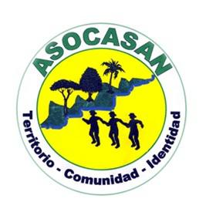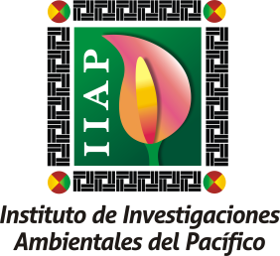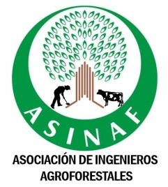
Contact name: Andrei Stoica, SUSTINERE Inc. info@sustinere-global.com

no poverty, zero hunger, good health and wellbeing, gender equality, clean water and sanitation, decent work and economic growth, reduced inequalities, sustainable cities and communities, responsible consumption and production, climate action, life on land, and partnerships for the goals.

