2019
A Concept Paper by: Liberia Emergency and Disaster Relief Fund (LEADER FUND)
2/18/2019

Integrating Solar Energy, Water and Food
for
Sustainable Community
Development and Resilience
in
Cestos City, Rivercess, Liberia, West Africa

Integrating Solar Energy, Water and Food for Sustainable Community
Development and Resilience

Introduction
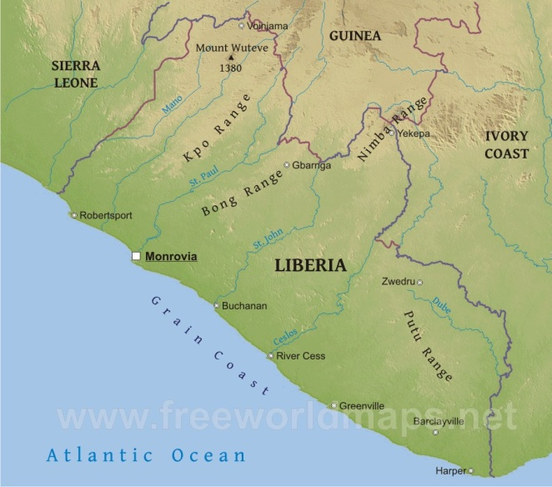
Liberia is endowed with abundant water resources, including rivers, lakes, streams, and access to the Atlantic Ocean. However, political instability due to a 14-year civil war left the country’s water system destroyed. Most Liberians living in cities, towns and villages get their water supply from untreated water wells, creeks and swamps. Cestos City is no exception. According to a report submitted by the Liberian government to the World Health Organization (WHO), only 8% of Liberians have access to piped borne water.

The Liberian government’s Poverty Reduction Strategy (PRS) plan was launched in 2008 and emphasized that access to water would double in four years. Unfortunately, only seven out of the 22 goals laid out in the PRS plan have been accomplished. The successor of the PRS, the Agenda for Transformation, AFT, which was the government’s development plan for 2012 to 2017, committed to “expanded access to healthy and environmentally-friendly water and sanitation services.” The government’s outcome indicator was by 2017, “A major increase in the share of households, institutions and communities, both urban and rural, will have access to improved WASH facilities.” The government did not meet those targets. Most of the hand pumps installed by government for water access do not work effectively to supply clean water required by the population. Recently, the rehabilitation of the water supply system by the state-owned Liberia Water and Sewer Corporation (LWSC) has restored the system to only 25% of its pre-war capacity of 16 million gallons of water per day in Monrovia, the capital and most densely populated city in Liberia. Outside of Monrovia, there is no potable water system.

Consequently, water and sanitation remain a daunting and critical health issue for the majority of Liberians, especially in the rural sector. A study carried out by the Water and Sanitation Program (WSP) in March 2012 reported that 1.2 million Liberians use unsanitary latrines and 1.7 million have no latrines and defecate in the open. The same report stated that 1,800 children under the age of five die each year from diarrhea and 90% of those deaths are directly attributed to poor water, sanitation and hygiene (WASH). The statistics have not improved since that report. Some even argue that WASH statistics have worsened since Liberia was hit by the Ebola Virus Disease (EVD).

The problem of poor water access in Liberia worsens during the dry season (October to March) because the creeks and tributaries where water is accessed dry up. This causes Liberians who live in remote rural areas to walk miles from one town to another in search of water. The water in these places is usually from untreated sources, which leads to health problems, mainly cholera and diarrhea. Infection rates from water-borne diseases, malaria and other environment-related diseases have continued to negatively impact the population.

Liberia needs urgent help from the national, county, district, and municipal levels. The task is so monumental but has to start from somewhere. Liberia Emergency and Disaster Relief Fund believes that implementing a solar energy groundwater access system in a rural area with some urban sprinkling that has a reasonable population will provide a success model that can be emulated and replicated across the country. Rivercess County, only 132 miles from Monrovia is a prime demonstration site for such a development model that integrates the nexus of solar energy, water, and food for sustainable community development and resilience. The LEADER FUND proposes implementation of a Green Systems that uses solar energy to access and distribute ground and rain harvested water for drinking, sanitation and hygiene and distribute water for organically grown field crops. Green Systems are designed to create jobs and small business in urban, peri-urban, and rural communities. This solution brings a holistic approach to solving the crippling problems of unclean water, no sanitation, no electricity, and food insufficiency. A successful implelemntation could be the beginning of a better Liberia for all Liberians.

Rivercess County is desolate and desperate for assistance and intervention. The people in Rivercess County are underserved and are suffering. There are urgent needs for changes in the Infrastructure (roads & transportation), Education system, Healthcare system, the Economic environment, and the Law & Order / Judiciary sectors. Over the last several years, no major development activity has been implemented from the Rivercess County Development Fund or its Social Development Fund. The County Development Agenda (CDA) that was created in 2008 for the duration of five years as an underpinning to the Liberian Government’s Poverty Reduction Strategy, became “just another document to be placed on the shelf.” This stands in total opposition to the caution of prominent Rivercessan, Dr. Toga McIntosh, who was Minister of Planning and Economic Affairs when the County Development Agenda and the Poverty Reduction Strategy were being developed in 2006. Back then, he said: “While this process represents an essential ﬁrst step, the CDA is meaningless if it is not backed with concerted action. This is not just another document to be placed on the shelf; it must be seen as a living framework for accomplishing our people’s plan for accelerated growth and social development on a sustained basis.” Unfortunately, the CDA turned into another document to be placed on the shelves just like most other policy and agenda documents in underdeveloped countries.

In essence, beyond the first step of developing a CDA which has been collecting dust for thirteen years, development has escaped Rivercess, similar to how it has escaped Liberia as a whole. This proposal focuses on implementing a holistic development project that integrates solar energy, water, and food to empower a community in Cestos City, Rivercess County to seek community development and be more resilient.

Solar Energy Groundwater Access System
The solar energy groundwater access system provides energy to access clean potable ground water during the dry season and harvested rain water during the wet season for storage and distribution in cisterns for drinking, sanitation and food production. The solar enrgy will also be harnessed for use by the County Service Center and a soon to be built Internet Café. .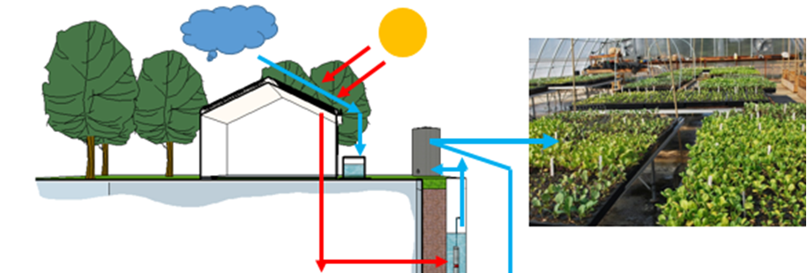
The stored water pumped will be treated with an ultra-violet filtration system for hygiene and sanitation in a public sanitation house (PUSH). The solar panels will provide adequate electricity for community activities and can be expanded to provide electricity for communities.

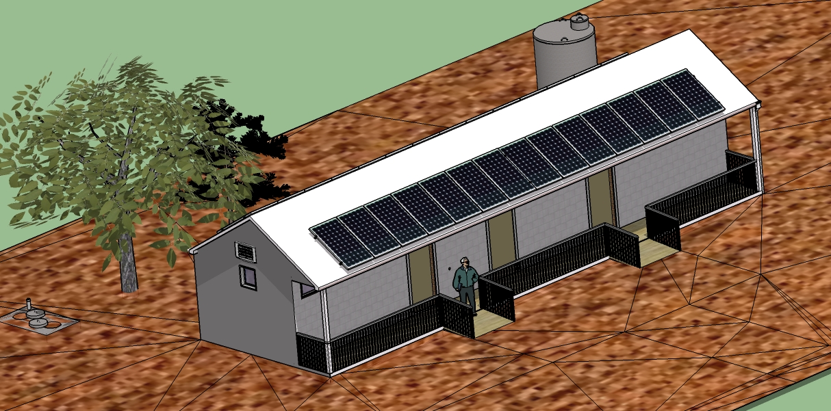
The PUSH will be partitioned into a male and female section with an electrical storage room and a janitorial supply room. The female restroom will include 9 commodes and 4 hand washing sinks while the male restroom will have 6 commodes, 3 urinals and 4 hand washing sinks.
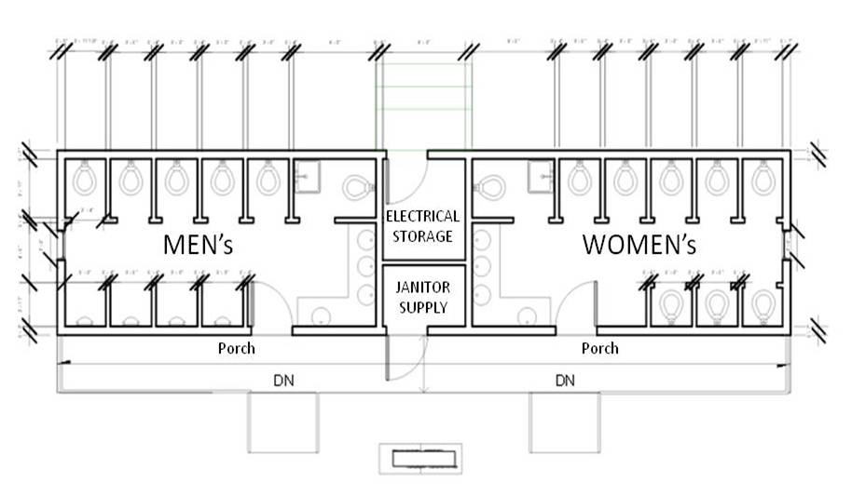
The roof of the PUSH will host solar panels to generate a minimum of 3KW (based on funding, this can be expanded to provide energy for entire communities) of energy to distribute ground water to the storage cisterns and energy required to distribute potable water to the PUSH as well as a community of 2,000 households or 10,000 residents for drinking, hygiene and sanitation. The system can eventually be scaled up or replicated for decentralization to serve more households in larger rural communities or urban centers. Solid waste collected from these PUSH in septic tanks will be collected and processed into energy and soil enhancement for food production.
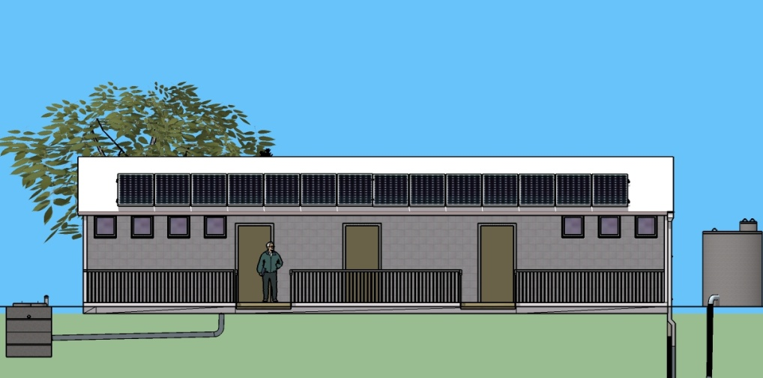

Objective
The objective of this effort is to build a solar energy powered potable ground water supply system for WASH, electricity for the community use, and water for irrigation. This system will:
- Provide access to water for drinking, hygiene and sanitation;
- Electricity for the community;
- Water for irrigation; and
- The collected solid wastes from the PUSH will be used for energy production;

The project involves the following tasks:

- Drill and sample to:
  - Determine soil strata and water quality;
  - Determine well depth, screen slot etc.; and
  - Collect soil samples at 5FT intervals.
- Installation of 6-inch Diameter Well;
- Pump tests and Well development to determine yield of aquifer;
- Collect Ground Water samples for lab testing;
- Implementation of solar panels and batteries
- Installation of 4-inch Diameter SOLAR PUMP in the Well;
- Erection of towers for the cisterns;
- Constructing the public sanitation house;
- Running PVCs and electricity to public facilities; and
- Connecting electricity to community buildings.

Drilling of the bore hole, installation of the pump, construction of the well head, tank and installation of water pipes, and construction of PUSH are tasks best suited to the local small business. They are best suited to the people with local knowledge, whose lives will benefit most from the project and at the same time giving them a sense of project ownership.
The initial technical expertise needed to assemble the solar powered water pump system as well as the commissioning and testing will be provided by the LEADER FUND team. The team will also provide basic training in the maintenance of the system over the short term, but eventually it is envisaged that interested individuals or businesses will be trained to design and install these systems as well.
Training of the local community on the care and maintenance of the system will be a major part of the handover phase. Water hygiene, testing and purification techniques, solar panel maintenance and care are value added information topics that can be easily conveyed in lectures/discussions, slide shows or literature format, the acceptance of which can be used as a measure of the project’s impact, acceptance and sustainability. It is expected that this system will supply water to a community of 10,000 people at a rate of 5 gallons of water per day per person.

Operation
Effective operation of the well and tank will require a Superintendent on site to handle daily security and operations. Duties of superintendent will include:
- Secure area around well head and tank.
- Ensure water flow during daylight hours.
- Ensure tank is being filled.
- Be vigilant in looking for obvious signs of damage or leaks.
- Alert maintenance team whenever water is not flowing during daylight hours.
- Protect key components from vandalism.
A responsible local can easily assume this role and he or she should be supported by a team that will carry out basic preventative maintenance functions. It is also conceivable that this may present a business opportunity for a local to provide the necessary logistics for operation, repair and maintenance.
Cost (labor included)
1. Clear Land | $500
2. Solar System Accessories (includes batteries, charge controller, inverters, wiring, brackets/support, shipping and labor) | $3,000
3. 1,000 Gallon Water Storage & Distribution System | $8,300
4. Drilling the well and conducting pump test | $8,000
5. Public Sanitation House | $6,000
6. Solar Electircal Connection | $6,200
7. Plumbing Connection | $3,500
Sub-total | $35,500
8. Miscellaneous - 5% | $1,775
9. Shipping & Duty | $3,500
10. Local Transportation | $6,500
11. Project Management - 15% | $12,416
Total | $59,691

Conclusion
According to the Water Poverty Index, strongly correlated to the Human development index, the longer it takes to access clean water, the poorer you are. Water is a fundamental human right and though hand pumps have been effective in immediate water access, this solar water access system sustainably utilizes renewable natural resources (solar energy and groundwater) in an integrated process to readily provide and distribute clean water for drinking, hygiene, sanitation; electricity for community residents, and also for food production. It allows a community of 10,000 to be sustained with clean potable water for twenty years, so long as the aquifer contains water and is recharged with harvested precipitation.

