Boost Women’s Livelihood Collectives for Equality

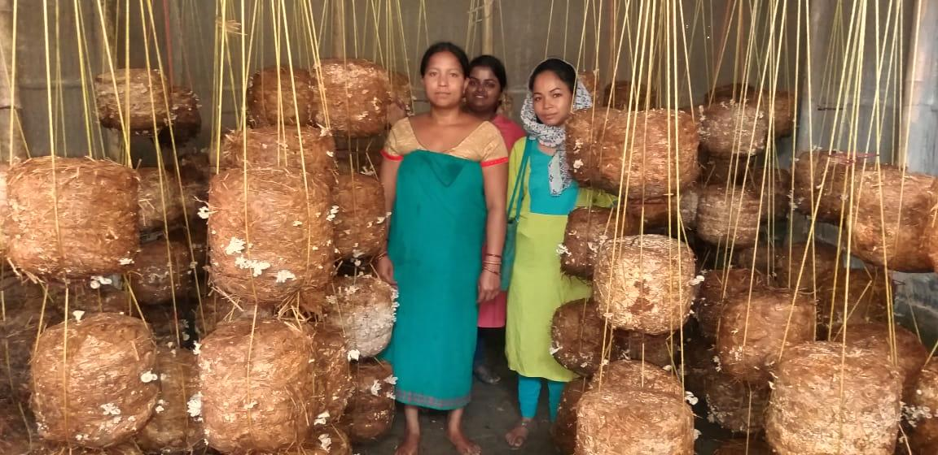
The project planned to assist 200 women mushroom growers in six villages in Assam’s one of the frontier districts along the Indo-Bhutan border. So far FST has helped in developing the skill in mushroom cultivation among the women who are already in Self Help groups (SHGs). The women showed their interest as they considered that the production would be an additional income to their marginal farmer families living in a remote part of the state.
Facilitating the women in livelihood activities was FST’s strategy to collectivise them in organisations at the village level. FST believes that this would help the women to analyse their situation and take up steps to create a conducive environment where everybody can access rights. Since nearly all of them are members of SHGs, they already have the idea of group and working in a team. However, the space provided to them by the SHGs is restricted within saving, loaning and repaying. A lot of social issues are thus left ignored which could as well be addressed by this united strength of the women. For this reason FST focussed in this project on facilitating the mushroom grower women in forming village level organisations, which would generate their solidarity beyond SHGs. The SHGSs will continue to exist within these organisations. So far the initial works of the organisation building have been taken up by the women in four of the six project villages.
Works done so far:
- 1600 packets of mushroom spawn were distributed among the women
- Women mushroom growers have produced 172 kg.s of mushroom
- The production has brought them a profit of INR 17200 as a whole
- They have conducted meetings, discussed local issues, especially women’s situation
- In one of the villages the women have called on the local self governance head and discussed about Government entitlements.

