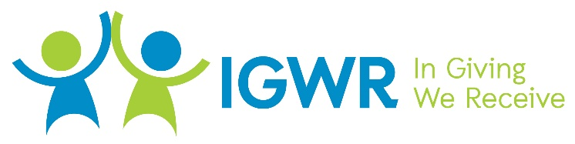
Project report 1
Report 11 for GlobalGiving
https://www.globalgiving.org/projects/after-school-support-to-30-needy-kids-in-nepal/

A New Year begins.

As I write this brief report on New Year’s Eve, I’m sure I’m not alone in wondering just what 2022 will be like.
Before we look ahead, a brief thank-you from Raja in Nepal summarises what we’ve done together in 2021, and that’s well worth celebrating.

“We at IGWR Nepal are lucky having you and your full support even this hard time. With your help we were able achieve our goals and we were able to help others in this difficult time.

With your help in 2021 we were able to complete following things:
- We fed and housed 26 kids and staff.
- We supported several families with food and financial help.
- We are providing educational support to 55 kids
- We successfully started a ‘special needs’ foster family home.
- We looked after 8 single mothers.
- We painted our houses.
- We bought new beddings, utensils, etc.”

We were able to achieve so much in 2021, especially considering the challenges of Covid in Nepal, and so we look ahead to 2022 with Hope, Optimism and empowered by the reality that together, even in difficult times, we can make a difference.

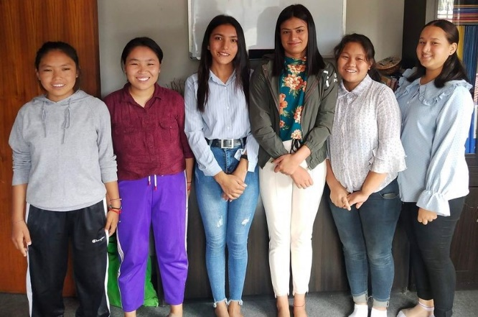
2022, what will be different?

The changing of years reminds us that the world is always changing; and perhaps we are slowly learning from the challenges we face.

“As global health leaders have repeated ad nauseum during the pandemic, no-one is safe until everyone is safe. Helping vaccinate the world is therefore a matter of national self-interest. Yet less than 3 per cent of people in low-income countries have to date received at least one Covid-19 vaccine dose.”
https://www.lowyinstitute.org/the-interpreter/assessing-australias-role-global-vaccine-equity

We are learning that “In Giving We Receive”, our own well being very much depends on our sharing what we have to ensure the well-being of others.

Our GlobalGiving supporters have already discovered this reality, and as we look to 2022, we might well expect our generosity to ‘infect’ others and so increase the possibility of bringing light and life to those who live in the shadows of poverty.

Project report 2
Report 11 for GlobalGiving
https://www.globalgiving.org/projects/after-school-support-to-30-needy-kids-in-nepal/

Our plans for the New Year.

Our budget tells the story of our commitments for the year ahead; we will make some adjustments early in 2022 when we have secured college places for some of the senior students and we’re also aware that circumstances in Nepal have created some inflationary price pressures, so the task ahead is very much a challenge for all of us.

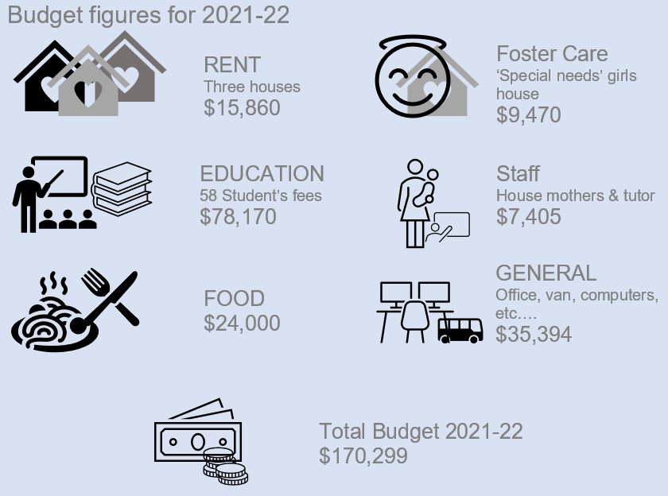

Thank you for so much.....

Our Budget, Our plans and the Future for the children in Nepal are a reality that is very much the fruit of your generosity. We continue to be inspired, and each gift is a very real YES! that we can make a difference.
My personal plan for 2022; is to give the kids in Nepal the opportunity that my own grandkids already have.
We know that we ourselves are changed by what we give....
So, thank you for sharing in making the world a better place for all.

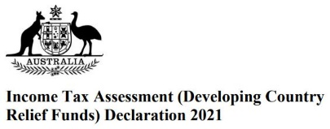
After an exhaustive two-year validation process, we have been acknowledged and all donations (from Australia) will now be given Tax Deductible receipts. It is also a recognition of IGWR-Nepal's reputation and performance; we do make a real difference in people's lives and we do it as a best practice organisation.
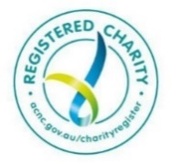
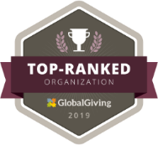
More information is available on our website:
https://www.igwr-nepal.com/

And there are regular pictures on our Facebook page:
https://www.facebook.com/IGWRNepal

