**Learning Squared Liberia PROJECT Report:** **Revolving Loan Support Rural Women in Liberia (38278).**

**DATE: May 27, 2020**

**LOCATION: MONROVIA, LIBERIA**

**Prepared By:** LSL-Liberia   
Phone: +231(0)886828014

+231(0)776828014  
Email: info@learningsquaredlib.org  
Website: [learningsquaredliberia.org](http://www.ida-lib.org)

**INTRODUCTION:** This report covers activities implemented under the Project mentioned above. Covering the months under review (**February 2020 –May 2020**). This Project seeks to address some economic issues faced by single mothers and other venerable women in two communities in Margibi County, Liberia. It also trained and supported rural female family heads of households, in providing additional income-generating opportunities. This report also reflects interruption by the CONVID-19 pandemic as 90% of women who had received loans, are constraints to use the fund for hardship.

**2.0 PLANNED ACTIVITIES FOR THE PERIOD UNDER REVIEW:**

2.1 Interruptions on payment on loan due to COVID-A9

2.2 CONVID 19 awareness with the women's group

**ACHIEVEMENTS FOR THE PERIOD UNDER REVIE**

**2.1 Interruptions on payment on loan due to COVID-A9**

Giving Liberia a struggling economy amid the COVID-19. Learning Squared Liberia has witnessed and or experienced a huge set back in implementing the small business loans program for single and venerable mothers in the project area.

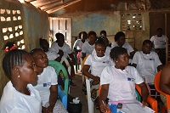A total of 30 women in two communities received over two thousand dollars ($2,000.00USD) as a start-up kit to mothers to empower and improved their income-generating activities. This program helps develop entrepreneurial skills, resilience, and families' ability to be self- sufficient.

Our beneficiaries signed an agreement on the payment terms, as low as $500.00LD (Liberian Dollars), which is (USD 3.50) weekly. That is paid into the organization's mobile money account by the chairlady of the group. Learning Squared Liberia has established a mobile money account with both GSMs in Liberia for collecting its loan payment. A recent mobile conference call meeting with our beneficiaries has shown an enormous challenge. Our beneficiaries raised the numerous concerns about the payment of the loan due to the COVID-19 pandemic. Most of the women complained that they had used the loan to provide food for their household as regular businesses were not permitted by Liberia's government because of fear of the spread of the virus while doing business. Learning Squared Liberia as a humanitarian organization could not demand the women's payment by looking at the situation in the country and worldwide.

This Project has beenable to impart over 1500 indirect beneficiaries and 30 women as direct beneficiaries. It is with a sense of humanity and compassion that Learning Squared Liberia and its partner are thankful that rural communities have collectively benefited from the organization program. Strategies are put in place to review the program after the activities are normalized.

**2.2 CONVID 19 awareness with the women's group**

Learning Squared and its partners have reached out to community members about the safety and protection of their families and communities during these difficult times. Radio messages and text messages sent regularly out to create awareness about the pandemic. Informing the community how to stay safe.

**Constraints:** The team's main challenge was the restrictions on movement and follow up field visits to monitor or collect data due to the CONVID 19 outbreak in Liberia. And the many challenges on our beneficiaries and the inability to repay the loan due to the COVID-19,

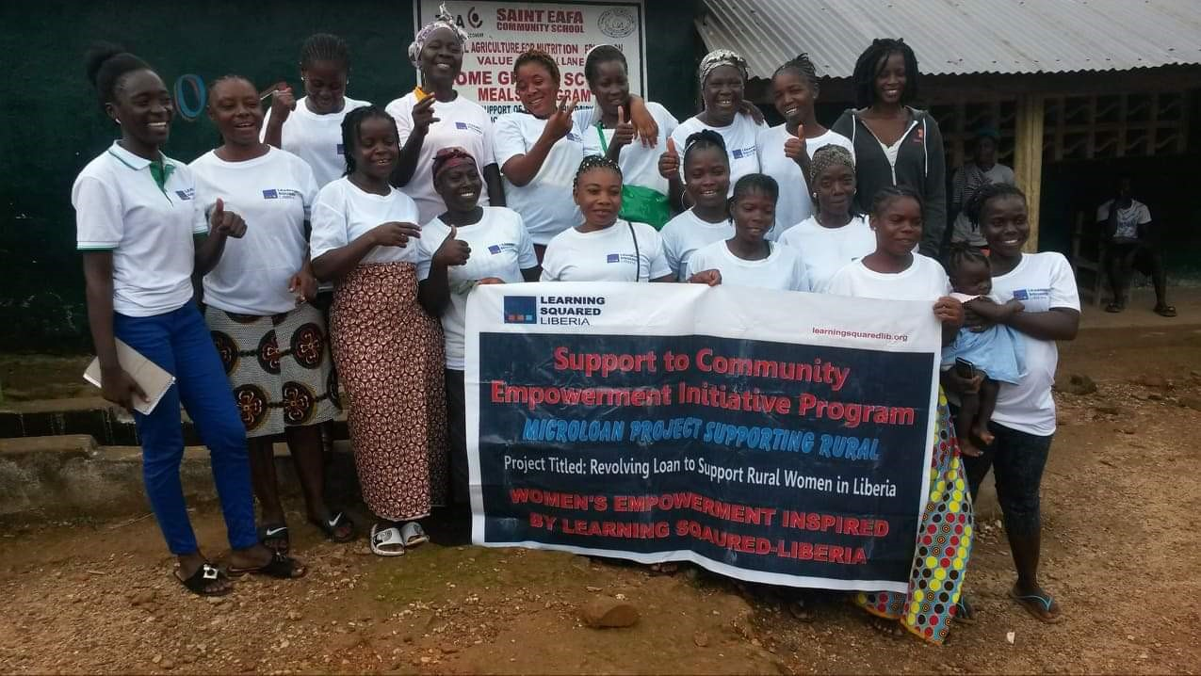**5.0 Recommendations/conclusion:** Thanks, and appreciation to our supporters, donors, Global Giving, local communities, and schools for the level of commitment shown towards the successful implementation of the Project.