Learning Squared Liberia PROJECT Report: Revolving Loan Support Rural Women in Liberia (38278).

DATE: January 29, 2020

LOCATION: MONROVIA, LIBERIA

Prepared By: LSL-Liberia
Phone: +231(0)886828014
+231(0)776828014
Email: info@learningsquaredlib.org
Website: learningsquaredliberia.org

INTRODUCTION:
This report covers recent activities implemented under the above-mentioned Project covering the months under review (November 2019 –January 2020). The project ‘Revolving loan to Support rural Women in Liberia’ begin its pilot phase in Minor Community, Kakata. Margibi County, Liberia. This project which seeks to address some economic issues faced by single mothers in the community will train and support rural female family heads of household including strengthening and providing additional income generating opportunities for them. This report reflect loan payment and monitoring.
2.0 PLANNED ACTIVITIES FOR THE PERIOD UNDER REVIEW:
2.1 Loan payment in Minor Community
2.2Project/ small business monitoring in Kakata
2.4 Women’s Meeting and additional training on small loan management
ACHIEVEMENTS FOR THE PERIOD UNDER REVIEW:
Loan payment: Loan payment in Minor community completed during the period under review, the total of 13 women in minor Community received the amount of $40.00 USD each for the establishment of small business that will empower them to continually keep their children in school. These 13 women are parents of the children that are presently on Learning Squared Liberia scholarship program in Margibi County. The total of $520.00 USD was given to these 13 rural women as a way of empowerment and a long term project for the advancement of their children’s education in the community. This amount will be paid back within the period of six months to the organization which will provide space and funding for additional women in the community to join the project.
The next phase payment will begin with women from the palm bush community also in Kakata city. These women are also single mothers of children on the scholarship program in the community. These women will also receive the amount of $40.00 each to start a small business or farm that will enable them provide school fees and uniform for their children at the end of the project. The total of 30 women are expected to benefit from this project from the two listed communities below:
- Minor community, Kakata, Margibi Country, Liberia
- Palm Bush community , Kakata, Margibi County, Liberia

Project/ Small Business Monitoring: Learning Squared Liberia begin its monitoring on small businesses established by women from Minor Community in Kakata. Upon receipt of the first loan payment, beneficiaries begin the process of establishing a small business in the community. These women begin a small table market with rice, oil, and other cooking items in the community. Other women went back to the soil with the planting of cassava, eddoes & potatoes which will be ready for harvest in three months. During the monitoring process, the team also monitor and encourage women to save daily that will enable them to purchase new goods and payback the loan on the giving time.
Women’s Meeting and training: During the period under review women from both palm and minor communities attended a one day join meeting and training section in Kakata city, Margibi County. These women were able to bring out issues faced by the first group of women who receive their loan payment. The progress made and challenges were discuss with total of 27 women in attendance including three counties authorities and the program team from Learning Squared Liberia. This training which lasted for three hours provided women with additional information as regards to the project and it implementation. Other women who have begun engaging the soul express happiness for the loan project and said that it is a good way to begin their life again after a long time without business and products on the farms to plant and harvest.
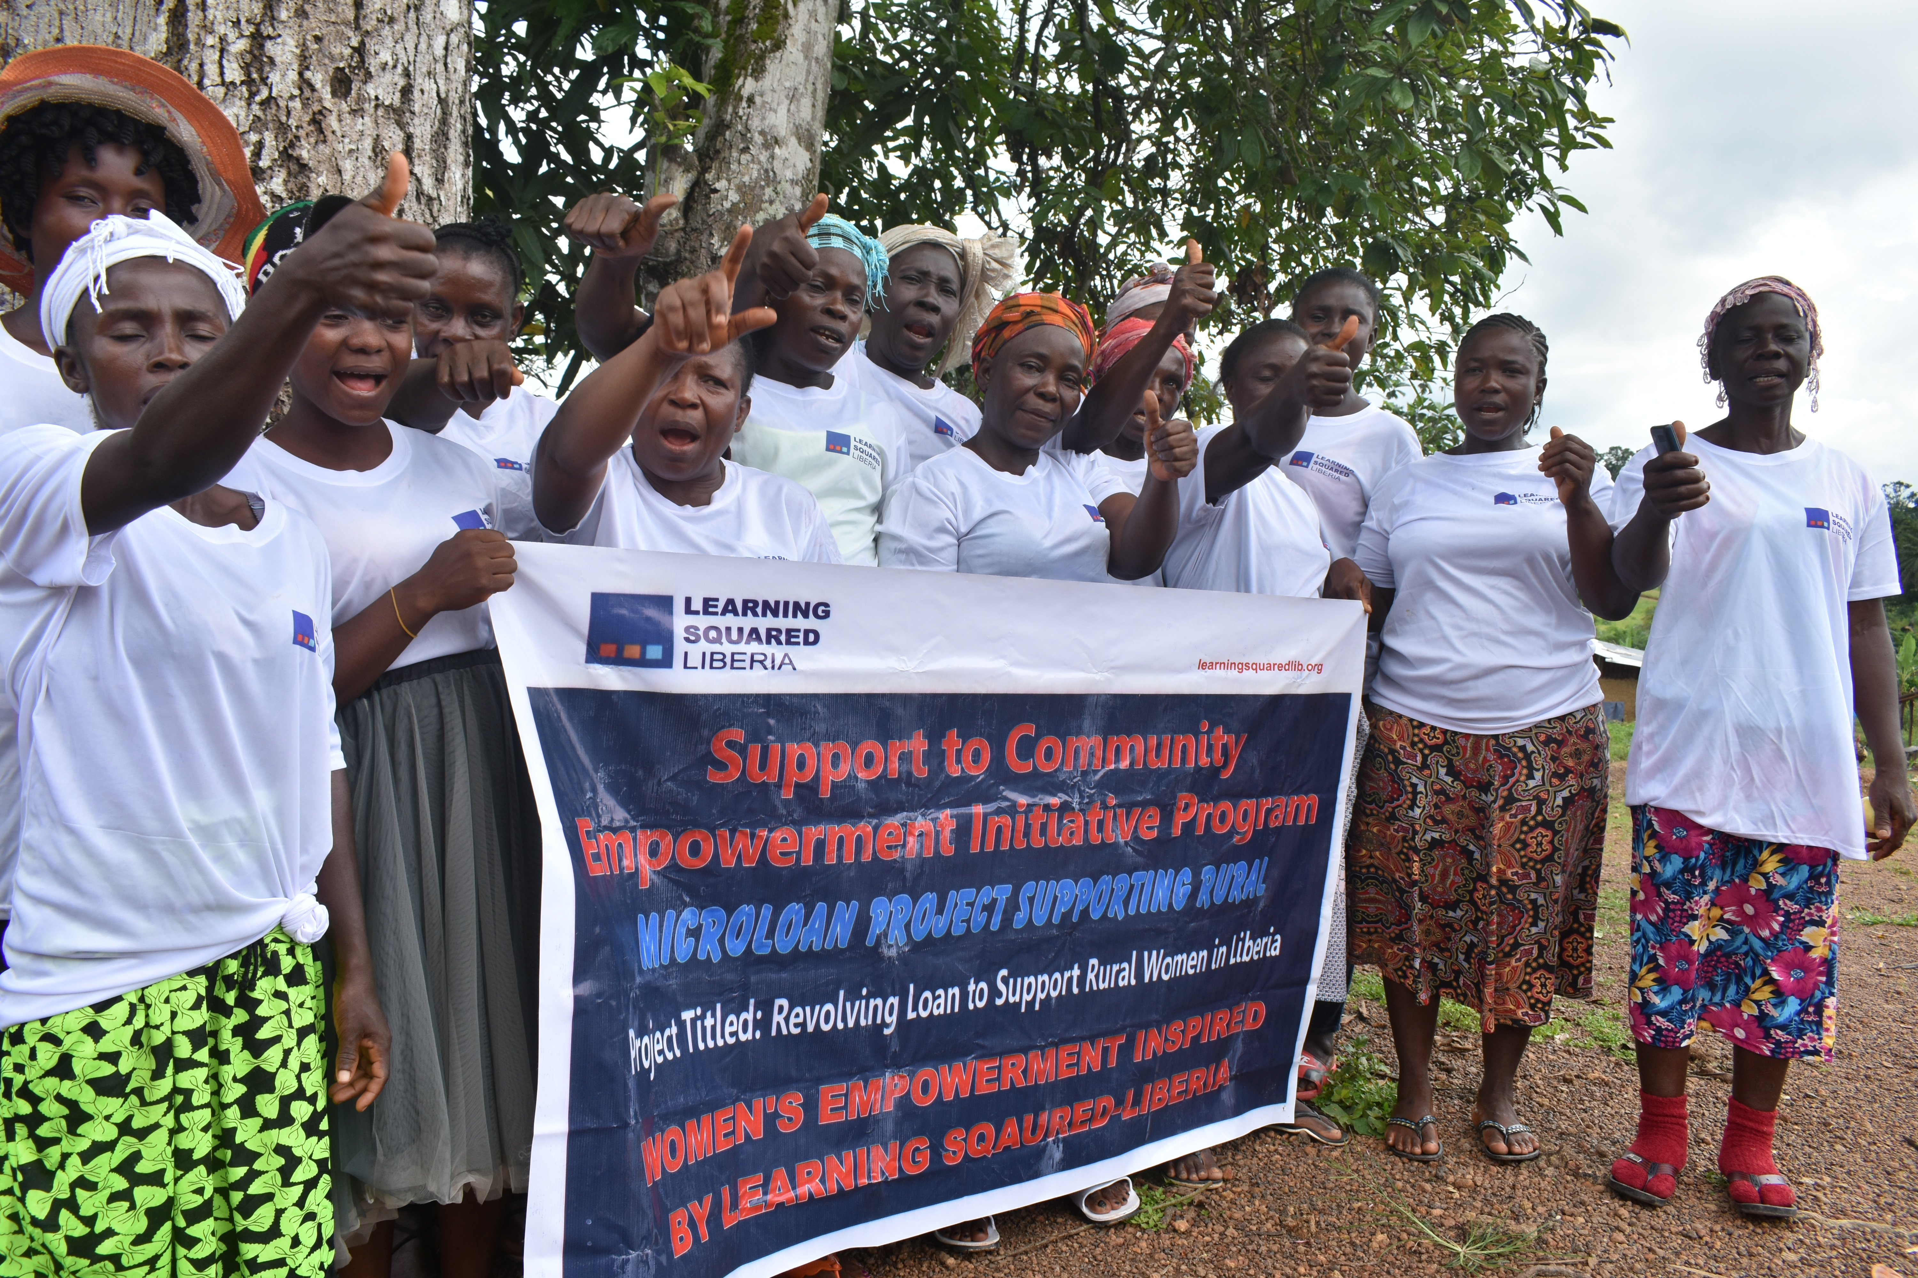

4.0 Constraints:
There were few challenges that the project team encounter during the period under review, the lack of vehicle for the official use of the organization is leaving program staff to travel through public transport vehicle/motorbike which most times delay before reaching the project site.
Also, the high demand for the implementation of the project in other communities is also a high challenge where other women that were not selected for the project is requesting to become a part. Lastly, language barrier is also a challenge as women in the community frequently communicate through their native language leaving the team speaking through an interpreter.
5.0 Recommendations / conclusion: Thanks and appreciation to our supporters, donors, Global Giving, local communities and schools for the level of commitment shown towards the successful implementation of the project. Learning Squared Liberia remain open in working with all women in the community and Liberia at large.

