Learning Squared Liberia PROJECT Report: Revolving Loan Support Rural Women in Liberia (38278)

DATE: September 2020

LOCATION: MONROVIA, LIBERIA

Prepared By: Learning Squared -Liberia
Phone: +231(0)886828014
+231(0)777171654
Email: info@learningsquaredlib.org
Website: learningsquaredliberia.org
INTRODUCTION:
This report covers activities implemented during the period under review. (June-September 2020). This project seeks to address some of the economic challenges rural women face by providing an opportunity through our social microfinance program to increase rural women's income-generating activities. The program provides women with a revolving loan to generate income to provide for their families. This report reflects activities including assessing the impact of COVID-19 on the revolving loan program, next phase of intervention for our participants
2.0 PLANNED ACTIVITIES FOR THE PERIOD UNDER REVIEW:
2.1 Assessment of the impact of COVID-19 on the revolving loan program
2.2 Next step of the project
2.4 Recommendation, constraints, and conclusion

ACHIEVEMENTS FOR THE PERIOD UNDER REVIEW:
- Assessment of the impact of COVID-19 on the revolving loan program
Learning Squared Liberia conducted a five-day field assessment of the social microfinance project in Margibi County in August 2020. The assessment aimed to determine the level of achievements, impact, and analyze the current situation caused by COVID-19. Participants and program staff reviewed the project to determine the relevance and level of achievement and recommendations for the next phase. The project's review session brought together over 40 participants, including community, youth, and women leaders.
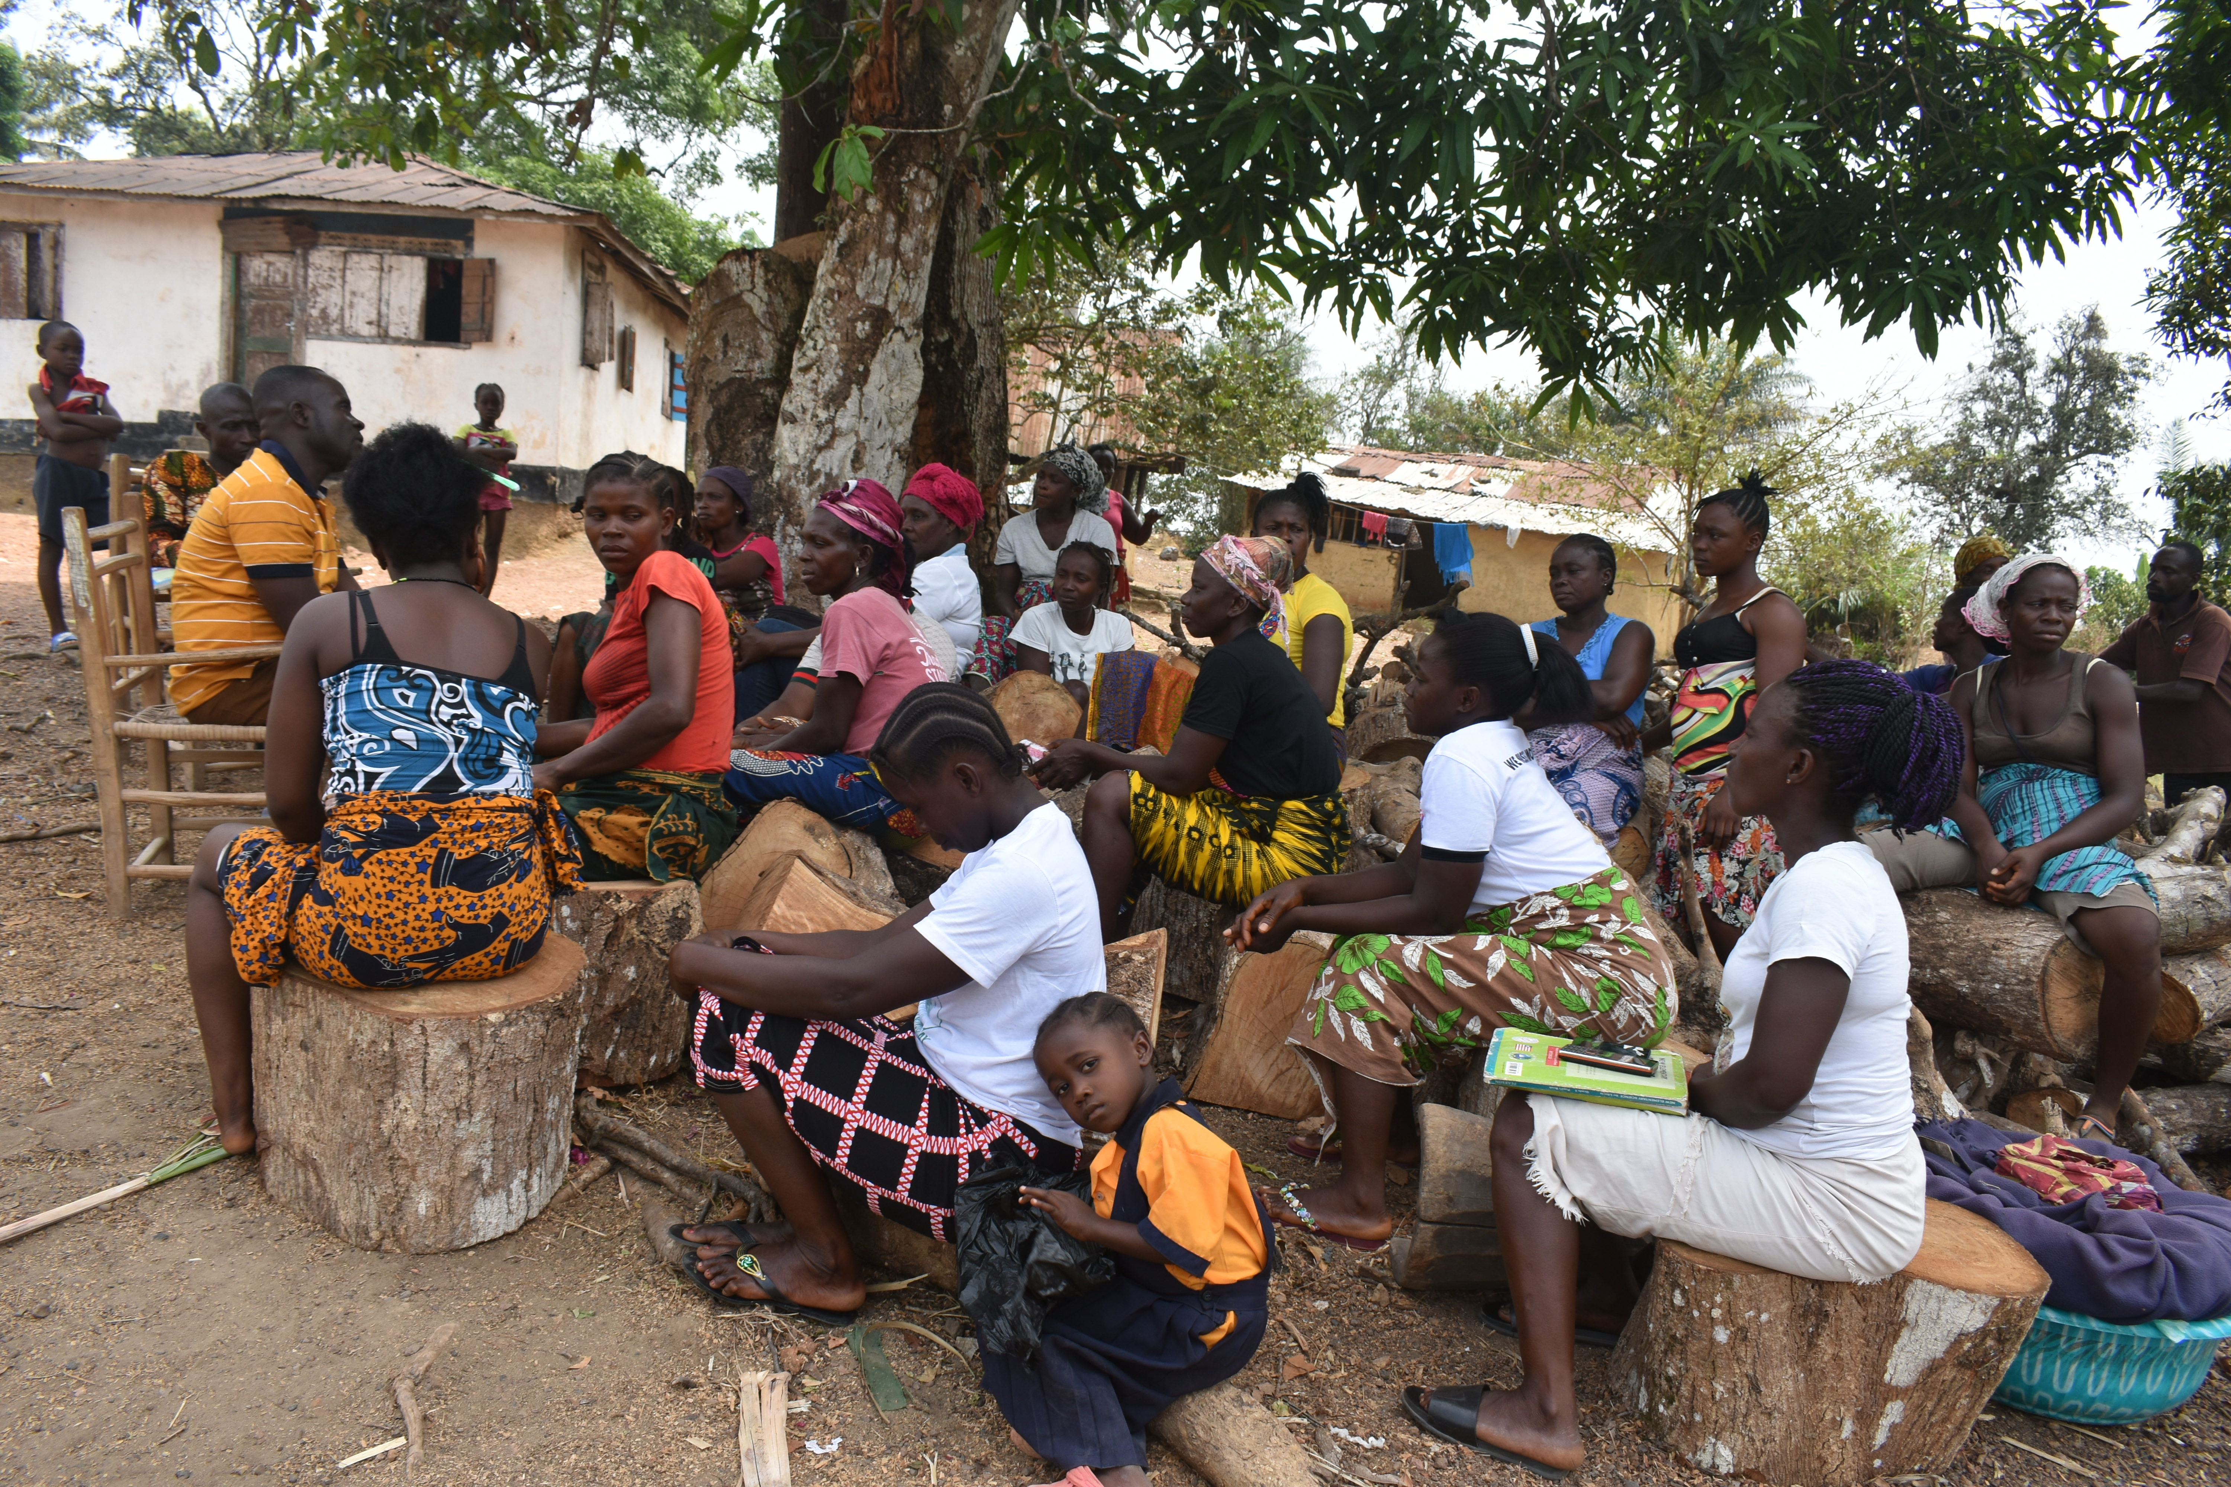
During the field assessment visit, questionnaires were distributed to participants to review the project's success and challenges. To also identify the impact of the project, especially before and during the outbreak of the pandemic. The questionnaires were to explain better how the project helped women generate incomes for their families' upkeep and contribute to their children's education.
Our survey report showed 80% of women were satisfied with the project's management and success and that it was beneficial to them. It provided an opportunity to get their children back in school and start their small businesses. 7% of the participant has relocated to other communities. 13% had commenced loan payment before the pandemic outbreak and are now serving as ambassadors of the project. Making a short remark at the review process. The head of the group, Yamah lauded the organization's efforts to provide the training. Women can now boost of skills to run their small businesses and save to send their children to school.

Participants recommended establishing a literacy and numeracy programs and trade school to provide women the options to venture into other businesses. Yamah also recommended on behalf of the group that participants were in urgent needs of personal preventive equipment and supplies.
2.0 Next Step forward:
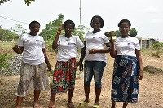
Due to the outbreak of the COVID- 19 in Liberia, and government restrictions on movement. As a way of keeping citizens safe. Beneficiaries could not undertake any form of a business transaction. Women were unable to pay back the revolving loan, and due to financial hardship, they had to use the loan money given them to survive during the COVD-19 period. As noted in our review process, beneficiaries have become more vulnerable in their communities since the outbreak pandemic.
As a way of trying to solve the current challenges faced by the beneficiaries, the following recommendations were put forward to Learning Squared:
- Continue the project in the pilot communities
- Conduct refresher training for participants
- Hold a community meeting with all members of the group and explain the new process and payment plan.
- Extend the program to other rural women
- Replaced participants who relocated

3.0 Constraints:
There were some constraints and challenges during the period under review. The stay home restriction by the government to respond to the spread of COVID 19 in rural Liberia. Several calls for humanitarian relief to families, lack of PPE, and health supplies in rural communities. Women are unable to make school fees payment for their children due to hardship. Most women depend on hand out to take care of their daily needs, including food.

Recommendations / conclusion:
Thanks to GlobalGiving and other partners for the continued support. Thanks to the community leaders, teachers, and volunteers. Including students and parents, for the level of commitment shown towards the fight against COVID 19. Learning Squared will continue to be reached out o our partners to provide opportunities for women in rural Liberia

