Global Giving September 2020 Narrative Report
From April 2020 to August 2020, different activities were done: trauma healing workshops, Self-help groups (SHGs), Street Business School and rice harvest.
- Trauma Healing Workshops
one three-day trauma healing workshop was done per month. Therefore five workshops were done. Facilitators were Grace Horanimana and Gisele Misago.
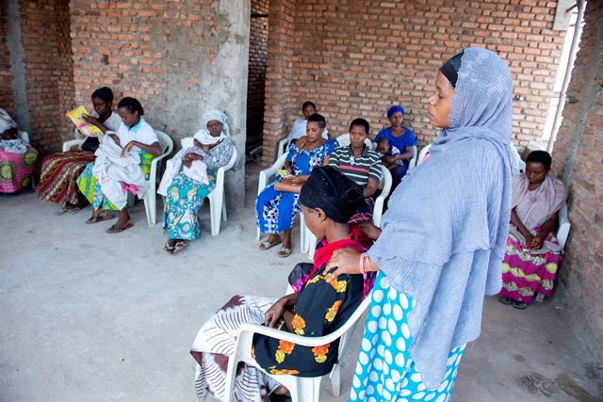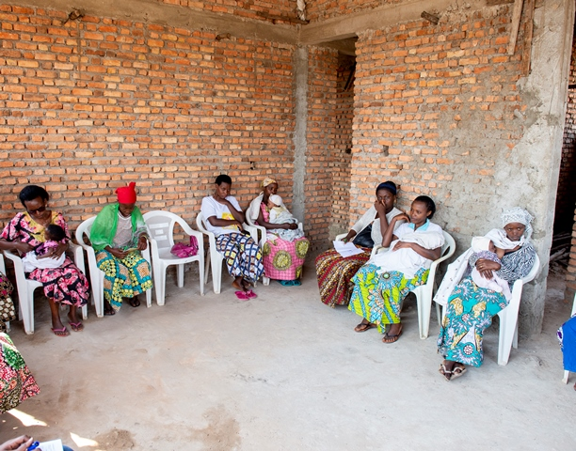

“I am Tutsi and I got married by a Hutu soldier, everything was fine until 2015. The in-laws family told my husband that he got married in an evil ethnic group. He started to beat me and tell me that if I don't leave his house he will kill me. He tried many times to kill me; he even hired people to kill me because he was in the crisis period; he thought he can kill me without any follow up in justice. I spend 6 months without sleeping at night because armed men were spending the night around my house. He saw that I don't want to leave him and he revealed to me that he had children with my 3 little sisters; This really destroyed me because all my hope was in my family.
The last evil he did to me was to come and take my 3 children and everything I had in the house; I cried for help in the road like a crazy person no one dared to help me because he had a gun. To punish me very well he left the army so that I cannot call upon army justice. Now I live at a friend I don't know where my children are, I can't appeal to justice because I'm afraid that he could kill me I have a big wound in my heart.”
“When I married a man he loved me but he betrayed me afterwards. I had 12 goats when I was a girl and I took them to my husband's house when I got married. These goats were the basis of blessing in our house; my husband sold them and created a business that was really successful. When he became rich he started mistreating me; he cheated on me with other women, he used to come back home late midnight and forced me to wake up and to prepare for him something to eat; he forced me to kneel down and begged forgiveness while I did nothing wrong for him. He used to beat me Wednesday, Friday and Sunday (market day) he beat me in the head and until now I have problems in the head. When he beat me he naked me and I was afraid to cry out; one thing I was doing, it's to start fighting to look for the cloth to cover myself and then I scream. Even if I was pregnant he beat me on my womb. When it rained he beat me in the rain naked; it hurt so much. He often told me that he would kill me and two knives were always under the bed. One day I heard on the radio a man who cut off his wife's arms and I started to be afraid. I decided to leave him and come to Bujumbura to be a nanny. I had some money and I started a business and I was able to bring my two children. Now I’m living safely together with them”.

- Self-Help Groups

At the end of August 2020, we had a total of 106 SHGs for a total of 2463 women.
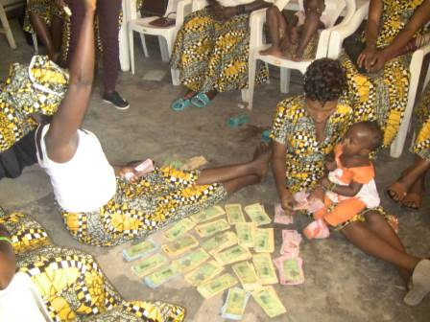

- Street Business School (SBS)
Since the month of March 2020, the second promotion of SBS has started. 40 women have benefited from the training. They are now waiting for the graduation day scheduled in October 2020.
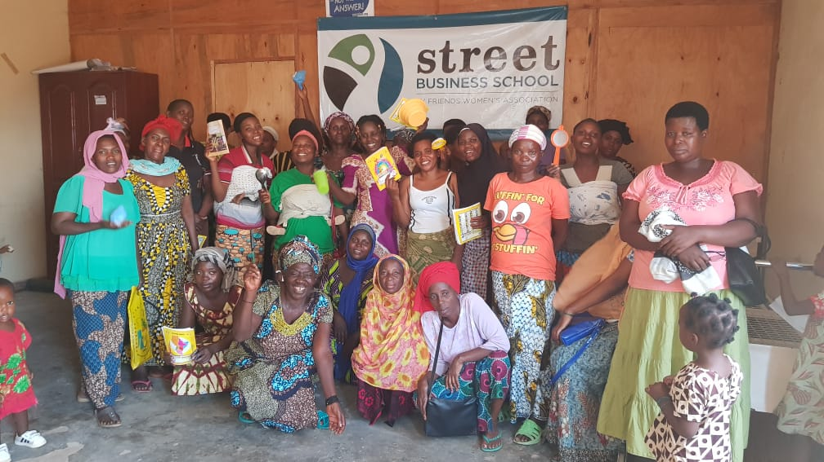
- Rice Harvest
The group of women who has initiated the project of growing rice together has now harvested for the first time. Now, they are waiting for the second season to grow rice again.
