Global Giving May 2025 Narrative Report
From February 2025 to May 2025, different activities were done: trauma healing workshops, Self-help groups (SHGs), income generating activities and the Women’s Socio-Economic Empowerment Center (WSEEC) Project.
- Trauma Healing Workshops
The FWA did three trauma healing workshops for a total of 60 gender-based violence survivors. The first workshop was done in March, the second one in April and the third one in May. All of them were done at in Maramvya in Bujumbura province. Participants were gender-based violence survivors.

Stories
My name is Gloriose. I was married when I was very young. My mother-in-law didn’t understand why I was not giving birth to child. She was so mean to me. She did everything so that my husband sends me back to my parents. My husband used not to give me food. He was saying that it is not important to stay with a woman who cannot give birth to children. After two years, I gave birth to a girl-child. My husband was about to kill me saying that it is a curse to have a baby-girl. I left my home and stayed in my Pastor’s family. Four months later, my husband came to take me again. Then I gave birth to two daughters in succession. My husband beat me to death until I was hospitalized. My husband wanted me to die in the hospital. After a few years, I gave birth to two boys, but nothing changed until my husband swore he would kill me one day. He even hid a knife under our mattress. I went to complain to the elders but without success. They have always been on my husband's side because of corruption. My mother abandoned me after my father's death to go and marry another man. So, she was never interested in my problems. That's why I have nowhere to go. For the moment, it is my three first daughters who protect me when my husband wants to beat me. Thank you very much for this workshop because I have just had an opportunity to share my pain.
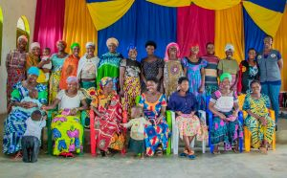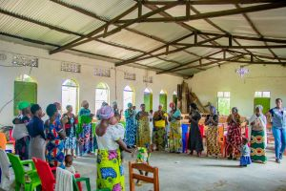
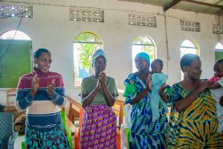
“I married a man with the hope of building a life together. Unfortunately, I was not blessed with children. For the first three years, my husband supported me. But as the fourth year began, everything changed. He became violent physically and emotionally. He beat me and insulted me, saying, “I’m going to find women who can give me children.” Then He left me.
I remained in our home, but his family didn’t want me there. One day, they came to my house in anger, trying to throw me out. I locked the door and called the police. The authorities detained them, but eventually, I pleaded for their release. Despite everything, they still believed they were right to remove me from my home simply because I was unable to have children.
Two years passed. Then my husband came back. He started fighting with me again until I separated. But since I had some financial independence, he had to beg me to come back home. I agreed with one condition: he would never raise a hand to beat me again. Today, he no longer beats me, but the emotional abuse persists. His words still hurt me deeply, and I carry within me the sadness of infertility and emotional trauma abuse.
When you came to teach us, I saw myself in what you shared. It made me realize that I need to manage my stress and begin to heal. I’m grateful for this opportunity to reflect and to find hope again.
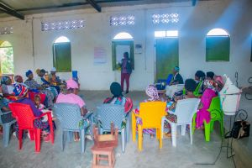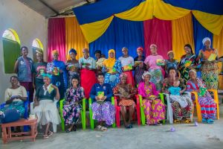

- Self-Help Groups (SHGs)

Self-Help Groups are now working again under the supervision of the FWA. They are now registered according to the new law of the central Bank of Burundi. At the same time, the FWA has encouraged those groups to initiate together small projects for income generating activities. At the end of January 2025, the FWA was supervising 63 Self-help groups.
- SHG Testimony
My name is Francine I live in Kamenge and I am member of: Self-Help Group (SHG).
Before joining the savings group, I was a deeply troubled woman. I had suffered domestic violence that left me feeling worthless and broken. I had lost all self-confidence. I no longer wanted to work and turned to alcohol to escape the pain. I spent a lot of time at the bar, begging for drinks.
Everything began to change when a friend invited me to join the SHG. Through this group and through Street Business School program, I learned valuable life skills, including self-confidence. I began to realize my worth again. At that time, I couldn't even afford clothes or take care of myself. Simple tasks like doing washing were difficult. But today, I'm proud to say I'm a clean and active woman. I can now rent a home on my own, and I know how to set priorities for my life.
I still drink occasionally, but not like I used to. Now, I make sure I meet my basic needs first: food, rent, and other responsibilities come first. My life has meaning and structure.
One of the most memorable moments for me is when, at the end of each year, our group members wear a new uniform. It may look like simple, but for me, it's a symbol of dignity and belonging. When I wear it, I feel proud and confident. It reminds me of how far I've come.
Joining the SHG has truly changed my life. I have confidence in myself again.
- Income Generating Activities
In April, a financial contribution was provided to a group of women who had benefited from trauma healing training in the past months. Following this training, the group organized themselves and initiated a rice cultivation project. They have already contributed 900,000 BIF of their own resources to support this initiative.
To strengthen their efforts, FWA provided an additional donation of 1,500,000 BIF. This support aimed to encourage their self-reliance and commitment to agricultural development.
The women warmly welcomed the support and expressed their appreciation for FWA’s continued accompaniment. They also raised concerns about the increasing costs of rice production, particularly the rising prices of field rentals. In light of these challenges, they requested ongoing support to ensure a successful and sustainable harvest.
- Women’s Socio-Economic Empowerment Center (WSEEC)
The Women’s Socio-Economic Empowement Center (WSEEC) is a new project that the FWA has started in the month of Jul 2024 under the support of the African Great Lakes Initiative (AGLI) of the Friends Peace Teams) and the Canadian Friends Service Committee. The aim is to avail training rooms and a temporary safe shelter for gender-based violence survivors at the FWA headquarters. This project will cost $200,000. We have so far mobilized $56,600 including $21,600 from The African Great Lakes Initiative of the Friends Peace Teams, $10,000 from the Canadian Friends Service Committee (CFSC) and $25,000 from the Segal Family Foundation (SFF).
PICTURE IN FEBRUARY 2025
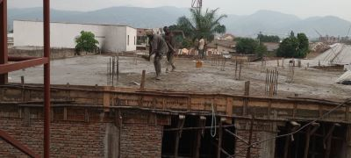

MARCH 2025
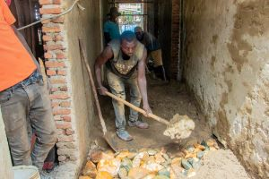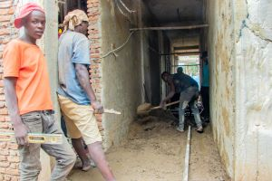
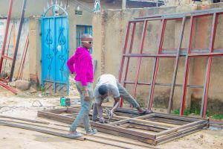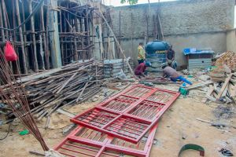
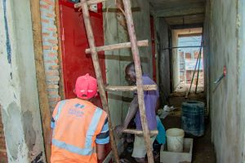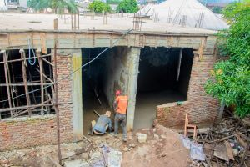
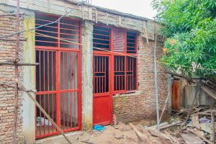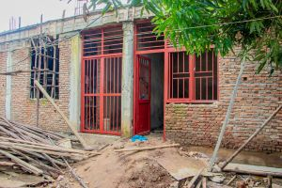

APRIL 2025
In the month of April, before continuing the construction upwards, under the support of AGLI of the FPT, we began to fit out three offices on the ground floor for our multi-story building. Now three offices are ready on the ground floor.
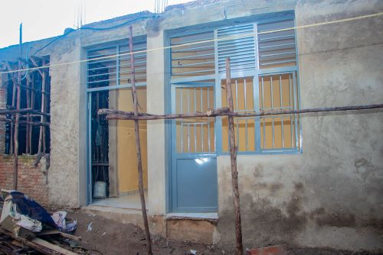
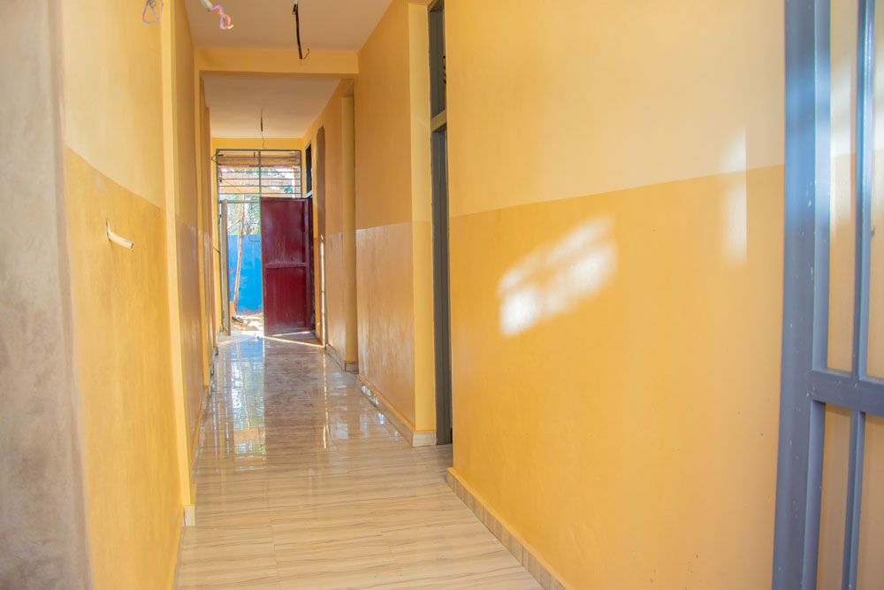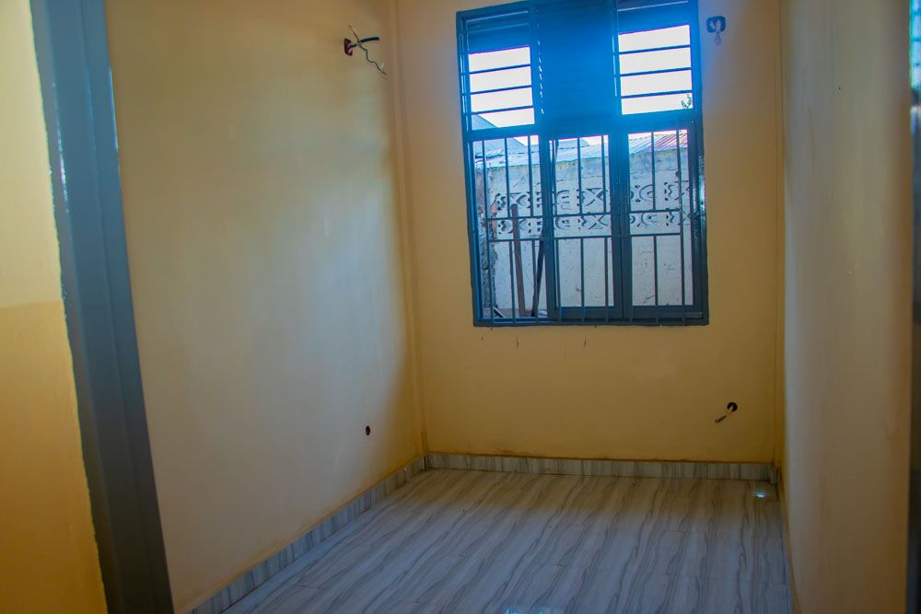
Three offices ready at the Women’s Socio--Economic Empowerment Center

