Global Giving May 2021 Narrative Report
From January 2021 to April 2021, different activities were done: trauma healing workshops, Self-help groups (SHGs), and the Growing Rice Project (GRP)
- Trauma Healing Workshops
The first three-day trauma healing workshop was done on January 27-29, 2021. The second was done on February 22-24, 2021, the third on March 16-18, 2021 and the fourth on April 26-28, 2021. Therefore four workshops were done. Facilitators were Grace Horanimana and Gisele Misago.

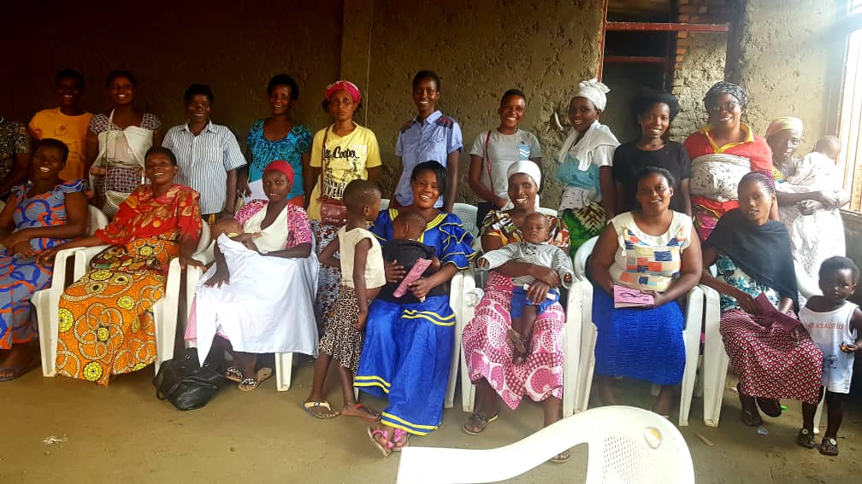
“I am a woman who knows how to do business I had a lot of dreams. Unfortunately my husband wasted everything. My husband loved me but I don't know what he suddenly changed him. He started to beat me and to be irresponsible; he wasted the family richness, he no longer gave me food while he refused me to work. My children lacked of what to eat until they vomited because of they were starving.
I began to look for a small capital to work so that I can feed my children. I started saving until I got 3 million Burundi Francs. I wanted to buy a plot of land, and I told to him this project. I went myself to withdraw the money in my account; I gave the money to husband to buy the plot. One of my coworkers called me to tell me that my husband was with another woman in a hotel. I got ready and took the road and saw my husband with my own eyes with another woman. I asked him where is the money of the plot he did not answer me. I spent sleepless nights crying. From there I understood that my husband became a monster I even thought to kill him.
I sold my place in the market because of him, I worked in the street in town and the police forbid us to work there, the goods were taken from me many times and I was even imprisoned because of that but he didn't come to see me. When I gave birth I managed to pay the hospital bills he didn't even come to see a baby
Conflicts became unbearable until we’ve separated. Now, I live with my six children, he does not know how my children live.”

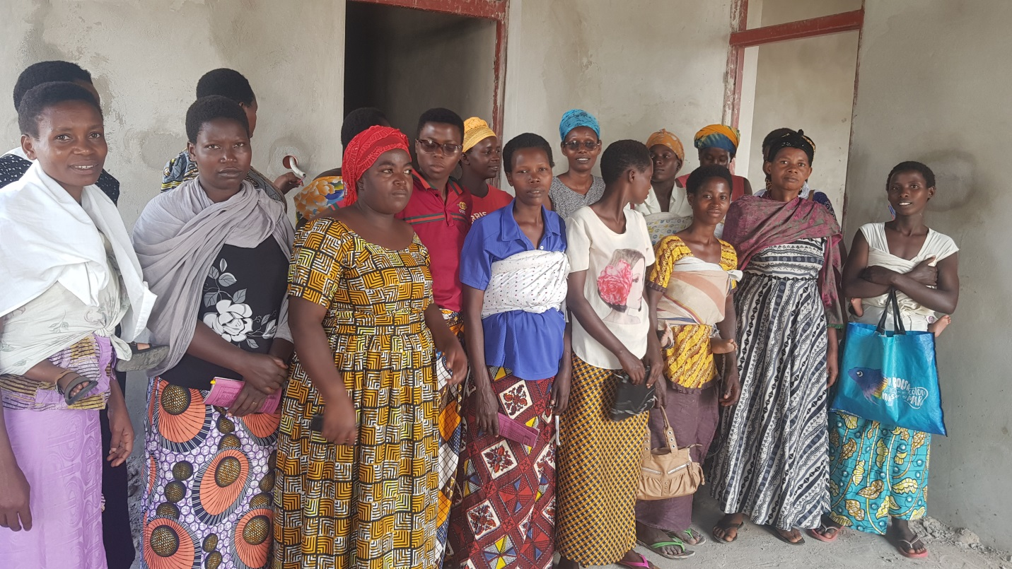
“I got married to a man who ended up marrying another woman and he rejected me with my child. I was in village; I depended on the agriculture of my husband's fields. This means that I did not have where to go and decide go back to my family.
In the Burundian tradition when you return to your family you are the shame of the family their call you “IGISUBIRAMUHIRA” meaning that you are something which returns back home. My mother told me that it is my fault: a real Burundian woman must tolerate all kinds of violence in her marriage. I thought that I supported my husband with all my strength and besides that it was he who chased me away. Then, I decided to suffer in my own family: my mother insulted me day and night and my brothers beat me and they told me that I am an incapable woman , that I came back to share their fields.
I saw that I have no future and I decided to leave my family's house without saying goodbye. I came here in Bujumbura looking for a job. I left my child with my mother; I told to myself that my mother will not mistreat my child. I work as a maid.
As s in my head was this idea that I am incapable. I had the feeling to try marriage again so that I can be accepted in my family. That’s how I married a flattering man. Arrived in his house I found that he was living in a small room with another man. We used all three to sleep on one a mattress; you cannot imagine the scenario.
He was beating, me insulting me and one day he stabbed me in the head. I bled so much that my neighbors forced him to take me to the hospital and the police jailed him. From that day he told me that he will do a bad thing to me that I'll remember all my life.
Until now I live this life it has not changed and I have to endure this to save the honor of my family. I will never divorce again”.

- Self-Help Groups

At the end of April 2021, we had a total of 131 SHgs in Kamenge, Bujumbura Mairie province for a total of 3088 women and 21 SHGs for 513 women in Nyabiraba commune, Bujumbura province.
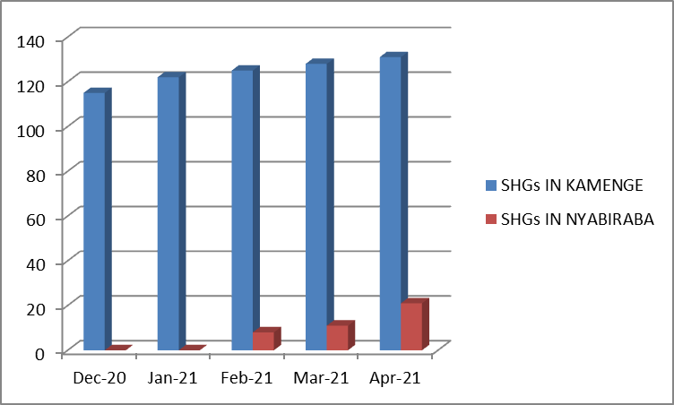 | 3013 | 263 | 3276 |  |  | 1
 | 3088 | 513 | 3601
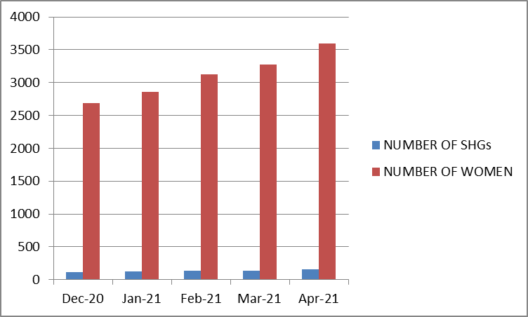 |  | 3088 | 513 | 3601

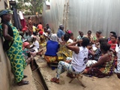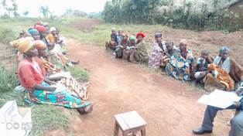

- Growing Rice Project (GRP)
In the month of February 2021, FWA harvest rice from the 2020 second season. The total harvest was one ton and a half of rice.
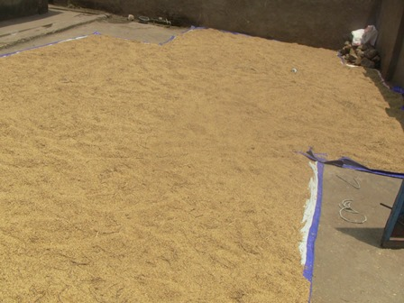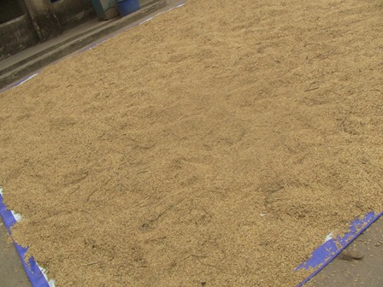
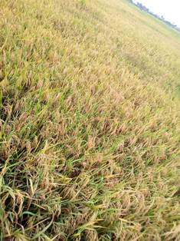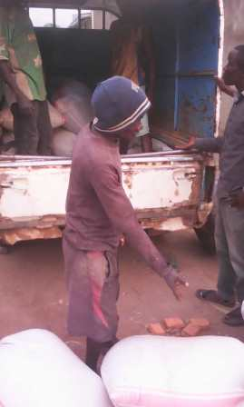
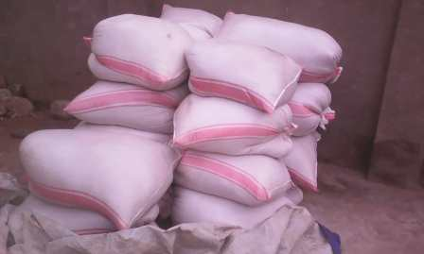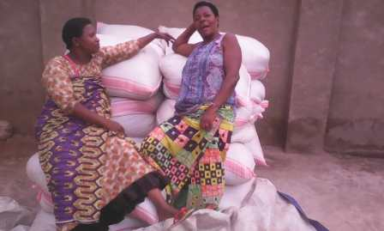
From March 2021, FWA has started to grow rice for the 2021 first season.
