Global Giving March 2022 Narrative Report
From January 2022 to March 2022, different activities were done: trauma healing workshops, Self-help groups (SHGs), income generating activities and the Street Business School (SBS).
- Trauma Healing Workshops
The three trauma healing workshops were done respectively in January 2022, on February 23-25 an don March 29-31. Facilitators were Grace Horanimana and Gisele Misago.

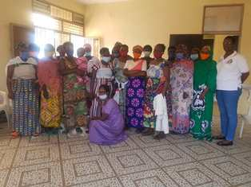
A Group photo after a three-day trauma healing workshop in January 2022
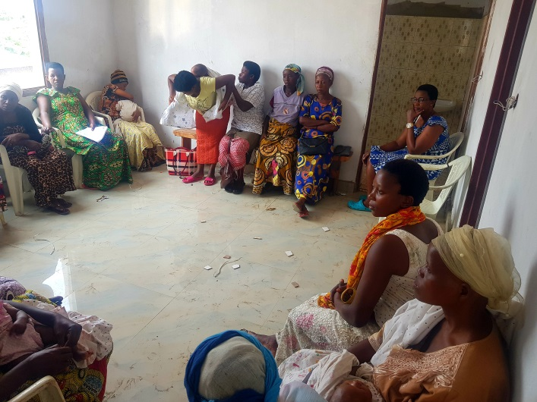
A three-day trauma healing workshop in February 2022
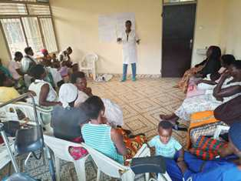
A three-day trauma healing workshop in March 2022
“I have been an unhappy person since my childhood. I didn't bury my father: He left the house as usual but he hasn't returned. My mother died when I was at school, they were hidden me that she died. I had hatred against my sisters and brothers; I spent a month without eating well or sleeping. It was Catholic monks who helped me to be able to sleep.
It was in 1993 during the war and I took refuge in a camp, the soldiers wanted to rape me but a refugee leader hid me in a prison and He helped me to go to Bujumbura because almost all the girls in this camp were pregnant because of the rapes by the soldiers.
In Bujumbura I was in the Rohero quarter where I did not leave the house. There was a boy who wanted to marry me in the village but I had refused. He tried to see me but in vain. He made a conspiracy with one girl who just asked me to visit her and I found myself with the boy in the house.
He raped me and made me his wife by force; I tried to look for the house where I lived in vain because I didn't know where to go. I tried to flee but where could I go? I was completely lost.
It was hard to accept this horror. I didn't want to be his wife and he looked ways to hurt me; he beat me, he brought other women to my house and they used to have sex in front of my eyes. I got pregnant and I calmed down.
When I gave birth, he didn't give me anything to eat while I was still staying at the hospital. He sent someone with transportation fees to go back home. Arriving home I wanted alcohol only to forget my situation. I was sleeping with alcohol.
I left this man being tired after two years. I wanted to start all over again; I became a woman who loves prayer and I had another boy who loved me very much. We were preparing our wedding but another man ruined everything. He told me: “if you don't marry me I will kill you”. I thought it was a joke but he killed my fiancé and he told this to me. He married me by force and I was afraid because it was during the war period. He taught me to take drugs, we spent the night at the cabaret, and He used to beat me and insulting me....
Now, I'm alone with my children but I'm not psychologically stable sometimes I don't wash myself. There are dates when I cannot wash me, comb my hair or see if clothing that I am wearing is suitable. I suffer so much in my heart; I no longer have any hope of living.
But really this training relieved me. I was able to cry and on the third day of the training I was able to wash myself. I ask to continue to help me to heal because it is not easy for me.”

- Self-Help Groups and Income generating Activities

At the end of March 2022, we had a total of 149 SHGs in Kamenge, Bujumbura Mairie province for a total of 3538 women and 30 SHGs for 738 women in Nyabiraba commune, Bujumbura province.
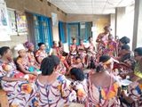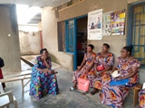

- Income Generating Activities
Income generating activities have continued. The handmade baskets project by young girls has continued at our FWA office.

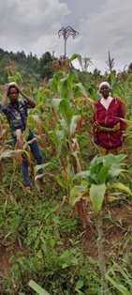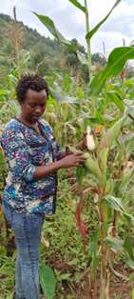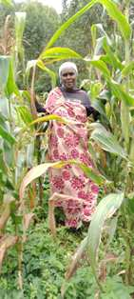
The Growing Corns Project in Nyabiraba commune, Bujumbura province
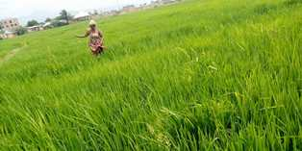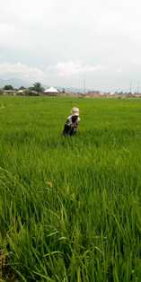
The Growing Rice Project in Bujumbura Mairie province

