Global Giving April 2024 Narrative Report
From April 2024 to Jul 2024, different activities were done: trauma healing workshops, Self-help groups (SHGs), income generating activities and the Street Business School graduation.
- Trauma Healing Workshops
The FWA did five trauma healing workshops for a total of 100 gender-based violence survivors. Two workshops were done in April 2024, two workshops were done in May 2024 and one workshop was done in June 2024. All of them were done at Ruvumvu in Bubanza province. Participants were gender-based violence survivors.

Stories in April 2024
“My name is Esperance, what traumatizes me more than others is that my husband stole money from the saving group; we were at the end of the year, I was given a sum of 544,000 FBU to keep it, I put it in a safe place but I don't know how my husband was able to see where I put it.
When I asked him where the money was, he told me that he was the one who took it and refused to give it back to me.
I hadn’t any choice than to borrow money from my neighbors until I totalized the sum; this is how I paid the saving group.
One day, I was done to reimburse money to my neighbors and I asked my husband to help me. We were quarreling about that money then he took a knife and wanted to kill me; that's how I fled and fell into the pit with my child of 2 weeks old. I found myself in the hospital; I had just given birth by cesarean section and because of that my operation must be redone. My child also lost consciousness and I bought him medicine that was too expensive without the help of my husband.
All this left a wound in my heart. I am lost, I don't want to live when I remember my dept. I cannot sleep.”

“My name is Consolate, I got married and had a child then I saw that I couldn't endure the behavior of that man and we separated.
After 5 years I remarried illegally with another husband but I came with my child. We agreed that he was going to take him as his child, which he did not respect after some months.
The violence I suffered is because of my child. He doesn't let him eat. My child is beaten for no reason, I can't count how many times we don't eat because he refused to let my child eat and I, as a mother I cannot eat without my child. Several nights I and my child sleep outside even though I am pregnant.
I have no father or mother to help me raise this child. There are times when I sit down and cry until I feel tired because I am unable to found the way out.
This training helped me, because of different interventions of other women, I heard that healing from trauma is a choice. After my years of mourning I have now decided to live alone with my child I’m waiting to give birth and I must leave this toxic marriage”.
Photos
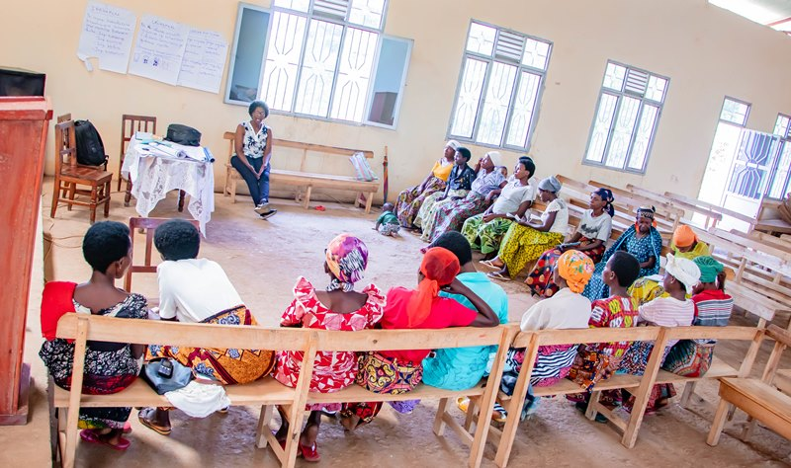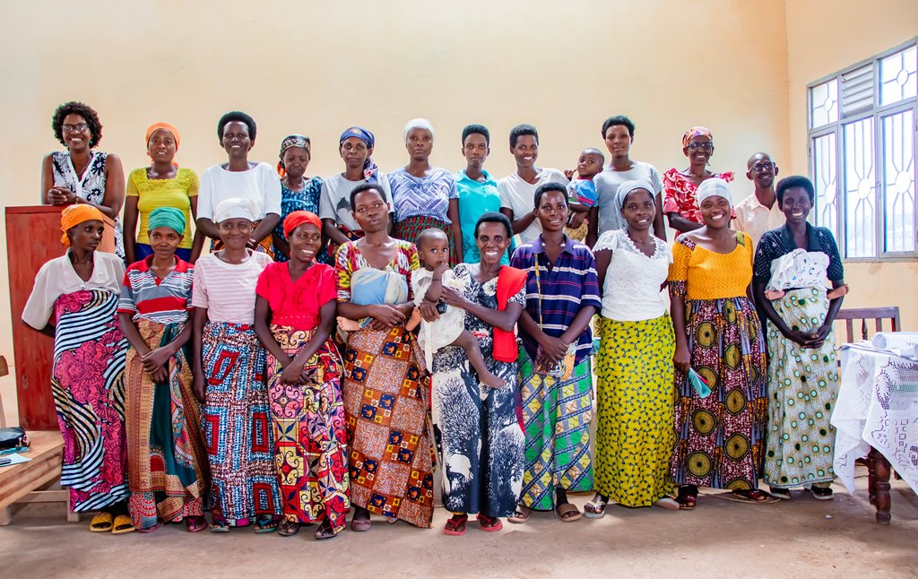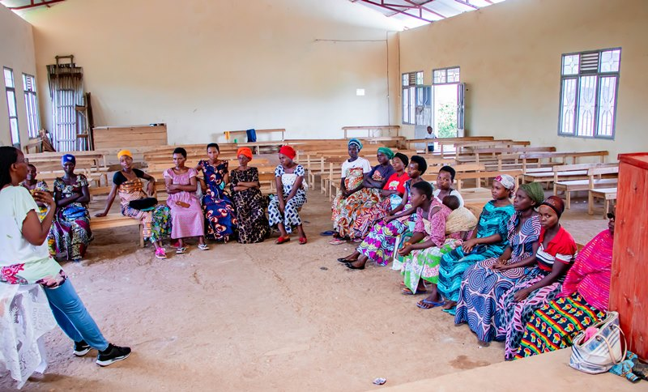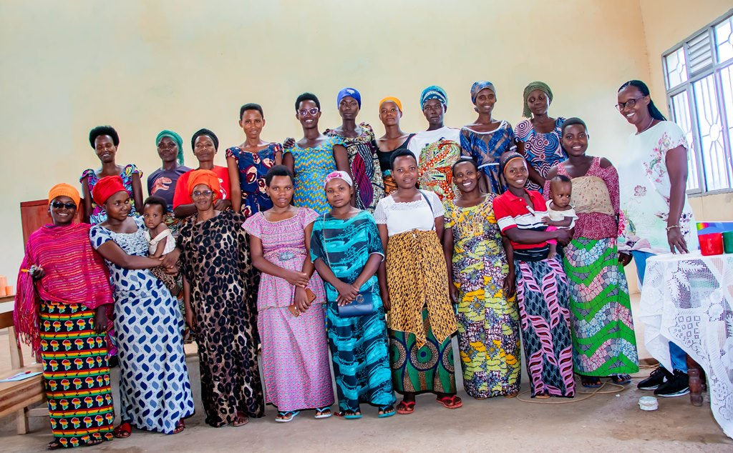

Stories in May 2024
“I married a man but I suffered trauma from the first childbirth, as we saw in JOHARI's window. I have a secret that no one else knows; my husband never buys me a fabric that is used to put a baby on the back (in our culture it is very important to buy this fabric as father). He buys everything necessary for the baby but he never buys this kind of fabric. I thought it was because I had given birth to girls but also for boys it was the same case.
He has often told me that I look ugly; that he made a mistake to marry me, that I am a stupid woman, he used to enjoy disgracing me in public and he beat me. I remained calm and easily forgave him because I am a Christian.
Something that has disappointed me and left a serious wound in my heart is that he left me with 7 very young children. I endured all these things to see that he would have pity on my children. Now, I live in poverty; I have a 2 month old child, and I am unable to work to feed my children.
I thank you for thinking on vulnerable people like us, I feel peaceful in my heart and I feel that I have recharged myself in this workshop.”

“My name is Odette, I am an unhappy woman; I married a husband who had two small children who were suffering from malnutrition. I remember how I often put them on my back even when I was pregnant, but my husband’s reward was the worst. Every week he has to beat me. If you look at my body, I have a lot of scars. He doesn't give us anything to eat, I know how hunger hurts. I have a child who is now 2 years old and has not yet walked. My husband has refused that we go to a medical doctor to see what is wrong with our kid.
I do everything to attract my husband, but it's rare that we have an intimate relationship with my husband. I know He has another wife. Sometimes when he comes back home, he tells me that I'm dirty, and that he has found another beautiful woman.
All this transformed me as you indicated into the signs of a traumatized person. I became aggressive towards my children and others. Sometimes I plan to take revenge in a wrong way. One day I should commit a crime but due to this training I understood my suffering and I think that I will be able to manage my depression in a good way to finally recover from trauma”
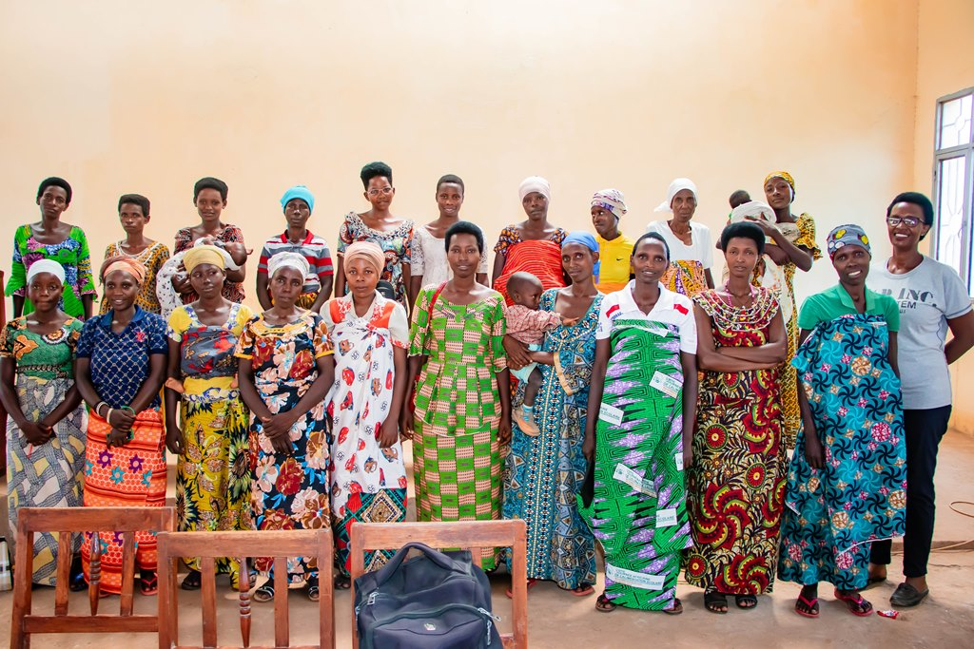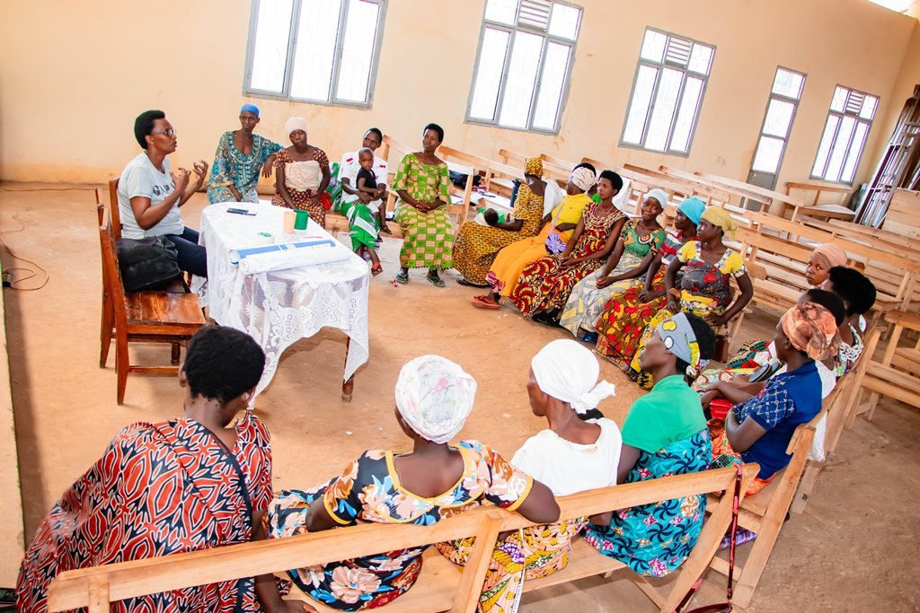
Story in June 2024
“I got married at the age of 16. My husband was a soldier. So I had to stay alone in the house. My house was in the same enclosure with the house of my father-in-law.
My father-in-law started flirting with me by touching me but I refused to let him touch me peacefully with a gentle voice; I was afraid that those around would hear me accusing my father-in-law of such a thing. It continued like that and he decided to rape me. I took a stick and I told him that I was going to hit him and I threatened him that I was going to shout loudly. He left me but he decided to torment me using another method.
He decided to relieve himself in front of my door. When I woke up I saw his poops in front of my door and I decided to check who was doing this act in front of my door and I discovered that it was my father-in-law.
I was overwhelmed and I decided to tell to my brother-in-law. What a mistake! My brother-in-law took me as a liar and hatred reigns between me and all my in-laws until they influenced my husband.
Until now my husband has not returned home for 2 years ago. I am like a widow. I stayed in this house where I have no rights; my fields are cultivated by my brother-in-law; he tells me that my husband no longer wants me and that he will never return.
When I came here my heart was broken; I didn’t know what to do but listening to this teachings showed me that I am not alone in this journey; I understood that I must mourn and let my husband go because I don't have any other choice; I must be strong for the life of my child.
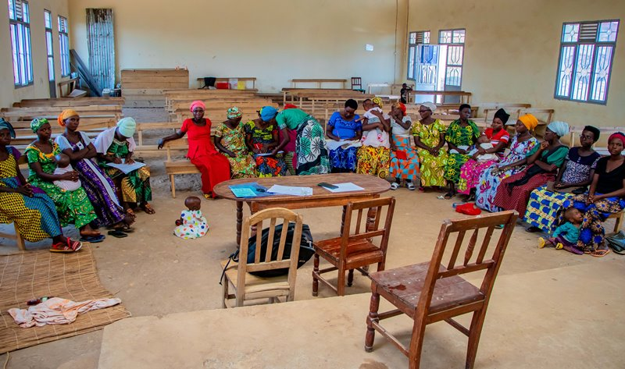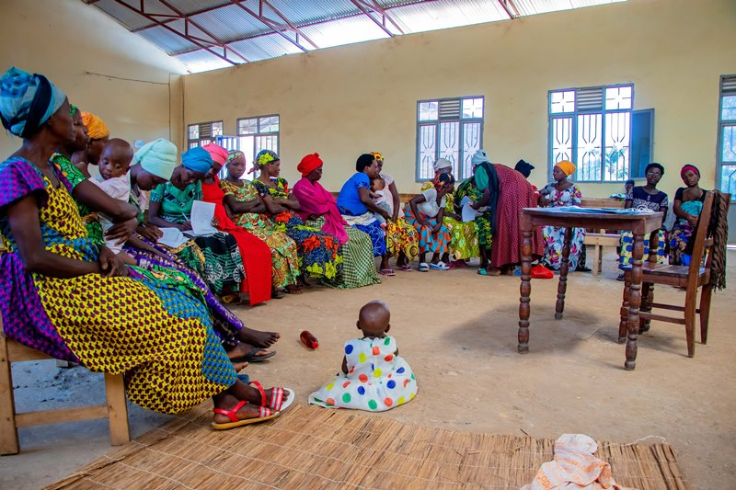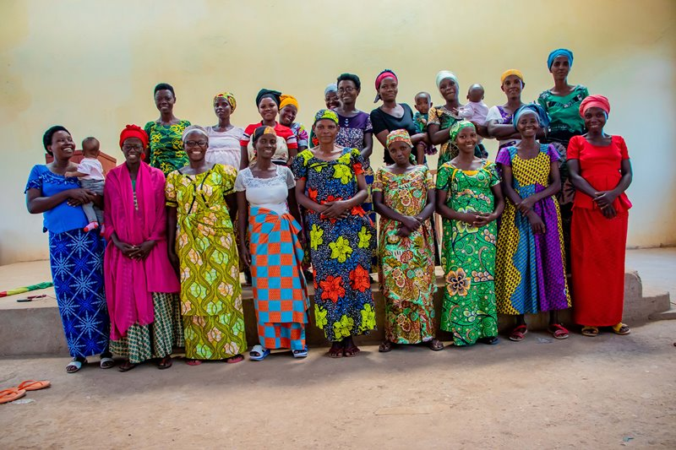

- Self-Help Groups (SHGs)

Self-Help Groups are now working again under the supervision of the FWA. They are now registered according to the new law of the central Bank of Burundi. At the same time, the FWA has encouraged those groups to initiate together small projects for income generating activities.
- Income Generating Activities
Income generating activities have continued. In the month of Jul 2024, there was harvest of 700 kg of rice.
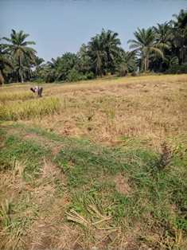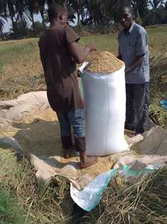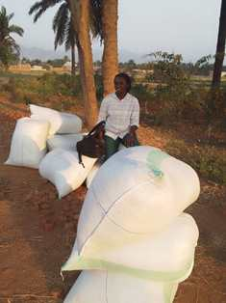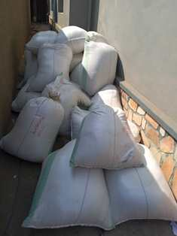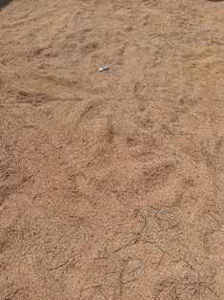
- Street Business School (SBS)
In the month of June, there was graduation of the fifth promotion of SBS. 40 women were graduated at the FWA headquarter office in Kamenge, Songa Quarter, 8th Avenue, N°212. At the same time 45 young girls were graduated for having attended session son sexual and reproductive health, leadership and entrepreunership and seven women were graduated on the sewing career.
