Global Giving February 2025 Narrative Report
From July 2024 to January 2025, different activities were done: trauma healing workshops, Self-help groups (SHGs), income generating activities and the Women’s Socio-Economic Empowerment Center (WSEEC) Project.
- Trauma Healing Workshops
The FWA did six trauma healing workshops for a total of 120 gender-based violence survivors. Two workshops were done in August 2024, one workshop was done in September 2024, one workshop was done in October 2024, one workshop was done in November 2024 and one workshop in January 2025. All of them were done at Ruvumvu in Bubanza province. Participants were gender-based violence survivors.

Stories in August 2024
“I grew up in a foster family because I was separated by my parents during the war. So I don't know if they are still alive or not. I grew up with emptiness in my heart; I don't know how to laugh like others; I hate myself, it is rare to see me among others and I have a great anger.
At the age of 15 the woman who adopted me revealed my story to me and things got worse; I could lock myself in my room and cry all day and I became very bitter.
My only prayer to God was to help me to have a husband who loves me; I thought that having a husband would help me to heal this trauma. What an illusion!
My engagement did not last because as I saw my husband as a refuge, I rushed to live with him without a legal marriage, without taking the time to know him.
In addition to the physical and psychological violence which I suffered, my husband is an irresponsible man, a thief and an alcoholic man.
When I was pregnant with my first child, he was imprisoned, and he left me alone with nothing. My mother-in-law did not pity me. When I gave birth, she did not give me anything to eat and she sold my field of sugarcane; the only thing I had that could give me money.
I know what hunger is because I lacked something to eat when I was breastfeeding. He returned from the prison when the child was 2 years old. Even now, as I speak e returned in prison, and I have 4 children that I have to support alone.
This training was like a mirror. I saw myself; I understood that I grew up with trauma and telling my story is a big step. At home I was able to grieve; I faced my past and I cried and cried; now I feel something heavy which was in my heart is gone.”
“The cause of my domestic violence was my in-laws. My husband moved to work in Bujumbura leaving me in Bubanza. I lived near my mother-in-law who did not love me at all because I am Tutsi and my in-laws are Hutu.
I suffered psychological violence from my mother-in-law. She used to tell me that we are a bad ethnicity. She told me that I am lazy like my ethnicity, and the other faults that people like to attribute to my ethnicity.
She influenced my husband to hate me by telling him lies; she did not give me food because I had not yet been given permission to cook as our culture is.
My mother-in-law created scandals to threaten me. One day during the night they threw stones on the roof of my house. It was terrible. I tried hiding me under my bed but I couldn’t because I was 7 months pregnant. For fear of being killed sometimes I slept at my neighbor's house.
One day my mother-in-law called a family meeting to tell me that my husband said that I had to leave his house. I hurried up without communicating with my husband because we were in conflict and I went back to my mother's house. My husband cut off all communication and I stayed with my mother.
After 3 years we reunite with my husband because he knew the truth and looked for a house far from my mother-in-law.
In this training I have understood that I have signs of the trauma caused by this experience. I have an interminable fear; I do not trust my husband. I sometimes thought that he will kill me one day but with this training, I see how I can work on this area in order to achieve healing
Story in September 2024
“I am a woman who is a victim of psychological violence and no one knows it. My husband is a quite person but I am suffering. We got married illegally and no one told me that he had 2 other women that he married before me.
One day, I was cultivating in the field and two women looked at me and said: his husband always chooses hardworking women, look how she cultivates!
When I heard that I was shocked, I became weak and I went home. I did my research about it and I found that this story is true.
After 2 years I started to worry because we had not yet had a child. My husband does not answer me when I ask about this subject. I went to the hospital alone. If I suggested him to go to a gynecologist, he didn’t answer me. I suffered in my heart, but when I am with others, I try to hide my pain. I said that I am well that this situation does not do anything to me. I took myself as a strong woman, but I suffered in my heart. My husband sometimes can't be able to have sex. We can go months without having sex, I beg him to go get treatment; he stays calm. Sometimes I saw him taking medication to resolve this problem for a while and until now it has been four years that we haven't had sex. I can't tell this problem to anyone because our culture doesn't allow it but I am suffering so much.
People pointed fingers at me saying that I am sterile. They invented words and traumatic things to justify the cause of my sterility. I am a leader and I pretended that it didn't affect me. I taught other women about sexual life in a couple while I was suffering.
In this training, I realized that I’m denying the reality. During this training it was difficult to pretend, I felt all the sorrow and I screamed loudly as you had seen I cannot control myself like before. I said things that I never talked and I accepted my vulnerability.
Thank you for giving us the time to unlock our pain, I feel a little lighter.”
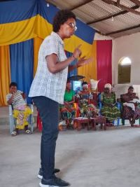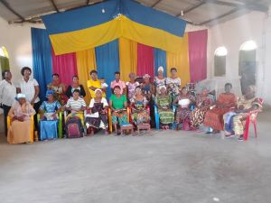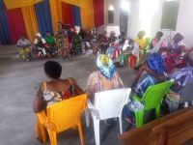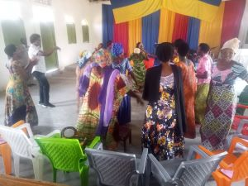
Story in October 2024
“I married an alcoholic man. He came home at midnight and beat me while I did nothing. One day he beat me when I was pregnant and I had an abortion. This abortion left scars in my heart; I didn't want to be pregnant anymore.
Unfortunately I found myself pregnant again, and my husband married another woman whom I took as my mother. I got depressed and I looked for medication to try to abort but in vain. I planned to kill my child at birth or leave the baby in the hospital. The day I gave birth I looked at my child and I felt pity and regret. I accepted it; I decided to go home with my child.
This child reminds me at what level I am a bad mother, when I see him I feel like a criminal; I cannot forgive myself. My child is three years old, but he is always afraid when I leave him alone He does not accept and it saddens me and I feel myself guilty.
This workshop taught me that I am traumatized and that I must admit my weaknesses and agrees to begin the healing process”.
Story in November 2024
“My name is Pascaline; I grew up as an orphan. When I was 14, my father remarried, and then married two more women after that. Unfortunately, his wives mistreated me, and I grew up filled with bitterness and hurt.
Later, I married a man who lied to me, claiming he was single when, in fact, he had children around my age. My husband, who was much older than me, traumatized me in many ways. He physically abused me, used cruel words to tear me down, and when I gave birth, he even denied that the child was his.
The more I was mistreated, the more I became withdrawn and "different." I started learning how to defend myself, but I also turned to drugs as a way to cope with the pain.
One day, I returned home and find my husband had locked me out. In a fit of anger, I forced my way in, grabbing him by the neck, desperate to hurt him, but he was stronger than me. He beat me violently. After that, I sought refuge at my uncle's house.
When I told my uncle what had happened, he told me that I should endure my husband's actions, because, according to him, many women accept this kind of life. Eventually, I went back to my husband.
Even today, I am still living in this toxic situation. As the training on stress and trauma highlighted, when someone hurts me, I fall back into old patterns of self-destruction, such as drinking. Even the simple tasks like taking a shower or doing laundry are hard to do for me.
However, this training has been a turning point for me. I have learned to understand myself better and to recognize that I am carrying deep emotional wounds. I now understand that I am not just broken, but sick—affected by trauma. My hope is that by applying the healing methods I’ve learned, I can start to heal these wounds and regain control of my life.”
Story in January 2025
“My husband was a civil servant in Burundi and He left his job to work in Kinshasa, DRC, but while He was there, He married another woman. Unfortunately, his job lasted only eight months due to unforeseen circumstances and He had to return to Burundi. It was a difficult time, especially since He could not return to work for the government.
I started to notice a change in him. He stopped taking care of me; when we slept, He would not touch me. Instead, He would focus on his phone to talk to his other wife, and I could not sleep. My heart was in pain.

Due to unemployment, He became depressed and we all suffer the consequences. He can even force us to leave the house for no reason, and sometimes we find ourselves without food or a place to sleep.
One day, He tried to hit me, so I ran away. In anger, He burned my clothes and I had no choice but to call the police. When they arrived, He was still burning my belongings. The police arrested him. What hurt me the most was his family’s reaction: they were counting the hours He would spend in prison and telling me that if He spent even one day there, I would have to face them. By the grace of God, my husband was released, but the pain stayed with me. I felt useless because his family supported him despite his misdeeds.
We live in fear and are exhausted. During this workshop, I realized that the physical pain I suffer, including stomach problems and fainting spells, comes from the emotional stress caused by my husband’s behavior. This experience helped me understand my own mental health and I learned how to build resilience and protect myself from further trauma.
Photos
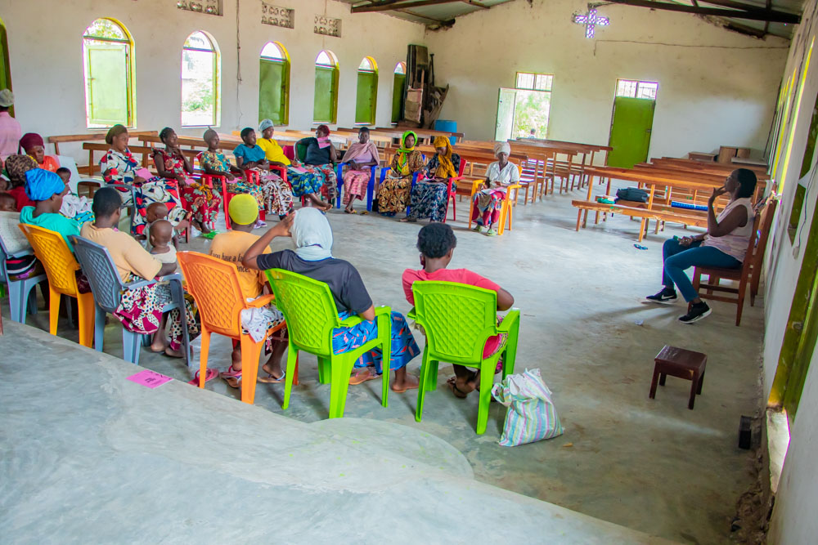
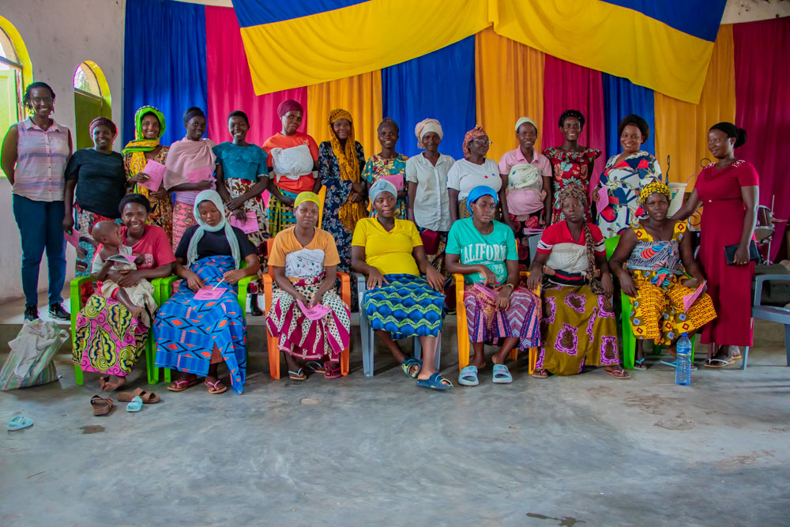

- Self-Help Groups (SHGs)

Self-Help Groups are now working again under the supervision of the FWA. They are now registered according to the new law of the central Bank of Burundi. At the same time, the FWA has encouraged those groups to initiate together small projects for income generating activities. At the end of January 2025, the FWA was supervising 63 Self-help groups.
SHG Testimony
“My name is Jeanine NZEYIMANA; I joined the savings group in 2015 when I was invited by the social worker at FWA, who was assisting people living with HIV/AIDS, including myself.
At the time, I had no vision for my future. I lived in my older sister house and wasn’t working. As a sex worker, all the money I made was spent on beer.
However, a lot has changed since I joined saving group:
- I now run a beer cabaret business with 13 lockers, worth 400,000 FBU (135$).
- I bought a bike for 600,000 FBU (203$), which generates 2,000 FBU per day.
- I purchased a plot of land in Bukeye for 4,000,000 FBU (1354$).
- I’m able to rent a house where I live with my child.
- Through street business school program, I learned the importance of having a bank account, which has helped me save a significant amount for myself.
Because it was difficult to save money each day, I decided to join three savings groups. I set a goal to save 10,000 FBU (3$) per group every week. At the end of each year, I collect everything I’ve saved from these three groups and deposit it into my bank account.
I’ve become an influencer in my community. People around me, noticing my progress, started asking me about my secret, and I shared it with them: “it's the FWA’s SHG program”. Today, I’ve brought four groups to FWA on my own, I mean over 80 people.
I’m truly grateful to the SHG guides who support us in this work. In the SHG, we’ve built discipline and a competitive spirit. For example, in my first group, several women were able to purchase their own plots, and those who haven’t reached that point yet are motivated to get there because it’s become a challenge for the group.”
- Income Generating Activities
In December, a visit was made to Maramvya and Bubanza to discuss and identify potential income-generating activities that the beneficiaries of the HROC training are interested in pursuing. The goal is to support their unity and financial independence moving forward.
Bubanza: After the trauma healing workshop, facilitators encouraged the participants to form a cooperative. In response, 30 women came together, contributing 2000 Burundian francs each per month; today the cooperative has six months of contributions. The cooperative has proposed maize farming as an income-generating activity.
Maramvya: In Maramvya, a cooperative of 20 women was established before the training, as local leaders recognized this group as more effective than other groups within the Maramvya Friends Church. This cooperative has chosen rice farming as its income-generating activity.
- Women’s Socio-Economic Empowerment Center (WSEEC)
- Women’s Economic Empowerment Center WEEC
The Women’s Socio-Economic Empowement Center (WSEEC) is a new project that the FWA has started in the month of Jul 2024 under the support of the African Great Lakes Initiative (AGLI) of the Friends Peace Teams) and the Canadian Friends Service Committee. The aim is to avail training rooms and a temporary safe shelter for gender-based violence survivors at the FWA headquarters. This project will cost $200,000. So far, the FWA has already raised $32,500.
Pictures in July 2024
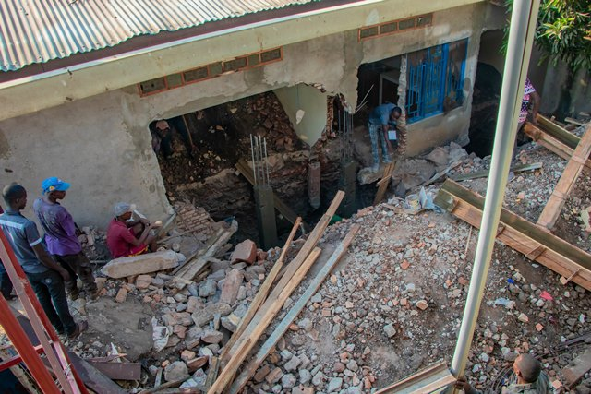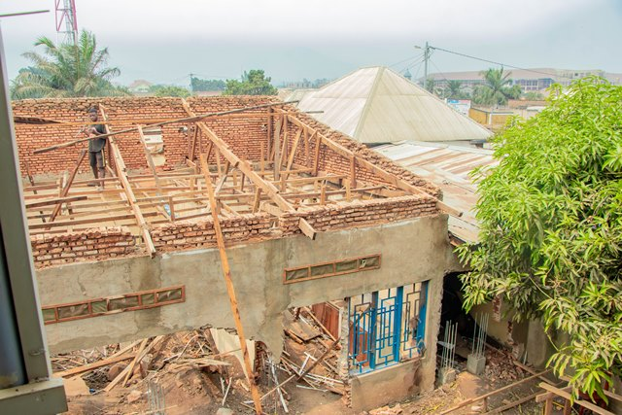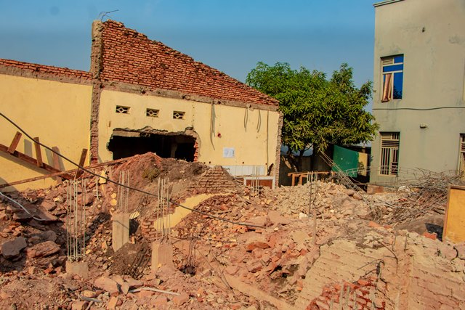
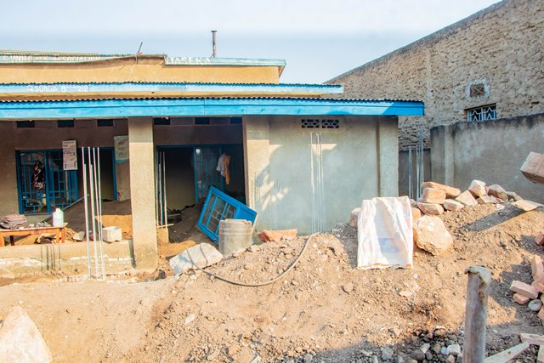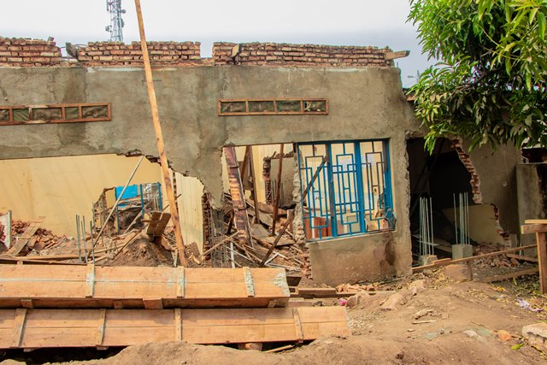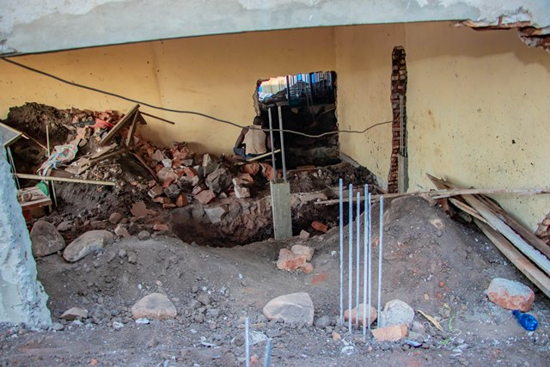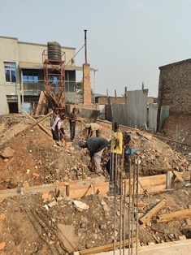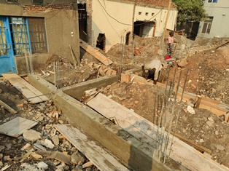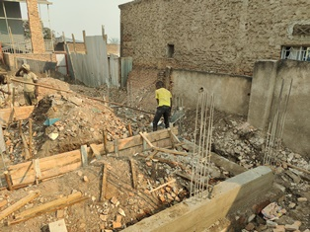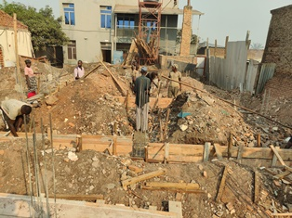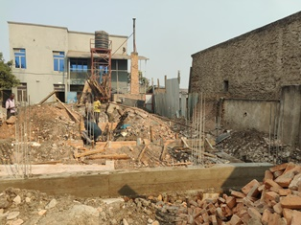
SEPTEMBER 2024
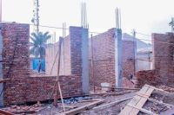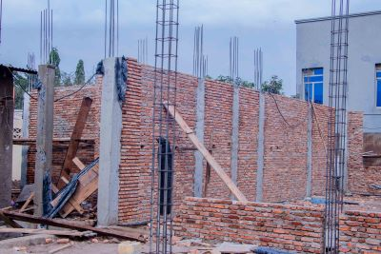
NOVEMBER 2024
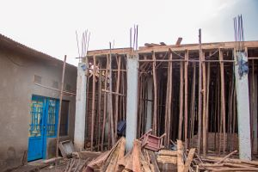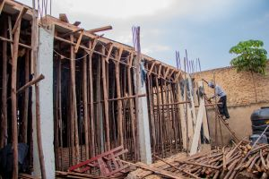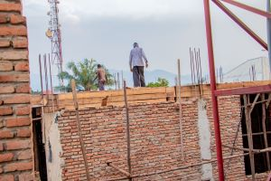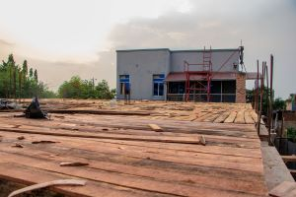

DECEMBER 2024
