Global Giving December 2022 Narrative Report
From August 2022 to November 2022, different activities were done: trauma healing workshops, Self-help groups (SHGs), income generating activities and the Street Business School (SBS).
- Trauma Healing Workshops
The first three-day trauma healing workshop was done on August 17-19, 2022. The second workshop was done on September 26-28, 2022. The third was done on from October 31st, 2022 to November 2^{nd,} 2022. The fourth one was done on November 29- Dec1st, 2022.

I married an orphan husband. He promised me to live happily and He used to say that I am all He has. After 4 year, he started dating other women. I lived in the village and He was in Bujumbura.
One day I asked him money to buy a cow in order to have manure. He answered me: "I bought one cow, it's a cow with two legs, (she talk about me and dowry) I can't buy another “Then He asked me for the money and I gave it to him. After I found that He had a premature child with another woman and the money was to pay for his hospitalization.
After that he called me and told me to come and live with him in Bujumbura. When I was hesitating, he told me that if I don't com, dangerous things could happen to me and I made the decision to go to live with him here in Bujumbura. It was afterwards that I discovered that this woman wanted to live with my husband by force and that my husband did not want it.
In that house I was victim of psychological violence; my husband gave me the order to prepare and serve food to his wife and my husband at the table while I and my children ate outside. I was preparing meals and serving them but my heart was bleeding.
One day I felt that I could not take it anymore; I told him that if this woman will come back again in my house I will throw hot water on them. He was scared and he made the decision to sleep in the house of his second wife or to come home late.
One day he came home around 2 a.m. and I refused to open until 8 a.m. I wanted everyone to see the bad husband he is. When I opened the door, he took everything in our house and wanted to leave us and I refused, explaining to him that he was not going to run away from his responsibilities. So, He took a rebar and beat me until I fainted. You could even see the scars.
Until now I'm in this situation but God gave me the courage to work to support my children He's there. When he wants, he comes back home; when He doesn't want he doesn't come home.

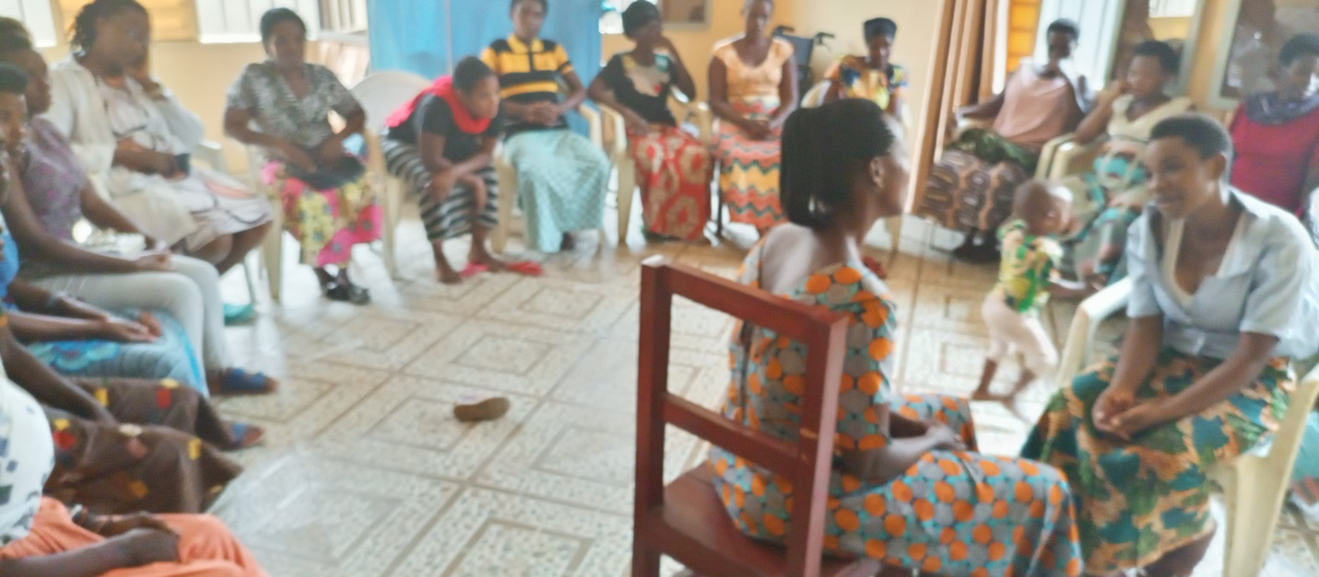
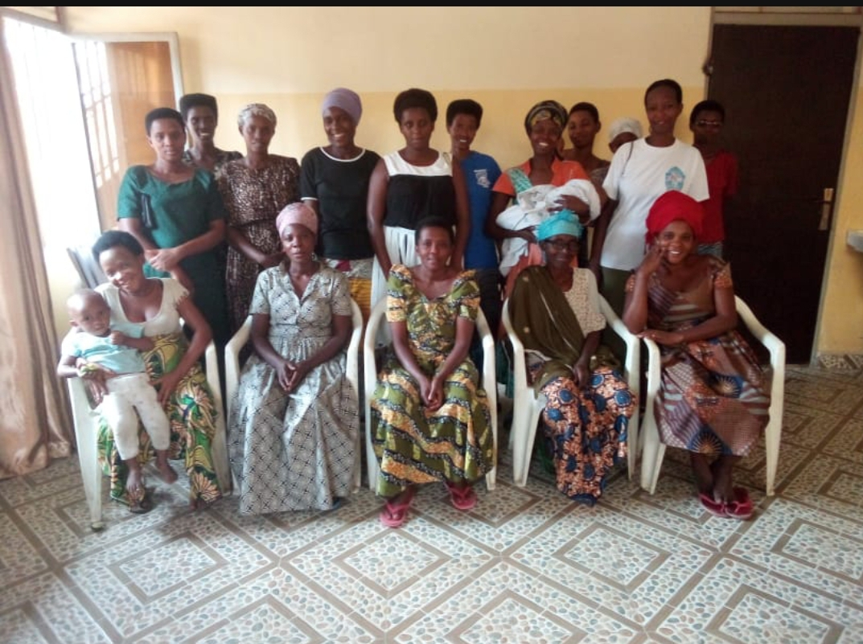
My name is Judith. In 1993 my family and I took refuge in Rwanda. In 1994 we returned to Burundi, we found our house destroyed and we built a small straw house. We suffered marginalization because we were very poor. They called us “pygmies”. I was 16 years old and I was very touched by this discrimination in my community and I decided to go to the rebellion soldiers.
After war, I was among the demobilized soldiers. I got married to a man and we had 4 children together and then he died.
After his death his family made me suffers the worst; my husband's family took away my 4 children and threw me out because we lived in the family plot. I started drinking a lot of beer to calm myself down.
Now, from morning until night I live in the cabaret; I mean I have become an alcoholic. In this cabaret men use to rape me when they find me drunk. I tried to give up to alcohol but it's stronger than me. Thanks for inviting me to this workshop to have a chance to share my sad story.

My name is Mary. I got married at 16; I was in the refugee camp in Kenya. My husband began dating a girl who was my maid. One day at night He left the house to go to sleep at that girl. This pushed me to say it loud for help.
When we started mediation with the services in charge of the conflicts in the refugee camps, my husband said to me: “you do what you want but I will not give you my children instead of giving them to you, I will throw them in the river and I too will throw into it also".
I knew that to kill is a simple thing for my husband because he was an ex-army rebel. I have chosen to suffer in this marriage for fear of being killed. He tried many times to kill me using poison, but I thank God he did not succeed.
One day he hit my arm and justice service separated us. I thought I would finally have peace but he corrupted my children. When I gave to children something to sell, he did everything possible to distract them so that my goods were stolen. Actually, I was a business woman. `,
I was almost crazy because of trauma. I found that there are times that I am not myself. I could find myself trying to kill my child that I carry in my back. I said to myself that I exceeded the limit; I decided to return to Burundi with my two small children, the other two are still with their father.
I went through several bad things; I have been even homeless, but a woman gave me a small room to live. I was able to start my life. I feel peace because I live far from my husband.

My name is Rose. I live in violence, now there is 20 years ago; I said to myself that I have to be a strong woman in order to protect my children.
After being disappointed by my husband who accused to have sex with his friend, there is no longer peace in our household. I suffered too much violence but I refused to be a victim, when He wants conflict I choose peace.
He uses to tell me that my son is my husband. He is not even afraid to say it in public, “what shame!” Now I sleep on a machete, He always terrorizes me saying that he will kill me one day. He told me: “I have already killed you, it remains to bury you”.

I was able to buy a plot and to build a house in Tenga without his support; I asked him to help me make bricks, and he refused; rather we live together in this house, and he wants to kill me.

When the kids hear us quarreling they come and grab that machete, so that he can’t kill me.
My heart has become hard. I don't think he will kill me.
As you said In JOHARI’s window, there are situation that we must surrender to God Who knows everything.

- Self-Help Groups (SHGs) and Income generating Activities

At the end of November 2022, we had a total of 154; SHGs in Kamenge, Bujumbura Mairie province for a total of 3638 women and 35 SHGs for 863 women in Nyabiraba commune, Bujumbura province
- Income Generating Activities
Income generating activities have continued. The handmade baskets project by young girls has continued at our FWA office. In the month of November 2022, two SHGs from Nyabiraba commune have started to grow potatoes..
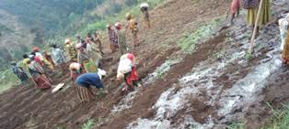
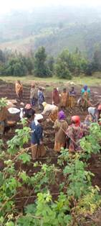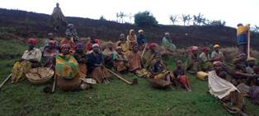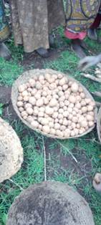

- Street Business School
Two training sessions on SBS were held where we discussed about Module 3 (Getting Out of your Comfort Zone) and module 2 which is about Business Opportunity Identification
