Global Giving DECEMBER 2023 Narrative Report
From August 2023 to November 2023, different activities were done: trauma healing workshops, Self-help groups (SHGs), income generating activities and the Street Business School (SBS).
- Trauma Healing Workshops
We did four trauma healing workshops for a total of 100 gender-based violence survivors. The first workshop was done on August 28-29, 2023. The second workshop was done on September 28-29, 2023. The third was done on October 30-November 1st, 2023 and the fourth was done on November 27-29, 2023. The fourth was done on June 26-27, 2023. The fifth was done on June 29-30, 2023 and the sixth was done on July 31 to August 1st, 2023

August 2023 Stories
“I am that woman victim of GBV who wanted and planned to kill my husband. I wasn't lying because I had already tried it for my first husband; it was even said on the radio: I threw hot water on his body and I fled to the DRC country. I spent 2 years there. They searched me in vain.
This training had a powerful impact in my life. I no longer recognize myself. It was hard to say that I was planning to kill my husband in front of the participants but it freed me. I felt light; little by little I felt the anxiety decreasing.
In front of a painful situation I am surprised to see myself calm and having a sleep. I said to my soul “be calm”; I leaned to talk with my soul. I am surprised that I forgive easily and that bad thoughts are gone.
I won't know how to say thank you because it's a miracle for me I was a Christian but I could not change. I tried to change, I used to give prayer requests but no change happened. The force of evil was too strong than me. Now I face every difficult situation with joy and hope.”
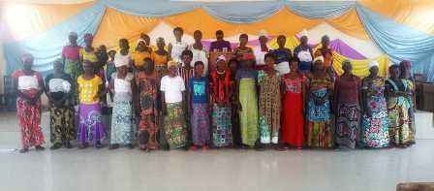
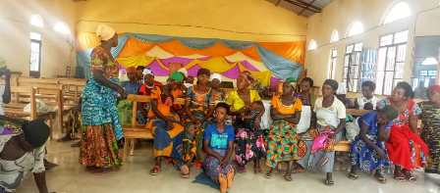

“This training helped me a lot. In the training I told you that I reached a stage of walking without knowing where I was going and that I was thinking about burning the houses of my community to have peace in my heart but now if you watch me you can see the change without saying anything. Before the HROC workshop, I could not wash myself and wash the clothes you saw it yourself. Now you can see that I am clean.
I didn't know what a sleep was but today it's very difficult for me to wake up. I was always worried and I didn't know peace of heart but now I have peace.
I hated my children I beat them seriously so that I can be imprisoned. I wanted to be imprisoned because I was hated by my husband until I hated myself.
Sincerely I tell you thank you, I had the courage to build a small house where I and my children will live. This will help me to reduce the stress of paying the rent each month.”
September 2023 Story
“When I was newly married my husband used to bring women into our house. He told me to prepare them something to eat and I did it because of the fear of being beaten. I was told that the wife must bear all the evil that her husband does and I chose to endure and to be quite but I was dying inside me.
Imagine, I worked alone the whole day, and in the evening I had to prepare something to feed my husband and his girlfriend. Besides that, we slept on the same bed. I endured that too.

One day he brought a very beautiful woman and told me to prepare another room for them. I did it but it destroyed me in my heart.
He married new wives four times in our house. Once, I was at the end of my strength and I appealed to justice so that at least he builds another house for his second woman. He built the house, but He increased the punishments for me and I suffered very much.
I remember that for the fourth wife I accompanied him when he was dating. I told to myself that by doing this I could have peace in my house but in vain.

When my husband died I didn't feel anything, but I felt the burden gone because I had endured too much.
Due to this training, I heard that I am a victim because I see many signs of trauma in my life
It was an opportunity to go back and grieve; I made some decisions for my well-being.”

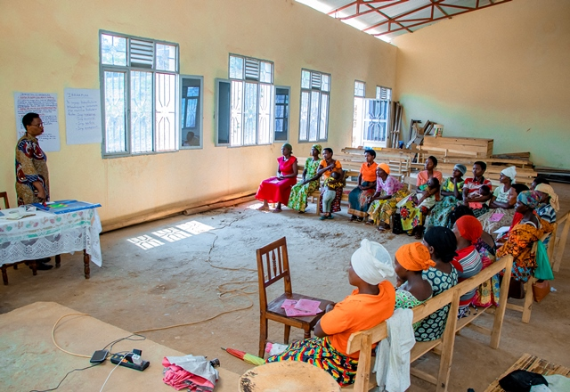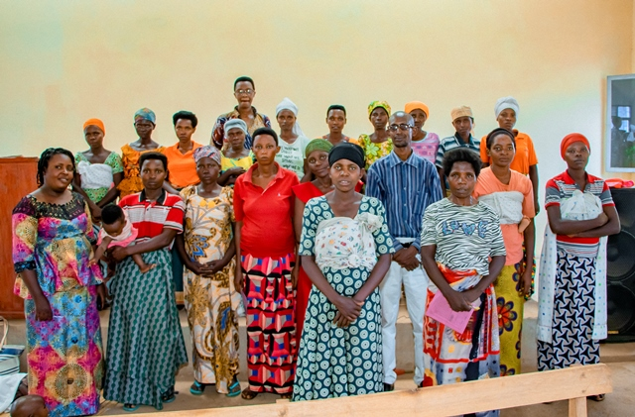
October 2023 Story
“My name is Nicelate, I got married in 2004 and I have 8 children now. When I gave birth to my third child I started to experience the worst in my marriage; my husband married another woman.
My husband and I had worked hard to build a business but all was gone because of this woman. I have been imprisoned many times unjustly because I couldn’t keep quiet, I was trying to defend myself; I use to speak loudly to claim my rights.
My husband's family tells me that I have nowhere to go and it's true because I am an orphan. When he comes home from his second wife, he comes for violence. He doesn't give us anything to eat; I must take care of my children alone; food, clothes, school fees , even if it comes to building our house it's me who has to repair the house.
Today my 3 children are no longer in the house, I don't know where they are at this moment. Maybe they have fled the quarrels which are always in our house. This saddens me too much.
This training helped me understand what I am experiencing and that if a child grows up in a trauma environment they will grow up traumatized. Now, I will try to protect my children”.

- Self-Help Groups (SHGs) and Income generating Activities

At the end of November 2023, we had a total of 159 SHGs in Kamenge, Bujumbura Mairie province for a total of 3763 women and 43 SHGs for 1063 women in Nyabiraba commune, Bujumbura province
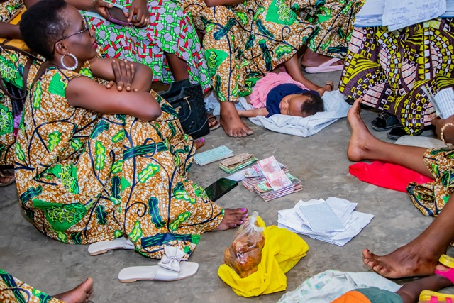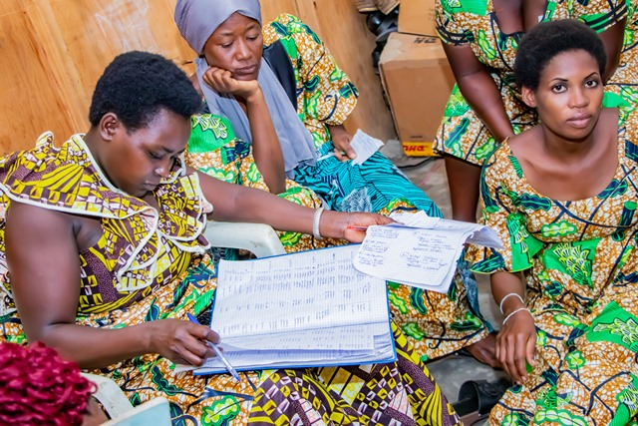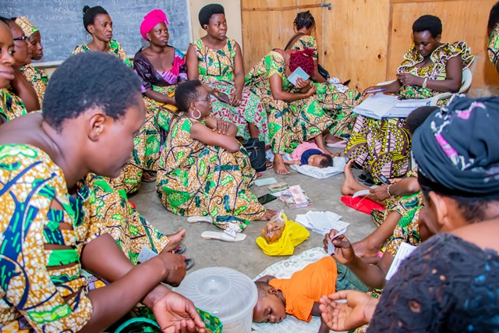

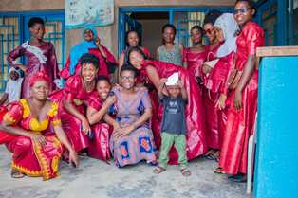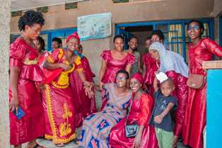
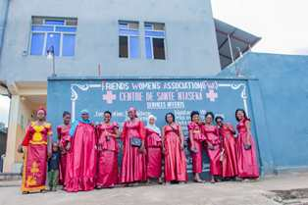
- Income Generating Activities
Income generating activities have continued. Young girls are still making handmade baskets and other basketry products.
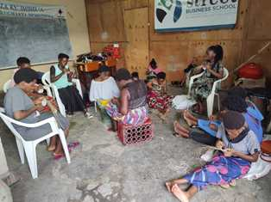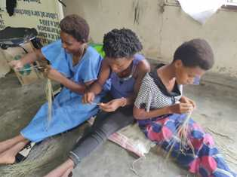
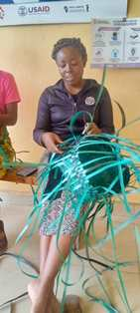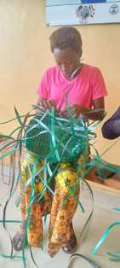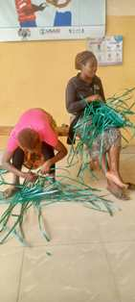

- Street Business School
Street Business School is on a mission to end generational poverty by empowering women as entrepreneurs. We equip women living in poverty with the knowledge they need to build sustainable businesses and we empower them to believe in themselves and seize opportunity.
In the month of August 2023, we discuss about “Business Opportunity Identification”. Participants were able to understand about; what is a business idea, what are the most common places where you get business ideas, why evaluate the viability of a potential business, the factors used when evaluating a potential business and When is the right time to start a business.
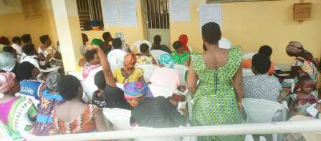
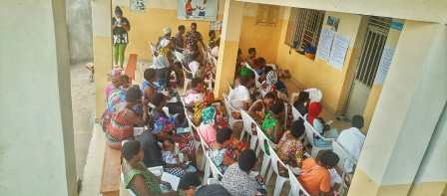
In the month of September we discussed about “Recordkeeping and Bookkeeping”. Participants were able to understand about; what is bookeeping, what are 3 different kinds of business records, what reasons to keep business records and what are examples of when money comes and goes into a business.

