Global Giving August 2022 Narrative Report
From May 2022 to July 2022, different activities were done: trauma healing workshops, Self-help groups (SHGs), income generating activities and the Street Business School (SBS).
- Trauma Healing Workshops
The first three-day trauma healing workshop was done on May 30 to June 1st, 2022. The second workshop was done on June 22-24, 2022. The third was done on July 17-19, 2022.

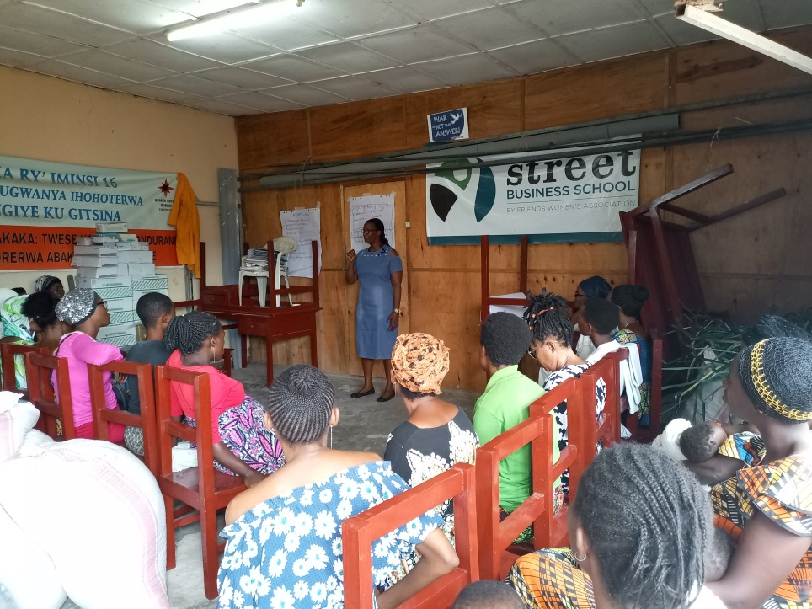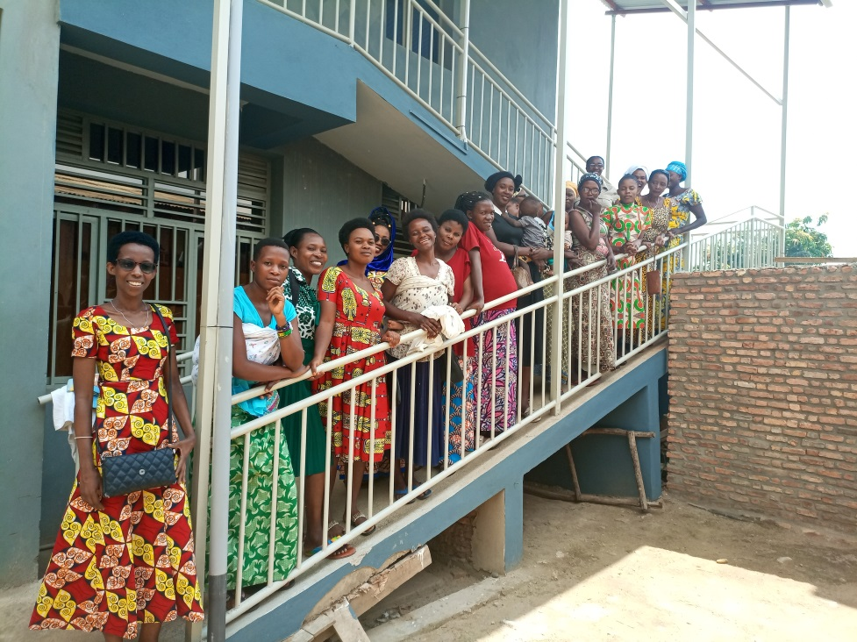
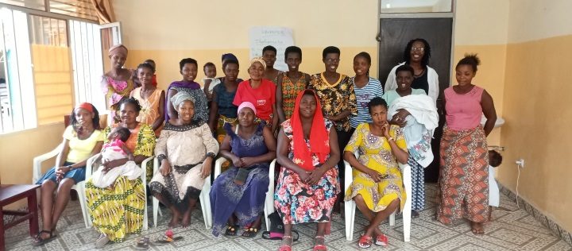
A Group photo after a three-day trauma healing workshop
“I was raped at 13 by a boy that I considered as a brother; I was doing some cleaning work in his room as usual and he raped me and I immediately got pregnant. This man gave me drugs to have an abortion and I refused.
When my elder sisters found that I was pregnant, they called for justice and this man was imprisoned. Then his sister gave the money to the judges and He got out of jail. This man's sister convinced me to say that I love this man in order to live together. She lied to me that she is going to take me to Europe and I accepted.
Because of this decision my family hated me, beat me, cursed me and refused me to go near their house.
Arrived in the house of this man, I suffered all forms of violence; he beat me, he raped me, he brought other women into our room, sometimes he threw the food I had prepared on the road in front of our neighbors.
I hated so much that man that I couldn't be able to look it in his face; even to have sex I begged him to use the position where I couldn't see him in his face.
I began a small potato business which helped me to live alone with my two children at the age of 15. I became an independent and beautiful woman. The man envied me and wanted to start life together again. When he was presenting his proposal to me I took a stone and I threw him in his face and the blood flowed; I said to myself; a man who ruined my youth, for me deserves to be killed. I will never forgive him. Thank you for this workshop where I got an opportunity to cry”
“My husband was hospitalized and we were given an invoice for the amount of 300 000BIF. This amount was very heavy for us, we were not able to pay it and hospital administration imprisoned my husband. The only solution I had was to apply for credit from the FWA’s saving group. They gave me a loan, and I was able to pay the bill with the agreement that my husband will help me pay this debt.
After that, my husband returned to his work but he did not pay this credit. I begged him but he refused. One day I came home and found the house empty; my husband left us with everything which has a value in our house and until now, 5 months ago I don't know where he is.
So I fell into depression: I used to cry every moment, I didn't know where to go. When I thought about this credit, I felt very bad. I wanted death. He left me with our three children “how can I start from zero, whereas I only have a capital of 50,000BIF”.
I thank FWA; this center has a really meaning on empowering and healing women. It’s like women’s refuge; my saving group understood my problem and gave me another deadline to pay this debt. This training helped me calm down I understood that I am not alone in this fight against gender based violence.”
“I am a woman who is married by force. My husband was a violent man He destroyed my life in a period of 14 years.
I was going to visit him with my friend. My friend went to the toilet, then he closed the door that time, I knew that my friend sold me. I tried to defend myself but in vain, He locked me in his house for a week and convinced me to stay with him. Covered with shame, I could not even come out and look my mother in her face. Then I decided to stay and live with my husband whom I never loved.
My man was a drug addicted; He used to beat me, he burned all my clothes, He can beat me naked in public. In addition to this, he took a knife and put it under our bed and told me that one day he will kill me. After that, I decided to be separated with him although it was too late (after 14 years). I have always hoped that he will at least help me to raise my three children but in vain. In these 14 years, I got HIV and heart disease because of my husband. I'm depressed. My thoughts are always bad. I have no hope, my husband stole my future.”

- Self-Help Groups (SHGs) and Income generating Activities

At the end of July 2022, we had a total of 153 SHGs in Kamenge, Bujumbura Mairie province for a total of 3613 women and 35 SHGs for 863 women in Nyabiraba commune, Bujumbura province.

SHG Success story

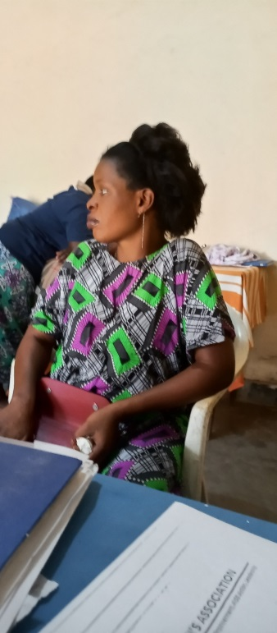
Now I have a word in my home. My name is Aisha. I have been here at FWA for 3 years. Before, I was mistreated by my husband. He sometimes told me that I am worthless.
I joined the SHGs and at the end of the year, I showed him the money I saved and my interest. From that moment, he began to support me in saving. Due to savings and credit, now we achieved many things; we have built a house, we have water and electricity in our house and we have bought another plot of land. I'm pregnant and I'm coming very far from here (Gatunguru). But, he encourages me to come to save money. Before, my husband received money but he wasted it in beer but today see our achievement! We are proud of ourselves! Now I have a word in my family, my husband loves me and we work together.

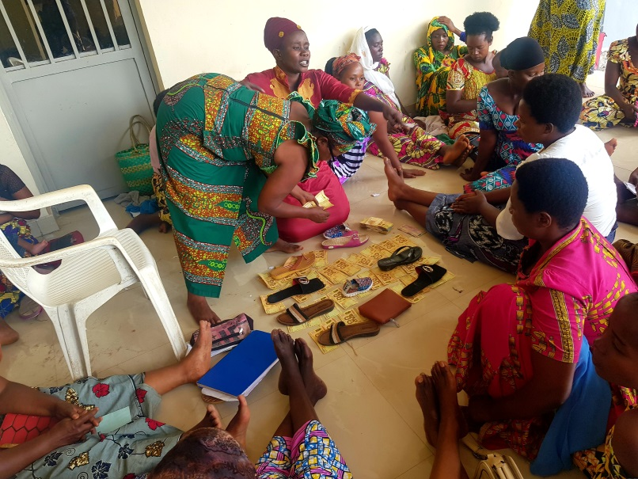

- Income Generating Activities
Income generating activities have continued. The handmade baskets project by young girls has continued at our FWA office. In the month of May 2022, we had the fourth harvest of rice.
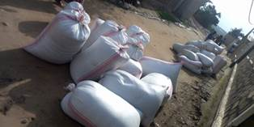
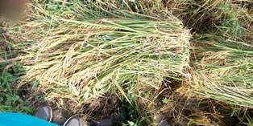
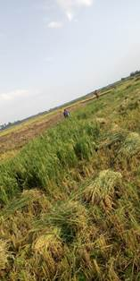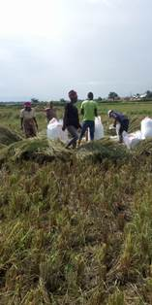
Rice Harvest

- Street Business School
In the month of June the training on entrepreneurship (SBS) has been started for the 40 women from the SHGs of FWA. The identification, SBS introduction and basic survey of participants, were activities that characterized the month of June.
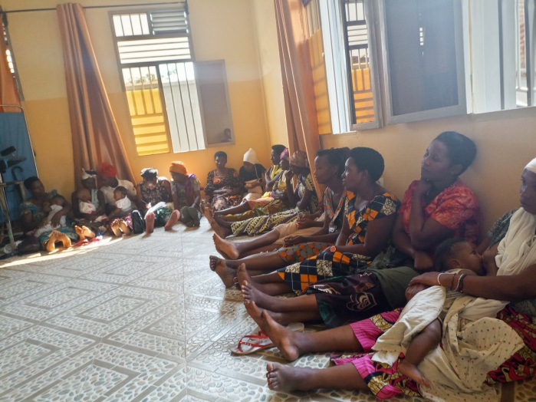
In the month of July 2022, two training sessions on SBS were held where we discussed about Module 1 (Getting Out of your Comfort Zone) and module 2 which is about Business Opportunity Identification.
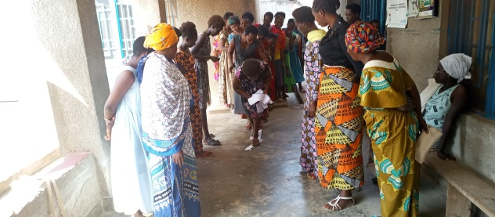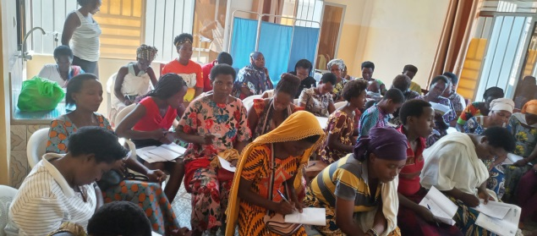
Illustrating game of getting out of comfort zone

