Global Giving April 2024 Narrative Report
From December 2023 to March 2024, different activities were done: trauma healing workshops, Self-help groups (SHGs) and income generating activities.
- Trauma Healing Workshops
The FWA did four trauma healing workshops for a total of 100 gender-based violence survivors. Two workshops were done in January 2024 and two other workshops were done in March 2024. All of them were done at Ruvumvu in Bubanza province
Stories
“My name is Pascasie. I spent 4 years without children in my marriage. I was living in hell because my husband and my in-laws mistreated me with hurtful words and my husband used to beat me whenever he wanted. I too was in pain because I didn't have a child like others. I blamed myself and I hated myself.
God gave me grace. I gave birth to twin girls. I thought my husband would be happy but the first word that came out of his mouth was the following; “this is worst” He said that because they are girls. He continued to beat me day and night.
I gave birth to the third daughter living in this situation. During the fourth pregnancy, I wanted to go to the hospital because I felt that the time of delivery was close. He told me:” This pregnancy is not mine because when I make a woman pregnant I know it and I feel it.” Then he beat me and I finally went to the hospital alone.
Until now I am traumatized; everything you said as signs of trauma touched me and I see myself with those signs. This training allowed me to discover myself as you said before you get better after knowing that you are sick”.

“I was in the 9th year of high school when my boyfriend impregnated me, and my family rejected me from their house. My boyfriend wanted to rent a house for me and give me capital for a small business but his mother suggested that I could go and live with her.
At my mother-in-law's house I saw the worst because she mistreated me; she gave me too much work, and she refused the people who lived in that house to work. I was the one person to do everything. She accused me of lies which made my husband no longer believe me; she made me sleep on the floor.
When I gave birth, we decided to live with my husband. I had the second child but my husband left me. He told me that he was going to Kenya but until now he hasn't sent me anything and it's really difficult to live for me and my two children. This pushes me to do actions that are not in my beliefs in order to survive. I sometimes have sex because a man gives me something to eat. I do it for my children but inside I feel guilty.
Thank you for organizing this workshop. I was able to talk about the things that I was hiding and that hurt me in my heart. I was encouraged by the testimonies of other women who were able to overcome the life of rejection and they choose to live. I come back full of hope believing that it will be well.”

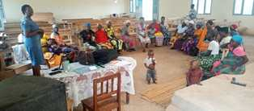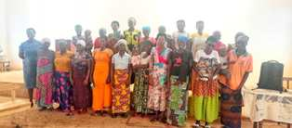
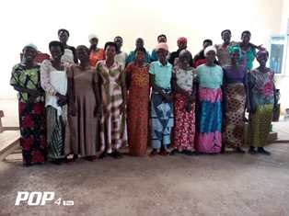

- Self-Help Groups (SHGs)

Self-Help Groups are now closing to comply of the new law of the central Bank of Burundi. At the same time, the FWA has encouraged those groups to initiate together small projects for income generating activities.
- Income Generating Activities
Income generating activities have continued. Young girls are still making handmade baskets and other basketry products. Now the Growing Rice Project has started again.
