Global Giving AUGUST 2023 Narrative Report
From April 2023 to July 2023, different activities were done: trauma healing workshops, Self-help groups (SHGs), income generating activities and the Street Business School (SBS).
- Trauma Healing Workshops
We did six trauma healing workshops for a total of 120 gender-based violence survivors. This means 20 participants per workshop. The first workshop was done on April 24-26, 2023. The second workshop was done on May 24-25, 2023. The third was done on May 26-27, 2023. The fourth was done on June 26-27, 2023. The fifth was done on June 29-30, 2023 and the sixth was done on July 31 to August 1st, 2023

Story 1
“My mother was a victim of GBV and abandoned me very young to marry another husband. I lived from one house to another which pushed me to get married very early without thinking much about my choice.
There were always conflicts in our house: He beat me pregnant, He brought a girl to my house and I had to leave the room to let them do what they wanted. I slept in the sitting room with my child.
One day I had just given birth to my second child and He wanted to force me to have sex, and I refused because I was not yet cured. He kicked me in the back and I fell to the ground; that's how I broke up with him.
A woman took me and gave me capital to do a small business. I worked hard and I had money to equip myself and live alone with my children.
My husband had information that I became an independent woman. Then he begged me to forgive him and I accepted to live together again. When I went to his house, the same night He stole everything I had including money and clothes. I was so traumatized that I didn't know that I went out naked to cry for help. Unfortunately we couldn't find him.
I was wondering how I'm going to start again my life and where am I going to find the money to pay for the house and do a new business. I used to cry day and night. I didn't tell anyone what I was going through. I used to see his second wife wearing my own garment and it hurt me so much.
Now I live with my two children and I try to rebuild my life, this training helped me to reflect on what traumatized me and to share it now I feel discharged.”
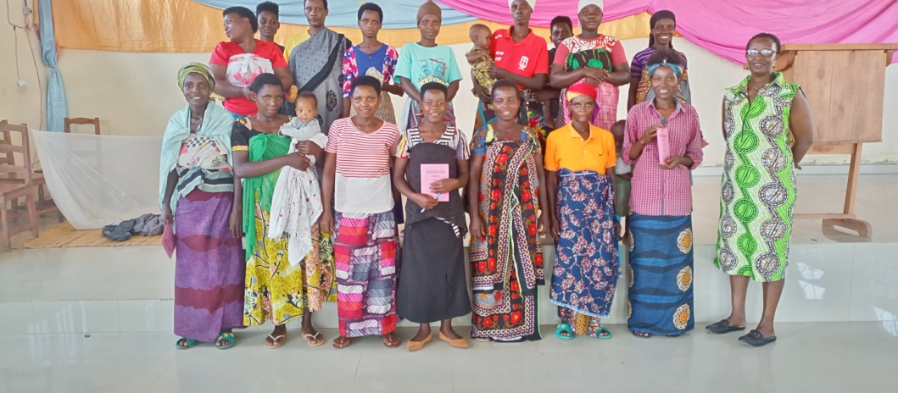

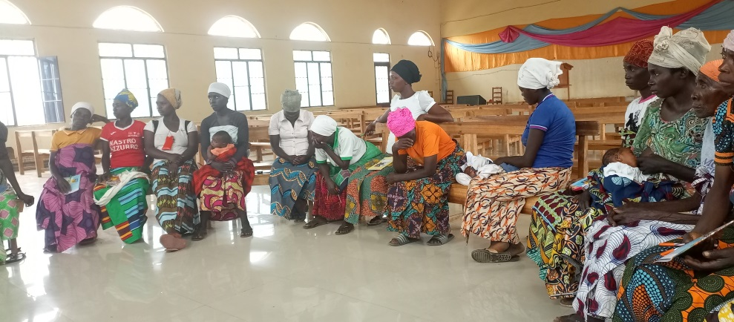
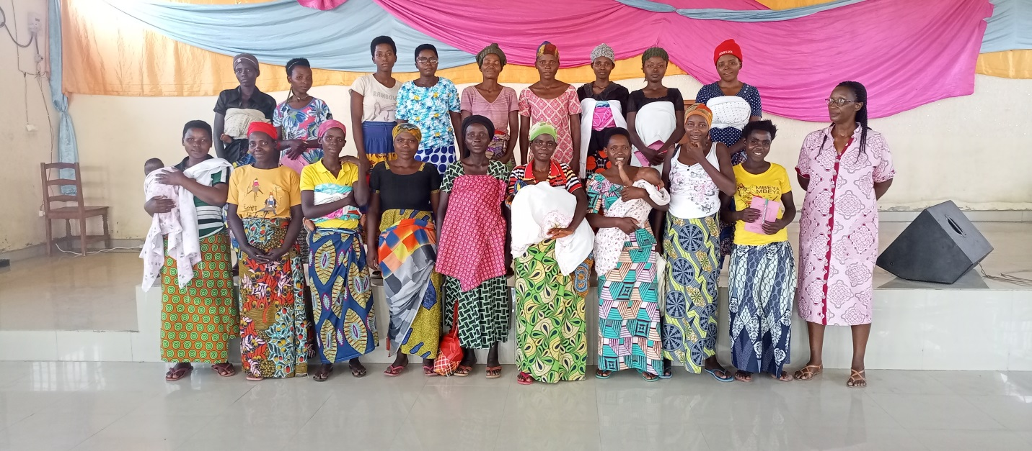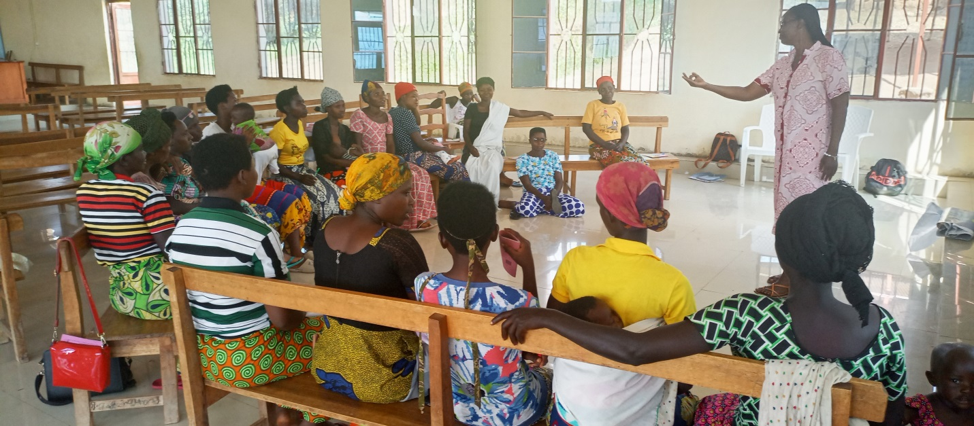
June 2023 Stories
“I never tasted love in my marriage. We worked together to get money. I used to spent the day working in our restaurant, when I came home tired, he threw at me traumatic words. He used to tell me that he will kill me one day. Sometimes he showed me the photos of his girlfriend. It was the way to show me that I am useless.
He sold the plots of land we had by changing my identity. He removed the photo and put the photo of another woman who signed using my identity.
He kicked me out of his house and my family gave me a plot of land where I built a house. I welcomed him into my house, but he wanted me to register him in the papers of my plot and I refused. That's how he left me. He took everything we had in the house and all the equipment we used in the restaurant. He left me with 7 children that I must feed.
I want to tell you that my heart bleeds, I'm afraid to stay alone because of the pain. I used to be surrounded by people because the time of loneliness, I live the worst. This training is like a refuge I want to stay here even if it's impossible”.

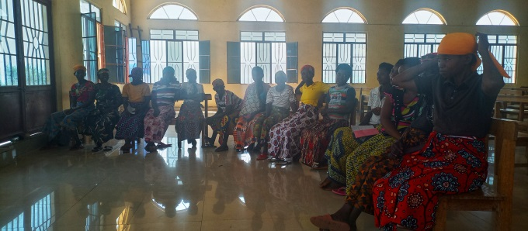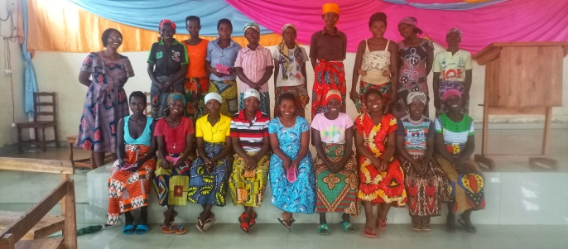
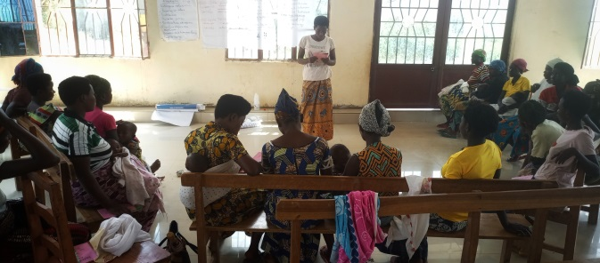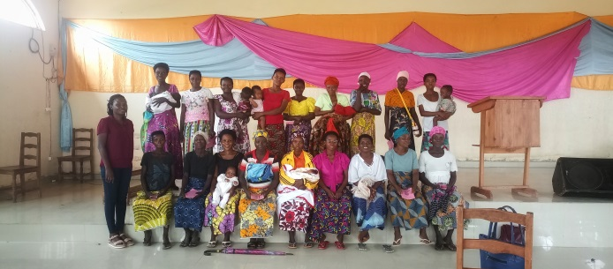

- Self-Help Groups (SHGs) and Income generating Activities

At the end of July 2023, we had a total of 159 SHGs in Kamenge, Bujumbura Mairie province for a total of 3763 women and 43 SHGs for 1063 women in Nyabiraba commune, Bujumbura province

- Income Generating Activities
Income generating activities have continued. There was field visit for the Growing Wheat Project initiated by two SHGs in Nyabiraba whose members are from the Batwa ethnic group.
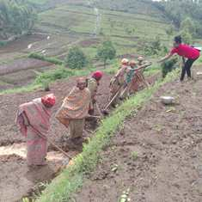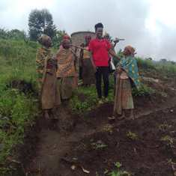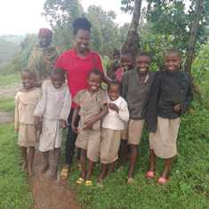
Chanelle, one of the FWA staff visiting both the groups and their children

- Street Business School
Street Business School is on a mission to end generational poverty by empowering women as entrepreneurs. We equip women living in poverty with the knowledge they need to build sustainable businesses and we empower them to believe in themselves and seize opportunity.
In the month of June, two workshops were done in the execution of the SBS program. The first workshop was based on introduction of the SBS to the participants, the recruitment and the survey with regard to their economic situation.
The second day was devoted to the first Module: “Getting out of your comfort zone” which prompts participants to try something that is new and may be uncomfortable and scary.

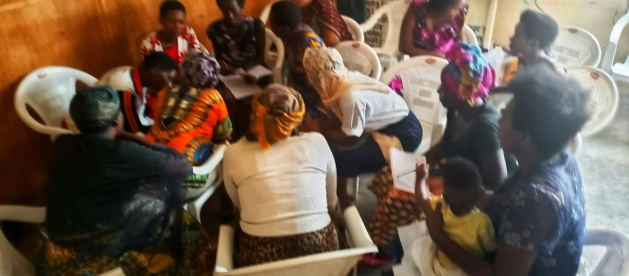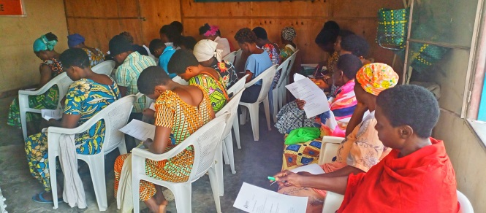
In the month of July, one training session on SBS was held where we discussed about Module 3; “Finding Capital and Starting Small “ Participant were able to understood what is capital, What 4 resources make up capital, What is good way to raise revenue for your business and What does “starting small” mean.

