Shaji
Ellumannam P O , Edavaka – 670645

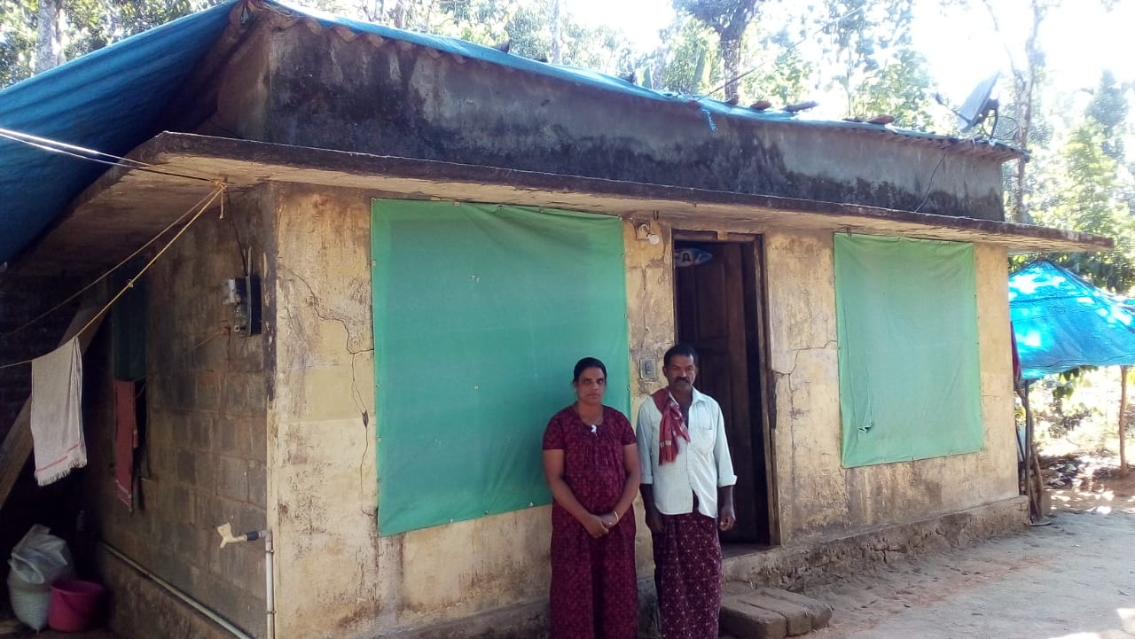

Shaji aged 52 yrs living with his wife and two children’s. During the flood the water had logged into the house and made the whole structure weak and was not in a living condition. The walls might collapse any moment, there were plenty of cracks, which has been developed due to the dampness. During the floods “Project vision” had given them temporary shelter and the panchayat house from the life mission was rejected since the structure was not collapsed. They hold a BPL card and have 20 cents of land in their name. They were still holding on to the building because they have 2 grown up daughter’s aged 20yrs and 18yrs. Shaji works as daily labour for their livihood along with his wife. Children’s are studying and are almost reaching out to be married off. Shaji’s wife shared her grievance saying that they have taken loan for their children’s education and very soon they will have to be married off. Without even a shelter it’s very difficult for them to live a normal life.
Our request for a house to this family was based on their financial condition and looking into the parents situation to meet their daughters education and marriage, which will never get them to dream a house for themselves. Even to get the daughters married off, they might need the house in the first place. Now since their request for a government support has been denied it was our intervention to help them provide a normal house and support them live again.

A project was submitted to Focolare foundation and kerala club. Project vision got funds for 3 houses of these kinds. We managed to build these houses in four months time. The house consisted of 550 Sft area with a living room and 2 bedroom with a kitchen and a toilet. The houses were handed over to the family on the 7th of July 2019 by the sponsors in the presence of the panchayat president and many more…

The joy in lighting up these families life inspired us to bring more number of such houses for the deserving family who had lost their houses during this flood.
Please find the photos of the house and the family members sharing the happy moments…….