Pictures for “A CRY FOR SUPPORT FROM A DISABLED PERSON IN K.G.F”

(A Project by Balajothi Centre for the Disabled - # 38220)

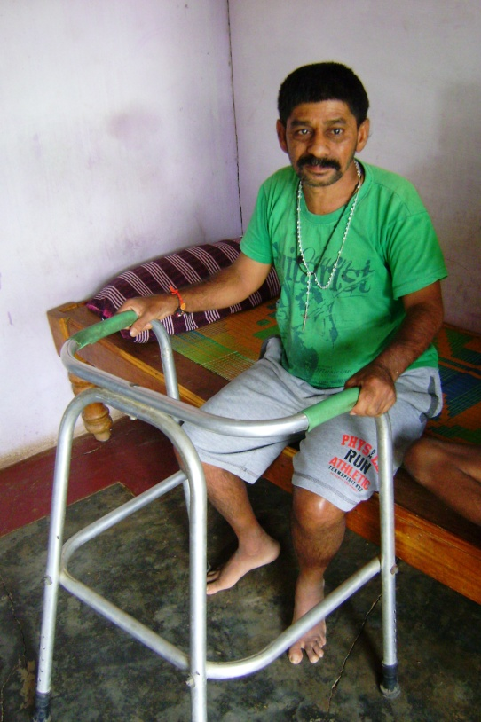 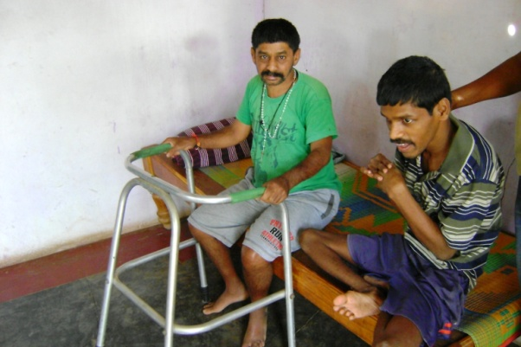

Picture of the person you helped to undergo operation. Picture on the right is that of his brother, also 100% disabled. Both need your support.

\*\*\*