Quarterly Report
July-August- September 2023

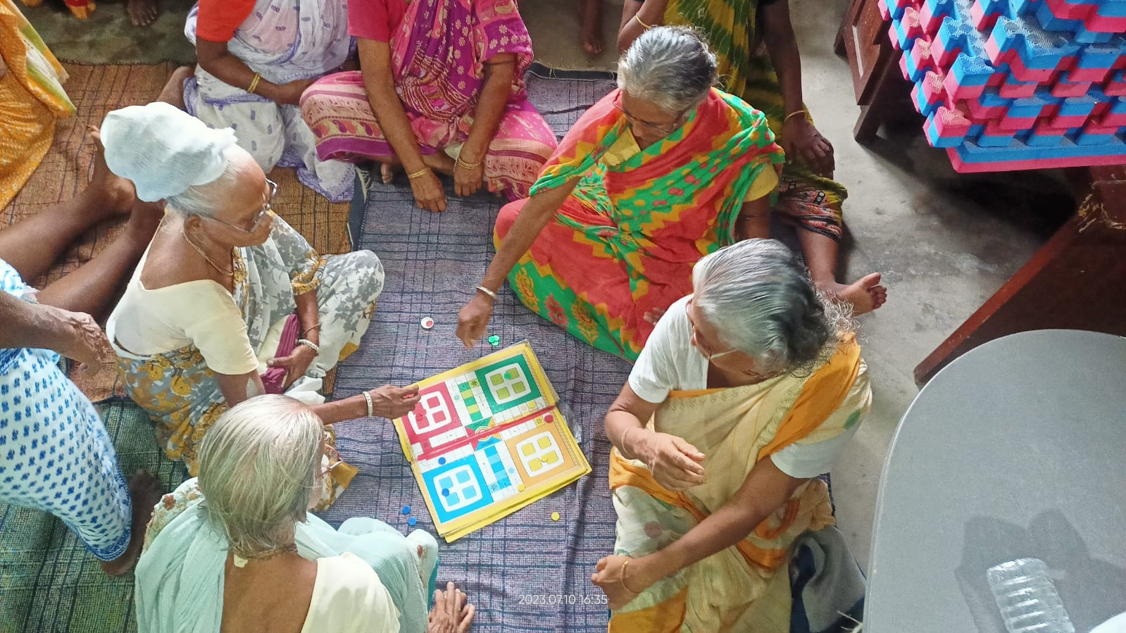



Implemented by
Centre for Health and Social Justice

Supported by
Global Giving

Introduction
Indian society is undergoing rapid transformation in terms of socializing urbanism and industrialization. Also lack of geriatric care or a specific drive for caring for elderly people are not popularized in India when the elderly population of the nation is massively growing fast and may reach 18% by 2036. In this milieu Centre for Health and Social Justice is working for the elderly people to support them to lead a healthy and fulfilling life. For the past seven years, CHSJ has been running drop-in centers i.e., daycare center in marginal communities for elderly people living in social and economic vulnerability. Currently, seven such centers are running in five marginal urban communities of the Kolkata metropolis and a new center is operational now. CHSJ supports 300 elderly women with psychological well-being support, health support, and nutritional food support through these drop-in centers.
Highlights

- Nutritional food support was provided to elderly women – Approx 12,753 food packages were distributed
- Two Health Camp was organsied for 150 elderly women. Their blood tests, thyroid tests, and blood pressure measurements were done during the health camp.
- Elderly women benefitted by getting linked to the government’s old age and widow pension schemes – Approximately 35 women
- Initiated dialogue between government pension office highlighting issues faced by the women in regards to government schemes. Approximately 150 women were accompanied by the CHSJ team to the government office.

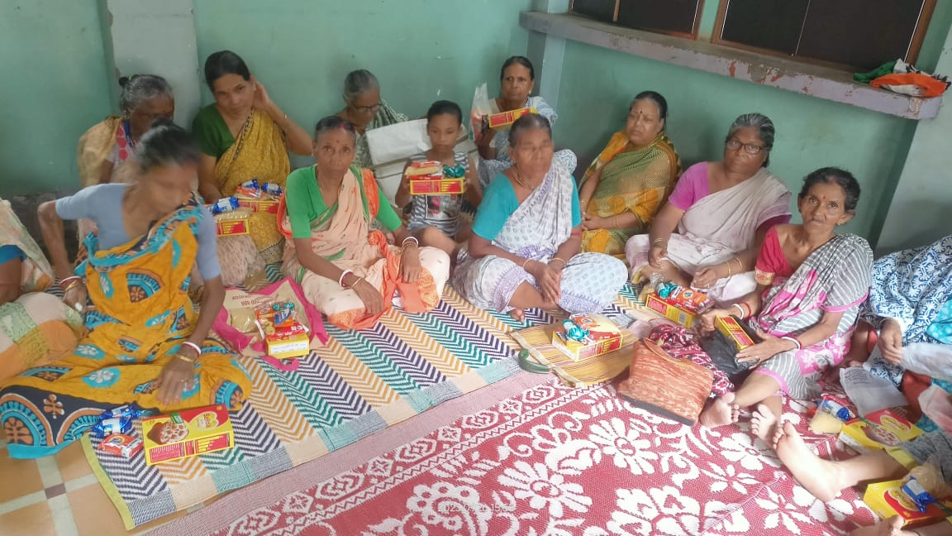
Major activities

Food Support
One-fourth (https://www.wfp.org/countries/india ) of the worlds undernourished people lives in India. According to the Govt. India has secured a massive record in producing cereals (https://pib.gov.in/PressReleasePage.aspx?PRID=1894899)in the last financial year but India is also securing an alarming position in global hunger index (https://www.globalhungerindex.org/india.html ). Through our filed level activities of last two decades, we have observed that the elderly people are one of the most neglected in the country irrespective of gender, caste and class. While the economically empowered section of the elderly people can seek justice according to the Maintenance and Welfare of Parents and Senior Citizens Act, 2007 (https://socialjustice.gov.in/writereaddata/UploadFile/83211672138255.pdf) , but the economically weaker and the marginal section have less access to this supportive measure of the Government. The post covid joblessness and economic vulnerability has created a more increased practice of negligence to the elderly people of poor families. In between September 2022 to March 2023, volunteers were active in distributing nutritional food items to the elderly women. A total number of 12753 (Twelve thousand seven hundred fifty three) food packages were distributed to needy people. The package mainly includes easy to digest dry food rations.
Health Camps
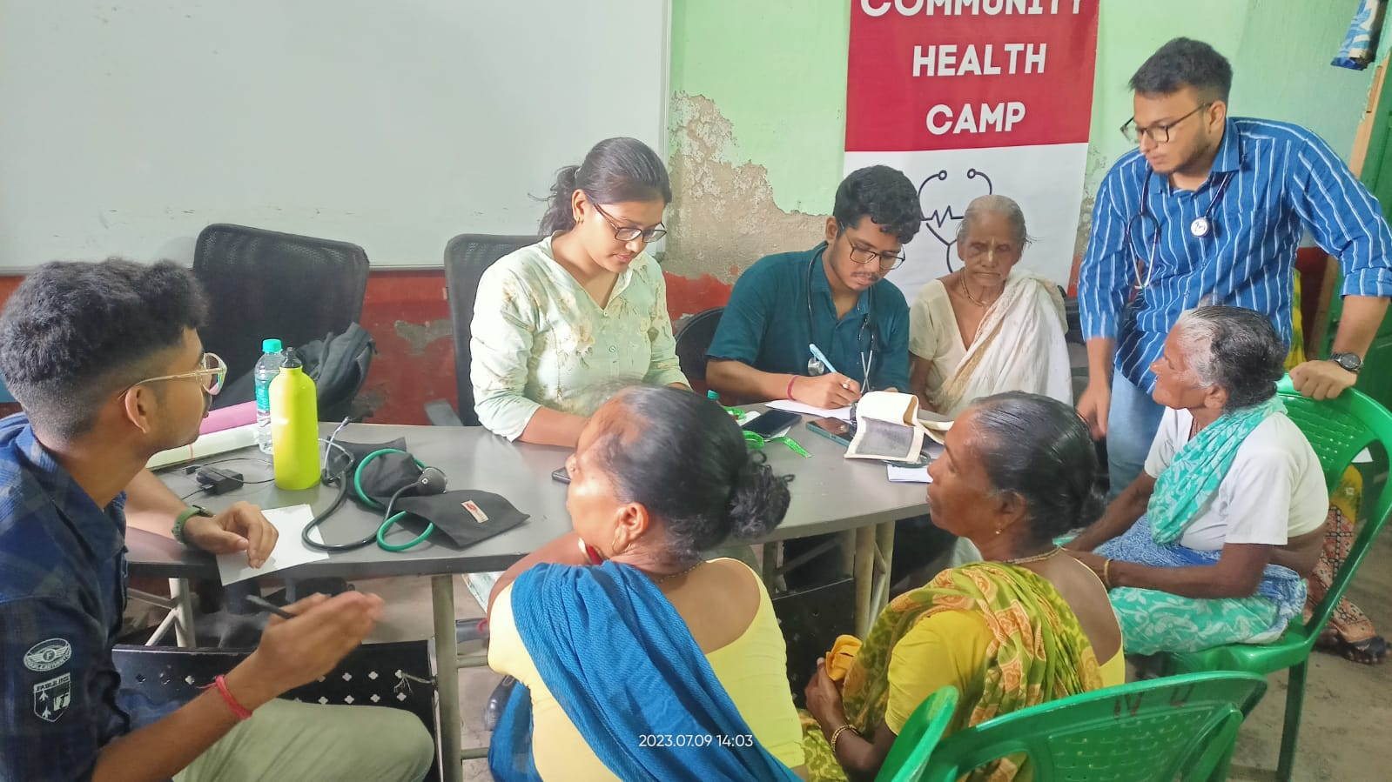
CHSJ in partnership with the South Asian Medical Students organised two health camp where almost 150 elderly women got the support from the reputed medical practitioners and medicinal support has also been provided. According to the medical experts present at the medical camps, hypertension, glaucoma, hyperglycemia, arthritis, and issues over bone density are the major medical concerns that elderly women are facing nowadays besides malnutrition and lack of proper medicinal support.

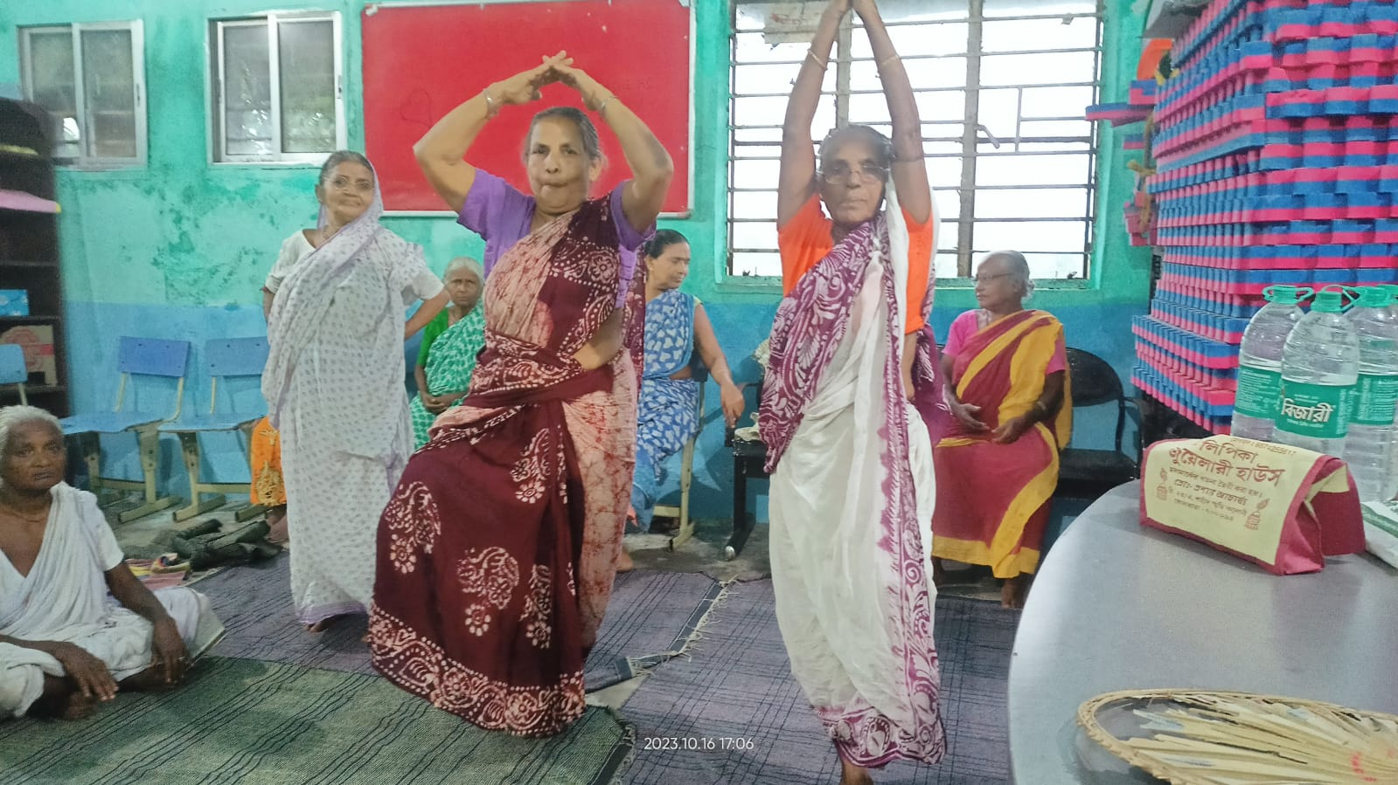
Wellbeing

CHSJ conducted 325 sessions of wellbeing activities with 1294 attendees in this period. Beside supporting with the nutritional food items daily, wellbeing activities are the most needful essential for the elderly people living with different vulnerabilities. In the seven elderly women’s daycare centers for 300 women located in five urban slums of the Kolkata metropolis, three center assistants are working to facilitate well-being activities like Yoga, Indoor Games, Storytelling Competitions, Recalling the beautiful events from the past days, birthday celebration, etc.

Inclusion-Enrolling Elderly Women with Government Schemes
Enrolling the names of the elderly women in the available government schemes is one of the most prior activities in this drive. During this quarter, the elderly women were aided with accessing entitlements such as widow pension, and old age pension from the government. The team has reached out to government agencies and officials for the new registration of widow pensions, and old age pensions for 150 elderly women. During the period, 13 elderly women were linked to the old age pension, and 15 applications for the same were submitted for new registration. 7 women were linked to the widow pension and 3 elderly women were guided and accompanied for opening bank accounts. During the period a survey conducted A survey conducted in 5 marginal communities where more than 150 elderly women were identified who did not have access to any government schemes.

Challenges
- After screening at the health camps organsied by CHSJ, old age women who have serious health issues are referred to hospitals that can provide better care to them. Most of the time, these referrals from one government hospital to another create problems for elderly people and voluntary organisations like us
- We are trying to include the names of the elderly people in the social welfare schemes of the Govt. as much as possible, but slow and lengthy work procedures of the Govt. offices are real issues we are facing.

A Case Story
A lost life dreaming for a better tomorrow: Story of Mira Pramanik
“ You may write me down in history
With your bitter, twisted lies,
You may trod me in the very dirt
But still, like dust, I'll rise.”

Maya Angelou, Still I Rise, 12th August 1978

In her poem, Maya Angelou wrote about the urge to create the world in her own terms being a prisoner of conscience again and again. Being defeated by social dilemmas and being crushed with sorrow, life moves on for a better hope. Unfortunately for some, this kind of situation comes again and again to life. Mira Pramanik of KP Roy Lane, Kolkata is a living example of such a spark described in the poem. Mira’s life is full of ups and downs, but Mira rises, Mira never says goodbye to the struggle, rather she develops a strong bond with the co-fighters like her.
Mira migrated from Nadia district of West Bengal to Kolkata at the age of eighteen. Mira’s husband was an unorganized sector worker and a serial domestic abuser who had a practice of beating Mira to blood at any time of the day regularly. Mira lives alone and she needs financial and medical help. Dida Centre in KP Roy Lane is her only resort.
Presently Mira comes to the KP Roy Lane Dida Center and talks to everyone and feels better emotionally. At the KP Roy Lane she dances, sings, tells stories, laughs and enjoys fun moment with her friends at the center. She said that the food provided by the center is very beneficial for her, she does not have to starve for these foods provided by the center on a regular basis.
But let us again focus on the reason why Mira’s life is quite similar to the poem of Maya Angelou’s poem. Mira has been living in the KP Roy Lane area for more than 30 years, she can't pay for the electricity in the house she lives in due to the tremendous economic crisis. Some politically motivated local boys in that area beat her up and kicked her out of the house to occupy her house to start unsocial activities. Dida Center volunteers along with the Samadhan Dal members reached out to her. Immediately a complaint was registered by the Samadhan Dal members (Samadhan Dal is the women’s collectives of CHSJ at the area. CHSJ is currently running 25 Samadhan Dal in 25 Communities with more than 600 domestic workers. Samadhan Dal acts as a support group for elderly women in the localities) in the local police station. Police rehabilitated Mira at her home by escorting her. Police officials also arranged a support system to provide daily food to her. A free electric lamp was also set up by the local police station at her home. It's an example of how the Dida Centre is working for a comprehensively developed and equitable second inning for elderly women.
