Six Monthly Report: Supporting Elderly Women in Health and Nutrition

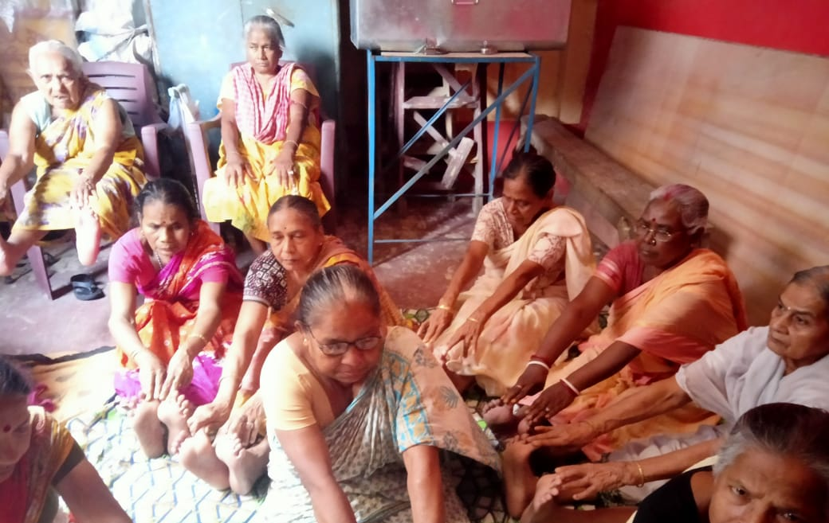

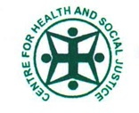

Implemented by
Centre for Health and Social Justice

Supported by
Global Giving

Introduction

Centre for Health and Social Justice is running seven Elderly Women’s Drop-In Centers in five urban poor settlements in Kolkata. Almost 300 poor elderly women are members of these centers and they visit these centers regularly. In this quarter nutritional food support was provided to the elderly women and linked them to government schemes. Major activities and highlights are below

Highlights

- Nutritional food support was provided to elderly women – Approx 11,500 food packages were distributed
- A Health Camp was organsied for 70 elderly women. Their blood tests, thyroid tests, blood pressure measurements were done during the health camp.
- Elderly women benefitted by getting linked to the government’s old age and widow pension schemes – Approximately 20 women
- Initiated dialogue between government pension office highlighting issues faced by the women in regards to government schemes. Approximately 60 women were accompanied by the CHSJ team to the government office.

Major Activities

Nutritional Food Support: According to the UNFPA data, the nutrition gap is one of the main issues for the elderly poor living in developing countries such as India. The post covid joblessness and economic vulnerability have created an increased practice of negligence toward the elderly people of poor families. Between September 2022 to March 2023, CHSJ has been distributing nutritional food items to elderly women. By providing nutritious food items, CHSJ is directly addressing a crucial aspect of the elderly women's health needs and contributing to improving their overall quality of life.

Health Camp: In collaboration with the South Asian Medical Students Association, CHSJ organised a health camp between September 2022 and March 2023, providing valuable support to 70 elderly women. Receiving assistance from reputed medical practitioners and access to medicinal support is undoubtedly beneficial for these women.

The medical experts present at the health camps identified several major health concerns prevalent among elderly women during that period. These concerns included hypertension (high blood pressure), glaucoma (an eye condition that damages the optic nerve), hyperglycemia (high blood sugar levels), arthritis (inflammation of the joints), and issues related to bone density. In addition to these specific medical conditions, malnutrition and a lack of proper medicinal support were also identified as significant challenges faced by elderly women. Identifying these health concerns through the health camps is an essential step in addressing the specific needs of elderly women. By focusing on these areas, it becomes possible to improve the overall health and well-being of elderly women, ensuring they receive the necessary care and support to lead healthier lives.

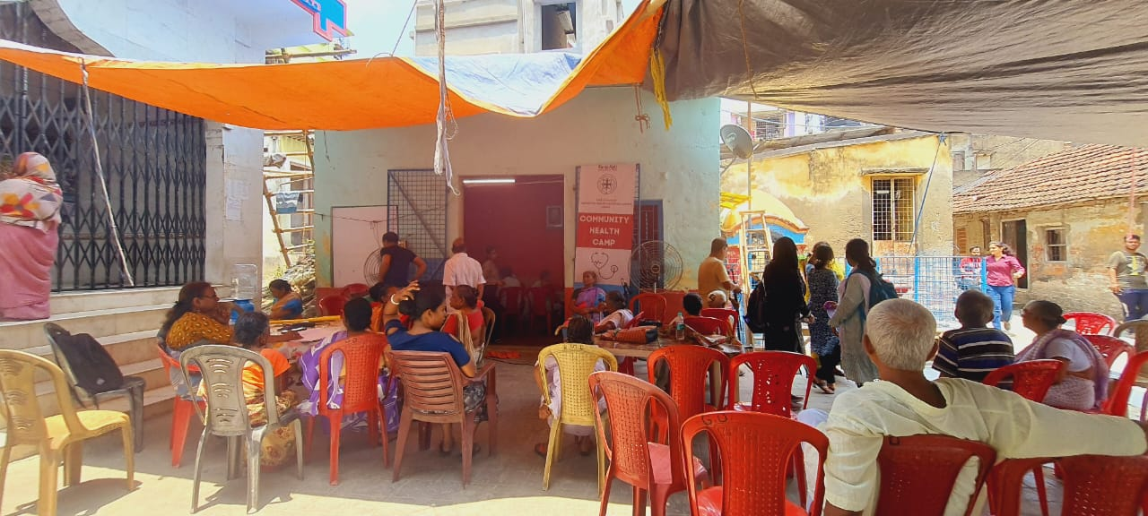
Health Camp Organised for Elderly Women

Wellbeing: Apart from nutritional food intake in food items, well-being activities are equally important for elderly people living with different vulnerabilities. CHSJ is taking care of 300 women in five urban slums of Kolkata. Through these centers, well-being and recreational activities were conducted. CHSJ also celebrates important days like birthdays, women’s days, etc. with the elderly group members.
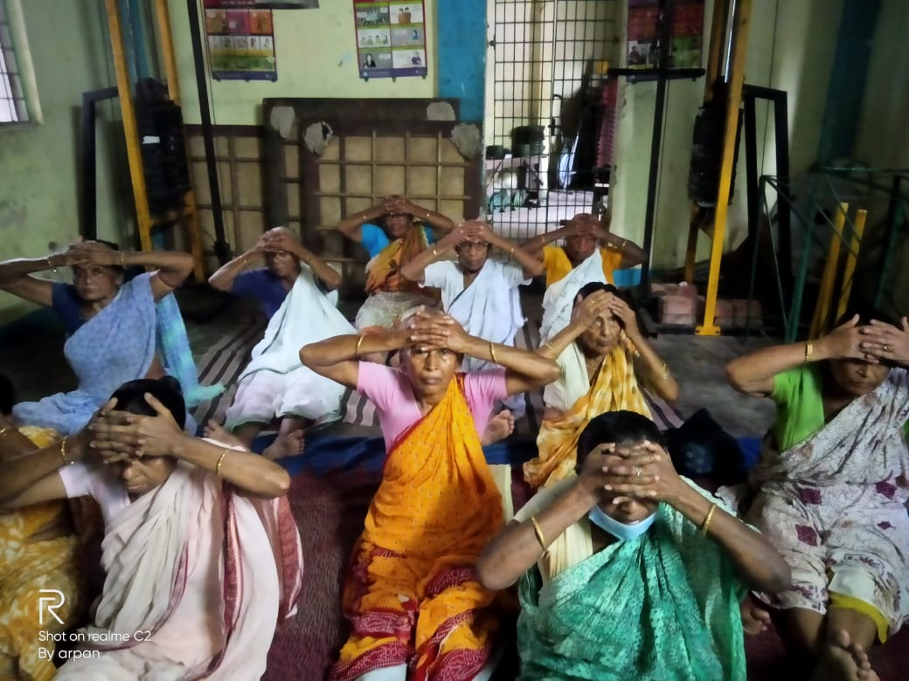
Elderly Women Practicing Yoga in a DIDA Centre

Ensuring financial stability through enrolling women in government schemes: Registering the names of elderly women in the available and eligible government schemes is one of the important activities of this initiative. During these six months, the elderly women were aided with accessing entitlements such as widow pension, and old age pension from the government. The team has reached out to government agencies and officials for the new registration of widow pensions, and old age pensions. The team has contacted government agencies and officials for the new registration of widow pensions for 170 elderly women. During the period, approximately 20 new registrations were done under the elderly women and widow scheme. Three elderly women were guided and accompanied to open their bank accounts. With our intervention, 60 elderly women collectively moved to the ward office and discussed their rights to pension under the Government Pension Scheme.

Life-Changing Experience of Joymala Halder

That's a remarkable story of resilience and overcoming adversity. Joymala Halder's journey is truly inspiring. Despite being forcefully married off at a young age and facing numerous struggles as a Bangladeshi refugee in Kolkata, she persevered and worked as a wage laborer alongside her husband near the Jadavpur railyard.

It's unfortunate that Joymala faced health issues with a mole behind her ear, and the local medical resources were unable to provide her with the necessary relief. However, her fortune changed when she attended a health camp organized by Parichiti, a unit of CHSJ the Sahid Smriti Elderly Women Center in collaboration with the South Asian Medical Students Association.

The medical experts present at the camp examined Joymala and recognised the seriousness of her condition. They referred her to the Chittaranjan National Cancer Hospital, which is under the government of West Bengal. Joymala visited the hospital multiple times with the help of CHSJ volunteers and underwent various medical examinations. Eventually, it was discovered that she was suffering from an early stage of cancer.

The doctors at CNCH performed an operation on Joymala and provided her with free-of-cost medicinal support. Thankfully, her treatment was successful, and she has now recovered from the disease, emerging from the danger zone. Joymala's story takes a positive turn as she currently runs a small stationery shop in front of her house, showcasing her resilience and determination to rebuild her life.
It's heartening to see how Joymala's life has transformed, from being a young girl forced into marriage and facing hardships as a refugee, to overcoming cancer and establishing her own business. Her journey serves as a testament to the power of medical intervention, support from organizations like CHSJ, and the strength of the human spirit.

The Status of Elderly in West Bengal, 2011, An UNFPA Report

