FAMILY HARVEST FOUNDATION
PROJECT PROGRESS REPORT JULY 2020
NAME OF IMPLEMENTING ORGANISATION | FAMILY HARVEST FOUNDATION
PROJECT TITLE: | LEARN TO EARN! TRADES TRAINING IN GULU, UGANDA
PERIOD OF REPORT | APR - JUN 2020
NAME AND CONTACT DETAILS OF PROJECT LEADERS: | - FRANCIS OYAT OTOO;  email: familyharvestfoundation@gmail.com  - ANNE MCKEE  email: anne.bt.mc@icloud.com
DATE OF SUBMISSION: | 2020/07/02

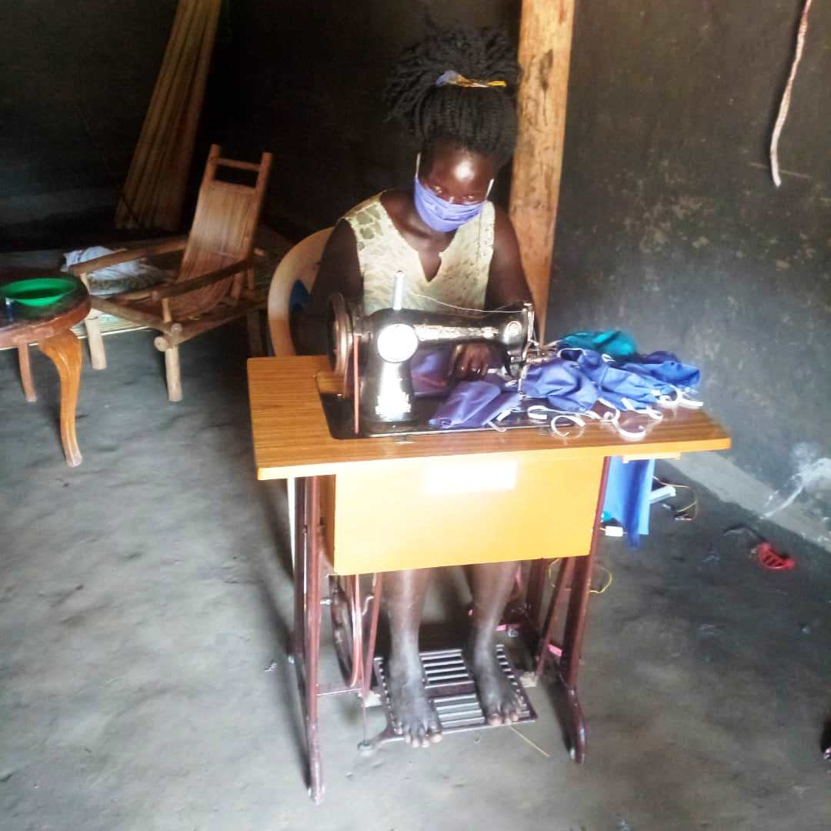
Part 1: GENERAL INFORMATION
Executive summary
Our target of providing vocational training to 90 youth from northern Uganda within 2 years has suffered yet another blow from Covid 19 other than the 20 year civil war that devastated the area. Well aware of the problems an idle youth can do from idleness, gambling, and prostitution or forming organized groups of street gangs the lockdown instituted to reduce the spread of the pandemic compounded the difficulty they are faced with thereby prolonging their economic challenges. We had considered project beneficiaries, enrolled them and were progressing well in their studies then the new of the pandemic struck in mid-March 2020. All the radio and community visits constituted the communication channels we made with the project staff and management in consultation with school heads and community leaders to advertise and attract enrolled.
We managed to attract the youth, trained them in vocational skills education, life skills survival and entrepreneurship. We had continued on with our affirmative action and enrolled 60% female youth, from the most remote areas to benefit from the project within our defined age parameters of 16 and 25.
Our livelihoods activities like on agriculture (horticulture), job creation, environmental awareness and entrepreneurship, volunteer work and public health talk constituted our routine task we carried. Before breaking-off because of the Covid 19 on 18/03/2020, 13 of the trainees received some basic training on the different skill set they were enrolled.
The funds received from parents and the balance from donor sources for school fees and other requirements continued to affect the tools and equipment, partial scholarship and tutor’s allowances, rent for the school premises.
1.1: Progress on Results
1.1.2 Progress on Activities
Project Specific Objectives | Activity area | activities | Outputs |  |  | Explanations
Project Specific Objectives | Activity area | activities | indicators | target | Actual
OBJECTIVE 1: To provide vocational skills to 90 youth from Gulu district | 1. Education and Entrepreneurship | Conducting training in hairdressing, tailoring, construction,  Catering,  Electrical installation and welding | Number of youth enrolled:  Hairdressing:  Tailoring:  Construction:  Electrical installation:  Welding:  Catering: | 90  5  5  3  5  5  5 | 0  0  0  0  0  0  0 | No activity took place within the school premises.12 phone calls were made to verify the safety and health of the trainees to their parents. 15 phone calls were made to the tutors.
 | 2. Education and Entrepreneurships | Visiting community Focal person | Number of visit | 2 | 0 | Planned but did not happen due Covid 19
 | - Education and life skill | Invited partner for health talk | Number of partner invited | 2 | 0
Objective 2: To provide educational scholarship for skills training to 90 youth | - Education and training | Training selected to benefit the youth | Number of trainees selected | 90 | 0 | Not done because of Covid 19.
OBJECTIVE 3: To procure tools & equipment , and materials for students training | - Education and training | Tools, equipment and training kits | Number of tools & equipment, materials bought:  Clothing materials bought: | 4  3 | 0  0 | It was planned but could not be implemented.
Objective 4: To pay Tutor’s allowances | - Education and training | Tutor’s teaching allowance | Months covered | 5 | 0 | Planned but none received any pay as there were no funds.

1.2: Progress towards Objectives
1.2.1 Objective 1:
To provide skills training to 90 youth with at least 60% females, in different skills trade mentioned. No progress realized as government declared a lockdown and school were all closed in the country with all the 13 trainees remained safe at home.
1.2.2 Objective 2:
To provide partial educational scholarships to 90 youth in five skills: No training took place due to Covid 19.
We received 1 donation during this report period with gross amount of USD 219.45 from a single donor on the GG donor platform being the second time.
1.2.3 Objective 3: To procure tools & equipment, and materials for students training. We did not make any procurement as there were no training allowed due to Covid 19.
1.3:0 Project continuations
1.3. 1 The post Covid 19 operations is yet difficult to determine though the existing trainees provide a good chance as they have kept in touch with the administrators of the institution. CARE International Uganda – Gulu office have expressed interest to support some trainees to take our courses when schools resumes.
1.3.2 Main activities planned for April, May and June 2020
Project Specific Objectives | Activity | Activities | Outputs
OBJECTIVE 1: To provide vocational skills to 90 youth from Gulu district. | Education and Entrepreneurship | Training for year 2 | Number of those enrolled | 0
 | Education and Entrepreneurship | Monitoring of activities | Number of monitoring done | 0
 | Education and Entrepreneurship | Register for examinations | Number of trainees who register to sit for examination | n/a
 | Education and Entrepreneurship | Number of announcements and community visits | Number of adverts made. | 0
Objective 2: To provide educational scholarship for skills training to 90 youth. | vocational skills training | Choosing new partial scholarship beneficiaries | Number of beneficiaries identified | N/A
 | vocational skills training | Fees payment | Number of youth receiving partial scholarship. | 0
Objective 3: To procure tools & equipment, and materials for students training. | Education and training | Procurement of tools, equipment and materials acquired | Number of tools, equipment and materials acquired | The lists on request persist.
Objective 4: To pay Tutor’s allowances | Education and training | Pay allowances for staff | Number of staff | 3 months arrears (Apr, May and Jun 2020).
Part 2: OTHER INFORMATION
2.1: Participation
a. We expect the 13 youth who had registered in term one 2020 to come back and complete the training.
2.3: Gender Equity
a. Gender issues remain a paramount concept in every aspect of our project and shall remain at 60:40.
2.4: Child Centeredness and Rights Based Approaches
a. We shall resume and take into consideration the approach.
2.5: Challenges, Lessons Learnt and dissemination
a. Successful and productive partnership continues to exist between GGF and FHF.
b.CARE International and VSO International have expressed interest to sponsor trainees.
2.6: Emerging Advocacy Issues:
a. No participation in any advocacy.
2.7: Organizational Changes:
a. Our ’’Learn to Earn! Trades training in Gulu, Uganda project’’ and ‘’Restart Gulu Trades School after Covid 19 closure’’, have remained active and continued to receive donations. We hope to receive the hardship micro grant due to Covid 19.
b. The Board, location staff and management structures remained in force.
c. Our website hosting and subscription plan are in suspense to no payment because of Covid 19.
d. Facebook and twitter publicity became active with a foreign supporter due to GGF name on FHF.
e. Staffs and Landlord have accumulated arrears in their remunerations for period Apr – Jun 2020.
2.8: Other Comments:
Through this partnership with GGF, FHF is bound to position itself into self-sustainable level as we plan to train the trainees’ on climate change/environment as well. One of the trainee managed to make 60 pieces of masks in the month of April 2020.

