ASHA KA JHARNA

Quarterly Activity Report (October 2021 to December 2021)

This quarterly activity report for the period October to December 2021 of Asha Ka Jharna (AKJ) special schools is aimed to depict, describe and list various activities undertaken with children, staff and community members during this period. The report also illustrates the various events organized by the organization, visits of prominent personalities, awards, honors and accreditations received etc.

- On the occasion of Gandhi Jayanti, our children at Sikar school, did Shramdaan in the school premises and locality, spreading the message of cleanliness. Along with this, the sanitation workers were also felicitated by them reinforcing empathy and inclusion in community.
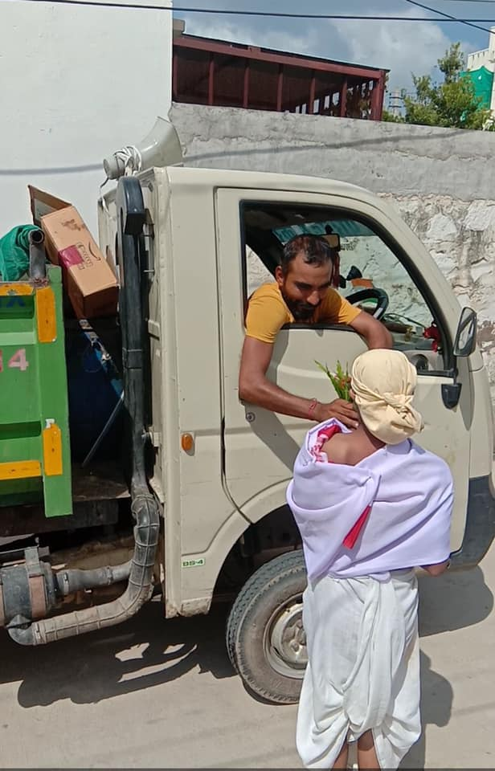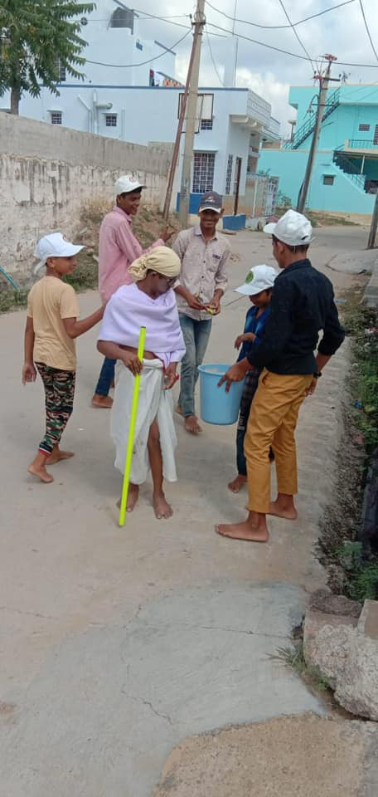

- District Level Games for Children with Disabilities were organized by Asha Ka Jharna on 7th October at Jhunjhunu. More than one hundred children with intellectual disabilities and hearing impairment from our Nawalgarh and Jhunjhunu schools enthusiastically participated in 15 sporting events including fifty & one-hundred-meter race, softball throw, shot put, standing jump, long jump etc. Chief guest of the program was Mr. Rajiv Kulhar of Social Justice & Empowerment Department Jhunjhunu who provided information about Government schemes. Wheel chairs were distributed to two persons with locomotor disability.
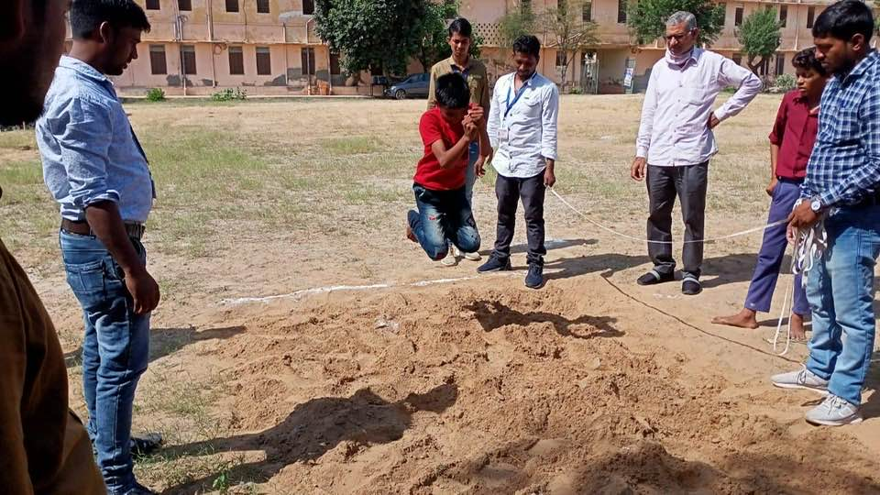
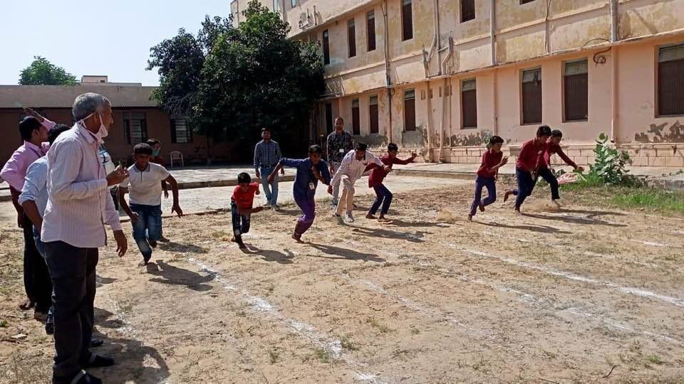
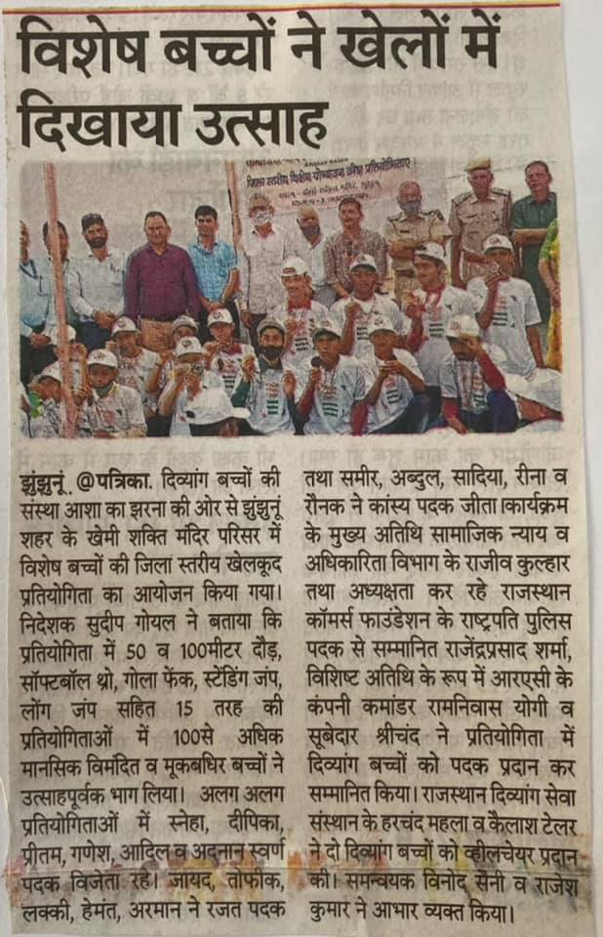

- Dance Movement Therapy workshop by dance movement practitioner Ms Nisha Purohit was initiated from 19th October. She visited regularly to our Sikar school and trained the children along with educators. Through video sessions, learnings were reinforced and practice done. There was marked improvement in body reflexes and hand eye coordination after this workshop.

- As part of convergence and outreach, we provided services of our special educator to district court as sign language interpreter.

- AKJ chief executive Sudeep Goyal attended Executive Committee meet of National Institute for Empowerment of Persons with Intellectual Disabilities (NIEPID) on 22nd October at Secunderabad (Telangana). We visited the premier institute facilities and learnt about best rehabilitation practices being followed. Meeting with Joint Secretary (Department of Empowerment of Persons with Disabilities), Director and other functionaries was very productive with many issues of organizational development, policy matters and strategic decisions discussed and constructive brainstorming done. Teaching and Learning Material Kits were distributed to persons with intellectual disabilities.

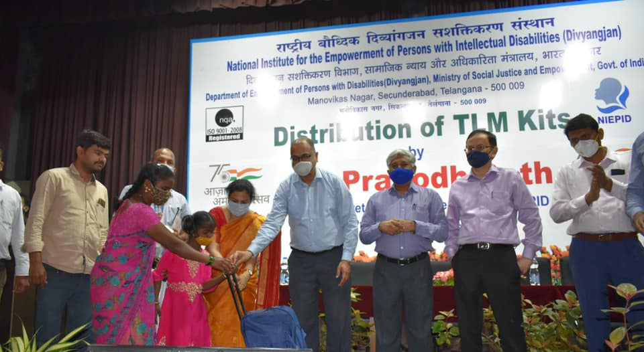

- Eight of our Children with hearing impairment took mid term examinations along with their regular counterparts at a mainstream senior secondary school as part of our Inclusive /remedial teaching program. All of them are pursuing Grades IX and X and have been progressing well. It was heartening to know that few of them scored more marks than their non disabled friends.

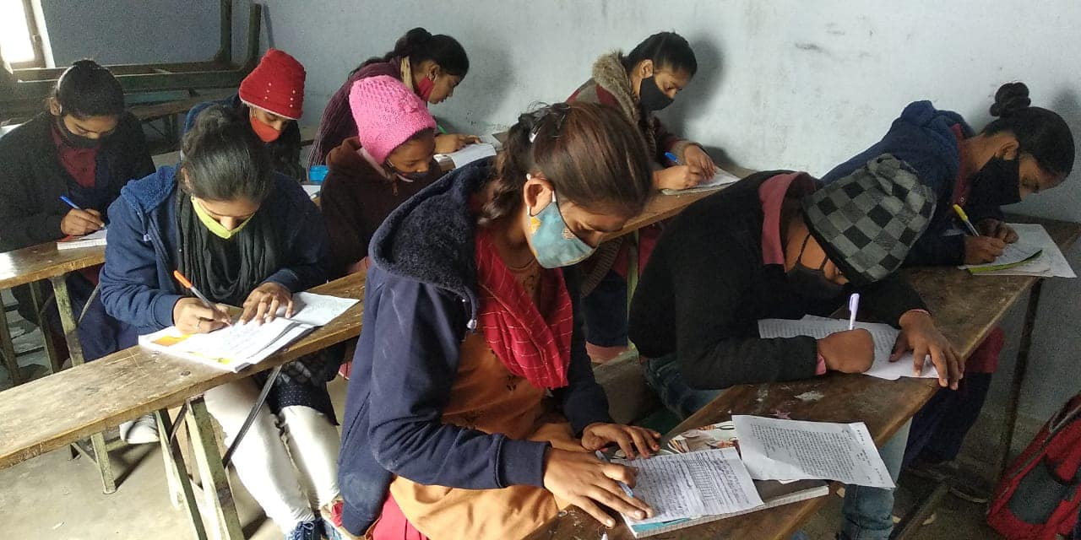
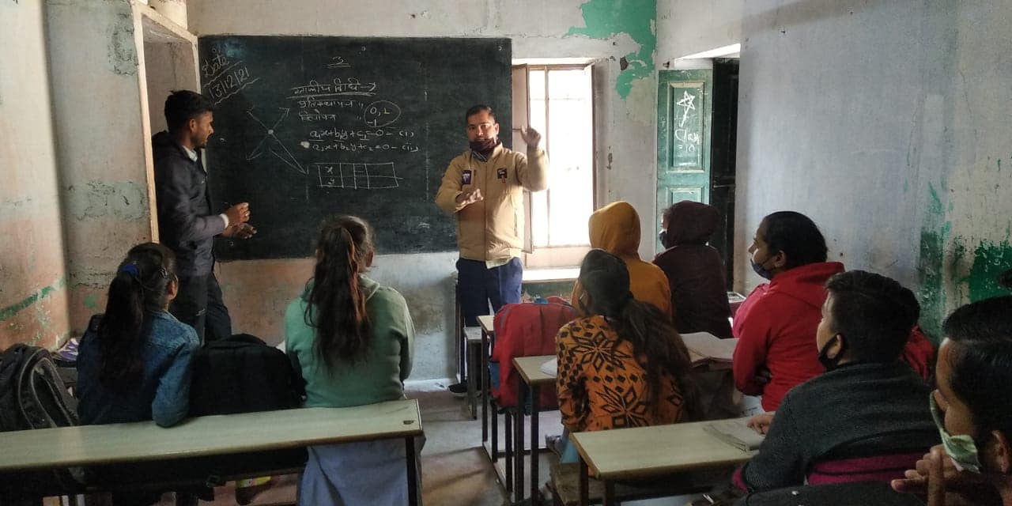

- Activities in pictures:
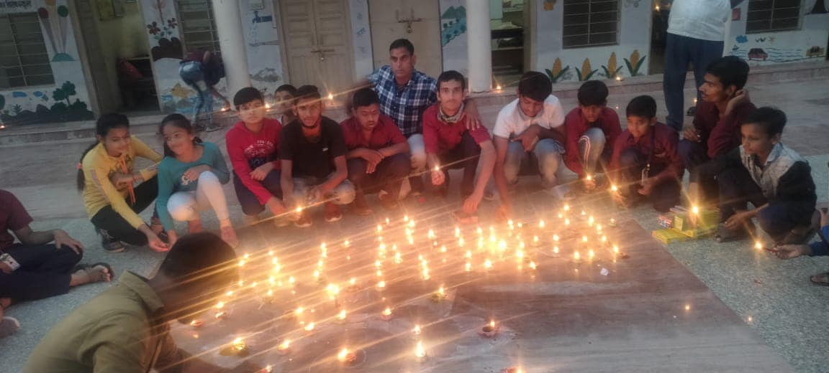
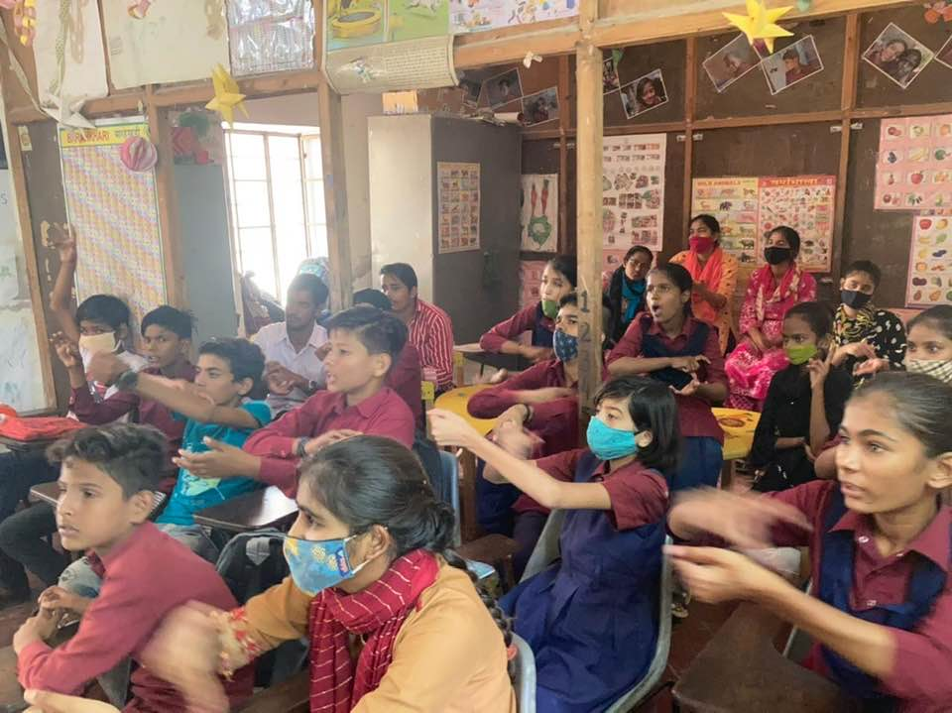
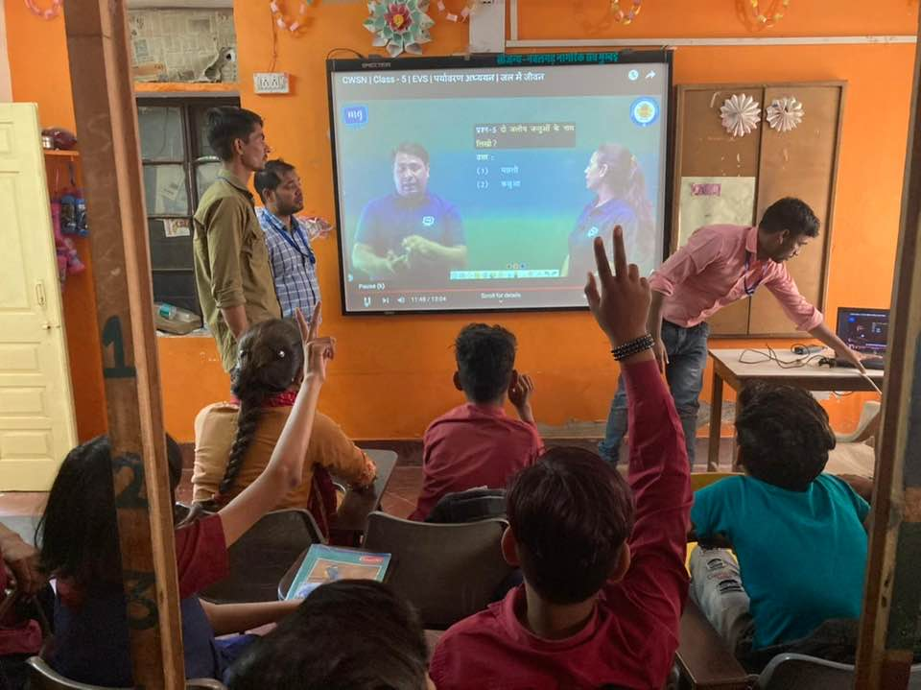
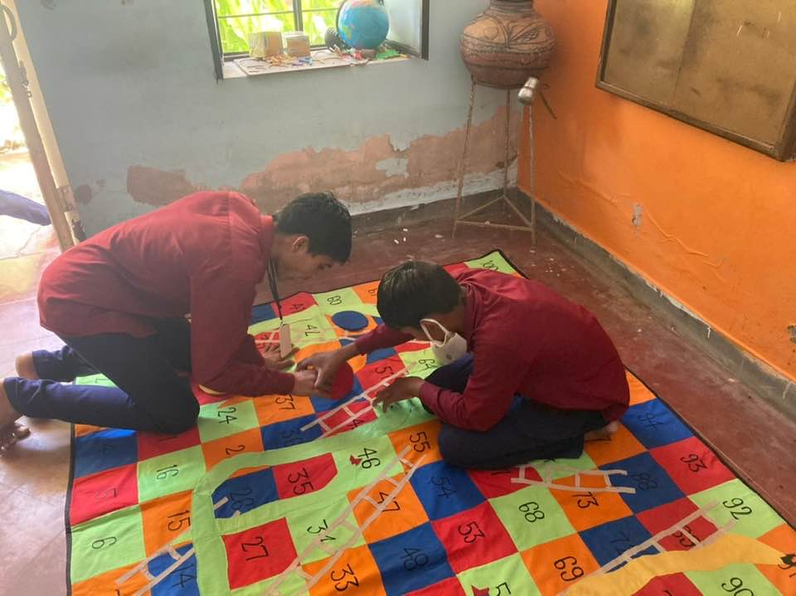
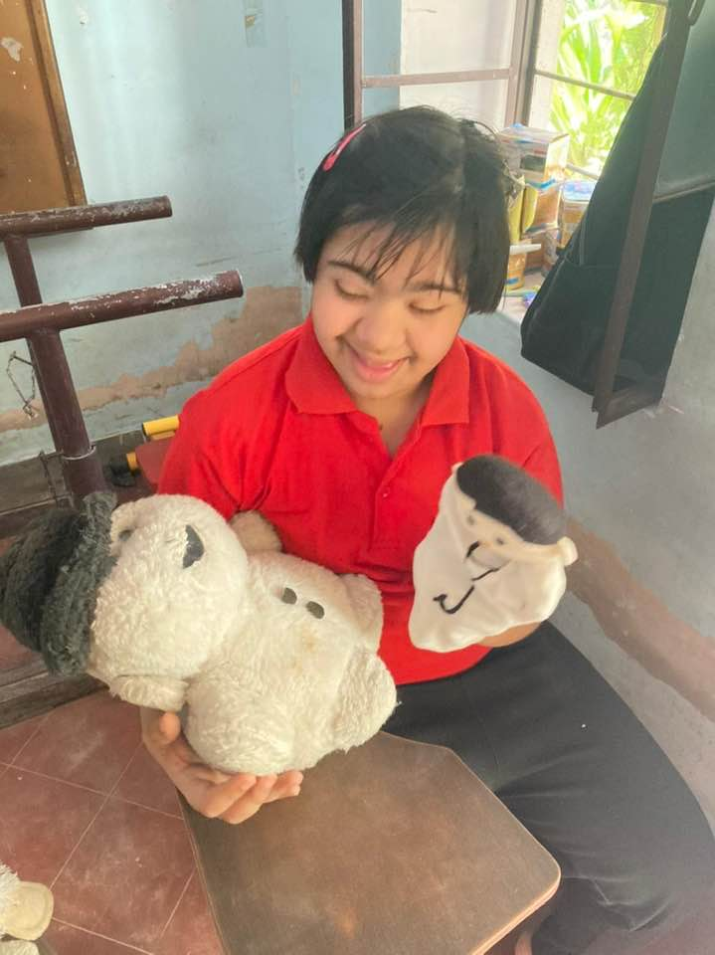

- As part of sensitization of allied stakeholders, we oriented 40 nursing trainees from MTCC Jhunjhunu about disability – early detection and intervention. On 13th November, they spent half day with our educators in the school and learnt the nuances. Most of them were only aware about physical disability and did not know about other forms of impairment one may have.

- Special Olympics Rajasthan State Selection Camp was organized at Jaipur on 14th November in which two athletes with intellectual disabilities from our Sikar school participated and assessed for Basketball and Volleyball National Games.

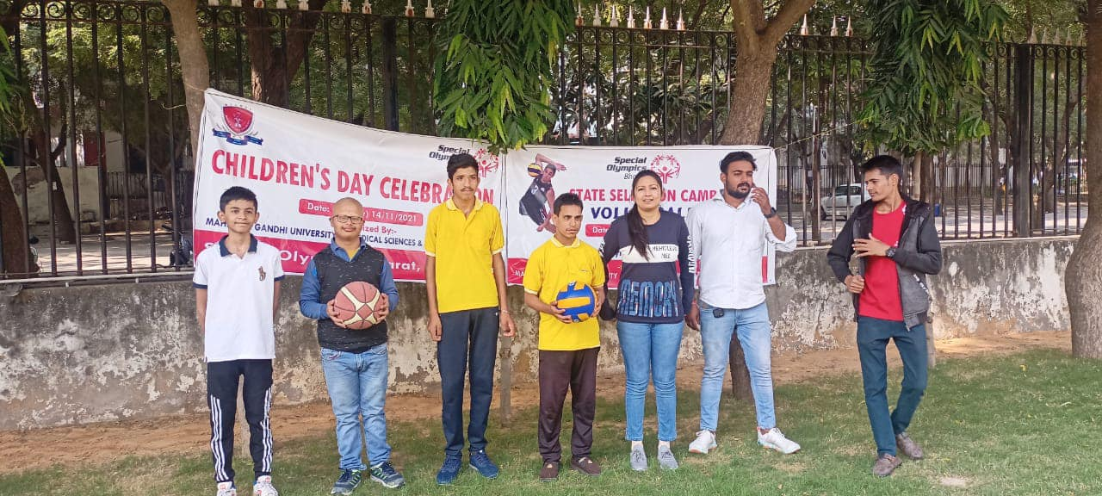

- On Children Day 14th November, Children Fair at Vatsalya Seva Samiti Raiwasa was attended by our children of Asha Ka Jharna special school Sikar who enjoyed a lot having field day. A variety of swings, clowns, puppet dance and snacks counter followed by a delicious lunch was served to them along with colourful cultural performances.

- Media as opinion maker is a crucial stakeholder and we always use this platform to raise issues concerning our sector. On 18th November, during a select invited gathering of prominent citizen, we highlighted the lack of livelihood options, non-conformity of inclusion in Govt schools and poor state of accessibility for persons with disabilities before Sh. Gulab Kothari, managing editor of Rajasthan Patrika (prominent regional daily). He assured to take up coverage of these vital issues.

- A webinar on less touched subject ‘Sexuality & Special Needs: Let’s Talk’ organized by NIEPID was attended by our educators and interactions made.

- As capacity building of other special schools, our chief functionary took opening session on a CRE program titled ‘Effective Classroom Communication’ organized by Tapovan Institute Ganganagar. More than one hundred special educators across the country participated in this webinar.

- On the occasion of International Day for Persons with Disabilities , Asha Ka Jharna in partnership with The Hans Foundation celebrated Inclusive Children Festival on 3rd December 2021 at S K School Ground Sikar (Rajasthan). We invited 250 children from 16 normal (government & private schools) as well as shelter homes for orphan children and one school exclusively for slum children. They along with 150 of our special needs children from three units participated in day long events. Day started with District Collector Sh. Avichal Chaturvedi and Deputy Director of Social Justice Empowerment Sh.O. P. Rahad along with special children letting balloons off to sky. Play cards depicting equal rights, equal opportunity, making all building barrier free under Accessible India Campaign were flashed. Following this, more than 16 sporting competitions were organized including fifty & one hundred meters race, sack race, spoon race, jalebi jump, musical chair race, three legged race, long jump, painting in which children participated enthusiastically. In all sports, both disabled and non-disabled children were there attempting inclusion. Special children also proved their talent by winning many prizes. Highlight of the day was the catwalk on the ramp and cultural tableaux of different states of India which stole the show. Children also enjoyed many amusement activities including puppet dance, bouncy swing, balloon bursting. Juice biscuits and chocolates were distributed by Digambar Jain Social Group. In the price distribution ceremony, Assistant Director Child Empowerment Ms. Priyanka Paree, Child Welfare Committee President Dr Madhu Arya, Member Ms. Reena Trihan , Vaish Samaj Trustee Sh. Suresh Aggarwal , Former CWC member Sh. Kamal Kant Sharma, Counselor Ms. Pramila Singh encouraged the children by handing over prizes and pledging to support equal rights of persons with disabilities. Trainee students of Shekhawati Special Education Training College volunteered in the event and Nursing students of Shekhawati Nursing Institute provided medical services with First Aid Box. All the children were provided with participation award and certificate. Day ended with sweet memories and fostering of new friendship with children vowing to take along their special buddy to the path of development. Feedback we received from non-disabled children validated our intended objectives of inclusion , sensitization of young citizens & showcasing talent of children with disabilities.
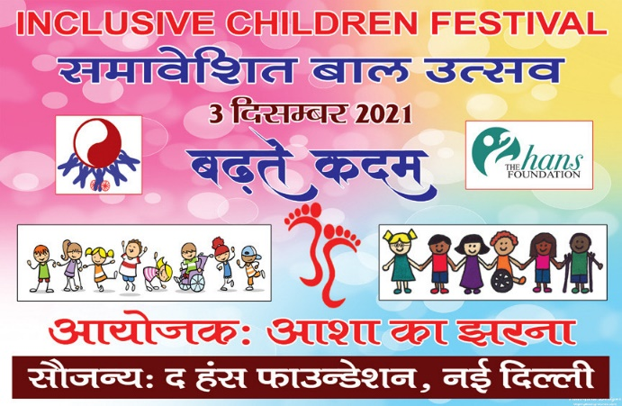
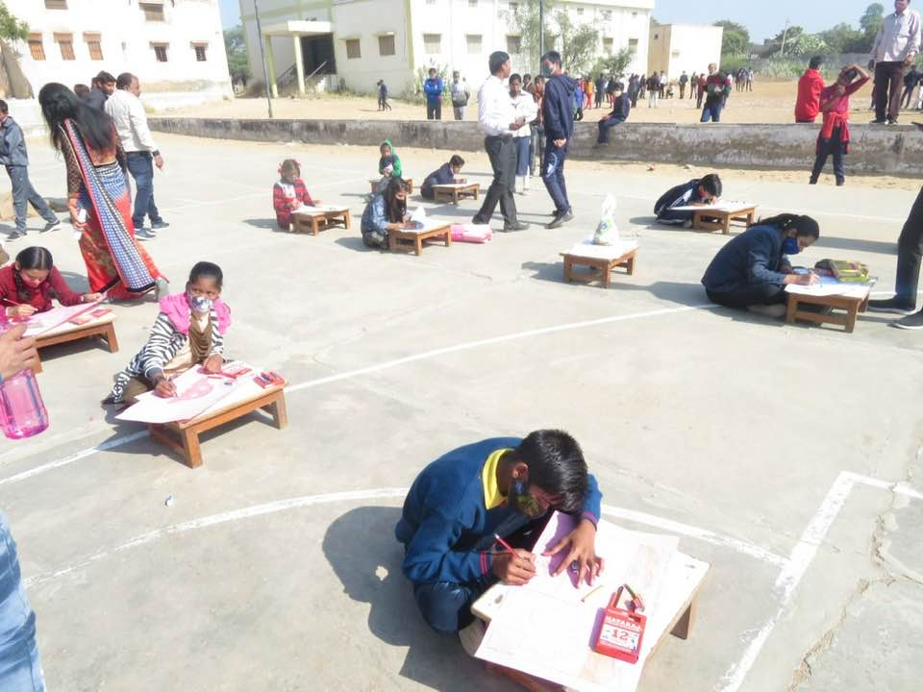
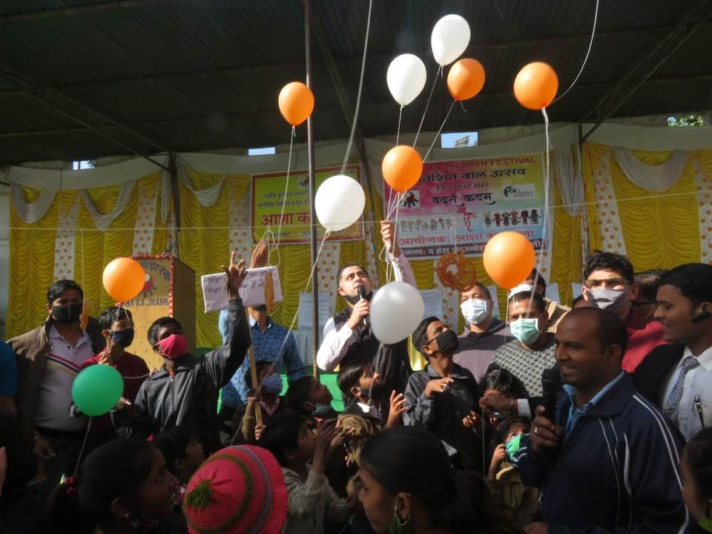
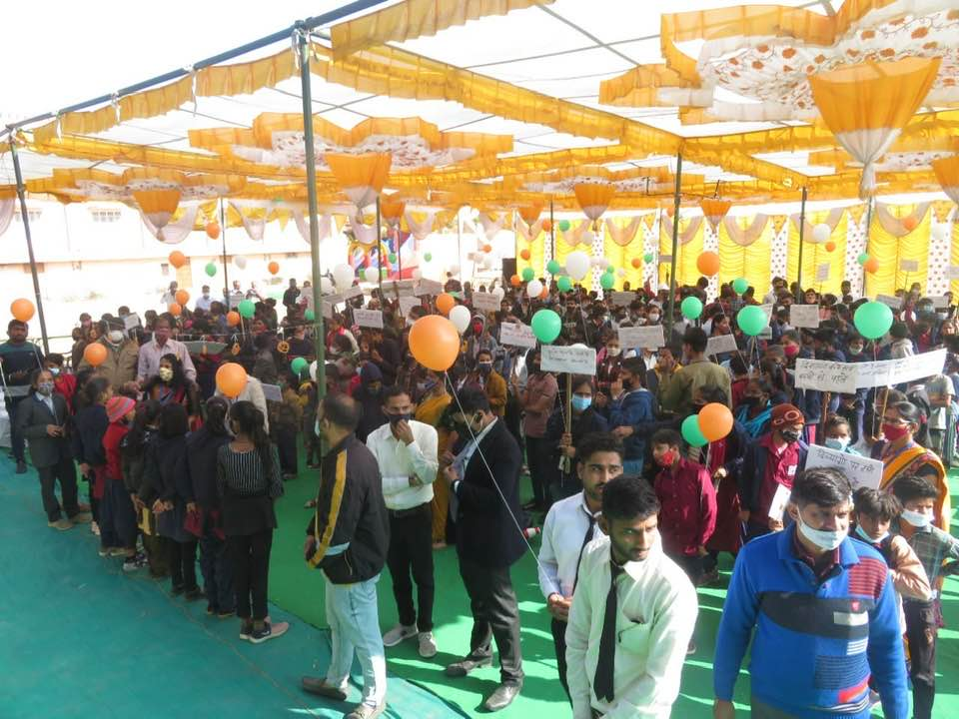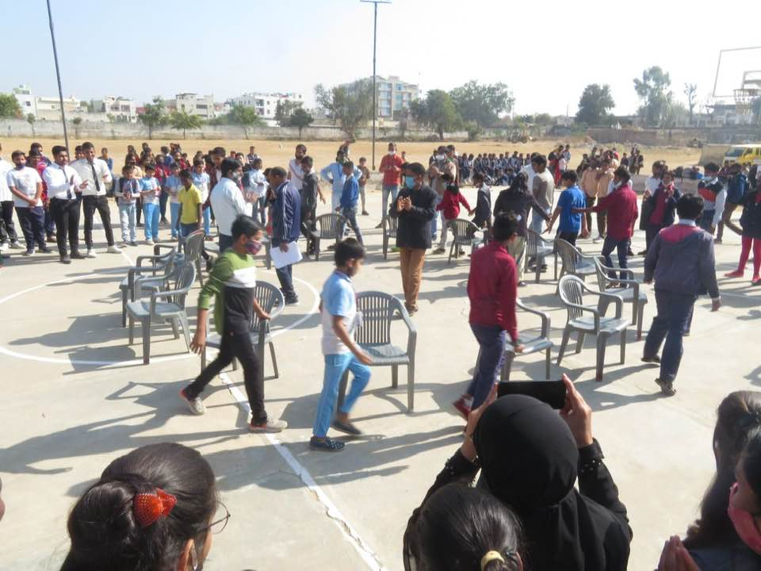
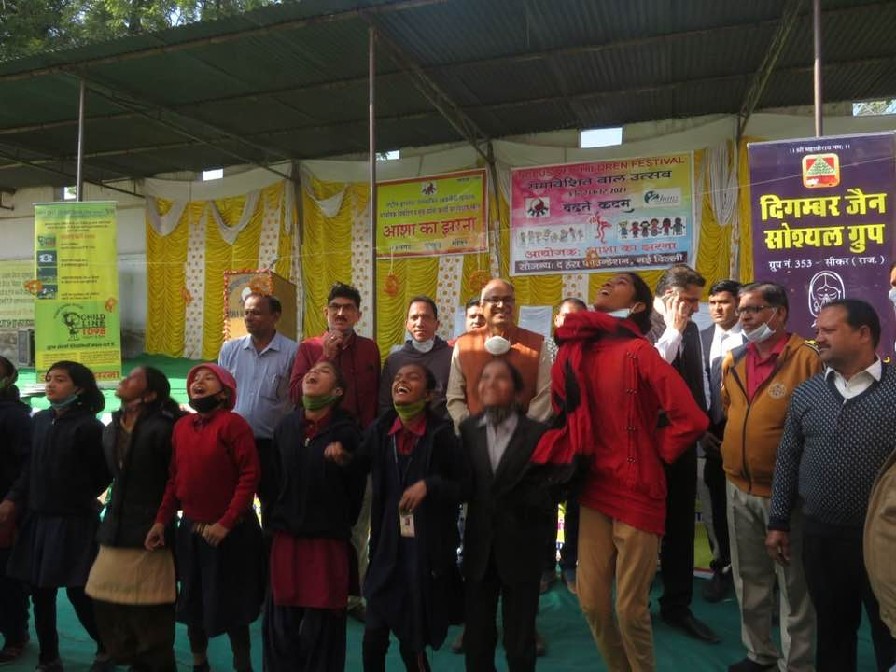
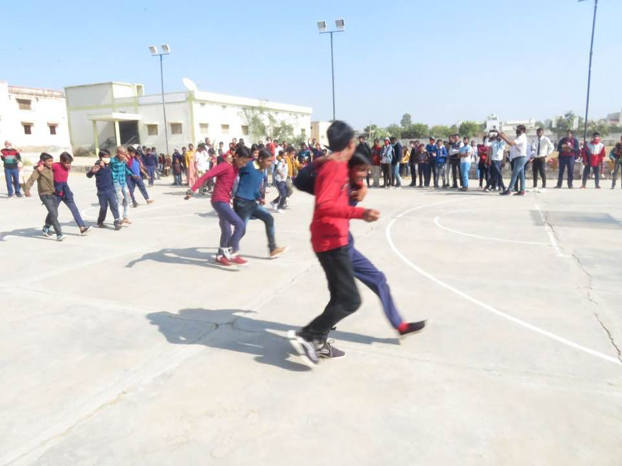
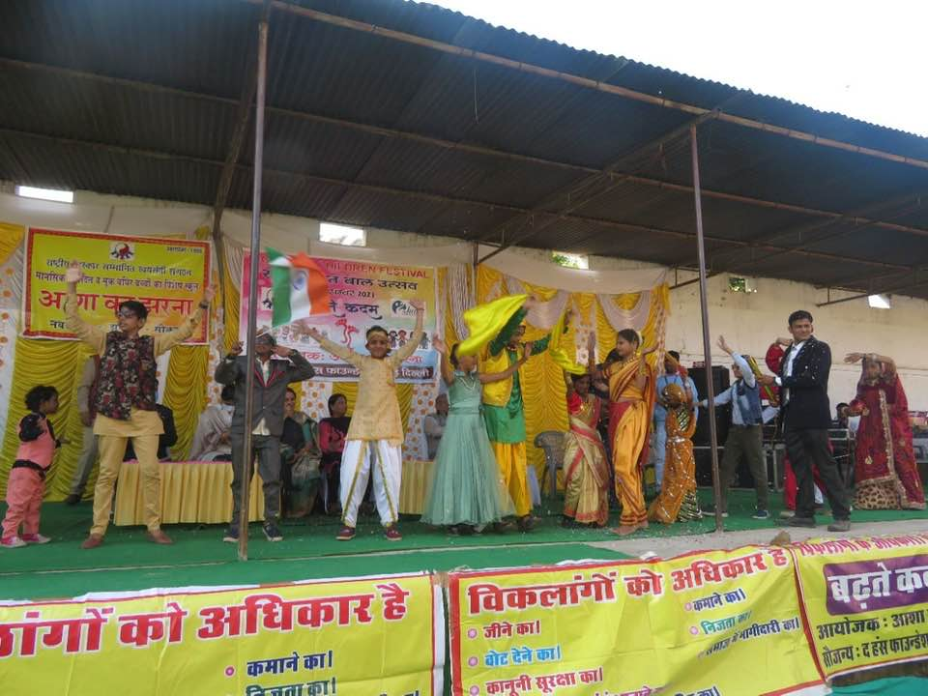
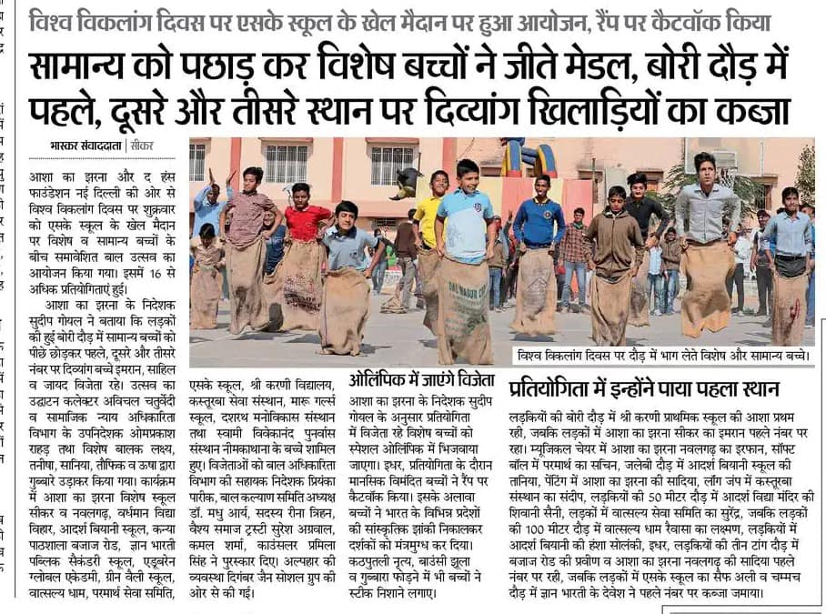

- State consultation to make Rajasthan Disability Inclusive was held by Department of Social Justice & Empowerment, Govt of Rajasthan at Jaipur on 3rd December to commemorate International Day for Persons with Disabilities. We were among top five NGOs only invited by department to share views and present suggestions. We submitted following memorandum:
On the occasion of International Day for Persons with Disabilities, we heartily welcome your initiative to brainstorm among stakeholders to make our state disability inclusive. We have shared our presentation during state consultation separately and are willing to hand hold the state offering following solutions to issues raised:
- To address lack of credible actionable disability Data in State, we suggest Government to develop a Mobile App on the lines of MP linkage of which can be provided by us.
- Universal accessibility of built environment, transport & ICT is to be ensured by June 2022 as per RPwD Act timeline. We in the capacity of certified access auditor can support in this. SIPDA Funds may be explored for retrofitting
- There is no standardized curriculum and assessment tools for children with intellectual disabilities at State/NGO run schools. Performance indicators may be developed in our state like being done in Maharashtra under Project Disha. We are ready to become a knowledge partner and rolling out same here in collaboration with Jai Vakeel School Mumbai. (A brief concept note is enclosed herewith)
- To tackle low UDID coverage, mission mode approach may be adopted taking front line professionals like RCI Training Centers Trainees / ASHA / AW / ANM on board. NGO like ours may be given access to UDID dashboard in each district to track the progress in coordination with DLOs.
- Convergence with Schemes of Other Bodies may be sought. We may explore the funding of insurance premium under National Trust Niramaya scheme for persons with intellectual & developmental disabilities.
- Establishment of Composite Rehabilitation Centre at Jaipur as one stop solution for assessment, distribution of aids & appliances, therapeutic intervention and rehabilitation of persons with disabilities must be expedited by the state as funding for this would be provided by Central Ministry. We may push the cause to higher authorities.

- Sixteen of our children with intellectual & hearing disabilities performed before audience assembled to witness 4th foundation day of AURA. At auditorium of science park at Jaipur on 7th December. our children presented a collage of diverse and rich cultural legacy of our country. Dressed in traditional attire of Assam, Gujarat, Punjab and Rajasthan, they displayed skills in folk dance with brilliant footwork, expressions and body movement.
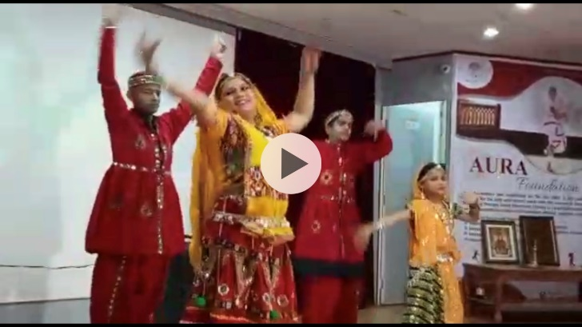

- As per our planned objectives, we have been redesigning and redeveloping student curriculum based upon ICF and SRV framework. Intensive brainstorming and conceptual study with Ms Arpita Yadav, Lead Content Developer followed by validation of draft resource material by our educators is underway.

- During the reported period, on line webinars and learning cohorts were regularly attended by us actively. Few of these included:

- AKJ Long Term Strategic Roadmap & Social Media Engagement policy documents discussed and finalized (drafted by Pro Bono volunteers of Toolbox India Foundation) on 1st October 2021
- PARIVAAR EGM on 2nd October
- Impact Assessment for CSR By BOSCH-VYK on 4th & 5th October
- Intervention for Street Children By UNICEF on 5th October
- Panel discussion on Inclusive education E- learning curriculum delivery by Anugraham
- Activating Special Olympics Bharat Rajasthan Chapter on 23rd November
- Global standard for CSO accountability Webinar By VANI on 24th November
- CBM – PARIVAAR Livelihood Project Review Meeting on 26th November

Case Study:

The Case study is based on the observation from the Dance Movement Therapy Workshop conducted during the months of October & November 2021 through a series of weekly onsite visits by professional trainer & dance movement practitioner Ms Nisha Purohit of AURA Foundation Jaipur at Asha Ka Jharna Special School Sikar. She imparted the training to both children with disabilities as well as educators.

Dance Movement Therapy is based on systematic application of movement, music and dance principles combining movement- oriented sequence of dance patterns and free flowing techniques allowing every child with disability to understand his/her body better and work on the body muscles that require strengthening. It improves attention and concentration of learners and gives them the liberty to be expressive of their emotions using movements. It also helps in enhancing social interactions, develops vocabulary skills using the imitation of the repetitive movements. Group bonding, improved body image, stimulation of verbal communication skills and strengthening of fine motor skills are other takeaways.

This was an event-based workshop in which we could observe the basic changes in the children from start to the end. This report is not based on any medical supervision. It is based on emotional content, rhythm, form and space relations.

Initially, the children were finding difficulties to form a tempo at times rhythm but the most important thing which was observed was the emotional connection with the therapist wherein the emotional response helped us to improvise the difficulties they were facing in developing the tempo, hold and seek comfort zone in the given space.

Slowly and gradually with challenges of hearing the beats they did very well, followed the hand movements and after a certain period of time the body knew when to move which means they start memorizing it. Simultaneously the body and mind were getting aligned.

Finally on 7th December, before the august gathering at Science Park Auditorium, Jaipur sixteen of AKJ children performed a medley of different Indian cultural legacy by enacting fusion dance of five states dressed in traditional attire. Audience applauded and appreciated that performance. This study shows that if this would be continued it would help them on the wholistic personality development. It was a great experience with these wonderful kids, I thank the whole team and Sudeep sir for your patience, believe and cooperation. Looking forward to have such wonderful experience again.

Thanking you,
Nisha Purohit,

Founder: Aura Foundation.

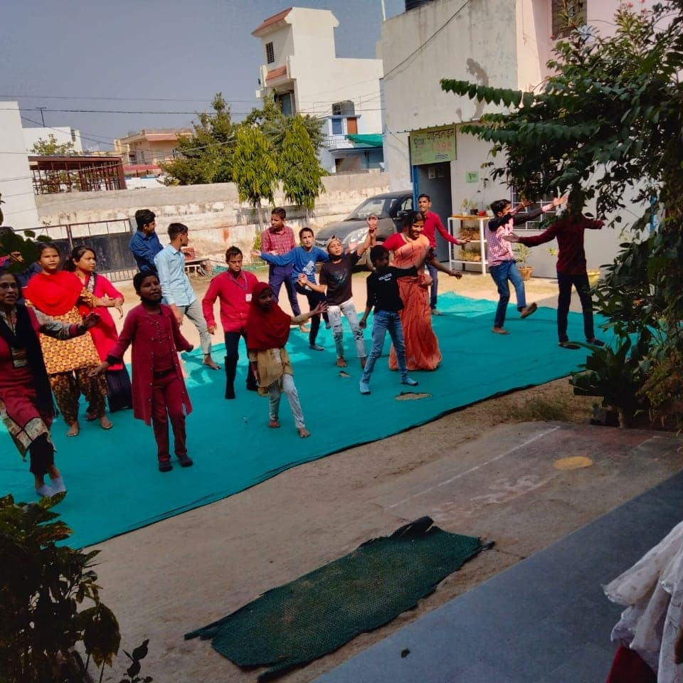
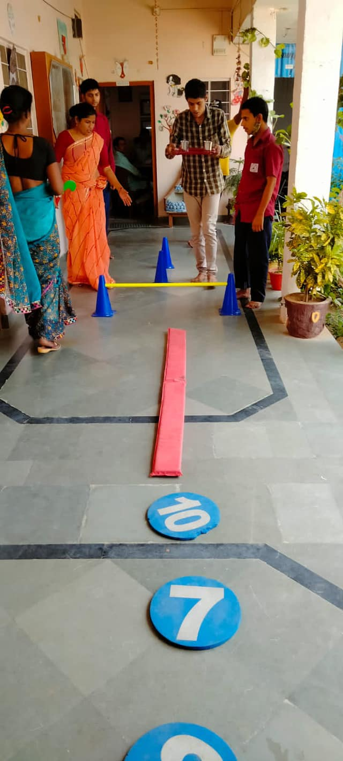

- During the reported period our CHILDLINE SIKAR did multiple activities both direct intervention and training of stakeholders as well as community sensitization and outreach. On 10th November, child beggar/labour free Sikar campaign by launched by district administration and CHILDLINE Sikar. We initiated signature drive and got local traders to pledge not engaging child labours in their enterprises. On 18th November, we in collaboration with directorate child rights Sikar organized a district level workshop on child protection with all stakeholders. We presented district statistics, action plan and vision before National Commission on Protection of Child Rights convened high level meeting. Our team rescued twenty four children begging on the streets of prominent religious place Sh. Khatu Shyam Ji during December itself. We also conducted a special drive there in sensitizing local community, police personnel’s and others not to encourage child begging and labour. From inception since July 2015 till December 2021, CHILDLINE SIKAR Team has served 2707 children & their families in need of care and protection vide a whole range of intervention services.

Special School 1: Harlal Ka Kothi NAWALGARH - 333042 Phones 91-1594-223094 & 91-1594-222930
Special School 2: Khemi Shakti Temple JHUNJHUNU - 333001 Phone 91-1592-237537
Special School 3 & CHILDLINE National Children Help Line No. 1098 (24 x 7): Bhagat Singh Colony Nawalgarh Road SIKAR - 332001 Phone. 91-1572-256537 Rajasthan (INDIA)

Emails: sudeepgo@rediffmail.com & info@ashakajharna.org
Visit us at: www.ashakajharna.org
FB Page: www.facebook.com/akjrajasthan Twitter Handle: @akjnwl

M 9414036896 (SUDEEP GOYAL, CHIEF FUNCTIONARY & SECRETARY)

