SEMI-ANNUAL ACTIVITY REPORT – CRESCA
Recreational, Social and Cultural Animal Center
January – June 2025
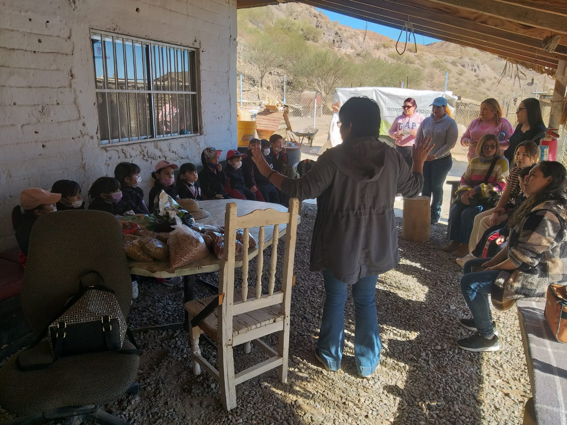
Group of preschool children visiting CRESCA

Introduction
As part of our commitment to transparency and animal welfare, we present to the community a summary of the activities carried out during the first half of 2025. At CRESCA, we work under four fundamental pillars: rescue, adoption, spaying/neutering, and community co-responsibility, always with the vision of generating a positive impact on health, education, the environment, and community development.

Institutional Collaboration and Outreach
Collaboration with institutions and allied organizations remains key to expanding our reach and strengthening animal welfare efforts.
- We are part of the Municipal Animal Welfare Committee of Mulegé.
- We shared CRESCA’s management plan to support the creation of a new rescue center in Guerrero Negro.
- We coordinated with Baja Mobile Steri-Vet and the Municipal Health Department sterilization campaigns, with a goal of 150 dogs scheduled.
- We provided equipment and materials (carriers, muzzles, leashes, folding tables, and tent) for campaigns in rural communities such as Punta Abreojos, Bahía Tortugas, Bahía Asunción, and Laguna de San Ignacio.
- We advised Steri-Vet during their visit to La Paz and facilitated contact with state authorities.
- We promoted responsible pet ownership, adoption, and spaying/neutering in elementary schools and welcomed visits such as that of Colegio de Salvatierra preschoolers.

Rescues and Adoptions
The rescue of animals in vulnerable situations and their placement in responsible homes remains one of our main missions.
- We rescued and sheltered 16 pets.
- 3 pets were adopted in Santa Rosalía.
- We provided logistical support with transportation for pet sterilizations in Santa Águeda and San Lucas.
- We prepared the veterinary record of the pet “Tacoma”, facilitating its adoption abroad.

Spaying/Neutering Campaigns
We consider mass sterilization as the most effective strategy to reduce the population of stray animals.
- We carried out 71 free sterilizations under the agreement with the State Health Department.
- We participated in the Baja Mobile Steri-Vet campaign together with the Municipal Health Department, where 157 pets were sterilized with our logistical and anesthesia support.
- We collaborated with Colorado State University (CSU) and the Municipal Health Department, achieving 172 additional sterilizations.
In total, combining our own and collaborative efforts, we achieved 400 sterilizations this semester.

Community Services
CRESCA also plays an important role as direct support for families and pet owners.
- We provided temporary care for pets of families who, due to work or health reasons, could not attend to them.
- We provided transportation and veterinary assistance to rural communities.
- We designed and printed the cremation certificate for a Steri-Vet client.
- We facilitated the transfer of pets to Veterinaria San Fernando, such as for the resident of San Lucas Cove (Scott).
- We provided 43 low-cost pet cremation services.

Donations and Support Received
The solidarity of companies, cooperatives, and individuals is essential to sustain our work.
- Nestlé Purina donated 2,700 kg of kibble, valued at $86,292 pesos.
- A group of foreigners from Punta Chivato (led by Joan Westfall) contributed 460 kg of food.
- Supermarket “Sotres 4” donated tools and 5 sacks of cement (valued at $3,480 pesos).
- Fishing Cooperative “Cuesta Hnos.” donated 540 kg of shark and ray fillets.
- Fishing Cooperative “Acuarios 2000” donated 58 kg of fish skins and skeletons.
- We received the visit and support of our donors and allies Gwyn McKee and Micky Steward.

Self-sustainability and Food Production
To move towards self-sufficiency, we strengthened initiatives for the use and production of pet food.
- We processed donated fish skins and skeletons to produce fish meal and supplements for dog food.
- We implemented storage and grinding of dried fish to expand our food reserves.

Center Improvements
Animal welfare also depends on having safe, hygienic, and functional spaces.
- We reinforced the foundations of 5 kennels.
- We restored roofs and shades in shelter areas.
- We reorganized kennels to improve internal access and mobility for visitors and volunteers.
- We dismantled and relocated doors to optimize spaces.
- We carried out integral cleaning of the warehouse, backyard, and access trail.

Water Project
Having sufficient and constant water is a vital need for the center.
- We acquired materials and 300 meters of hose.
- We transferred and cleaned a 5,000-liter tank.
- We adapted the old basin as a base for tank installation.
- We installed 3 tanks with a combined capacity of 10,000 liters.
- We built supports with concrete posts for the installation of more than 300 meters of pipes and hoses with air purges.
- We successfully carried out tests of potable water delivery from a neighbor’s home to CRESCA.

Summary of Achievements (January – June 2025)
- 16 pets rescued.
- 4 adoptions completed, 3 in Santa Rosalía and 1 abroad.
- 400 sterilizations performed in collaboration with different institutions.
- More than 3,700 kg of food received in donations (kibble, fish, and chicken).
- 5 kennels reinforced, 16 new metal feeders, and water storage capacity expanded to 10,000 liters.
- Consolidation of alliances with national and international institutions.
With the support of the community, sponsors, and allied institutions, CRESCA continues to transform lives and promote a future of animal welfare in Mulegé.
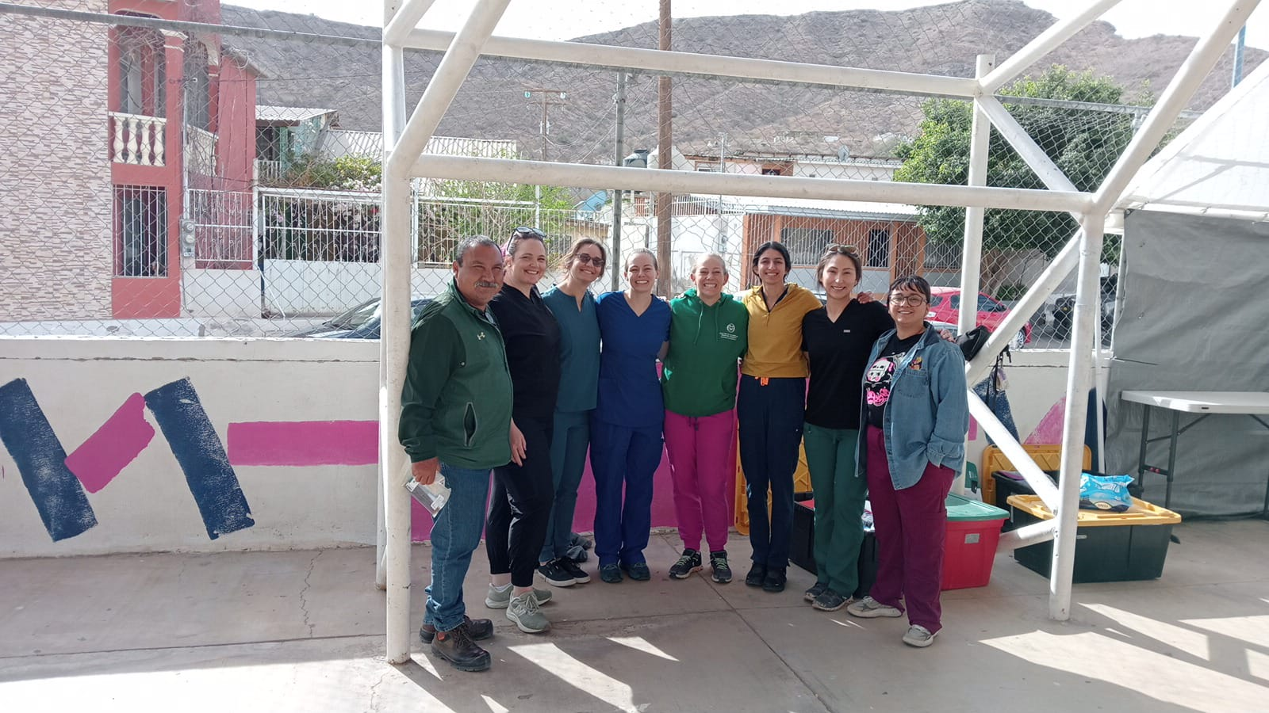
Volunteers from Colorado State University participating in free sterilizations
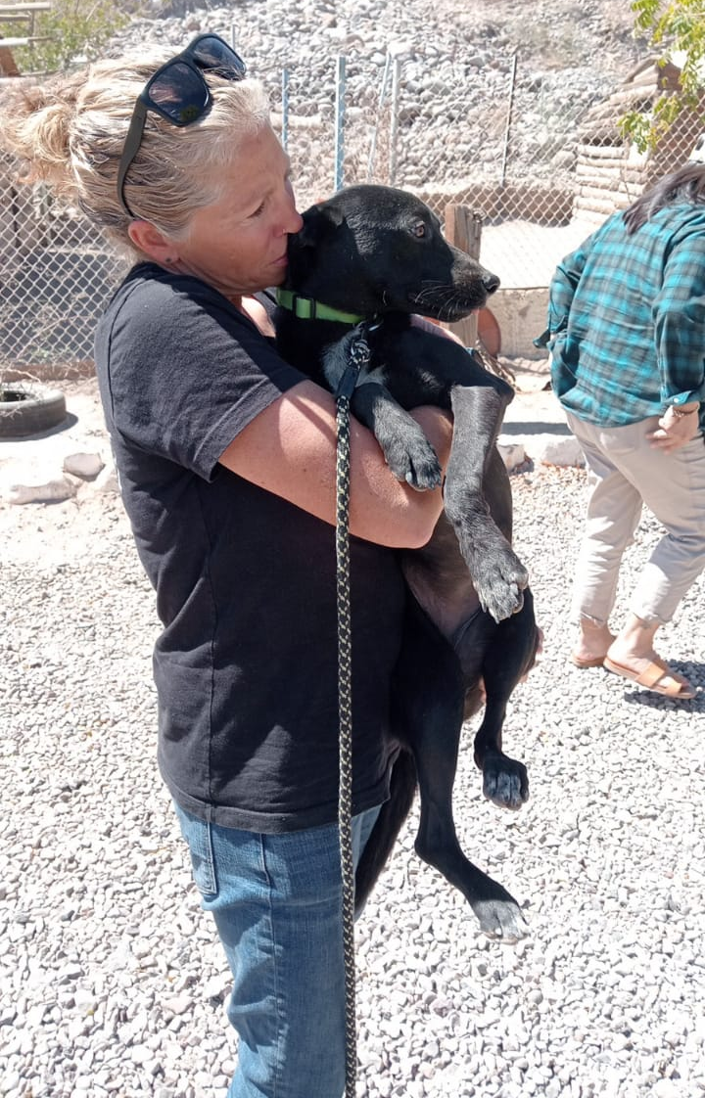
Adopted pet
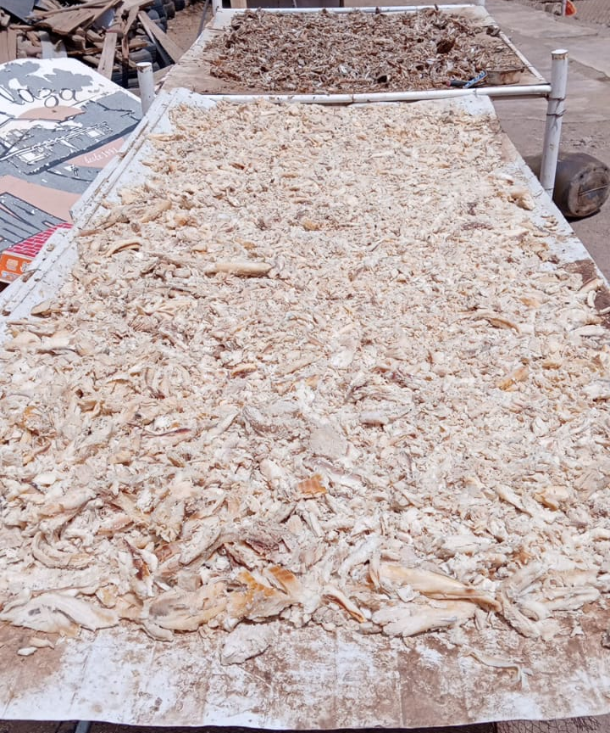
Fish dehydration (process for making flour)

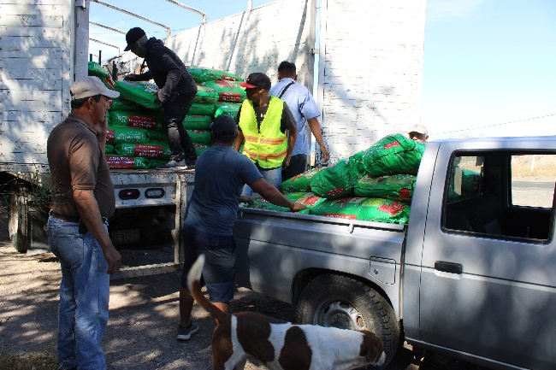

Receipt of donation of dog food

