-Introduction-

RE: Introduction of Whisper and our needs
Whisper’s Magical Hospital
The first children's hospital of its charitable kind in Uganda, launched and opened by His Majesty, the Kyabazniga of Busoga, William Wilberforce Kadhumbula Gabala in March 2016 and its new bigger premise together with maternity department was opened by Hon. speaker Rebecca Kadaga on 25th May 2018.
Our hospital is registered under an International NGO Whisper, The Union for Child Care, Outreach and Education, reg. no: 10790.
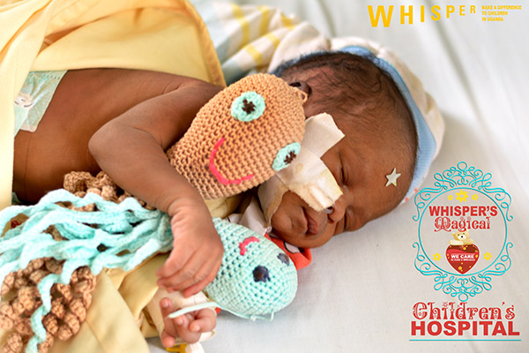
After having a tremendous success with our medical services, treating more than 30 thousand children since the hospital first launch, mainly focusing on emergency unit, blood transfusions, malnutrition and burn unit. Our hospital is a great asset to our Jinja community and Uganda at large.
Only in 2018, we treated 11,513 patients; out of those were 639 visits to our new maternity and gynecology department.
Whisper on average treats 960 children a month.

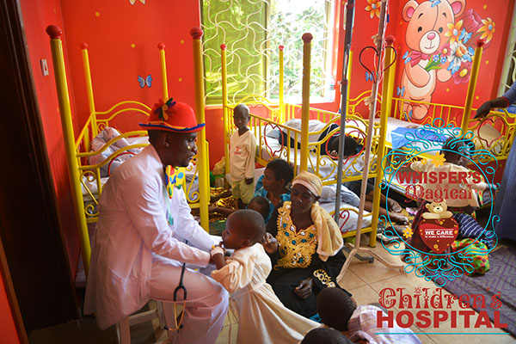
Since Whisper launch, we successfully healed on 200 burns victims, organized and funded 4 plastic surgeries for those victims just in the 18 months.
Whisper also funded 3 heart surgeries for our patients and works on taking two pediatric patients for a heart surgery to the USA in 2019.
Thanks to our nutritionist and social workers over 235 malnourished children were treated resettled back to improved homes.
Our success lies in first class medical and customer care 24 hours a day, seven days a week, and free services to all of the inpatients and their care takers.
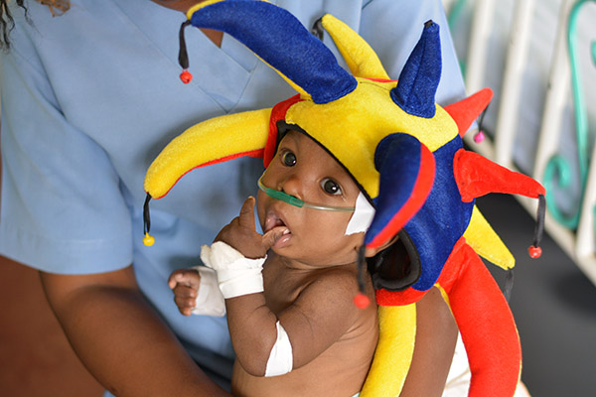

This time we also decided to help women and babies stop dying during childbirth, and we established a maternity department, offering major surgical theatre and a 4D full digital ultrasound Doppler.
In order to do it better, we purchased a portable ultrasound device that will be used for our outreach work that I believe; you could be a part of.
The objectives of such programme are:
- Promote antenatal (eradicate birth defects and rising cardiac problems in new-borns)
- Ensure unborn baby’s safety
- Prevent rising abortions
In the last 9 and half years, Whisper has been doing daily community health outreach work in 9 districts of Busoga region and established a great relationship with local leaders.
Our beautiful midwives, social workers and radiographer will play the main role in our maternity outreaches and provide free pregnancy ultrasound scan to the pregnant mothers.
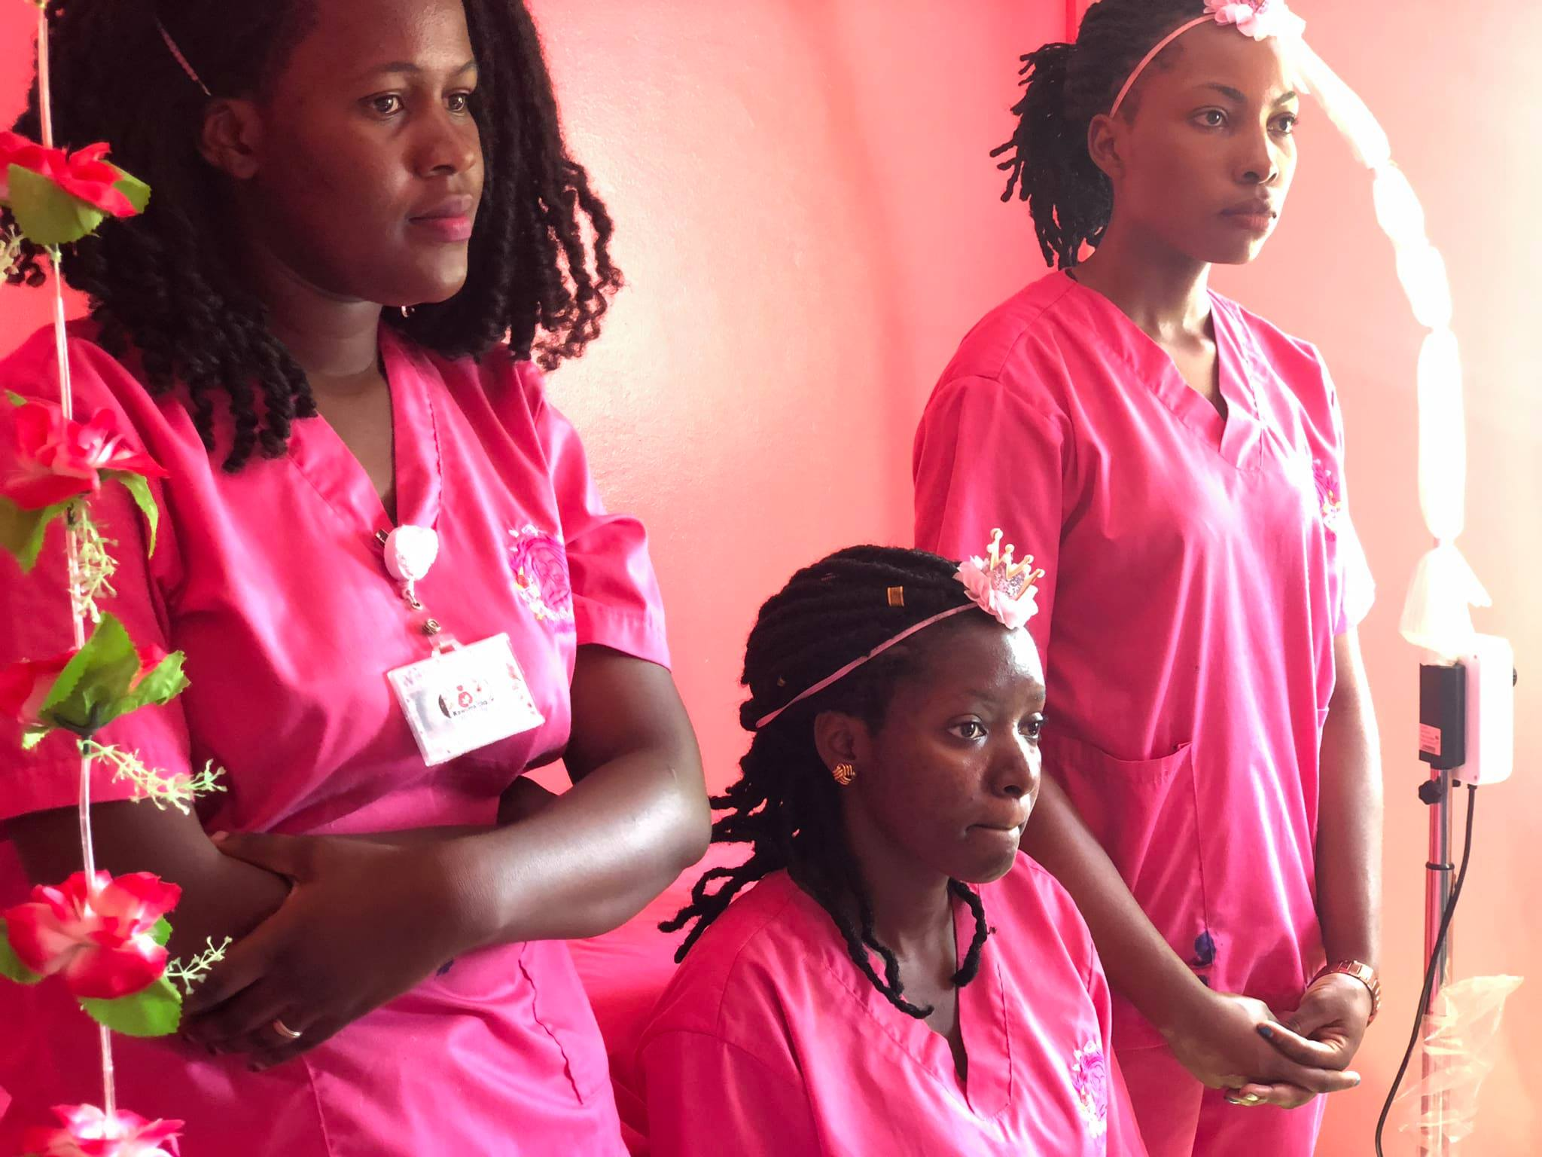

Some of the 6 Whisper’s midwives.

Our Success Rate in 2018 shows:

1. Total number of patients treated in 2018: 11,513
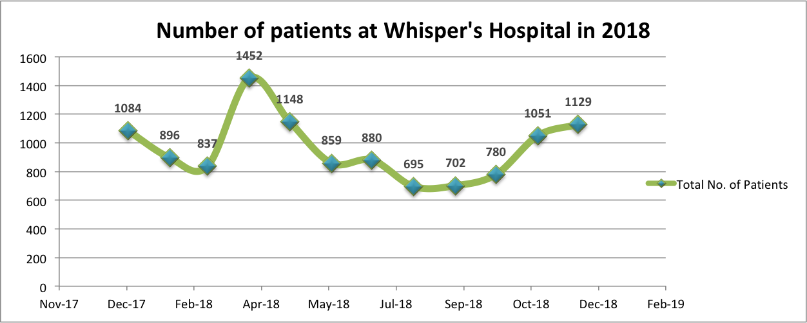

2. Total number of blood transfusion in 2018: 2,270
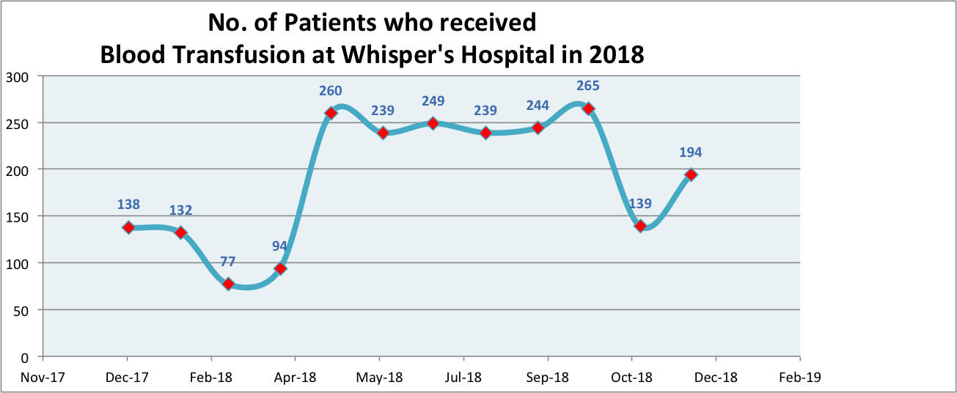

The hospital is Whisper's highest fundraising priority at the moment.

Hospital care has many components, all of which have to work; the care is only as good as the weakest component. Uganda has good (if scarce) medical staff but they are routinely let down by poor support
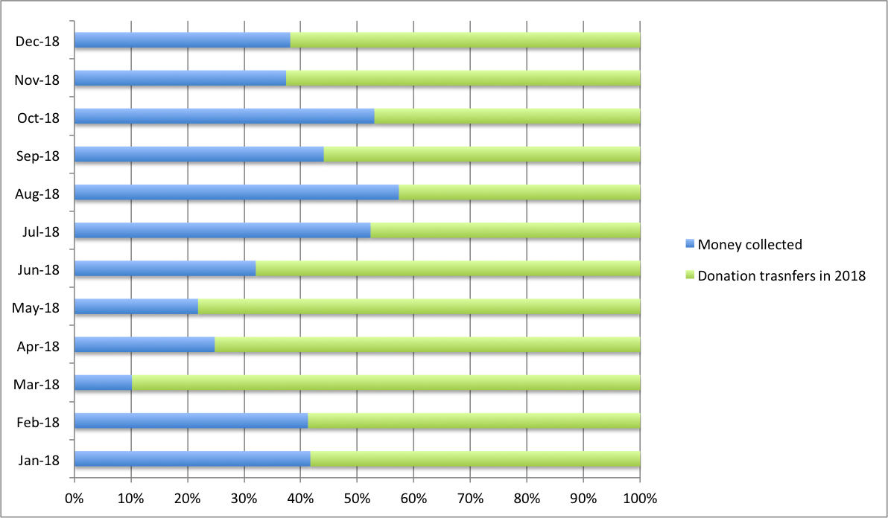Above chart shows the amount of funding (in green) Whisper gets comparing how much money it generates with its minimum hospital charges.

Services and standards of care, which must greatly reduce their effective productivity. Through good management, Whisper has been able to save many children's lives that would not otherwise have been saved, at very low marginal cost. For example, power cuts are common in Uganda; in the government hospitals, small children on oxygen routinely die when the power fails, whereas Whisper has multiple backup systems for oxygen delivery. Blood supply is another key issue and Whisper has done much to improve the local blood collection system. Whisper’s inpatient mortality rate has been very low by local standards.

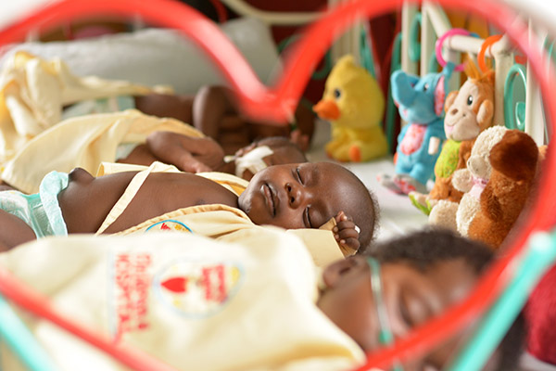

Whisper’s accounts

Whisper produces accounts for two entities, the UK-registered charity and its Ugandan NGO. Both entities have accounting years ending on 30 June, which is the convention in Uganda.
The accounts for the UK-registered charity, which are very simple because it mostly acts as a feeder for the Ugandan NGO, are best fetched directly from the Charity Commission website here: http://apps.charitycommission.gov.uk/Showcharity/RegisterOfCharities/CharityWithoutPartB.aspx?RegisteredCharityNumber=1139078&SubsidiaryNumber=0
The main thing to note about the UK accounts is that Veronika draws her income from the UK-registered charity by submitting invoices to it. Her income is then taxed by HMRC, and under the UK-Uganda dual taxation treaty, which makes surprisingly generous provision for such arrangements, there’s no further tax due on that income in Uganda which is her country of tax residence.
The Ugandan NGO accounts are currently prepared on a PC-based package in Uganda; we’re keen to see that changed or at least shadowed by an online accounting package such as Xero to improve visibility from the UK.
I hope, that you will find a value in the partnership and support to each other, and together reach out more women and children, heal them, assist them and bring them hope that is so much desired by every Ugandan.
Shall you have any questions, please do not hesitate to contact me

Veronika Cejpkova
Founder & CEO
Veronika@whisperorphans.org

