INDIGENOUS WOMEN UNITED FOR RECONSTRUCTION

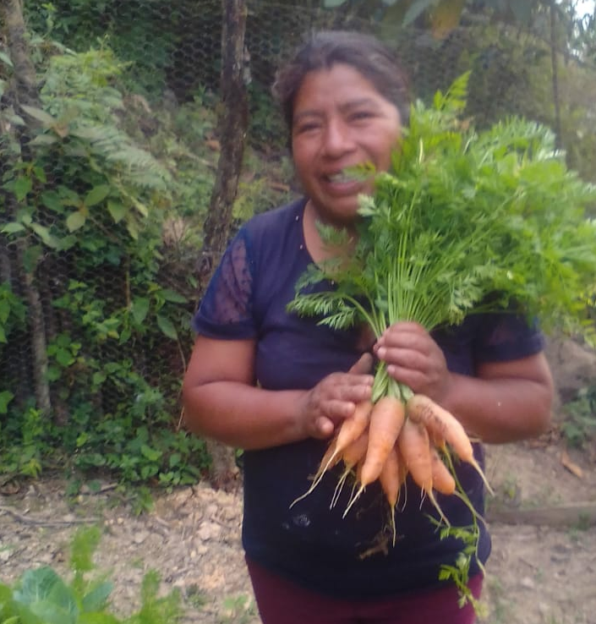
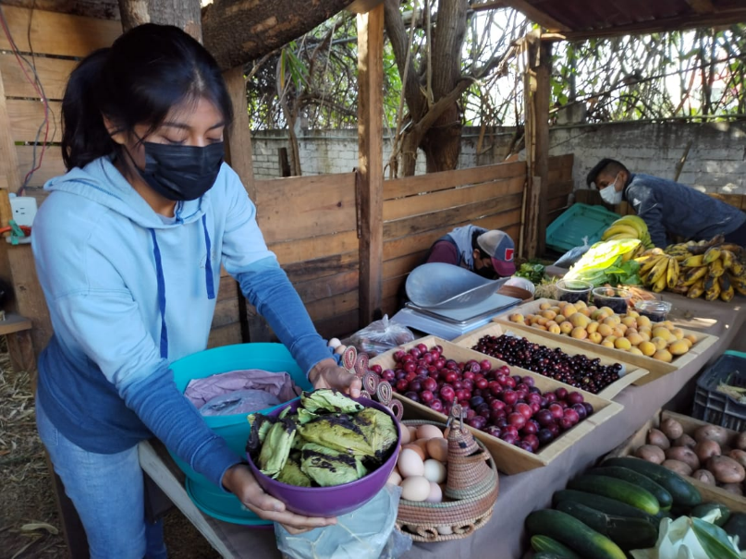
The COVID 19 pandemic showed us how important and valuable health is, so with the support of the CODICE team we have focused on producing our own food, working the land with our families and continuing to apply what we have learned to manage garbage and the water that comes out of our homes to avoid contamination.

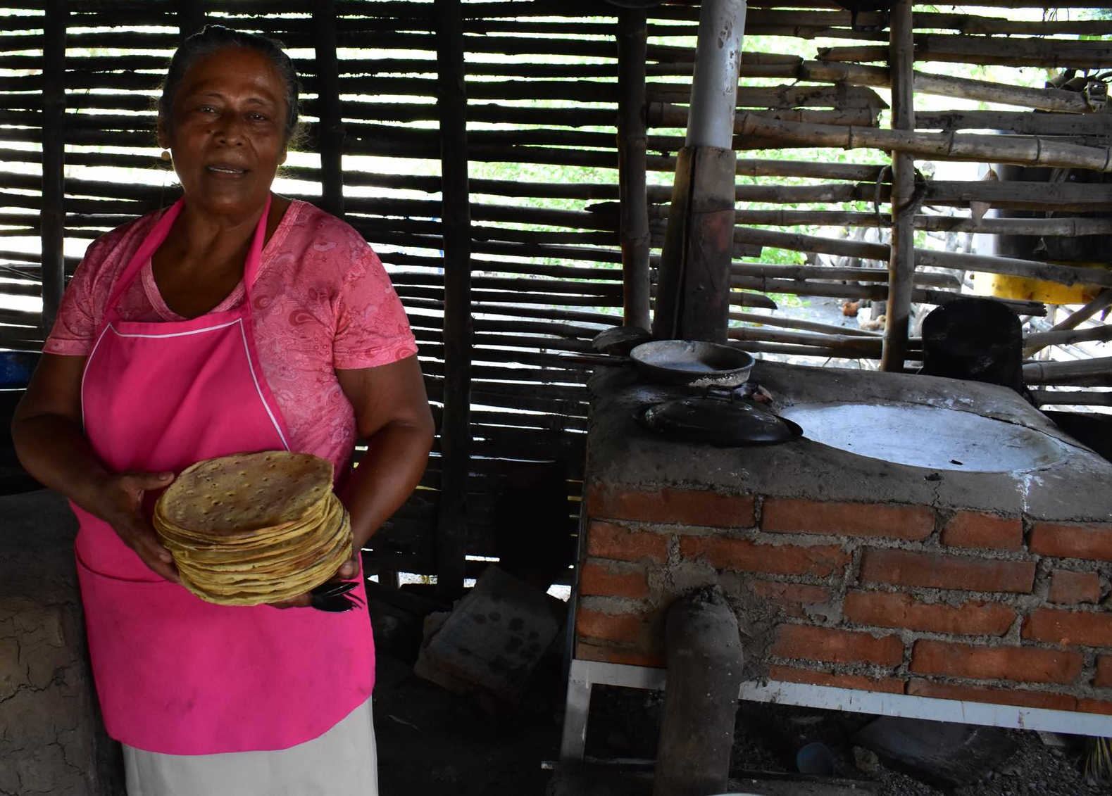

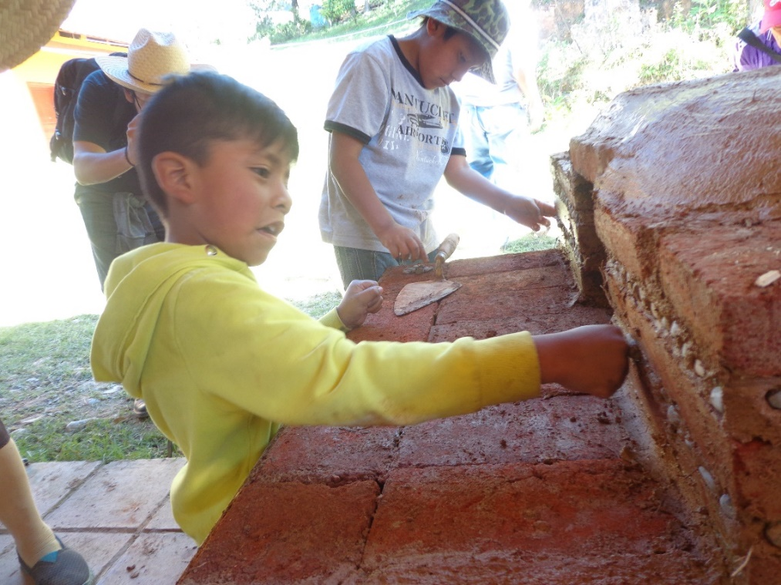

Wood-saving stoves prevent smoke and heat in the kitchen and that also helps keep us healthier and more united.

 |  | 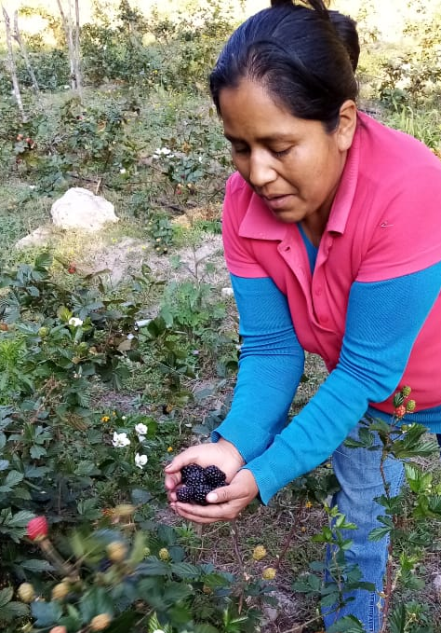
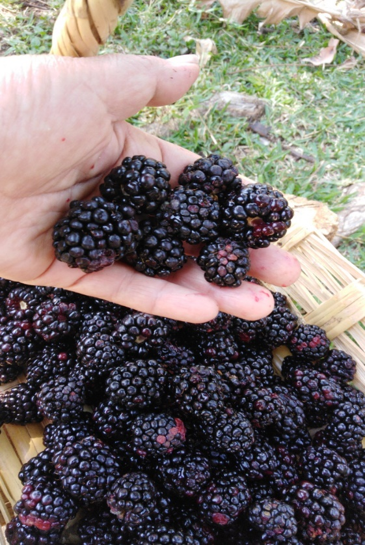 |  | We have a plot in production and we sell good quality blackberries in small markets in the Region and in the city of Oaxaca, where we have a direct relationship with consumers.

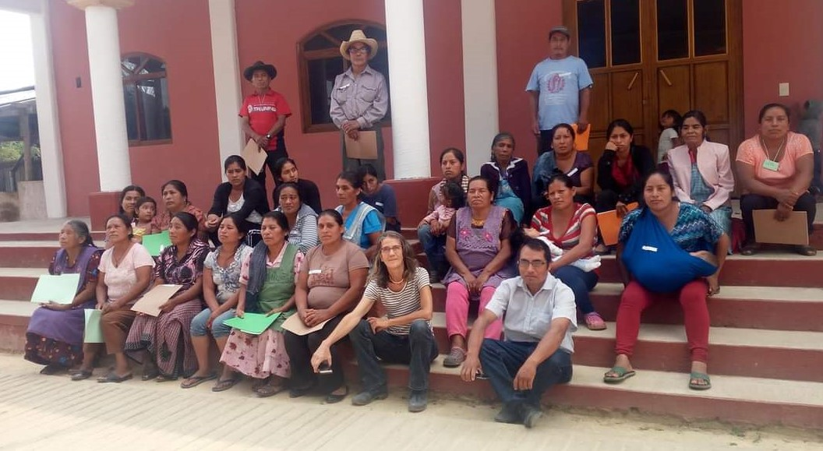

The pandemic affected us both physically and emotionally, we lost some members of our family and our colleagues from CODICE also suffered those losses. But we are together and we have shared experiences with colleagues from other organizations, we know that together we will be able to continue advancing.

Thanks for your support.
Zompantle mixes women.
November 2022

