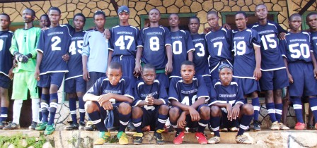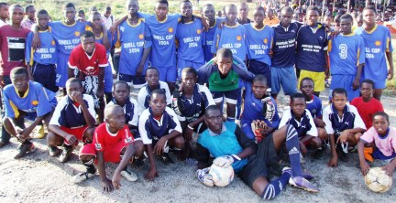
Host team, Christ’s School, Ado-Ekiti Ekiti State football team

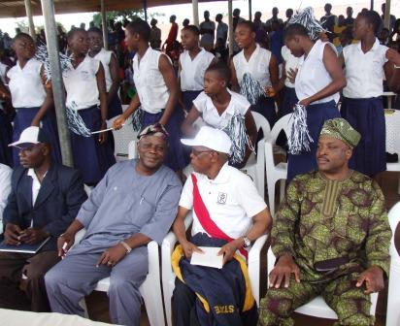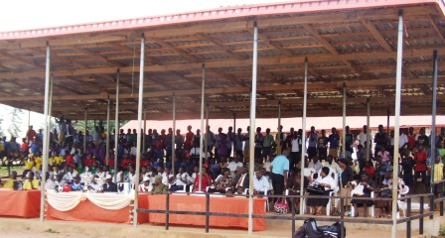
Okan Seye Adetunmbi (Chestay), Messrs Idowu Aderibigbe (O-Jesu) & Bisi Olawole (Sinbad)

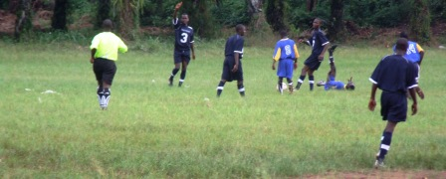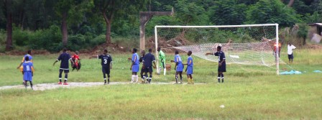
Christ School Vs Ekiti State Soccer Team

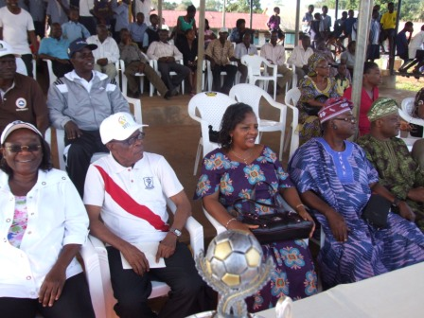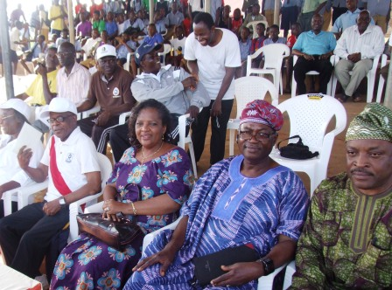
Mrs Wura Ajibade, President of CSAANA, Mr Idowu Aderibigbe, Mr & Mrs Segun Ogunkua, Mr Bisi Olawole
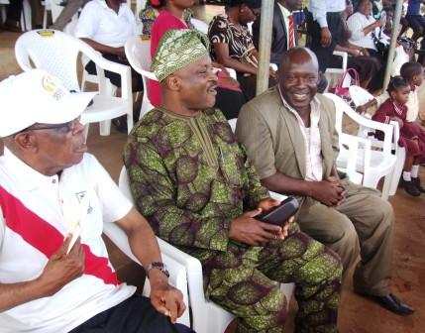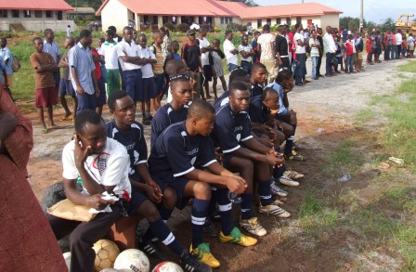
O-Jesu, Sinbad & Deji Samo Reserve Bench

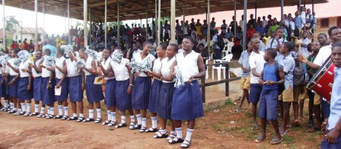
Supporters in their elements

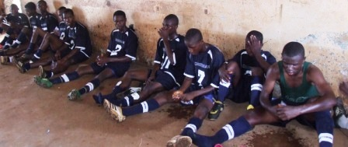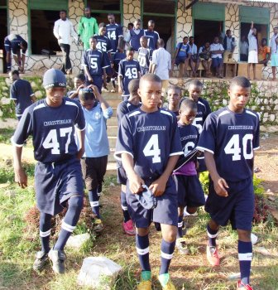
Half time

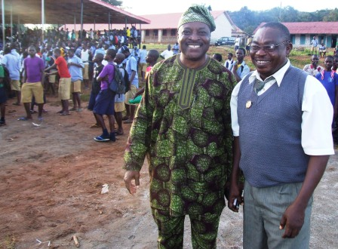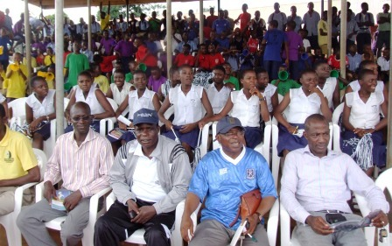
Sinbad and Oyeee, Oyebode ‘World 5’ (great footballers in their set) Cross ssection of the spectators

Christ’s School Supporters Club
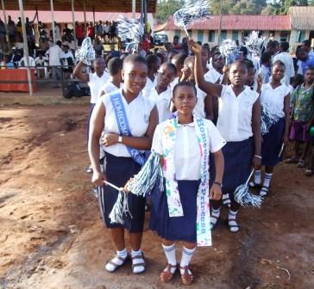
Homecoming Queen & Homecoming Princess and fellow students from the Girls section cheered their team

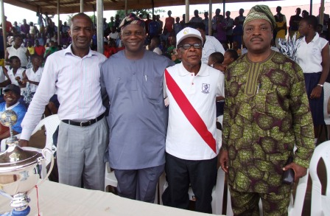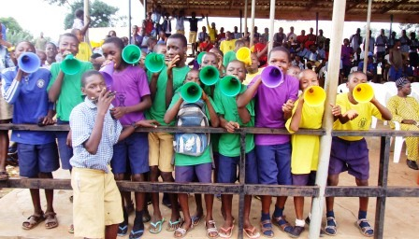
Messrs Yinka Adeosun, Adetunmbi (footballer in HSC days), Aderibigbe & Olawole (old students)

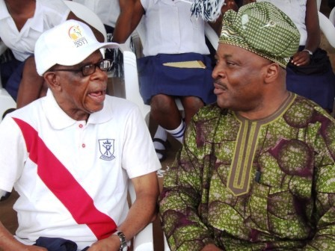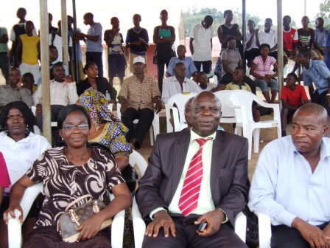
O-Jesu (alumnus & onetime Games Master) & Sinbad and some teachers of Christ’s School
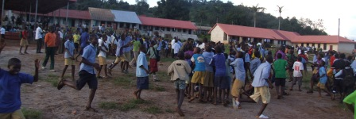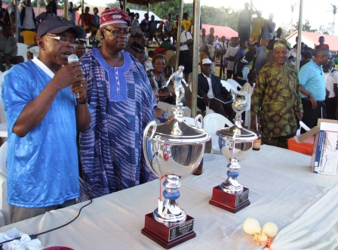
Students celebrated the final whistle/victory of 2:1; Principal, Prince Wole Akinyede & Baba Ijo Ogunkua

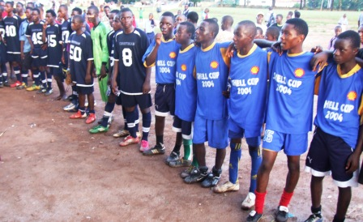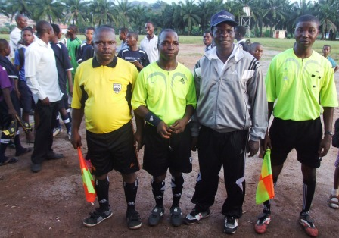
The two teams and the match officials, Refrees and Linesmen

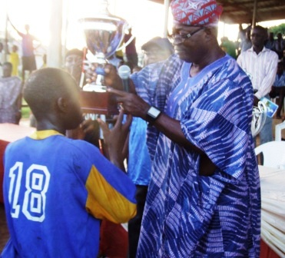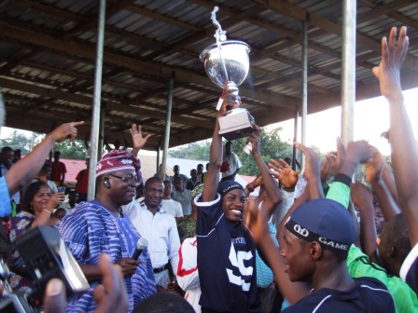
Baba-Ijo presented the Homecoming Cups on behalf of Prof Bolaji Aluko, the 2011 Homecoming Celebrity

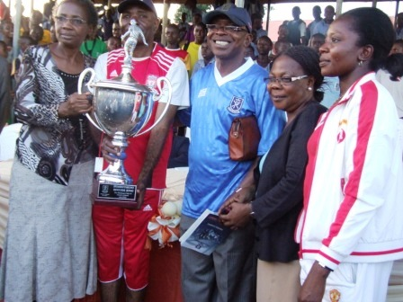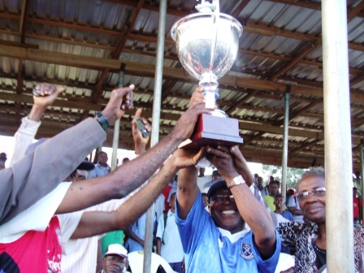
Delighted Principals of Boys & Girls section with some staff of The School on the victory of their boys

