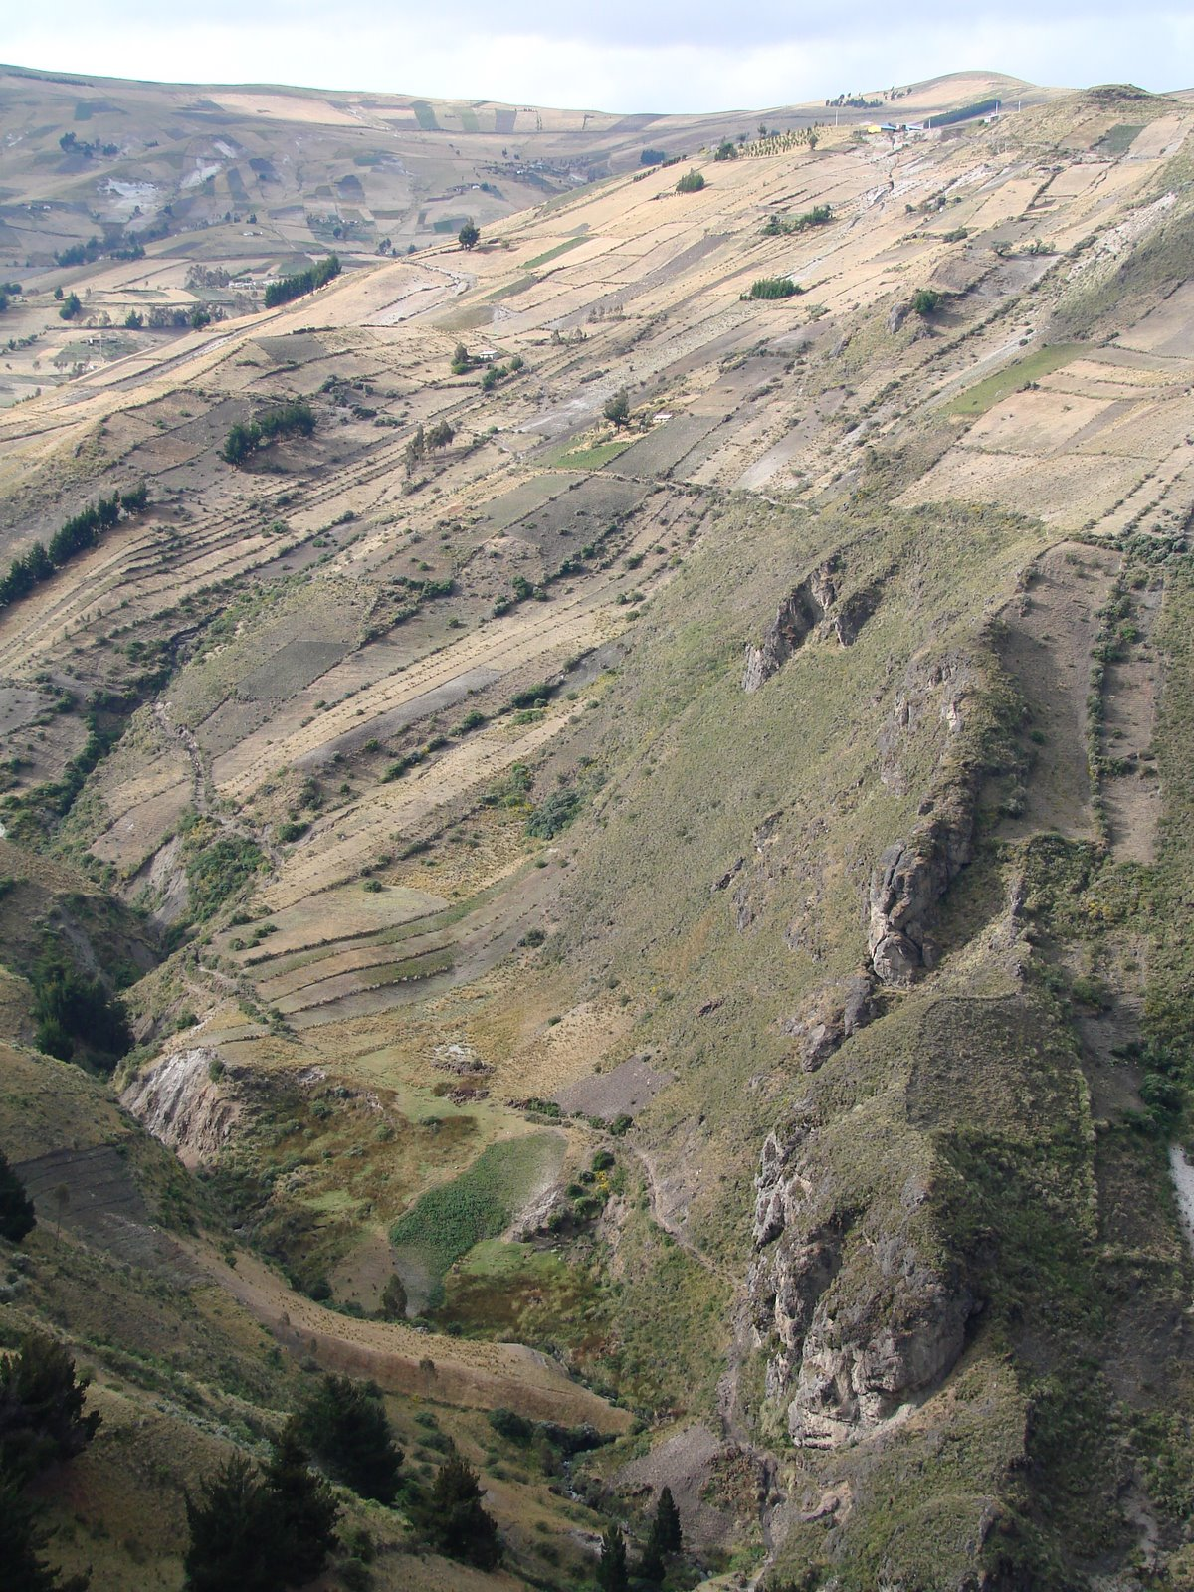
Quiloa Source
Tingo Pucara
Secondary Source
Pucara
Figure 1: Global view of Tingo Pucara surrounding relief*
* Source Document 507, 2008

 | Flow | Quality | Remarks
QUILOA SOURCE | ~3.32 l/s |  | No electric cable
SECONDARY SOURCE | ~0.23 l/s |  | On the edge of a cliff
*Source Document 507, 2008

Water Quality from Document 522, 2009

Parameters | Guideline Value | Primary Water Source | Tap Water from Other community | Biosand Effluent
Nitrate | 50 mg/L | 1 mg/L | 10 mg/L | 10 mg/L
Nitrite | 3 mg/L | 0.25 mg/L | ~ 0 | ~ 0
Chloride | 250 mg/L* | 500 mg/L** | 500 mg/L** | 500 mg/L **
pH | 6.5 - 8.5* | 6.3 -6.5 | 6 | 9.5 (Influent 6 -6.5)
Hardness | Acceptance issue | 100 ppm (Soft) | 100 ppm (Soft) | 80 ppm (Soft)
Iron | 0.3 mg/L* | 0.01 ppm | N.A. | ~ 0
Chlorine | 5 mg/L | N.A. | N.A. | N.A.
Coliform | 0/100 ml | N.D. | N.D. | N.D.
* No guideline values from WHO, but exceeding listed values are recommended for additional attention.
** The testing kit seemed to show up wrong colors.
N.A. = Not analyzed. N.D. = Not detected.
Tap water was tested by Oswaldo's house, and the Biosand filter was at Agustin's house.

