Mountain women rebuilding life
Tenth report.

From what happened during the 2017 earthquake, as a community we have planned to strengthen our resilience capacities, for this we have advanced in three main aspects:

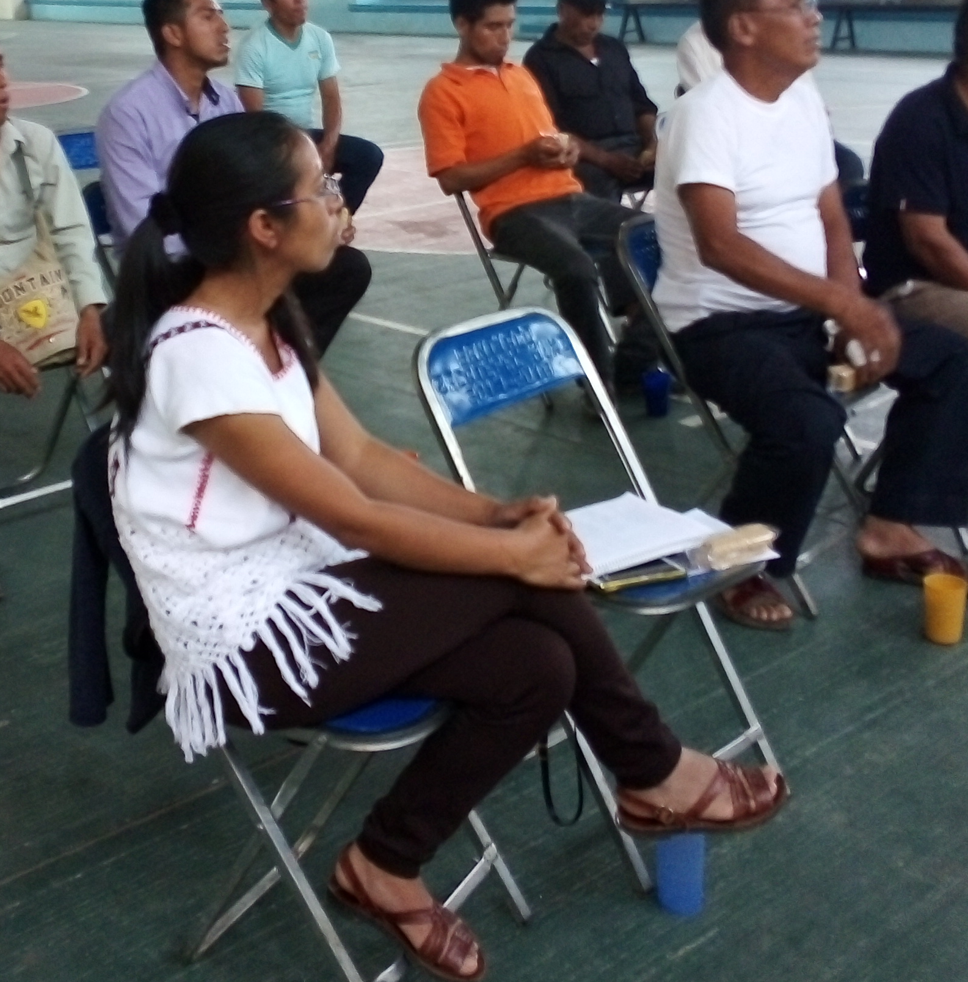
The first is to have a municipal civil protection plan, this is very important because it helps us to organize ourselves to respond to any eventuality and community support is required for its constant updating through the participation of men and women in information activities, training and management.

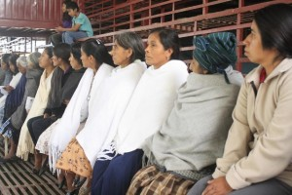
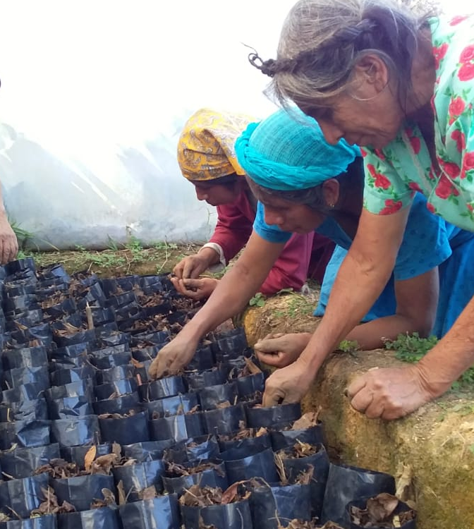

The second is to ensure food by promoting the planting of native corn and beans, which have been the basis of our diet since we can remember, and to strengthen the family economy through the establishment of more profitable crops such as blackberries and cocoa

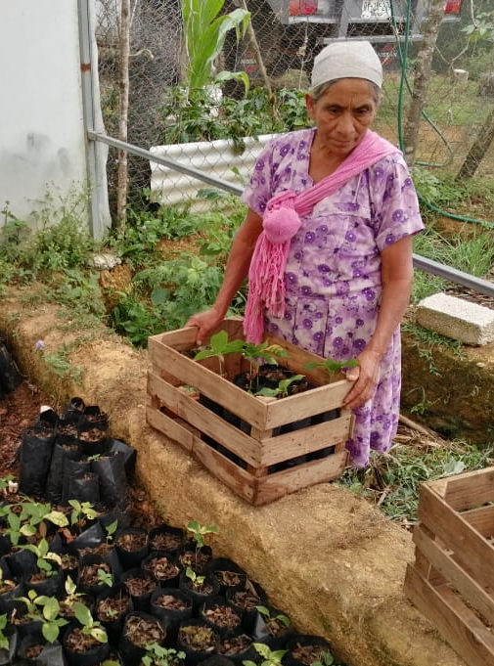

And a third, but perhaps the most important now is the health crisis caused by COVID 19. Thus, prevention actions are reinforced through information to the Authorities and the population in general .
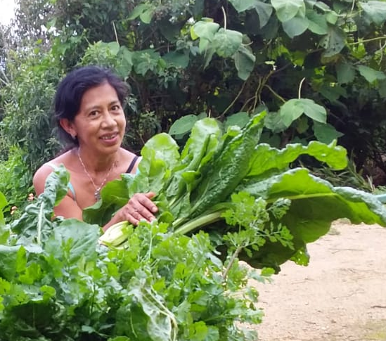
This is closely linked to strengthening nutrition and self-care.

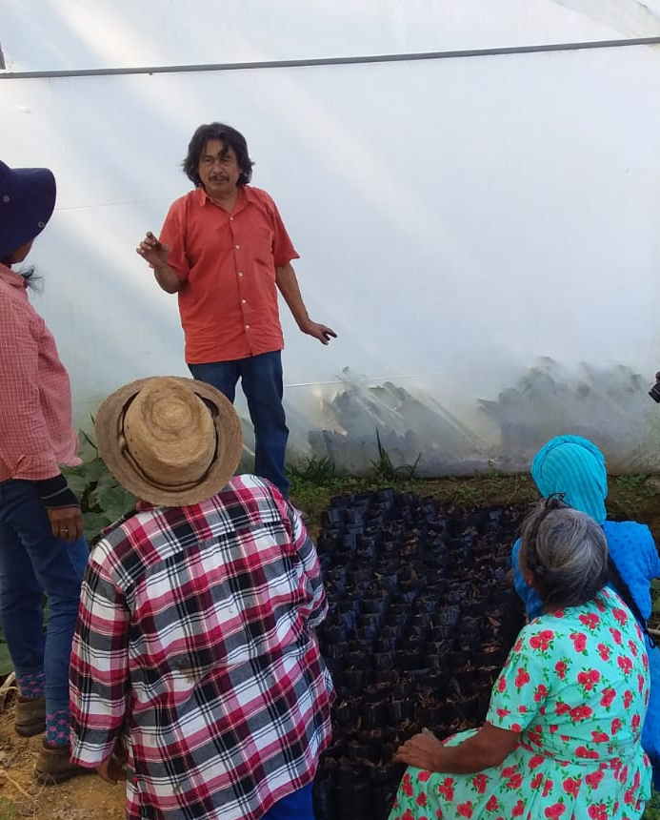

Throughout the process we have had the support of the PRODER S.C. team. and with that of the Global giving community, to whom we express our gratitude.

