ANNUAL REPORT 2016-2017
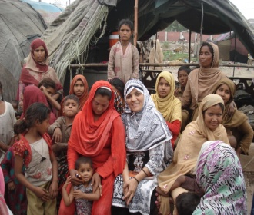 |  |  | 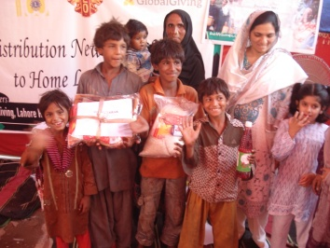
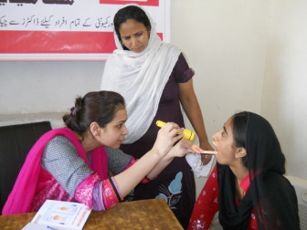 | 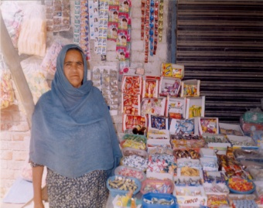 | 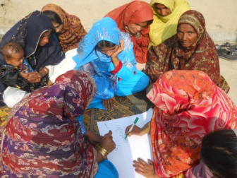 | 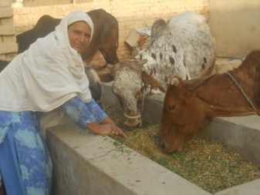
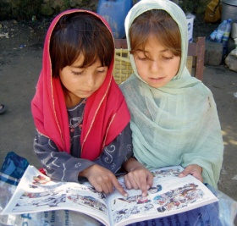 |  |  | 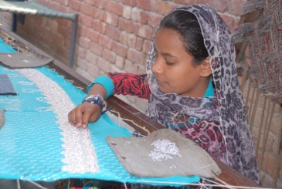
MUWAKHAT FOUNDATION
SAFETY NET PROGRAM
_____________________________________________________________
Central Office: House# 46 C Block A-1, Board Of Revenue Society, Lahore Pakistan
Tel: 92-042-35151105 Fax: 92-042-35151105
Email: info@muwakhat.org URL: www.muwakhat.org

Muwakhat talks
In beginning of July 2013, Muwakhat Foundation started operation with interest free loan for food package. Food Security Program quite popular in Lahore city, the evident is 20,000 food packages worth rupees 8 corers distributed in three years and recovery rate 100%. It is individual loan product in microfinance sector, which provide for household consumption to purchase monthly grocery instead invest in business.
In January 2017, Muwakhat Foundation opened two branch offices in rural areas of Kasur District, I congratulate the spread and success of the security program to staff, individual donors and Orangi Charitable Trust.
The Muwakhat Foundation has begun free legal aid services for women in Multan and Lahore cities with support of SJ Law Firm. In addition, various awareness sessions conducted on basic law and in three months, 25 women and girls were benefit.

In January 2017, partner GlobalGiving was given donation to the homeless children for warm clothes. Muwakhat Foundation distributed warm clothes at Branch Office Lahore. Children expressed their joy and gratitude to GlobalGiving by past their colour hands at flip chart.

In 2017, Muwakhat is working at five programs:
- Interest-free loans for food packages to poor families.
- Free legal aid program for women, in addition awareness sessions on basic legal laws especially domestic violence, benefits of register marriage.
- Help 200 homeless families to meet their basic needs and financial assistance for start up business to generate income.
- 500 girls back to high school, especially the girls who left school after primary education
- Health services and awareness program for women and girls provide free medical facilities and conduct brief sessions in community about how make healthy and safe work place for force labour children.

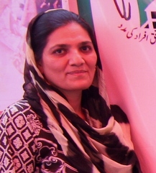

Zareen Aamir - Chair person
Feed the poor (Food Security Program)
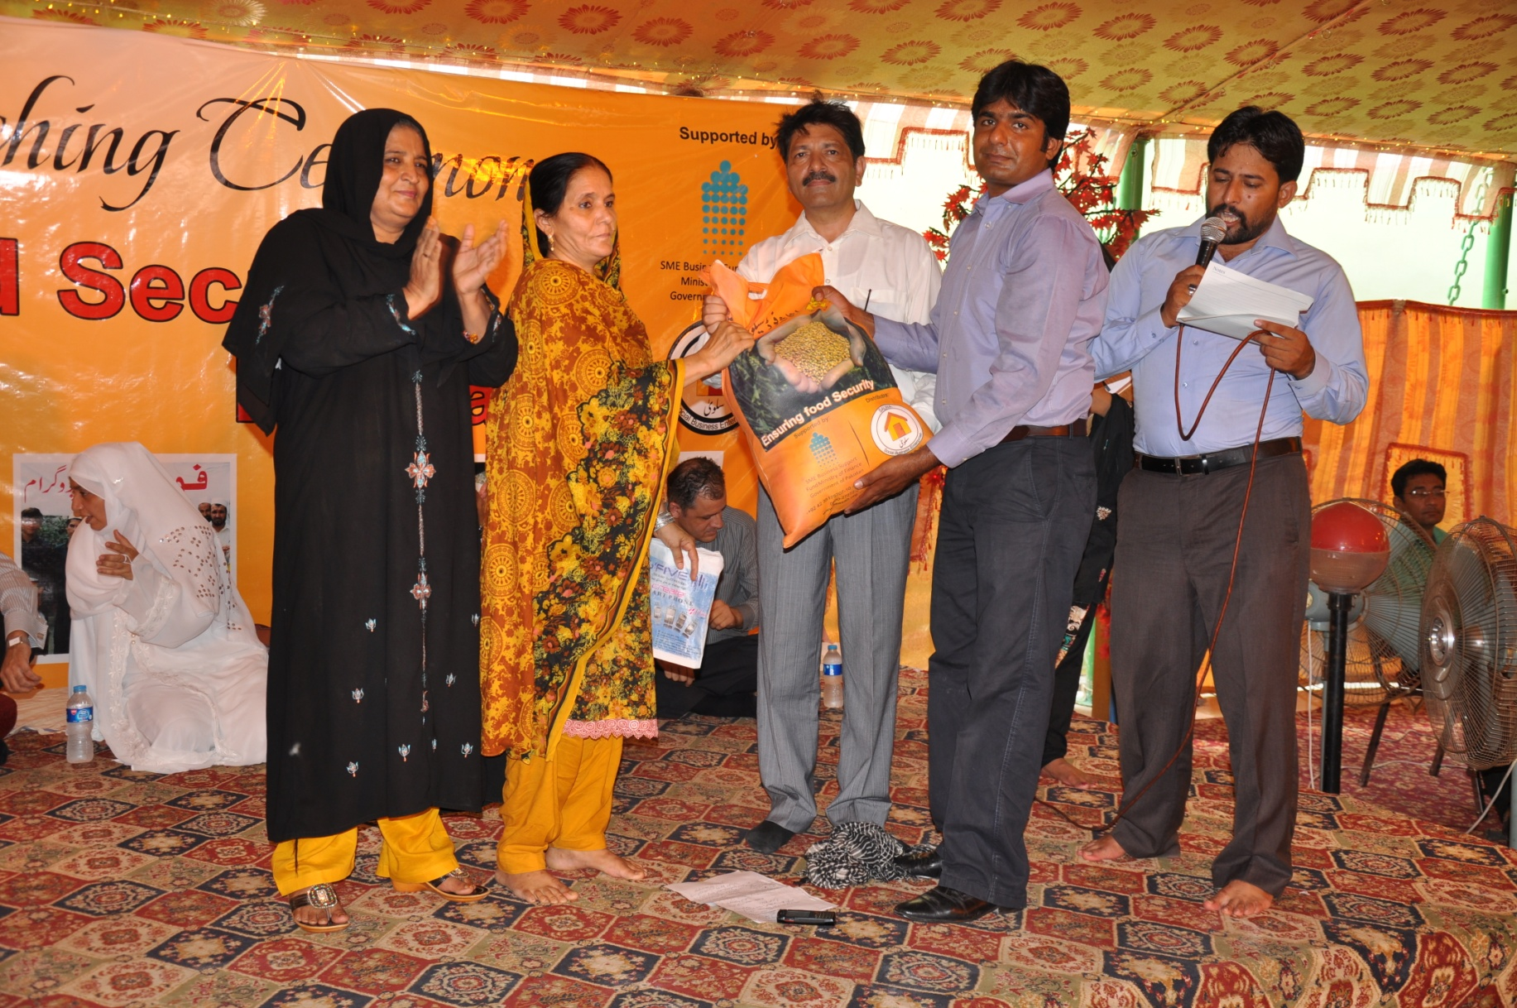

As per report of Food and Agriculture Organisation (FAO) ,”
“8th largest food producing country and on the other, its 50% population is food insecure. Pakistan was the 6th largest producer of apricot, 5th largest producer of milk. On the other hand, 40% of its children are malnourished and underweight due to lack of access to adequate food.”
With the increase in poverty, people spend more on food as compared to non-food items. Within the poorest group, the average household’s expenditure share on food has gone up to 61.6 percent
In the poor families, the earning usually comes in daily or on weekly basis and due to this it becomes difficult for them to purchase the grocery on monthly basis. On days when the person fails to find any work, it becomes difficult to buy the daily use/food items.

Keeping in view all these issues, Muwakhat Foundation launched the “Food Security Program” in July 2013. The Food security program is so designed whereby MUWAKHAT is providing the ration in the form of packages on 1st week of every month on interest free loan. Poor family return in four weekly installments as earned. It helps to get secure and three times quality meals.

This solution is warm welcome by community. We introduced food package program with objectives
- Consistent access to quality food for healthy and active living
- Elimination of hunger and malnutrition from the poor families, especially women and children

We served to 330 poor families; assure food security by offer consistent monthly food packages on interest free loan.

Total 18,876 food package, value US$ 666,713 disbursed in poor communities and recovery rate is 99%.

10 breadwinners died of poor families but they got free food packages and financial support for business by avail insurance product. Ultimately these families not went for starvation and beg.

Number of Branches | 03
Number of Households | 330
Total # of food packages disbursed | 18,876
Loan Portfolio | 70 million – Pak Rupees

Here are some women members spoke about our solution for hunger.
Members Speak Out…

Sajida Bibi – Ghaziabad, Lahore – Mughalpura Branch
MUWAKHAT food package has saved us from the daily purchase of one item or another. We had to wait for the daily wages in the evening, get the food stuff and then cook the meals. In case there was no work for the day, then we had to borrow the food item from the grocer. These items, since we were not paying for them, proved to be costly and were of inferior quality. With the MUWAKHAT Food Security facility, now we get our food items in the beginning of the month and pay no extra cost at all.

Mohsin Masih – Dharampura, Lahore – Mughalpura Branch
Food items included in the package are of good quality. We are now no more dependent on the grocers for borrowing food items. Secondly, it is always better to get the month’s rations in one go.

Kausar Bibi – Mohallah Qureshi, Lahore
Before the provision of MUWAKHAT food package, I used to buy the food items on daily basis, sometimes since there was no money we had to request the grocer to borrow stuff, due to this fact had to compromise on quality and price. We then availed the MUWAKHAT food package facility and are very happy with this. We now need not buy ration everyday and can cook whatever we wish to. There is no tension of payment and we get the monthly ration all in one go. We are very happy and pray that MUWAKHAT continues to help the poor families for their welfare and betterment. Ameen.

QARZ-E-HASNA (INTEREST FREE LOAN) FOR INCOME GENERATION

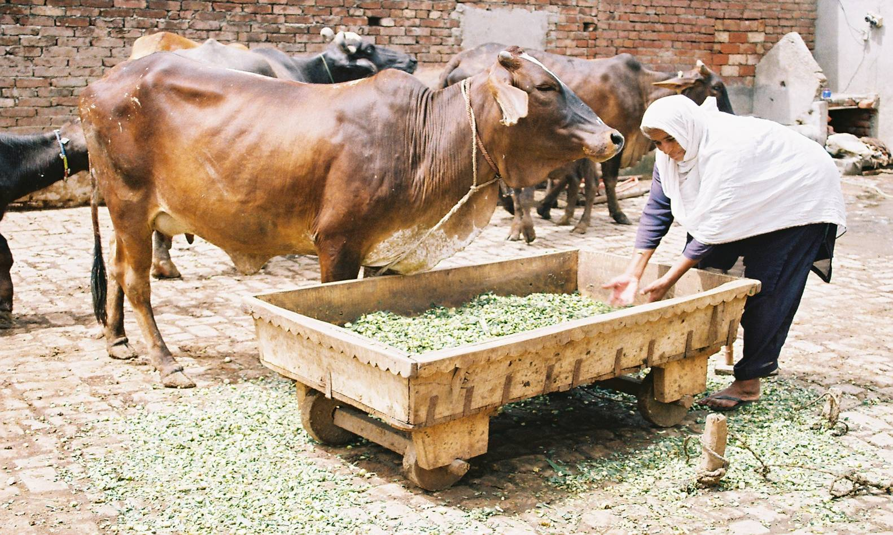

Muwakhat Foundation, in September 2013, introduced Qarz-e-Hasna (Interest Free Loan) for destitute women to generate income.

Criteria for Qarz-e-Hasna eligibility are as follows:
- PPI score should be above 40%
- Not able to meet the basic needs of the family
- Skilled labor but have no work to do
- Sole breadwinner of the family and scarce income

Muwakhat Foundation selected, specifically, women who
- Were skilled and wanted to work for economic empowerment
- Were either widows or divorcees and wanted to earn a livelihood for their children

Members are selected after mutual consultation of a committee comprising of three members, including the Imam of the mosque. The selection is based on the Shariah guidelines.

QARZ-E-HASNA – AN OVERVIEW
Number of Branches | 3
Number of Women | 30
Donations for Qarz-e-Hasna | Rs. 71,000/=
Number of Interest Free loans | 30
Amount of Interest Free Loans | Rs. 1,91,000/=

QARZ-E-HASNA – CASE STUDIES

CASE STUDY OF AMNA BAJI
Amna baji lives with her son in a small, one roomed, rented house in Ghaziabad, Lahore. Due to some feud, her family forced her to take divorce from her husband. Since her family is also not very well off, Amna baji decided to live separately with her son and earn her living. She knows stitching, but her problem was that she did not have a sewing machine. Asasah decided to help her with Qarz-e-Hasna and bought her a machine as well as the other required stuff. She is now working hard, supporting herself and her son and wants her son to be highly educated.

CASE STUDY OF MAHAM BAJI
Maham baji lives in a two roomed house in Islampura, Swat. Her husband worked as a private security guard who died during one of the bomb attacks in 2007. She has two sons and three daughters to feed. Her in-laws are also not very well off and cannot support her on regular basis. She knits woolen sweaters and in order to fulfill her domestic needs she started acquiring orders from her close neighbors and relatives. After some time she realized that she can increase her income if she had a knitting machine. She contacted Asasah and was selected for the Qarz-e-Hasna from which she was able to buy the machine. Now she makes sweaters in the winter season and earns upto Rs 10,000 per month.

FREE LEGAL AID & AWARENESS PROGRAM FOR WOMEN
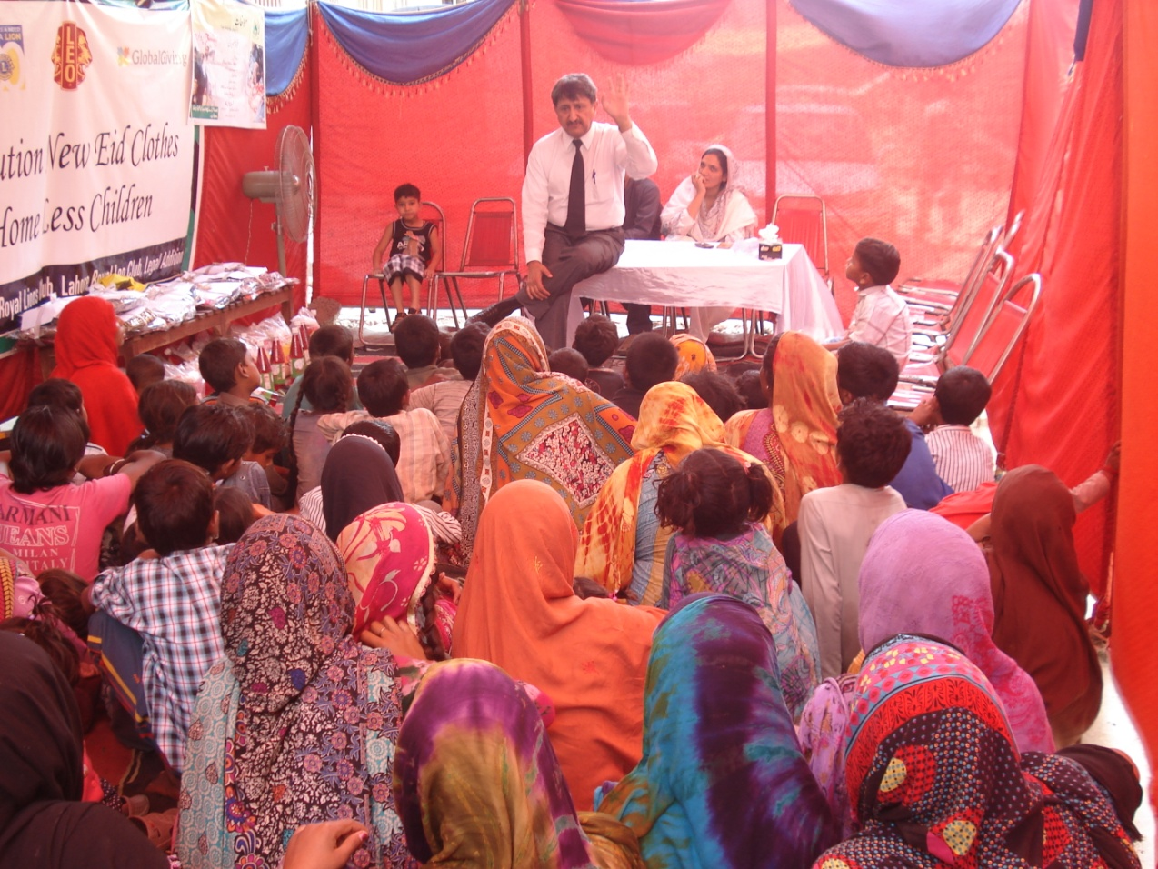

Muwakhat Foundation is non profit organisation working in Lahore, Gujranwala and Kasur District since July 2013 to uplift and support women of poor community. In early 2016, free legal Aid and awareness program started with following objectives:
- Free legal aids to victim (women & children)
- Awareness on basic legal laws especially domestic violence, benefits of registered marriage contract, rights of women in property etc
- Training of young female lawyers belong to poor family as trainer for conduct awareness sessions and assist in free legal cases

Muwakhat Foundation did MOU with legal Firm “SJ Law Firm” to meet above objectives. This law firm has experience of 32 years for providing free legal aid in Lahore and Multan Court to very poor accused especially poor ladies and children who could not engage lawyer.

Since May 2016, Muwakhat Foundation provided free legal Aid to eight women victims and four awareness sessions on basic legal rights to women and girls. (ref: page 3 and 4 Muwakhat Nama Feb 2017)

Case 1- Saeeda Qamar belongs to poor family. They took loan from bank for income generation activity but not able to paid back on time due to long illness of her husband. Bank continuous followed her. She was requested for grace period but refused by bank. Zareen Aamir Lawyer & chairperson of Muwakhat Foundation fought her case. Result Bank reschedule her loan and stopped followed. (ref: Page 3 Muwakhat Nama Feb 2017)

Case 2- Bushra Baji is resident in slum area of Lahore and doing bamboo business with support of her brother. She need NTN number for her business, unfortunately no one guided her. Muwakhat Foundation help her to sent request Federal Board of Revenue Office and within a week National Tax Number got by Bushra Baji. (ref: page 3 Muwakhat Nama Feb 2017)

EDUCATION PROGRAM FOR WOMEN & GIRLS
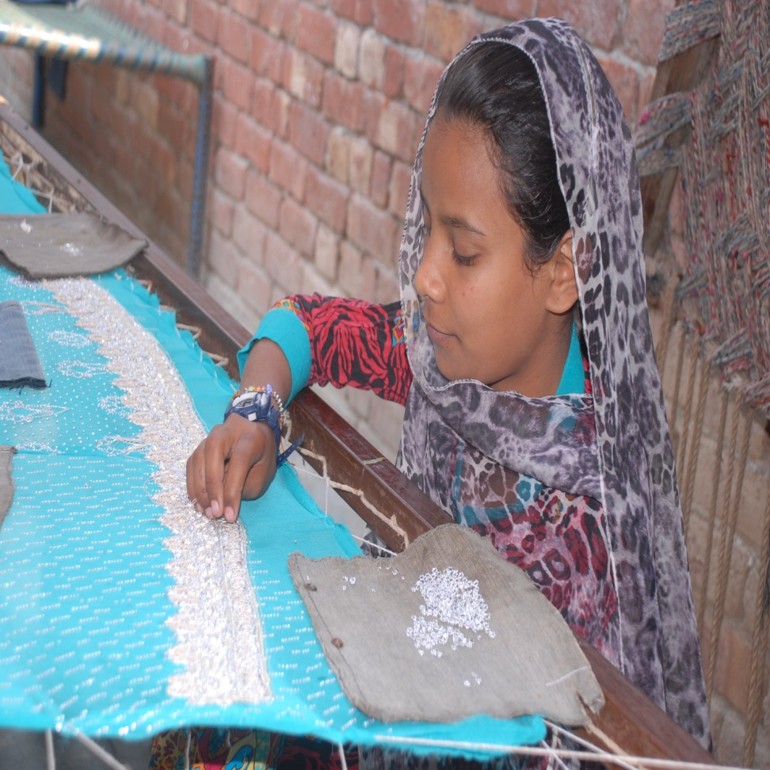
Pakistan has one of the lowest literacy rates in the world. Women which are the 51% on the country population and their literacy rate is alarming especially in rural areas due to social and cultural obstacles. Of Every 100 girls in rural Pakistan, only 18 will reach the 8th grade, only 1 complete high school.
Educating a girl is our joint responsibility. Muwakhat foundation goal is “Education and food for every girl”
In three years, Muwakhat Foundation send back 30,000 drop out girls to high school after counseling of their parents and overcome obstacles. Result with collective effort, we can change their world.
AWARENESS SESSIONS HELD FOR PARENTS
Muwakhat Foundation team conducted eight awareness meetings with parents on girls education in Lahore and Kasur cities.
In awareness meeting, share importance of girl education especially in the light of quran and did interactive sessions with mothers. We observed that mothers want to send their girls to school but cannot raise voice in front of the decision of father or head of households.
Total 365 mothers attended awareness meetings.

PROJECT: 500 homeless families transform from poverty to respectable life in Pakistan
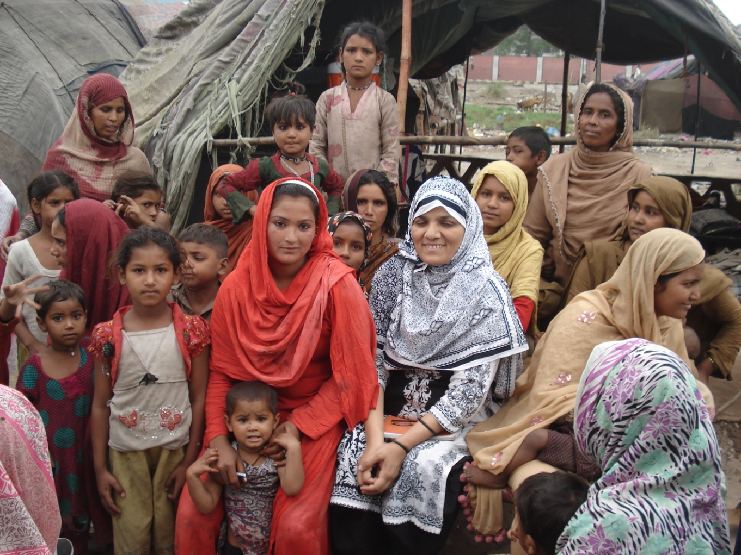
Since 2013, Muwakhat Foundation helping vulnerable group by give food , new or used clothes, free health services and clean water. We believe that a collective effort to address the issues affecting the lives of more than seven million Pakistanis and it is possible brought back them to safety, and into the fold of society.
We selected 500 homeless families to help come out from poverty trap.
Need Assessment Survey for fulfill dreams of homeless women & children
Background for Need Assessment Survey
Muwakhat Foundation team started project to help homeless women and children since July 2016 with distribution of new clothes to children age zero till twelve years on Eid-ul-fitar.( muslim festival). It was observed that these women and children are most neglected and vulnerable group, lack basic needs and most important these families ignored and not treated as respectable citizen of Pakistan. People help once in a while by food, dry ration and clothes but no one did effort to bring them in society who excluded.
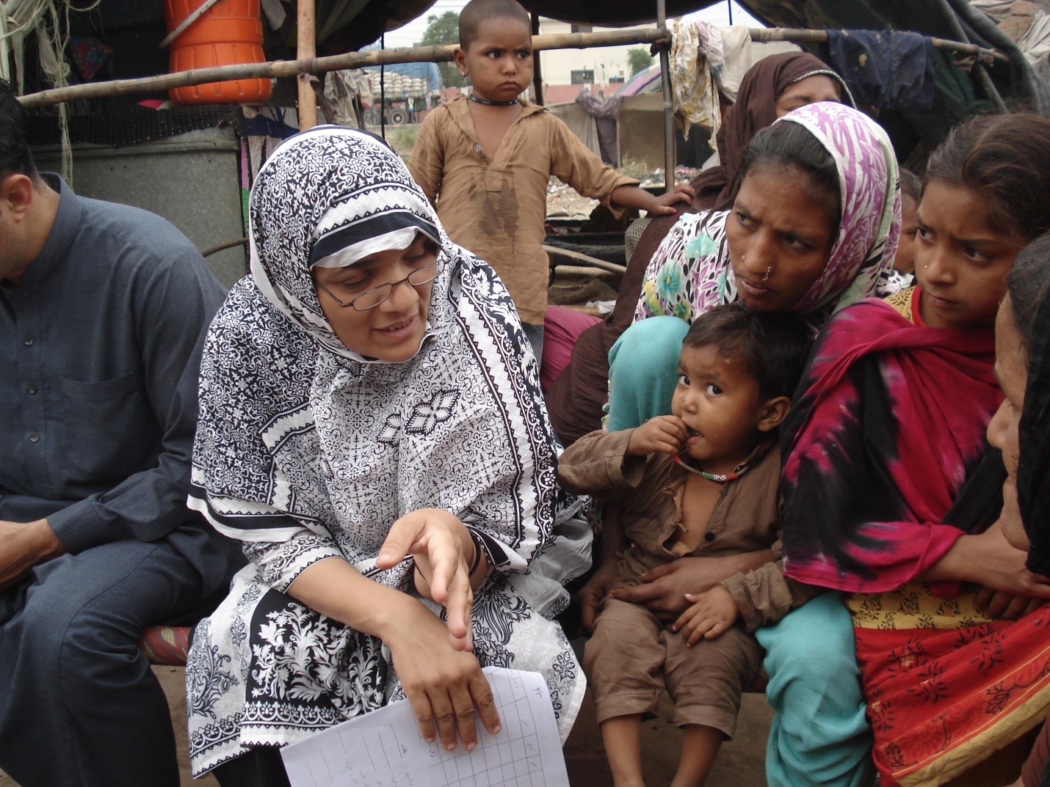
April 16 & 17, 2017 Muwakhat Foundation conducted need assessment survey incomer to identify needs, their income generation activities and poverty level. This help to develop road map of homeless families for transformation of their life from neglected to respectable citizen. Women and children given warm welcome to our team members. This was the first time that women were interviewed. They were shared their life challenges and dreams.

Areas focused in survey
In survey form, questions related to basic needs i.e health, education, water, sanitation, income and expenses details were asked to women. This survey will help to understand homeless families living pattern, life challenges & threat, income generation sources and household expenses.
Highlights of Survey
Muwakhat Team did one to one interviewed with fifteen families and did focus group discussion with women and children. Survey data will be analyzed and Report will be published in mid of June 2017. Here we are sharing some snapshots for give and idea of their life:
- Biggest challenge: There is no concept of birth registration within the community, which makes it difficult for them to get Computerized National Identity Cards (CNIC).
- They do not have permanent place and all families living in tent from 30 years.
- Community lives below the poverty line, in severely unhygienic conditions.
- 100% women and children illiterate.
- Most of their children send for force labour at age of seven
- 100% women birth their children at their tent which is so called house due to not have facility of health center.
- No clean water available
- Donot have facility of electricity and gas
- No proper sanitation
- 85% families sleep with empty stomach twice in a week
- More than 80% women have embroidery skills and some of them show their work ( see pictures)
Plan of Action
Muwakhat Foundation will work with homeless families in three phases. Phase I will start soon and plan of action of phase II & phase III will set after survey report.
Phase I: In this phase Muwakhat Foundation will do following action
- Register homeless families and issue card for receive help from Muwakhat Foundation
- Ramadan Month (fasting & holy month for Muslims) will be start in next week, Food package distribute to homeless families to assure food in holy month.
- After 30 days Eid festival coming, Muwakhat team will collect donation, purchase food and clothes for children and women and distribute before festival.
Join us for this noble cause. Your small contribution bring big change in their life

Some pictures of distribution of gifts to children
