Respected Donors
Greetings from Chhattisgarh Agricon Samiti
We have got your valuable support through Global Giving. We have started the awareness and baseline research with rural community in this quarter.
During this quarter we did not carries more activity due to Covid-19 pandemic and lockdown.
In previous We have selected 2 districts (Bastar and Bilaspur) to start community mental health program. Firstly, we have carried out baseline research in 5 village of each district. On this process, we have organized many awareness programs like corner meeting, poster exhibitions and social mapping. We have addressed many mental health issues and challenges. We have identified some high-risk clients. We have mapped support system and institutions in village level for mental health needs.
These all activities are increasing our knowledge and capacity about community mental health issues. We are involving actively into the rural community.
Some Pictures from Villages
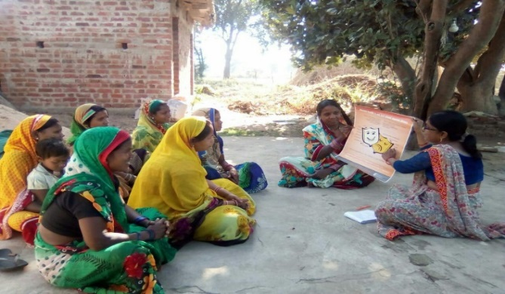 | 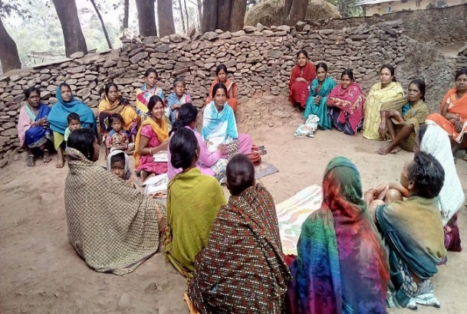
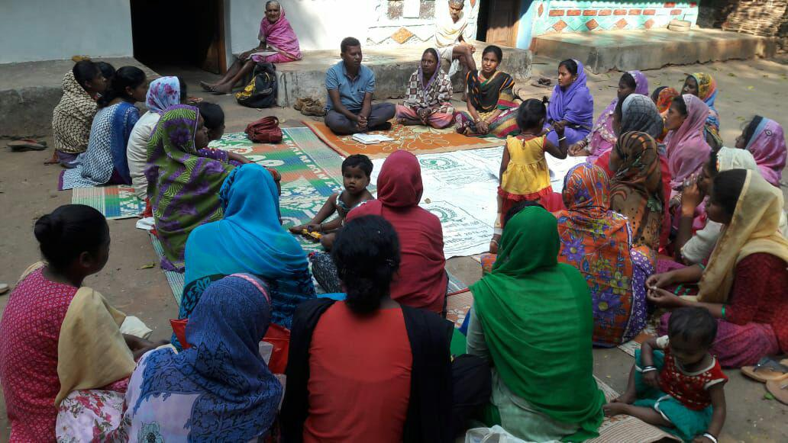 | 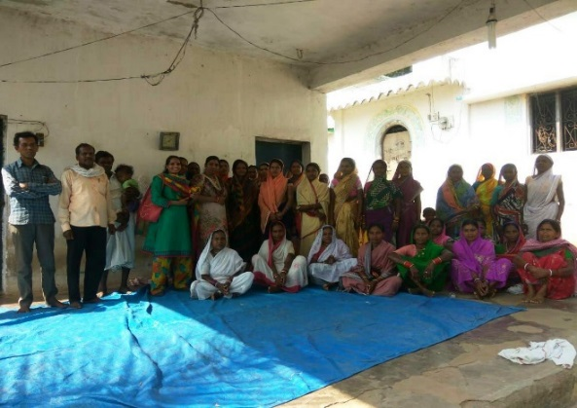
Awareness activities with rural community in village level

We expect that you will spread the word within your social reach about our work and initiative to help us garner great support for our team.

