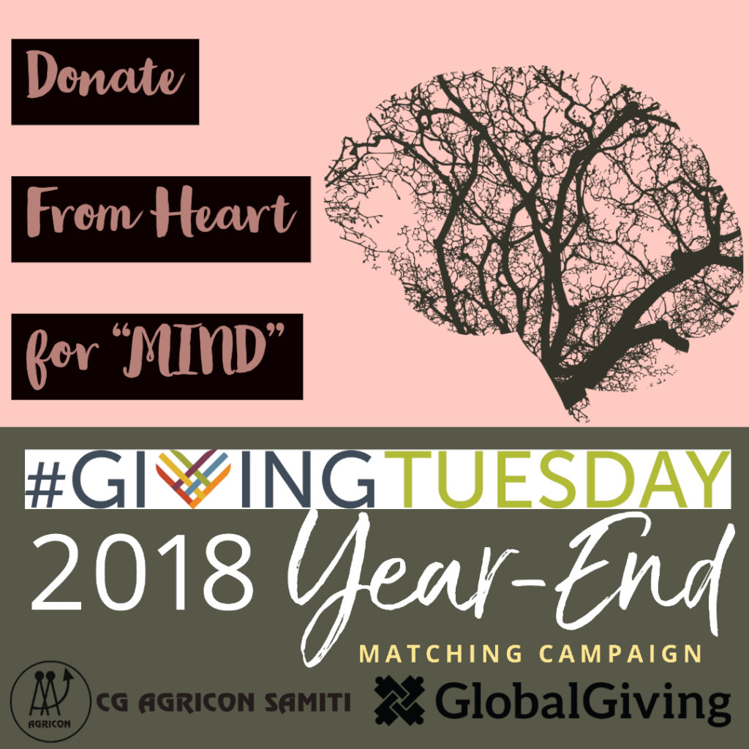
Respected Donors
Greetings from Chhattisgarh Agricon Samiti
We have got your valuable support through Global Giving. We have started the awareness and baseline research with rural community in this quarter.
We have selected 2 districts (Bastar and Bilaspur) to start community mental health program. Firstly, we have carried out baseline research in 5 village of each district. On this process, we have organized many awareness programs like corner meeting, poster exhibitions and social mapping. We have addressed many mental health issues and challenges. We have identified some high-risk clients. We have mapped support system and institutions in village level for mental health needs.
These all activities are increasing our knowledge and capacity about community mental health issues. We are involving actively into the rural community.
Some Pictures of Activities
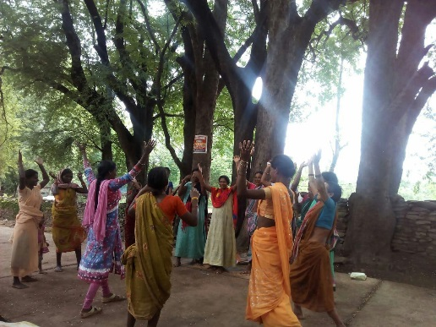 | 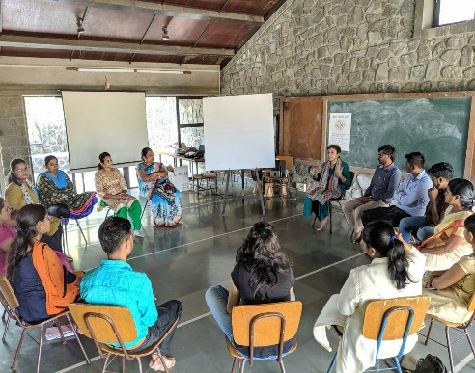  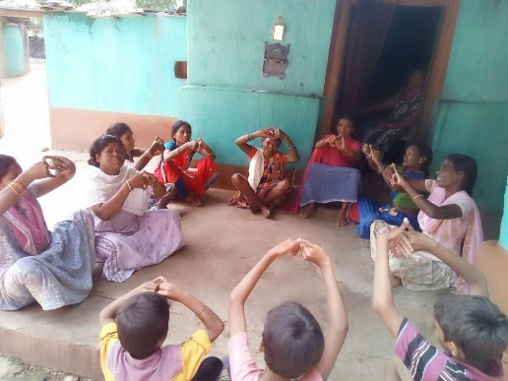
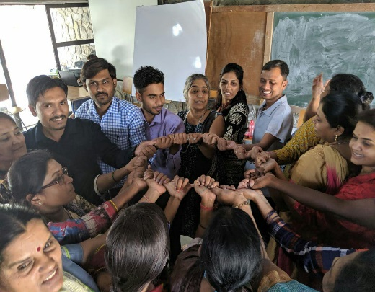 | 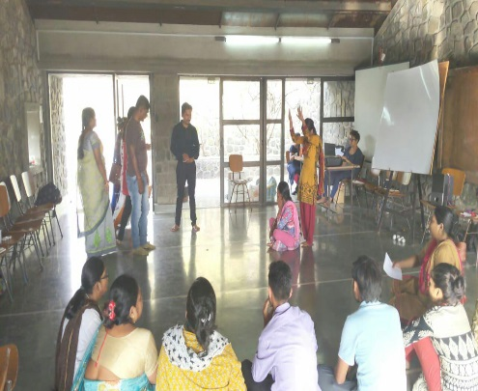  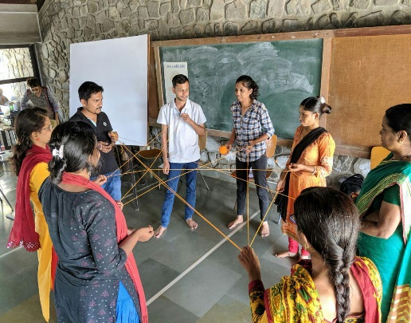

Activity during the quarter (May 2019 to Jul 2019)
During this quarter our team has participated to the 2nd phase of training program “Programing for Inclusion of Person with psychological disabilities” held on 27 May 2019 to 3rd Jun 2019 in Pune Maharashtra. We have learned about the Art and play for wellbeing in development, Community Mobilization and Participation, Peer support and support counselling, Family counselling for communities. We have learned about client assessment tools like WHO-QoL, Nutrition assessment, family and social assessment and clinical assessment etc.
Presently we are assessing our 47 identify client in both district Bastar and Bilaspur. We have prepared an intervention plan for each client. We have started some intervention like peer support, art-based activities and individual and family counseling. After the interventions some clients are likely came out from there mental stress. With the time it will be more effective.

Our First Achievement (about client A)
As we shared in our last report, we had found a client “A” (for client privacy issue, we are not disclosing the identity of client). Who was completely facing mental stress and phycological issue.
We are providing her some peer support and individual counselling. Now she has almost came out from her socio-phycological issue. She is deciding to start a new life and get marry again. Hope we will share the detail of her marriage in our next report.
We expect that you will spread the word within your social reach about our work and initiative to help those people like our client “A”.

