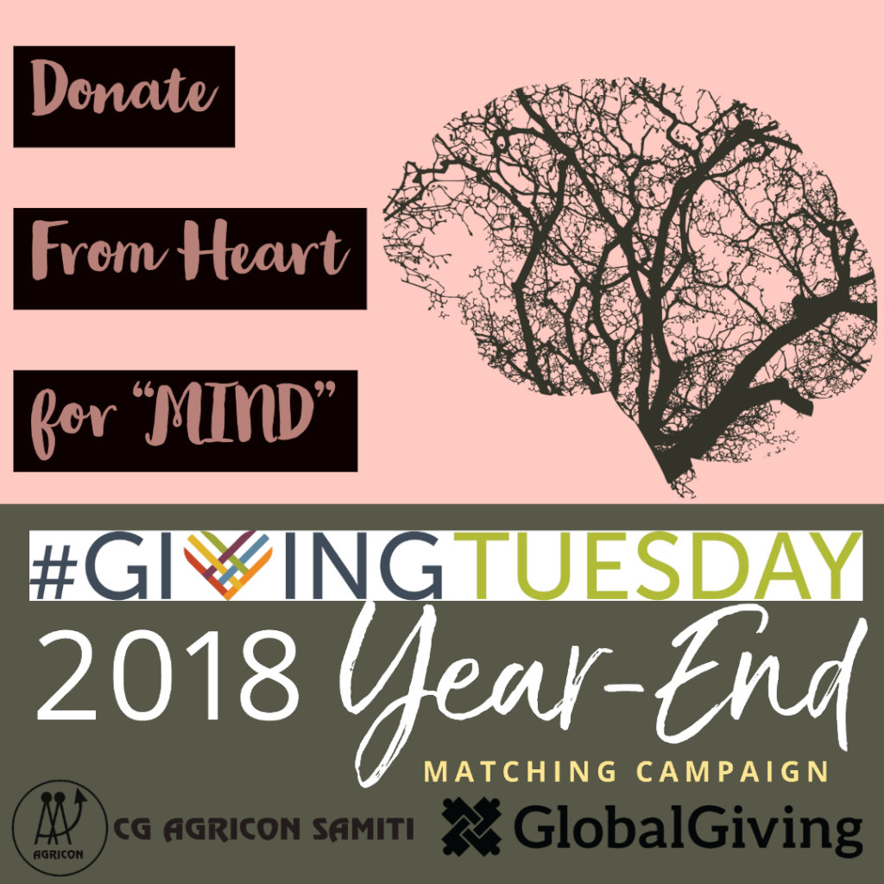
Respected Donors
Greetings from Chhattisgarh Agricon Samiti
We have got your valuable support through Global Giving. We have started the awareness and baseline research with rural community in this quarter.
We have selected 2 districts (Baster and Bilaspur) to start community mental health program. Firstly, we have carried out baseline research in 5 village of each district. On this process, we have organized many awareness programs like corner meeting, poster exhibitions and social mapping. We have addressed many mental health issues and challenges. We have identified some high-risk clients. We have mapped support system and institutions in village level for mental health needs.
These all activities are increasing our knowledge and capacity about community mental health issues. We are involving actively into the rural community.
Some Pictures from Villages
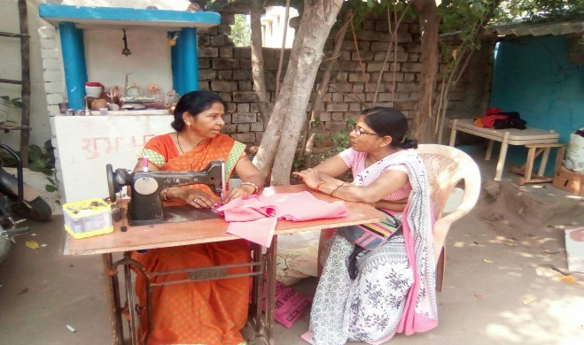 | 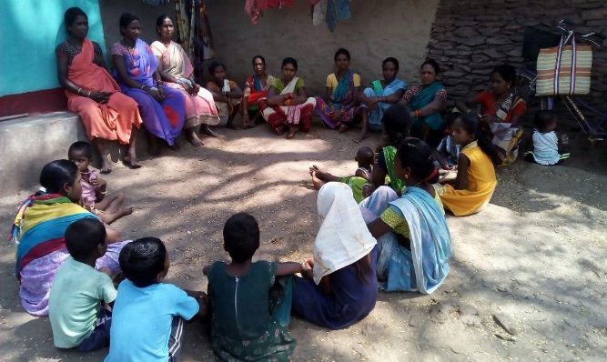
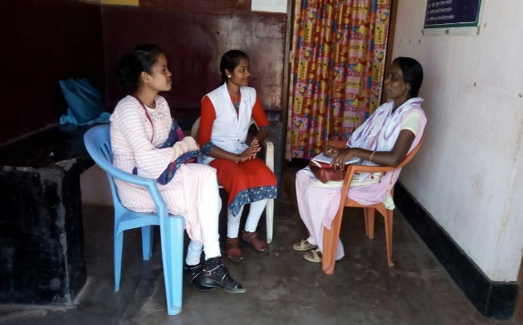 | 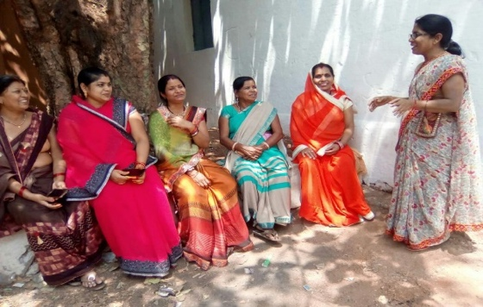
Awareness activities with rural community in village level

Our First Achievement
During Awareness and baseline research we had found a client “A” (for client privacy issue, we are not disclosing the identity of client).
A is a single widow living in a village of Baster district. Her husband has died before 3 year ago and she also lost her single child in Jul 2018. After discussion with her, we found mental or socio phycological issue with her.
- She feels continuously headaches with her.
- She felt lonely and sad.
- She always lived under fear and worry.
- She felt hopeless and disappointed.
- She was thought about not to live or suicide.
- She here strange sound or similar illusions.
- She felt always ill herself.
Our team were continuously in touch and talked with her. We found that she is completely lonely. We included her with a Women Self Help Group. It’s a social cum economic activity group. She started to connect with group members and feeling better. After some days she had an opportunity to attend a livelihood training and counselling in nearby city Jagdalpur.
After she came back from Jagdalpur, she was more confident with herself. Now she has overcome her socio-phycological issues. Now she wants to marry again and live happy as like others. Hope we will share the information about her marriage in our next repot.
We expect that you will spread the word within your social reach about our work and initiative to help those people like our client “A”.

