THE GRANDCHILDREN EDUCATION FUND
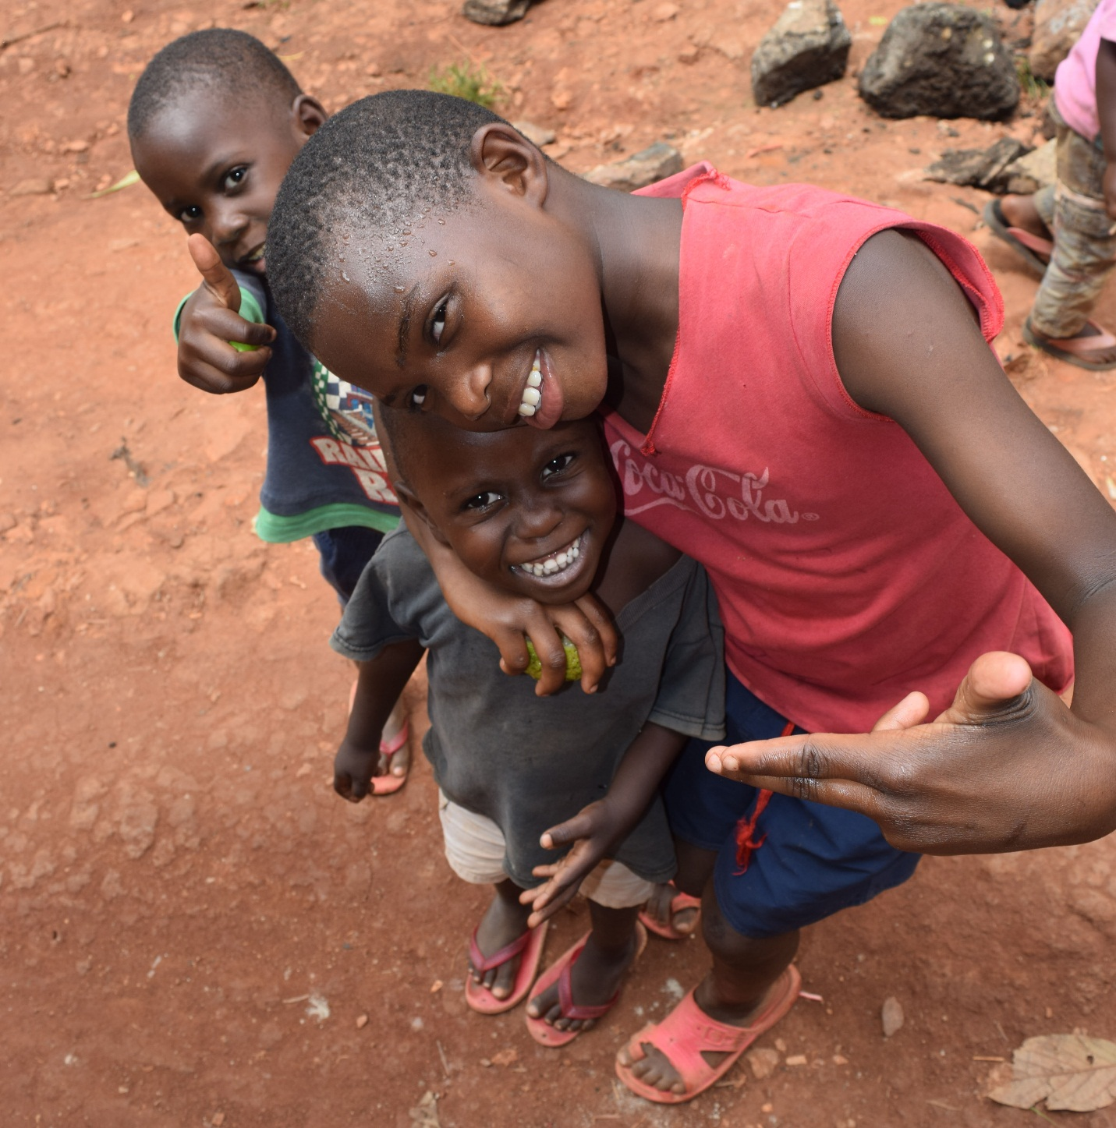
THE GRANDCHILDREN EDUCATION FUND is a project of MY GRAND PAA-MAA UGANDA established to tackle one of the biggest challenges faced by the older persons in Uganda.
The biggest number of orphans in Uganda is left under the care of their grandparents, this is mainly caused by HIV and Aids.
With the financial difficulties the older persons are characterized with, it’s quite hard for most of them to afford taking these little ones to school.
THE GRAND CHILDREN EDUCAION FUND aims to have this problem solved by taking the children left under the care of the most disadvantaged older persons to school
The program is set to start in January 2019 with the pioneer enrolment of 10 kids all in their primary level of education.
This program is designed with a clear criteria through which the eligible children will be determined
HOW ARE WE GOING TO IMPLEMENT AND MONITOR THE PROGRAM?
MY GRAND PAA-MAA UGANDA as an NGO will get into an agreement with the schools our beneficiaries are going to attain education from, clear terms and conditions are designed to make our beneficiaries have the best out of this project.
We have identified the best universal primary schools (UPE) and these are the schools our students are going to be educated from, The program is progressive, meaning we will be adding 10 children every year from a different district with emphasis put on districts that are far away from urban towns because these are the districts that are most affected by luck of education opportunities. The program is to kick start with 10 children from Luwero district.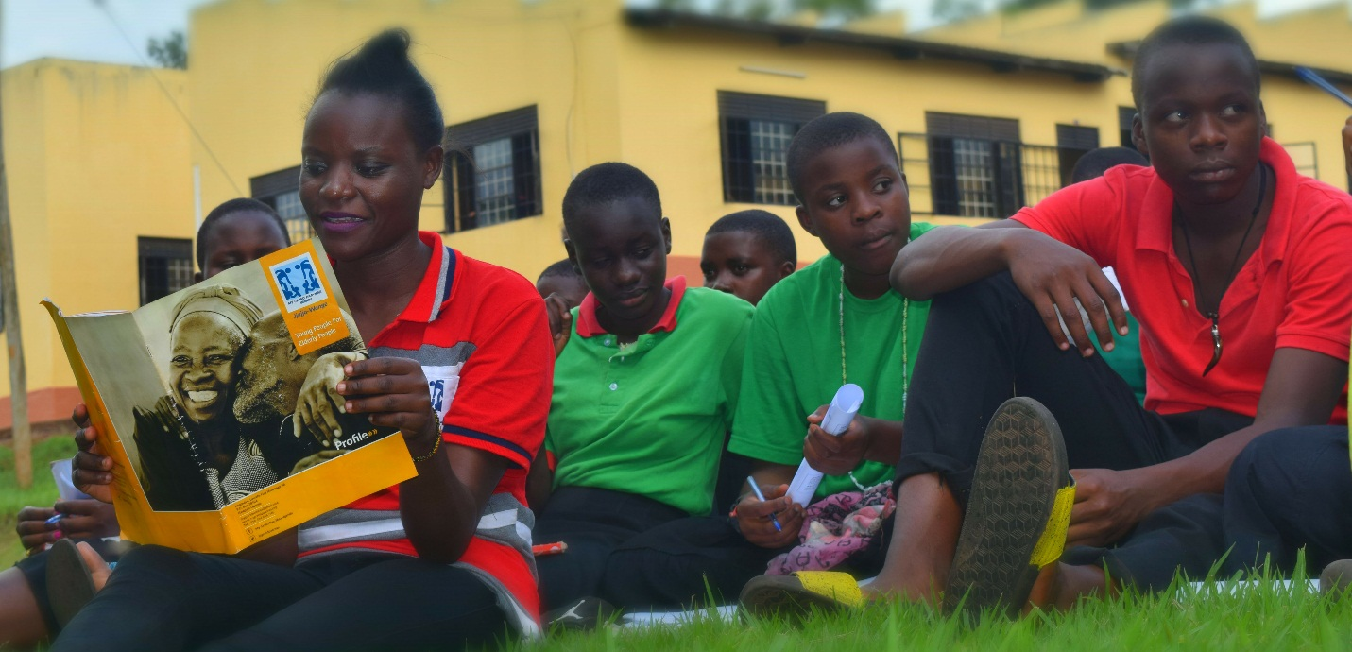
WHAT THE FUND WILL PROVIDE TO THE CHILDREN ON ITS BURSARY
All the children on the grandchildren education fund bursary will be provided with the following
- Full school fees (As paid in the Universal primary schools)
- Full meals fee.
- A pair of shoes.
- Books, pencils, pens and a school bag.
- A school uniform.
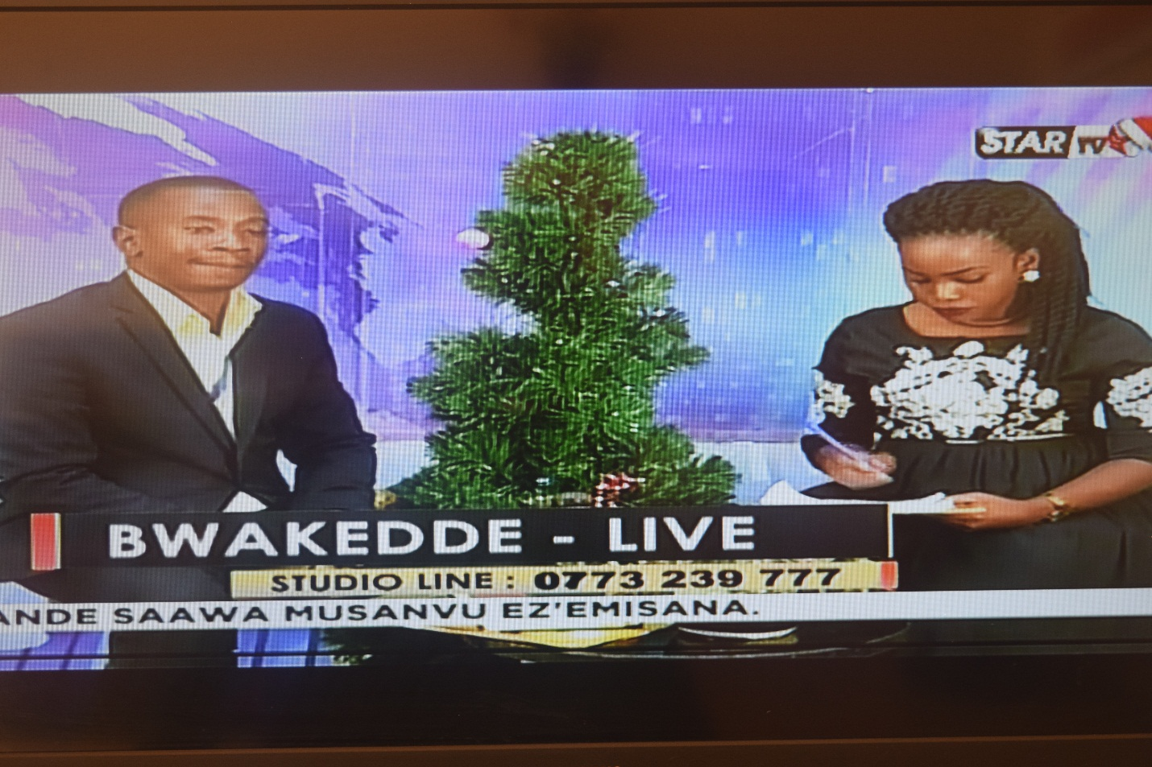
OUR TEAM LEADER KYOBE ALLAN addressing the nation about this amazing program to kick start next year. He was responding to questions from the viewers of star TV a national broadcaster, about the GRAND CHILDREN EDUCATION FUND.
WHICH CHILDREN CAN’T THIS PROGRAM FUND?
This program cannot fund the following children;
- If a child is related to any of the directors or influencers in MY GRAND PAA-MAA UGANDA.
- If a child is not under the care of an elderly
- If a child cannot take education from a universal primary school
Those are the first critical essentials to be analyzed with care before.

