CAMPAIGN AGAINST FEMALE GENITAL MUTILATION(FGM)
AND
GIRL CHILD ABUSE
IN
KANGEMI & KAYOLE COMMUNITIES,
Nairobi, Kenya

HEAD OFFICE: 88 Hon.Sanni Street, Iraye, Epe, Lagos, Nigeria.
MAIN OFFICE: Maximum Business Centre Building, MM18, Tsavo, Odion, Nairobi, Kenya.
Branch Office:902, 9th Floor, Modern Christian Building, Ngara, Nairobi, Kenya.
TEL:Nigeria +234-8023179658, Kenya+254-738082836, Ethiopia +251929184731
E-Mails:akdjoan@icfaonline.website, akdmorenikeji@gmail.com
Website; www.icfaworldwide.org

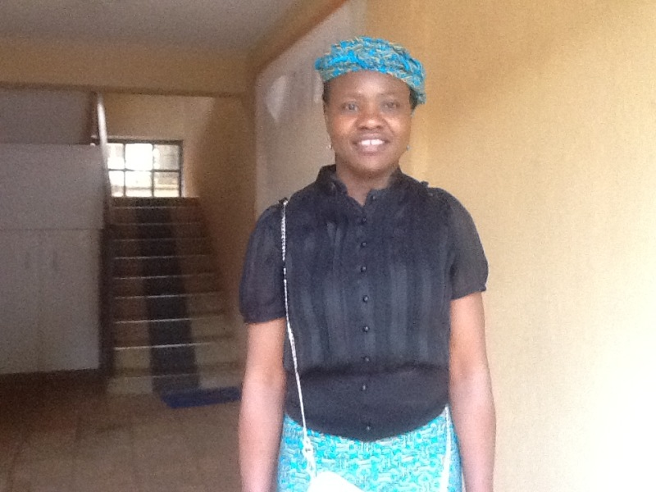

Mrs Joan Oyinkansola Akin-Davis
Founder/CEO
International Centre For Family Advancement (icfa)

PROJECT SUMMARY OF INTERNATIONAL CENTRE FOR FAMILY ADVANCEMENT, (ICFA) KENYA
ON ‘CAMPIAGN AGAINST FEMALE GENITAL MUTILATION & GIRL CHILD ABUSE’ PHASE 1 YEAR 2018
Our Organization has been able to carry out intensive campaign ON GENITAL MUTILATION and GIRL-CHILD ABUSE on women of NAIROBI, KENYA.
Our effort at enlightening and re-orientating the women of KANGEMI and KAYOLE communities in Nairobi, about their rights to ”NO CIRCUMCISION” and to safe guard them from the resultant HEALTH and PSYCOLOGICAL effects of such traditional practice.
ICFA has been able to reach out to over 1000 Mothers, Children & the elderly through our rigorous Program tagged “CAMPAIGN AGAISNT FEMALE GENITIAL MUTILATION & GIRL CHILD ABUSE”
Our previous strategy of conducting FORUM and WORKSHOP, PUBLIC RALLY were social workers, psychologist and legal officers facilitate the enlightenment and re-orientation course has been very rewarding as they are beginning to see things in light of civilization, but we need to employ a more pragmatic means where evidence of things said becomes reality, by solving the backlog of health and psychological problems on ground.
As a tradition in Kangemi and Kayole communities in Nairobi, Kenya. Girls of certain age grade, 7-11 years old (which are averaging approximately 2.5m) are complied to be circumcised in their native traditional way at a feasts or ritual-like ceremony slated for fixed dates.
The negative effects of this genital mutilation is conspicuously evident in some teenagers and young adults between 12-25 years old (which are averaging approximately 1.7m), with at least one (1) out of every ten (10) persons with FGM developing serious health complications. Its complications are either PHYSICAL i.e. ranges from, excessive bleeding and infection, chronic pain,swelling,problems with wound healing, urine retention, recurrent urinary and vaginal infection, and difficult labor.
The girls and women undergoing FGM often suffered more than one immediate complication.
Or it’s PSYCOLOGOCAL IMPACT such as anxiety and post traumatic stress, stigmatization and castigation. And ABNORMALITY in the female sexual function.

Our pragmatic strategies are;
- Immediate medical attention to address their health issues.
- Further psychological therapy to stabilize them.
- To engage a competent term of at least four (4) women of substance, who are professionals in diverse felids to ‘lobby’, sensitize and re-orientate the female traditionalist who are core advocates of this CIRCUMCISION to at least make it a voluntary exercises for the young girls of such age bracket.
- Establish a Mediation and Legal Aids Centre, were young girls and women can seek refuge, take counsel and get legal assistance in the event of litigation. Also take legal actions on their behalf if they are willing and if necessary, but we are bias on the side of abolishing circumcision.
- Intensify our normal campaign on genital mutilation.
- Help sponsor a bill to the Legislative House and pursuing it to a conclusion. A bill on the ABOLISHMENT OF GIRL CHILD MUTILATION AND ABUSE
Financing of these campaigns has rested majorly on me as the founder of the NGO, coupled with the effort of our partners (SKILLS ASSISTANCE FOUNDATION),a few private Hospitals and some few other kind hearted individuals who are also members of the NGO,along side family and friends that believe strongly on the course of our struggle.
This second phase of our campaign is highly capital intensive and we require as much financial support as possible. As well as technical assistance in terms of more professional social workers, Lawyers and Administrators.
For us to forge ahead with this campaign, phase 2, which is the immediate medical treatment for one thousand (1,000) affected circumcised teenagers and young adult at the rate of $20 per person, is $20,00
Female genital mutilation (FGM) has been performed in various forms and involves the partial or total removal of the external female genital or other injury to the female genital organs for non-medical reasons. It is the removal or damage to the highly sensitive genital tissue, especially the clitoris.
The practice is generally performed on pre-pubescent girls, often without anaesthetics, thus, it is reasonable to assume that it is a traumatic event that may cause both short-term and long-term harm. With regards to long-term harm, it has been established that women with FGM were more likely than women without FGM to experience attenuation of sexual functioning, obstetric complications, and possibly psychological disturbances. Also harm occurring during the cutting or alteration modification process and the short-term period.
The issue of Female Genital Mutilation (FGM) or female circumcision as it is generally called is an age old traditional practice in many countries including, Kenya. The practice was based on certain beliefs, one of which is that it helps to reduce female promiscuity. Research has shown that FGM has numerous psycho-physiological consequences. A study tried to establish if there is any relationship between promiscuity and FGM, if circumcised females suffer depression more than the uncircumcised females and, if circumcised females have less difficulty than their uncircumcised counterparts in becoming sexually aroused and attaining orgasm. Three null hypotheses guided the study and data obtained were analyzed using t-test statistics. The findings revealed that FGM does not reduce promiscuity, that circumcised females experience depression more than uncircumcised and, that circumcised females have more difficulty than their uncircumcised counterparts in becoming sexually aroused and attaining orgasm. Psycho-counseling measures for helping FGM victims manage their lives, achieve sexual satisfaction and become better adjusted were highlighted.
FGM is a harmful practice with severe health complications, its complications are either PHYSICAL i.e. ranges from, excessive bleeding and infection, chronic pain, swelling, problems with wound healing, urine retention, recurrent urinary and vaginal infection, and difficult labor.
The girls and women undergoing FGM often suffered more than one immediate complication.
There were few differences in risk of immediate complications among different types of FGM, but there might be a greater risk of immediate complications for women with FGM type III (infibulations) compared to types I-II.
Or it’s PSYCOLOGOCAL IMPACT such as anxiety and post traumatic stress, stigmatization and castigation. And ABNORMALITY in the female sexual function.

Our campaign and activities for the FGM PROJECT is done within
Kangemi and Kayole, remote communities located at the South Eastern part of the capital city Nairobi, Kenya.

FGM are in categories ranging from Type I through IV, with Type IV been the least. This issue of FGM has seriously endangered the lifes of affected teenagers and young adults. Each of the most common complications occurred in more than one of every ten girls and women who undergo FGM types I through IV, thus immediate complications such as bleeding and swelling occur in setting with all forms of FGM. Even FGM type I and type IV 'nick', the forms of FGM with least anatomical extent, presented immediate complications like urinary and vaginal infections, chronic pains etc.While the results that multiple immediate and quite serious complications can result from FGM should be viewed in light of long-term complications, such as obstetric and gynecological problems, Infertility, difficult labour, and protection of human rights.

With at least one out of every ten persons with FGM been affected with health complications the community and society at large is affected in various ways;
- The number of potential work force is reduced
- The dependency ratio on the society will increase
- The general well-begin of the affected person is in question
- The mortality and death rate in the community will increase
- Because of the prevailing poor economy existing there, the affected individuals are further ENPOVISHED, even to destitute level due to negeclects and castigation when circumcision results to complication.

From the statistics made available to us, it is estimated that over one hundred and seventy thousand (170,000) teenagers and young adults and even elderly are presently living with one form of health complication or the other directly related and caused by FGM,most of whom if given proper medical attention can be cured. And in addition to this, the psychological therapy will alleviate them a lot.

We at INTERNATIONAL CENTRE FOR FAMILY ADVANCEMENT (ICFA) have scheduled a strategic work plan to tackle these problems in PHASES.

PHASE I 2018; PUBLIC ENLIGTHENMENT & ORIENTATION ON‘CAMPAIGN AGAINST FEMALE GENITAL MUTILATION AND GIRL CHILD ABUSE’

PHASE II 1st QUARTER 2019: IMMEDIATE MEDICAL TREATMENT FOR 1000 PERSONS WITH FGM COMPLICATIONS

PHASE III 2nd QUARTER 2019: IMMEDIATE MEDICAL TREATMENT FOR 5000 PERSONS WITH FGM COMPLICATIONS

PHASE IV 3rd QUARTER 2019: IMMEDIATE MEDICAL TREATMENT FOR 5000 PERSONS WITH FGM COMPLICATIONS

PHASE V 4th QUARTER 2019: IMMEDIATE MEDICAL TREATMENT FOR 5000 PERSONS WITH FGM COMPLICATIONS

Our immediate need, is for the first quarter project, after having consulted with and solicited for the support of some medical hospitals, which have been supporting and assisting in the treatment of just a few cases we could handle, we come to a compromise on the treatment rate of $20 person with FGM complication types I to IV
IDEALLY the complete treatment should have cost $50 each and about $20 for individual transport logistics and miscellaneous expenses totaling about $70 person. But due to their poor financial condition must affected persons cannot afford this amount, they normally result to the use of native herbal medicines, which in most cases are not effective and in some cases worsen the situation.

MEDICAL TREATMENT COST ESTIMATE (subsidized rate by partnering Hospitals)

1 PERSON = $20
1000 PERSOS = $ 20,000

This phase ll, so also with all other subsequent phases, will be running with our phase I project which is the ENLIGTHENMENT AND OREINTATION PROGRAM. While other long term measures will follow in due course.

With this strategic work plan, if well followed and adequately implemented, we are optimistic that in ten (10) years or less cases of FGM complication will have been completely treated and eradicated and the practice abolished.

The fight to stop FGM and eradicate its resultant complication has become necessary so as to give victims and prospective victims their FOUNDAMENTAL HUMAN RIGHTS.

Attached herewith are photographs of our ENLIGTHENMENT AND OREINTATION activities and the few beneficiaries of our FGM complications treatment.
We strongly solicit for all the support we can get to achieve these objectives and liberate these victims form their sordid condition.

OUR ACTIVITIES AND EVENT PICTURES
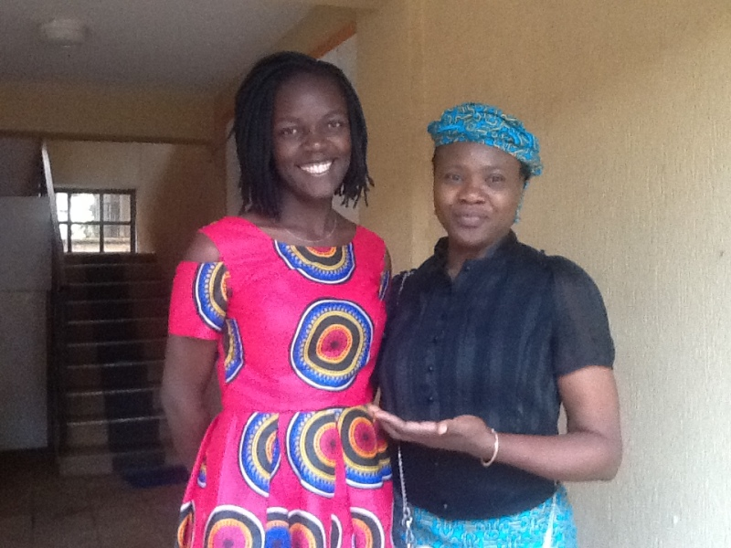 Mrs Joan Oyinkansola Akin-Davis with a Volunteer Facilitator
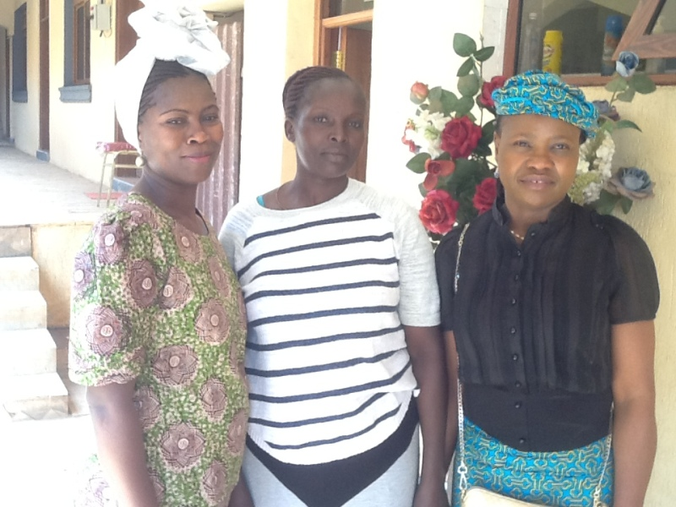
Mrs Joan Oyinkansola with some Volunteer Social workers

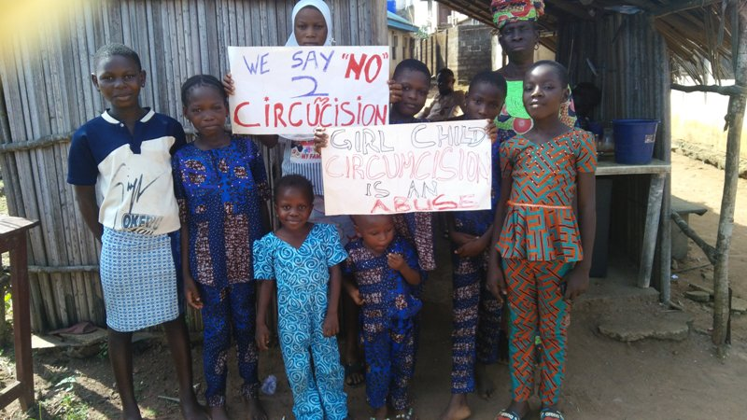
CROSS SECTION OF TEENAGERS IN OUR ENLIGHTENMENT CAMPAIGN
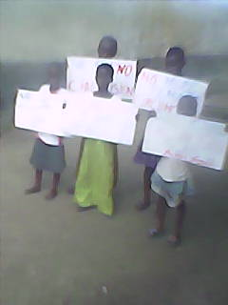
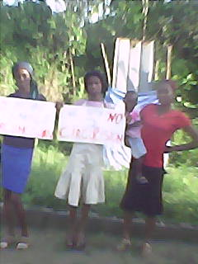
CROSS SECTION OF CAMPAIGN OUTREACH
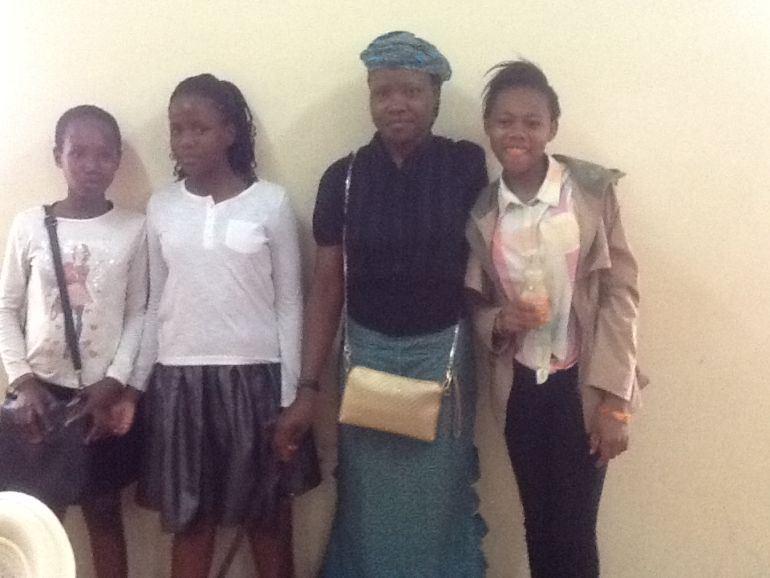
Mrs Joan Oyinkansola Akin-Davis with participant at a workshop for FGM
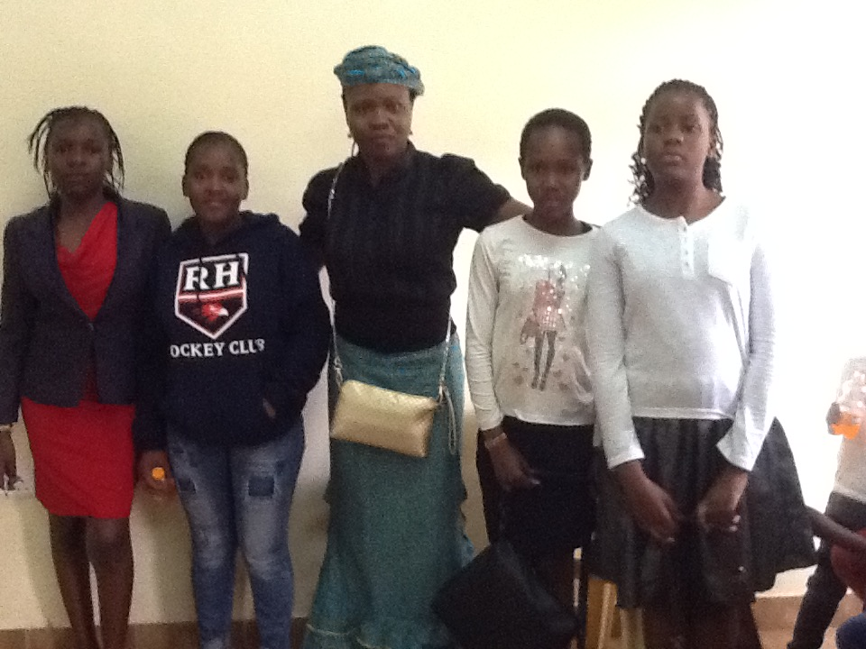
Mrs Joan Oyinkansola Akin-Davis with participant at a workshop for FGM
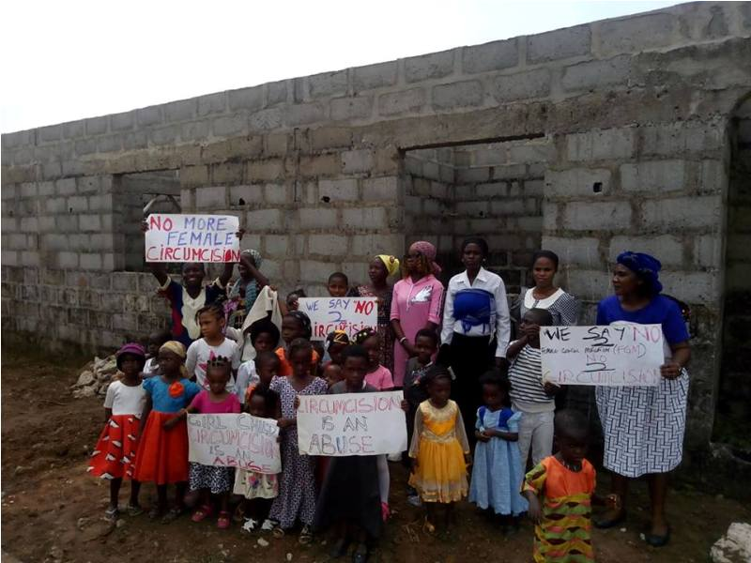
CROSS SECTION OF A CAMPAIGN PROGRAM

THANKS
MRS JOAN OYINKANSOLA AKIN-DAVIS
FOUNDER / C.E.O
International Centre for Family Advancement (ICFA)

