Transforming Education for Sustainable Futures: Call for Proposals
FULL APPLICATION
Closing date for submission: 14 June 2021 at 12:00 (BST)
Completed form and attachments to be emailed to tesf@bristol.ac.uk
(Please state your proposal reference in the subject line of your submission email)

PROPOSAL | Your proposal reference was sent to you in your shortlisting email
Proposal reference  (e.g. RW84M, SO61S, ZA77L) | ZA35M
Project title | Agriculture, Arts and Livelihoods; investigating integrated school learning  approaches for improved educational and livelihood outcomes
Proposed start date and end  date (maximum 12 months) | 12 Months
Amount of funding applied  for in GBP | GBP29 930

HOST ORGANISATION | Please make sure you have authorization for this project to be hosted by  your host organisation
Name of organisation | Institute of Natural Resources NPC
Postal address | PO Box 100396, Scottsville, 3209
Website (if available) | www.inr.org.za
Details of the person who has authorized this project to be hosted at the host organisation
Title, first name, last name of the authorizing person at
host organisation
Email
Position in host organisation | Executive Director
Details of an authorised signatory for the host organisation (if different from above)
Title, first name, last name of
the authorised signatory at host organisation
Email
Position in host organisation

INVESTIGATORS | The project team should include a Principal Investigator (responsible for  the leadership of the project) and one or more Co-Investigators (Co-Is). The PI must be from India, Rwanda, Somalia/Somaliland or South Africa.
Principal Investigator
Title, first name, last name
Email
Organisation | Institute of Natural Resources NPC (INR)
CV | - attached as word/pdf document

Co-Investigator 1 (optional)
Title, first name, last name
Email
Organisation | PSI Molekane
CV | - attached as word/pdf document
Co-Investigator 2 (optional)
Title, first name, last name
Email
Organisation | University of KwaZulu-Natal (UKZN)
CV | - attached as word/pdf document
Co-Investigator 3 (optional)
Title, first name, last name
Email
Organisation | Institute of Natural Resources NPC (INR)
CV | - attached as word/pdf document
Co-Investigator 4 (optional)
Title, first name, last name
Email
Organisation
CV | - attached as word/pdf document
Co-Investigator 5 (optional)
Title, first name, last name
Email
Organisation
CV | - attached as word/pdf document
Co-Investigator 6 (optional)
Title, first name, last name
Email
Organisation
CV | - attached as word/pdf document
Please add more lines for additional Co-Investigators if needed.

CASE FOR SUPPORT
A description of your aims and objectives, the relation to the network’s aims and objectives as well as to the research context in which you are working. We would like to know the problems you intend to address and issues you will explore. You should also address the context of this research, looking at why it is important, other research in this area and the contribution you will be making to this. You need to explain what is original and distinctive about your approach and what new knowledge you will provide. Show how your proposed research relates to a larger project if applicable. [max 1000 words]

Rural schools in South Africa face multiple challenges in providing learners with the diverse skills and sufficient experiential learning required to advance effectively in modern society. Learners come from communities that are characterised by poverty, food insecurity, unemployment and most do not have the benefit of growing up in households that provide an environment and sufficient stimulation to effectively support learning.

There is clear evidence in the literature and amongst educators that children learn through music and song¹. Children’s choirs can also provide an excellent platform for psychotherapy, joyful learning, improving literacy levels, facilitating peer support and learning and community engagement. Food gardens that make use of the principles of regenerative agriculture² are another mechanism to give learners from rural and urban schools a more holistic understanding of the environment around them and human-nature interactions, apart from teaching them about nutrition and sustainability. Apart from teaching them skills around growing food which can set them on a path of lifelong learning, the integration of food gardening into the school curriculum can teach learners about caring for their environment and also about the various biological processes that occur (at its simplest level, water and carbon dioxide being converted to carbohydrates through interaction with sunlight). Action learning through activities such as gardening provides the opportunity for abstract concepts taught in school lessons to become embedded in the mind through understanding how such systems operate in practice. Understanding such fundamentals is a critical part of the learning journey to generate the knowledge required for future leaders to deeply understand the interconnectedness between people and the environment and towards achieving the interlinked goals of social and environmental justice.

In combination, schoolchoirs and regenerative agricultural activities may, therefore, help children develop soft skills such as communication, punctuality, decision-making, systems thinking, and so on. These are skills that are not easily developed within the traditional classroom setting. It is our view that knowledge generation is best achieved through theoretical teaching and practical application, but with the caveat that the learners should be empowered to co-generate knowledge through sharing their own understanding and perception with their peers to develop a shared body of knowledge³. Furthermore, we anticipate that inclusion of regenerative agriculture principles can improve perceptions about agriculture and the environment, with potential spillover of the learning from the schools into the community in which the respective schools are located.

The Institute of Natural Resources (INR), whose mandate is to promote the wise use of natural resources for the benefit of the environment and society, has teamed up with UKZN and PSI Molekane to roll out a project that speaks to the above in rural schools in KwaZulu-Natal, South Africa. Steve (UKZN) is an educational and agricultural extension specialist with over 30 years’ experience in rural agricultural extension research, training and educational material development and knowledge creation. Bridget (PSI Molekane) has worked for the past five years in the KZN Midlands supporting educational initiatives in rural schools, with a specific focus on supporting choirs as a means of improving learning and knowledge creation in underserviced schools. Through this partnership, we will be working with five rural primary schools in the KZN Midlands, all of which have existing programmes of choir support and development (viz. Celimfundo, Nkosi Mjwayeli, Sifisosethu, Emadolobheni and Meadow Sweet schools).

The aim of the research project is to understand how knowledge can be co-generated and shared when two student groups with different skills (specifically, [1] music and song and [2] regenerative agriculture) work together in a creative setting.

The objectives of the research project are to:
- Apply performing arts (visual media, music) as innovative approaches for the dual purpose of furthering educational development and kindling a passion for regenerative agriculture and sustainable development within schools and the broader community;

¹ Kolb, G.R., 1996. Read with a beat: Developing literacy through music and song. The Reading Teacher, 50(1), p.76.
² Regenerative agriculture consists of a suite of different practices that aim to achive the dual objectives of sustaining production while improving social and environmental outcomes. Practices that enhance soil health (biodiversity, carbon, etc.) in particular are considered particularly important.
³ Topping, K.J., 2005. Trends in peer learning. Educational psychology, 25(6), pp.631-645.

- Use the co-created knowledge to develop community awareness around food gardening using regenerative agriculture;
- Share the learnings through a music and agriculture festival at each of the schools;
- Document the knowledge generation process, share lessons and identify opportunities for refinement, replication and upscaling of the learning approach.
Describe the methodology and methods you will use to address your research questions, explaining why you have chosen these. This is also where you would include any creative aspect of your research and any new processes that you will be developing. You should demonstrate within this section how work will be equitably shared between your partners. [max 1000 words]

Our proposed methodology is a participatory research framework using theatre, rich picturing and conceptual mapping to understand co-creation of knowledge in this setting at the five schools. The research process will involve (1) observing the learning processes associated with the activity of establishing the gardens; (2) monitoring the learning journey of the two participant groups and (3) bring the food gardeners and choristers together to co-develop a ‘learning theatre’ to share messages on regenerative agriculture, the environment and associated concepts (e.g. recycling, water scarcity, climate change), through a music and agriculture festival at each of the schools. The emergent learning and knowledge generation processes associated with these activities will be documented at key stages to better understand the processes, share lessons and suggest opportunities for replication and upscaling of the learning approach. This is elaborated below.

The project will facilitate the establishment of tower gardens⁴ at the five rural primary schools as a means of introducing regenerative agriculture concepts and practices (including climate change) to learners, their families and teachers.

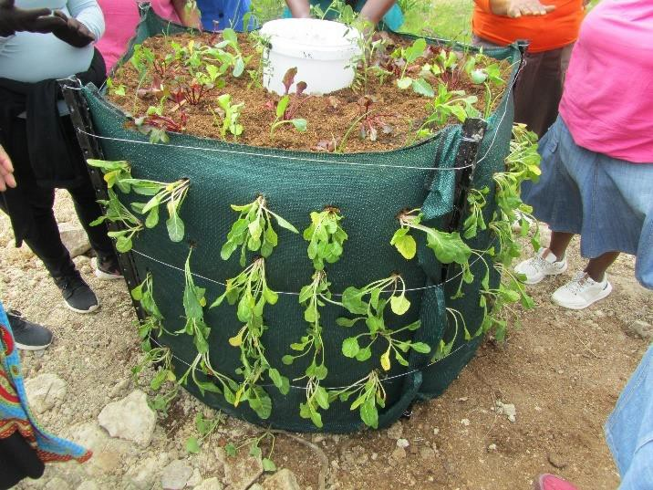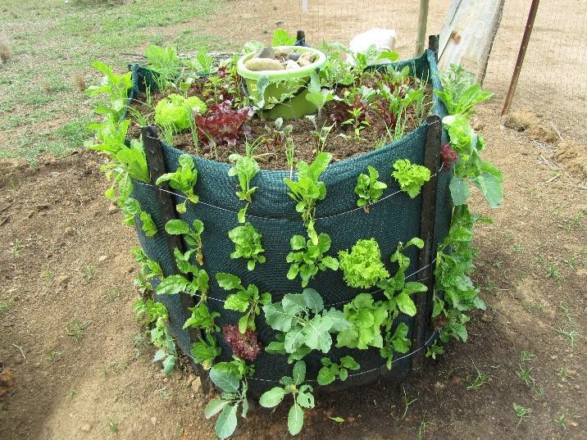
Figure 1: Examples of tower gardens established by community members through a recent INR facilitated project …. See UNDP Attachment

Learners participating in the tower garden construction activity will be selected in consultation with teachers and principals, with the approval and involvement the learners’ parents as required. Learner self- selection is the preferred approach which the team will endeavour to facilitate. In a highly participatory manner, learners will construct the gardens and this negotiated process will be documented. Once established, the planting, management and harvesting of the produce will be monitored on a regular basis with the school staff.

⁴ See appendix 5 for more detail on tower gardens

The choristers are part of an existing initiative and are being supported by the schools and local NGOs to develop their skills in choir singing. Their learning journey and learning capacities are being monitored and will be demonstrated at an annual choir festival where each participating school will introduce and sing at the annual Siyacula Festival, in collaboration with the Drakensberg Boys Choir School. Choirs that are sufficiently developed will be encouraged to enter for the ABRSM (Associated Board of the Royal Schools of Music). We will encourage song choice for this project to focus on themes of climate change, agriculture, water and sustainable communities.

Once the tower gardens are established and are producing, and the choristers are well established as a group (we anticipate a minimum of six months for this), the research team and school staff will bring together choristers and tower gardeners at the five schools to co-develop a ‘learning choral theatre’ to share messages and lessons from the food garden establishment with fellow learners and the broader community through the medium of song. This will culminate in a music and agriculture festival at each of the schools where singing and acting, in combination with practical observation of the tower garden will be used to ‘tell the story of sustainability’.

It is through the learning theatre development process that the co-generation of knowledge will be documented in detail. In addition to the process, we will also evaluate the development of learners’ capacities, for example soft skills (e.g. negotiating song development), conceptualisation of practices (through the development and operation of the tower garden, and through the negotiated process of song development). Furthermore, the impact on learners’ perceptions of agriculture and farming, climate and environment, and sustainability will be documented.

Acknowledging that it will be challenging to collect meaningful data on school academic performance over the short timescale of the project, a participatory research framework using theatre, rich picturing and conceptual mapping will be adopted. Consequently, our focus will be documenting the processes and outcome of group activities rather than traditional data collection (i.e. school marks). In the case of the tower garden, we would document the process and principles which can be obtained through a collective process of Focus Group Discussions (e.g. ‘let’s talk about what went into the tower, how did you apply the principles, how was the division of labour [watering, weeding, etc] negotiated, how is the harvest being recorded’).

The story of the musical and theatre co-creation by the tower gardeners and the choristers is central to the learning process. Here we will observe how knowledge is created and the innovative processes for acquiring and creating knowledge among learners; students become researchers and learn about themselves. This process will capture a number of the key principles of regenerative agriculture using the tower gardens as an example and converting them into music, capturing the story of the gardens in simple words put to music.
The team will document the process of how the theatre was negotiated, the level of engagement among learners and the extent of learning about the subject.

To determine baseline and end of project perceptions and knowledge we will use drawing and art along with oral presentation to document changes between the beginning and the end of the project in the two groups. Through a process of collective rich picture development and oral presentations by learners, we anticipate being able to document changes in perceptions on agriculture, the environment and climate change, learning at school and the role of music. This methodology will be repeated at the end of the project to evaluate changes in the perceptions and capacities over the research period.

Key questions to be answered through this process include:
- What was learned about regenerative agriculture through this process?
- How effective was the learning and knowledge generation process within and between the participating schools?
- How have learner perceptions changed as a result of their involvement in gardening or choir?

- How could this approach be refined and applied in daily learning at schools and integrated into different subjects - Maths, English literacy, Physical Science?
- What are the opportunities to deepen the role of agriculture, art and choral music into the curriculum; how can these stories be written?
- How can this be replicated and upscaled in different schools?
Monitoring, evaluation and learning (MEL). Please tell us who you will appoint as your Project Monitor, give brief details of their previous experience with MEL or educational assessment, confirm that they have agreed to take on the role, and let us know what support they’re likely to need (if any). Also, please tell us how often your Project Monitor plans to do a full project review. [max 250 words]

We have adopted a two-prong approach to MEL in this project. Providing strategic oversight to MEL will be Steve, who has extensive experience in the development and monitoring of training materials and curricula. Steve will be supported by Zanele who will conduct the monitoring in conjunction with selected staff members at the school who will be selected at the initiation of the project. We anticipate three main MEL events (1) inception (baseline assessment); (2) mid-term and (3) project completion and will use the methods described in the methodology section of this document.

As part of this initiative we would also like to further explore the 15% improvement in English literacy of choristers observed in one school, when compared to non-choristers in the same grade.
Project management, including how you will allocate roles, staff time on the project, timetables and milestones, risk assessments. [max 500 words]

Overall project management will be the responsibility of Brigid(INR) who will be ultimately responsible for project reporting and management of the research objectives.

Nosipho (INR) and Zanele (INR) will provide operational support and facilitation for the project through regular engagement at the schools. An important role for the facilitators is supporting the teachers to engage meaningfully with the learners in the choir and the gardening activities.

Bridget (PSI MOLEKANE) will support the choir elements through music instructors currently engaged with the schools, and the development of the ‘learning choral theatre’ with the support of the INR team
Prof Steve Worth will provide strategic support to the training and learning elements of the projects.

The project milestones and timetables are provided below.
 | Project activities | Month
 |  | 1 | 2 | 3 | 4 | 5 | 6 | 7 | 8 | 9 | 10 | 11 | 12
 | Inception and mobilisation
 | Site visit and stakeholder engagement
Training and installation of tower garden
systems.
 | Ongoing mentorship and support
 | Co development of choral learning theatre
 | Music and agriculture festivals at schools
 | Monitoring and evaluation
 | Final report

Risk assessment
Working with children in a learning setting requires that the research team be highly aware of any physical and psychological risks to which the children could potentially be. At project inception, the team will work with school staff and TESF to conduct a full risk analysis and develop a risk management strategy before any active engagement with the learners takes place. Potential risks identified to date include:
- Lack of effective participation by parents / community, which could negatively impact construction of the tower gardens and limit the outreach potential of this work.
- Negative perceptions associated with agriculture and food gardens in general may limit participation by learners.
- Limited time on the part of school staff to support the gardening initiatives.
- Extreme climate events (flood, hail, cold) impacting on garden production.
- Pest and diseases impacting on vegetable production.
- Appropriate songs and song choices may be difficult with climate change and sustainability relatively new concepts and traditional material being less applicable to this learning journey.
Ethics and permits to include any ethical considerations of your research. Give brief details of these and how you will address them, indicating whether your host organisation has ethical guidelines and whether your research is consistent with them. Explain how your project will fully take account of national C-19 guidelines and restrictions. [max 500 words]

INR Policies
The INR has a range of policies and procedures that guide how we operate as a business, engage with our clients and partners and share personal information. Included in these policies are our ethics, scientific, anti- bribery and corruption policies, which can be made available upon request. Working with children, in particular, requires a particularly close examination of ethical considerations prior to and during the research process through regular reflection and re-examination. It is particularly important to consider the integrity and dignity of the participants and their full consent (and that of their parents / guardians) and assent based on a proper understanding of the research.

Ethical Clearance
As an NGO, the INR does not fall under any formal Research Ethics Committee. Consequently, the INR will apply for ethical approval and associated processes under the umbrella of the Rhodes Ethical Clearance process.

COVID-19
The INR as an action research organisation has been actively engaging in field activities to support rural livelihoods during COVID-19 pandemic. We have a set of internally documented protocols for fieldwork that comply with the requirements of the Department of Health. It is noted here that our approaches may need to be revised considering that we are working with young learners. Where meetings and gatherings occur, these will be limited as much as possible to less than 7 people, where possible outdoors, and with the necessary safety protocols. The possibility of holding small focus group discussions outside will be considered, to limit the risk of transmission.
Mobilising and developing capacities. If funded, how will this project draw on and strengthen existing capacities within the team? How will it draw on and strengthen capacities within the wider TESF network? [max 500 words]

The project team includes a blend of youth and experienced individuals with complementary skills that can effectively implement this research work. Bringing together extension, agricultural and music specialists will allow for new information to be shared and ‘new ways of doing things’ to be developed. Importantly, we will

be encouraging the teachers at the schools to actively support and participate in this learning journey and finally, the learners themselves will be closely supported to participate in the research.

While we believe that the team brings a good set of skills to the project, we recognise that there are many new learning opportunities for us from working with the TESF network. In particular, it is envisaged that learning more from TESF about transformative learning would be of substantial benefit to all team members, as well as developing a deeper understanding of MEL approaches as they pertain to learning environments and young learners. In turn, we anticipate that sharing our learning journey with the broader network will create the opportunity for other partners to draw lessons from our work.
Explain the kinds of outputs that you intend to produce, how you will maximise these, and how we will be able to share them (or evidence of them) on our website. [max 500 words]

The main outputs from the project include:
- Five tower gardens established at each of five schools, along with the technical and social processes that are required to achieve the garden development and production, along with the monitoring of ongoing production and harvest (to be documented using short video clips, soundbites and photographs).
- Through the establishment of the gardens, learners have a better understanding and can articulate the principles of regenerative agriculture and food and nutrition security.
- Active cooperation and collective knowledge creation by the learners through the development of a ‘learning theatre’ to articulate the process of establishing and managing tower gardens, regenerative agriculture principles and sustainability practices in general
- School music and agricultural festivals to share the learning, with a focus on disseminating information and raising awareness around food security and sustainability in the broader community (documented using film clips, pictures and written reporting)
- Rich pictures and oral presentations documenting the change in perceptions and capacities of the learners from project inception to end of project.
- A final report documenting the learning journeys and considerations for refinement, replication and upscaling of the process, considering in particular how choral music and agriculture can be more effectively integrated into holistic learning systems.

BUDGET JUSTIFICATION
Your budget justification should cover the following [max 750 words]:
- Explain why the indicated resources are needed, taking into account the nature and complexity of the project
- Justify the need for investigator time, consultancy or subcontracting, considering the administrative responsibilities of running a project
- The need for facilities or staff must be justified, but we do not need a justification of their value
- Overhead costs need not be justified but must not be more than 20% of the total staff costs
- Cost for items expected to the found in a host institution must be justified
- Will there be a contribution from another source (other project and/or in-kind contribution)?

This research project includes staff time for key resources required to mobilise and implement this project effectively. Music instructors will assist with the choral elements of the project and the development of the ‘learning choral theatre’. These instructors will support local teacher- conductors in a visit to each school fortnightly, explaining and demonstrating the choral skills that learners can develop.

CHECKLIST OF ALL INFORMATION AND SUPPORTING DOCUMENTS NEEDED
✔ All questions completed

✔ CVs for the Principal Investigator and all Co-Investigators attached

✔ Annex 1: Completed budget form

✔ Annex 2: Completed due diligence application letter

✔ Annex 3: Completed host organisation due diligence form

✔ Annex 4: Completed letters of support (from host organisation and project partners)
NOTE: Awaiting support letter from UKZN, which we expect shortly

✔ Annex 5: Full due diligence assessment – FOR INFORMATION ONLY and does not need to be completed/submitted at this stage

✔ Optional: Visual evidence (maximum of two sides of A4) and any other supplemental material (short video, etc.) [maximum of 2-3 items]
See Annex 5

