BUILDING STRONG COMMUNITY

VIDA Y PROSPERIDAD TODOS SANTOS, A.C., was formed in September of 2013 by the residents and business community of Todos Santos, Baja California Sur, Mexico to address the concerns and problems of the local population, protect environmentally sensitive area within the community and to support education and social programs to provide greater prosperity and quality of life for the residents.
Vida y Prosperidad maintains its’ strong commitment to encourage youth sports in our community. By fostering sports teams, we can help to enhance a young person’s life. Playing sports is vital to aid in one’s self esteem and helps to instill personal discipline.
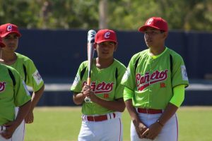Physical activity is essential for healthy and optimal development, through childhood and early adulthood, and youth sports provide many opportunities for a physically active routine. Boosting the well-being of kids through this time can help any community’s future, as children who participate in such activities are better adjusted as they enter adulthood, with plenty of life skills and lessons under their belts.
We offer support for general sports: Including Youth Baseball, Girls Softball, Soccer, Cycling, Chess, shore fishing, marathon running and Paralympics.
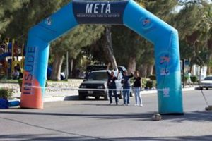Our experience with the area baseball teams over the past several years has shown us that sports programs contribute to personal self-esteem, builds character and combats obesity. We have also seen that team participation is an attractive alternative to joining a gang by encouraging community, group pride and positive collaborative values thereby reducing drug usage and petty crime. As a former gang member told me, "I am now with a team, not a gang. You can't score a goal when you are high on drugs. I like scoring goals".
RESPONSIBILITY: Our Organization will work with team coaches and parent’s associations to coordinate program development and execution. Funds will be used to:
Offer support for uniforms.
Provide new equipment where needed.
Provide funding for transportation and fees for teams to participate in out of area league games.
Help build leagues and teams.
Encourage local community participation and support of the program by individuals and local businesses.
Sponsor an annual marathon and cycling event.
Help fund champion athletes compete in national and international competition.
Reinforce the structure of the volunteer leadership and coaching staff.
Offer support to the Asociación de Padres de Familia (Parent’s association).
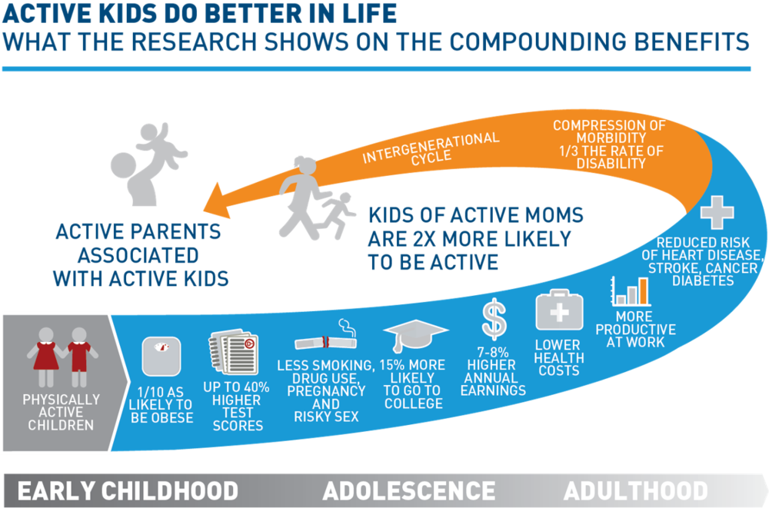
- Support all youth leagues in baseball, and girls’ softball teams, with equipment uniforms and transportation.
- Support wheelchair competition for Olympics
- Support all Fútbol teams
- Youth cycling team
- Basketball teams with equipment
- Fishing tournament providing prizes for the youth shoreline fishing.
- Sent champion athletes to compete in state, national, and international support for travel and equipment.
- Organize and fund marathons
Our 2018 budget was $8000, help us hit our
2019 goal of $15,000

